St Nicholas, Emmbrook & St Paul, Wokingham
The Livestreamed Eucharist
in the Season of Lent
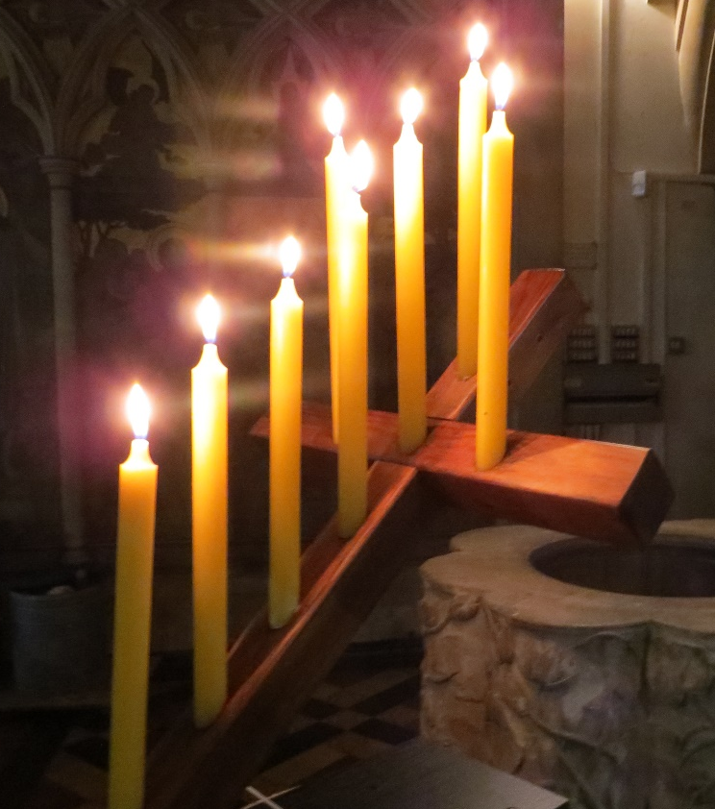

Before the service we gather as one, conscious that we are united with people all over the world in this moment and in our shared purpose, which is our shared longing to come face to face
with the living God who calls us to follow him.

The invitation into Lent is the invitation to travel with Jesus into the wilderness of reflection, stillness and questioning that we might be with him in these 40 days and with him still as he enters Jerusalem
on Palm Sunday and beyond.

Incense rises like our prayer and is deeply Biblical.
The thurible is used to cense holy things- the altar, the Gospel Book, the elements on the altar, and us, God’s holy people.
The Gathering
In the name of the Father, and of the Son,
and of the Holy Spirit. Amen.
Grace, mercy and peace from God our Father and the Lord Jesus Christ be with you: and also with you.

Words of welcome and introduction follow.

Prayers of Penitence
A time of silence is kept as we recall our sin and our need of God.
Almighty God, long-suffering and of great goodness:
I confess to you, I confess with my whole heart,
my neglect and forgetfulness of your commandments,
my wrong doing, thinking and speaking:
the hurts I have done to others;
and the good I have left undone.
O God, forgive me, for I have sinned against you:
and raise me to newness of life;
through Jesus Christ our Lord. Amen.

Lord, have mercy. Lord, have mercy.
Christ, have mercy. Christ, have mercy.
Lord, have mercy. Lord, have mercy.

The Absolution
Almighty God, who forgives all who truly repent,
have mercy on you, + pardon and deliver you
from all your sins, confirm and strengthen you in all goodness,
and keep you in life eternal;
through Jesus Christ our Lord. Amen.
The Collect
The Lord be with you: and also with you.
Let us pray for grace to keep Lent faithfully.
A moment of silent prayer follows.

The Liturgy of the Word
The Reading
This is the word of the Lord. Thanks be to God.

The Gospel
Hear the Gospel of the Lord Jesus Christ according to Mark.
Glory to you, O Lord.

And at the end…
This is the Gospel of the Lord. Praise to you, O Christ.

The Sermon

The Creed
We believe in one God,
the Father, the Almighty,
maker of heaven and earth,
of all that is, seen and unseen.

We believe in one Lord, Jesus Christ,
the only Son of God,
eternally begotten of the Father,
God from God, Light from Light, true God from true God, begotten, not made, of one Being with the Father;
through him all things were made.
For us and for our salvation he came down from heaven,
he became incarnate from the Holy Spirit and the Virgin Mary and was made man.
For our sake he was crucified under Pontius Pilate;
he suffered death and was buried.
On the third day he rose again
in accordance with the Scriptures;
he ascended into heaven
and is seated at the right hand of the Father.
He will come again in glory to judge the living and the dead, and his kingdom will have no end.

We believe in the Holy Spirit, the Lord, the giver of life,
who proceeds from the Father and the Son,
who with the Father and the Son is worshipped and glorified, who has spoken through the prophets.

We believe in one holy catholic and apostolic Church.
We acknowledge one baptism for the forgiveness of sins.
We look for the resurrection of the dead,
and the life of the world to come. Amen.

The Prayers
At the end of each section, a response may be used:
Lord, in your mercy: hear our prayer.
(or) Lord, hear us: Lord, graciously hear us.

Merciful Father,
accept these prayers
for the sake of your Son, our Saviour,
Jesus Christ. Amen.
The Liturgy of the Sacrament
The Peace
During the peace we hold out Christ’s peace to one another, picturing the whole people of God gathered together in this moment.
Do please put your message in the comment box on YouTube.

The Preparation of the Altar
Blessed be God, who feeds the hungry, who raises the poor, who fills our praise. Blessed be God for ever.
Pray, my brothers and sisters, that our sacrifice may be acceptable to God the Almighty Father. May the Lord accept the sacrifice at your hands, for the praise and glory of his Name, for our good and the good of all his Church.
Be present, be present, Lord Jesus Christ, our risen high priest: and make yourself known in the breaking of the bread.

The Eucharistic Prayer
The Lord be with you:
and also with you.
Lift up your hearts:
we lift them to the Lord.
Let us give thanks to the Lord our God:
it is right to give thanks and praise.

The Priest says the Eucharistic Prayer, reminding us of God’s grace and actions. Then we say together:
Holy, holy, holy Lord, God of power and might, heaven and earth are full of your glory. Hosanna in the highest.
Blessed is he who comes in the name of the Lord. Hosanna in the highest.
After the Priest has led us in remembering the Last Supper, Christ’s great offering of himself, we say:
Praise to you, Lord Jesus:
Dying you destroyed our death, rising you restored our life, Lord Jesus, come in glory.
The Greater Silence follows in which we reflect on all we have heard and said in our service, and on the immensity of God’s loving mercy.

The Lord’s Prayer
Lord Jesus remember us in your Kingdom and teach us to pray:
Our Father, which art in heaven,
hallowed be thy name.
Thy kingdom come, thy will be done,
on earth as it is in heaven.
Give us this day our daily bread.
And forgive us our trespasses,
as we forgive those who trespass against us.
And lead us not into temptation, but deliver us from evil.
For thine is the kingdom, the power
and the glory, for ever and ever. Amen.
The Fraction
We break this bread to share in the body of Christ. Though we are many, we are one body because we all share in one bread.

Agnus Dei
Lamb of God, you take away the sin of the world, have mercy on us.
Lamb of God, you take away the sin of the world, have mercy on us.
Lamb of God, you take away the sin of the world, grant us peace.

The Invitation
This is the Lamb of God who takes away the sin of the world.
Blessed are those who are called to his supper.
Lord, I am not worthy to receive you,
but only say the word and I shall be healed.

Christ is in our midst. He is and always will be.

The celebrant holds out the body and blood of Christ, offered to you. This may be a helpful prayer to use while you listen to the anthem:
We do not presume to come to this your table,
merciful Lord, trusting in our own righteousness,
but in your manifold and great mercies.
We are not worthy so much as to gather up the crumbs
under your table.
But you are the same Lord
whose nature is always to have mercy.

Grant us therefore, gracious Lord,
so to eat the flesh of your dear Son Jesus Christ
and to drink his blood,
that our sinful bodies may be made clean by his body
and our souls washed through his most precious blood,
and that we may evermore dwell in him, and he in us. Amen.
Prayer of Humble Access

Post-Communion Prayer
Lord God, you have renewed us
with the living bread from heaven;
by it you nourish our faith,
increase our hope, and strengthen our love:
teach us always to hunger for him
who is the true and living bread,
and enable us to live by every word
that proceeds from your mouth;
through Jesus Christ our Lord. Amen.

The Notices

The Dismissal
The Blessing

The Lenten Wreath
The Lenten Wreath is a St Paul’s tradition, and works like a reversed Advent Wreath. In Advent the light builds and gathers to show that the birth of Jesus is getting nearer- in Lent, the darkness gathers as, candle after candle, the lit candles are extinguished .
As we journey into Lent, may we do justice,
love mercy and walk humbly with you our God. Amen.
Go in peace to love and serve the Lord.
In the name of Christ. Amen.

Do please join in with the Zoom coffee morning after the service- you’d be very welcome. You can text a donation to St Paul’s to 70450, texting STPAULS5 or STPAULS10 or STPAULS20 to donate that amount of money.
If you’d like to find out about everything that is happening in the parish, please email church.office@spauls.co.uk and we will happily put you on our regular mailing list.

