Our Mad Life 52
Lockdown here, lockdown there
Dear Friends,
Having got to Lincolnshire at the beginning of January and met up with Sarah after nearly a year apart, like you, I have been living with the frustration of Lockdown. Last week we treated ourselves to that “essential” of UK life – a visit to a garden centre, beside where I had a medical appointment. It was full of people enjoying the spectacular range of plants and shrubs. Joining in the spending spree we got a gorgeous bunch of daffodils at 25p and enjoyed our outing. It seemed so bizarre doing that when our local church has been closed and we cannot visit the family!
My return to Madagascar proceeds with what seems like one step forward and two back. Only Malagasy nationals and residents are permitted to enter the country. You may recall that I was waiting for my resident’s visa to arrive and finally had to fly home without it.

On Monday, 8th March, all bureaucratic activities took a back seat with the news of the death of the Bishop of Diego/Antsiranana, the Rt Revd Théophile Botomazava. He was in hospital in Antananarivo due to have a foot amputated but had also heart problems. His remains were transferred to Antananarivo Cathedral and services were led by Bishop Jaona of Antananarivo assisted by the bishops of Tamatave and Fianarantsoa. After a Requiem on the Wednesday they flew to Antsiranana where again services were held in the Cathedral there and a great number of people were able to pay their respects. A huge crowd gathered for the last service at Ambilobe before he was placed in his tomb at Anjiabe on the Saturday. I was able to follow most of this on Facebook.

On 14th March we had the happy news of the election of the next diocesan bishop of Toliara, the Rt Revd Dr Samitiana Razafindralambo. This is a great joy to me and Sarah as we have known him since he was a young student entering the Theological College where he excelled in all that he did: always throwing himself fully into the job in hand with enthusiasm and good humour. My only worry about him and his lovely wife, Holy, is that they will seriously overwork. In the southern diocese of Toliara there has been a serious famine following three years without rain. The church has been heavily involved in famine relief. This has brought many people into closer contact with the church and last month over 1,500 people were baptised in one district.

Madagascar remains one of the countries most affected by climate change, suffering both from increased droughts in the south and more frequent devastating cyclones and floods.

There is another wave of Covid-19 but the government is reluctant to give exact numbers. It is the ‘South African variant’. However, on the ground reports are of the hospital in Mahajanga being overwhelmed with patients. Currently a new cordon sanitaire has been placed around the Mahajanga district with no one allowed to enter or leave by road, ship or air. I heard of a FJKM (equivalent of URC) pastor, his wife, lay leader of his church and son-in-law who all died of Covid-19 within 48 hours.

The Archdeacon and his family are distressed as yesterday his Grandmother, aged 110 years, died and they are not allowed to travel to the funeral. Sarah was able to visit this remarkable lady when she attended the MU festival. Grandmother constantly chewed tobacco and, educated at the height of the colonial era, spoke impeccable French.

Thanks to DHL I am astonished to report that my resident’s visa has been sent from Mahajanga and has just arrived safely. But are there any flights? We hear that at the moment only Air France is being allowed a weekly “repatriation” flight. However, as the coronavirus situation changes rapidly in France even this may be banned. There is also a 14 day quarantine period in place for arriving passengers in Madagascar.

Meanwhile the death toll is rising in Mahajanga and the Archdeacon is discouraging me from hurrying back, not that I would be able to enter the area anyway because of the present restrictions.

Encouraging news is that the President has at last agreed to import some vaccine and not to rely on his herbal tonic as a cure.

Thus I remain in the position we are all familiar with: plans are tentative….
I am glad to report that the Development Committee has continued with various projects.
The photograph is of the new well at Port Bergé. This is to serve the school with over 300 children and the new house for the priest and his family.
There is no public water supply or electricity in this part of the town. I am hoping that we can make great advances here with hygiene both with the school and the Mothers Union. Last year there were several cases of typhoid including the then priest.
When I last visited the town I noticed that the best buildings belonged to the RC Church so I asked our priest to find out how they set about building. He discovered that they had an excellent band of self-employed builders who were only too delighted to work for us.

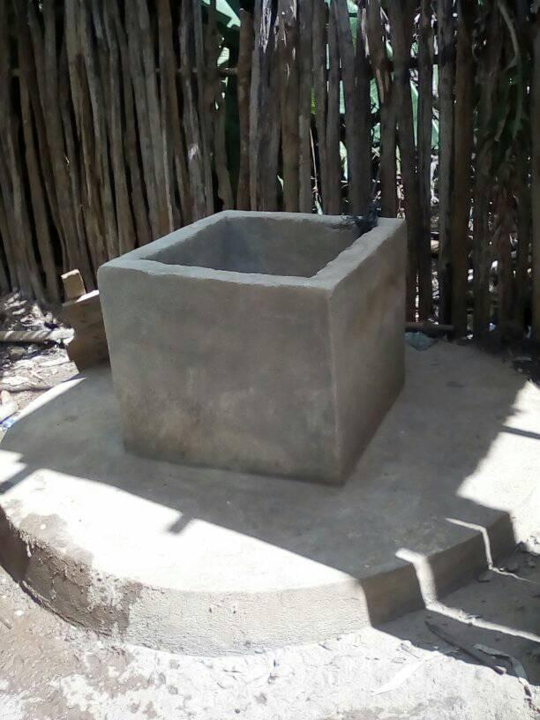
When funds permit we will construct a water tower, etc.

Some of the same men were also available to start work on St. Andrew’s Church much to my delight.
This photograph shows the church foundations. The walls are now near completion. As you can imagine I am anxious to get back and resume confirmations and some clergy meetings that have been postponed since last August.

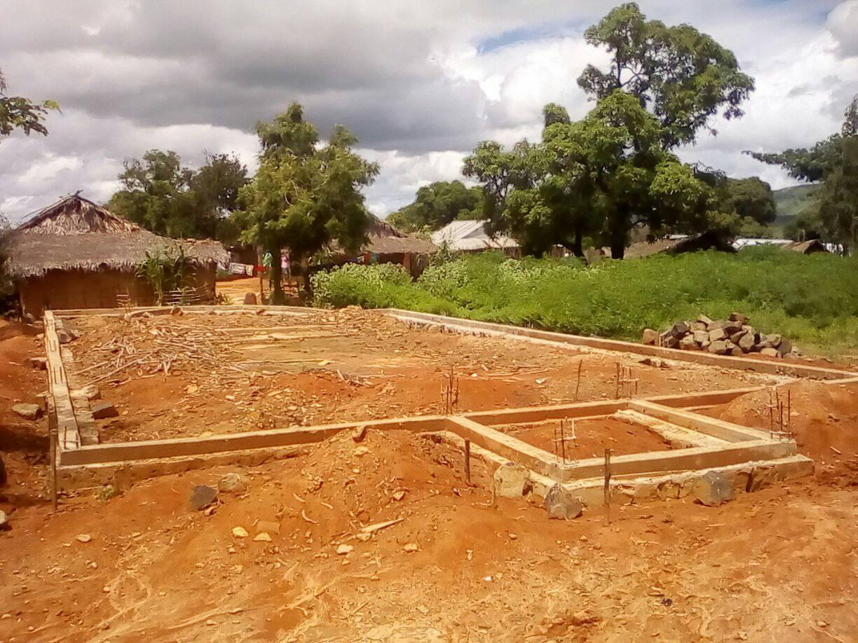
Thank you to all who continue to so generously support us in prayer and in giving. May we all soon be able to make plans and keep to them!
I wish you all a Joyful Easter.
God bless
+Hall
hallspeers@gmail.com

25 March 2021

