A Reflection on the Marquette: Richard Lamey

The look on Mary’s face is the first thing you notice- possibly the only thing. You cannot take your eyes from the chasm of her mouth which is the chasm of her heart, of her hope, of her love, of her future. It is a look we have seen repeated every day since the crucifixion, in same distant country or close to home as a mother cradles her dead child, or a husband hugs his dead wife, or a child clings to their parent, dead.

There is no sense of, no space for, self-awareness, no attempt to maintain decency or control, no time to worry about what others might think. Mary is simply buried in the immenseness of her loss. We are drawn into her grief because it is for us that she is suffering- because it is for us that Jesus died.

Her desolation cries across time and space and finds an echo today in Syria, in Afghanistan, in the Democratic Republic of the Congo, in the cries of a mother whose child has been stabbed to death on the street of an English city.

In a moment others will come to help her, to lift the dead weight of her dead child and carry him to the place of burial where they will arrange his limbs and swaddle him in cloth. But her agonized scream will not be swaddled, or wrapped, or buried. It will grow. It will not be silenced. It will join with the cries of countless others, who have been forced to bury the child they bore in their womb and nursed and held and loved, the child imprinted on their heart and in their soul for always.
St Paul’s Church, Wokingham
Holy Week 2021
“Pieta Realiste” by Russell Bignold

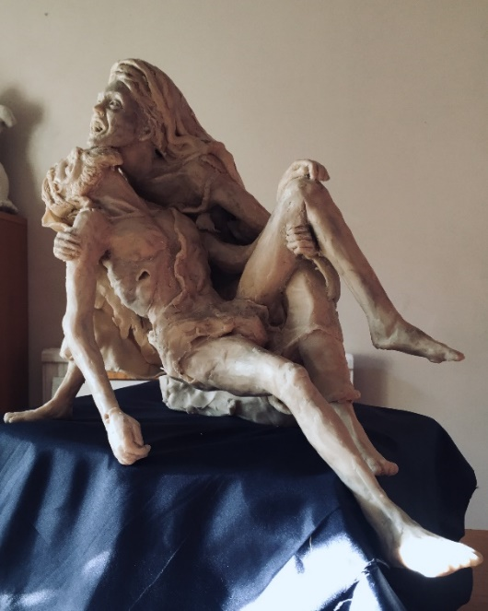

“After this, Joseph of Arimathea, who was a disciple of Jesus... asked Pilate to let him take away the body of Jesus. Pilate gave him permission; so he came and removed his body. Nicodemus, who had at first come to Jesus by night, also came, bringing a mixture of myrrh and aloes, weighing about a hundred pounds. They took the body of Jesus and wrapped it with the spices in linen cloths….
Now there was a garden in the place where he was crucified, and in the garden there was a new tomb in which no one had ever been laid. And so, because it was the Jewish day of Preparation, and the tomb was nearby, they laid Jesus there.” John 19.38-42
How the ‘Pieta Realiste’ came to be made: Russell Bignold

My journey to sculpt this Pieta started quite a few years ago during my honeymoon to Florence, Italy. Actually, it started a very long time ago when I was a child and first saw the sculptures of Michelangelo Buonarroti. Of course these images from many art books could never show the real magnificence of the marbled sculptures but it gave me a sense of the power of creativity that is visioned within a man’s mind. Later I was lucky to travel to Florence to see the great works of art and sculptures of Michelangelo, Bernini and Donatello and it was here that I saw the master’s tomb.

I of course saw his magnificent ‘David’, linking bone and tendon to give the illusion of real life. The veins that run through the wrists and backs of the hands are masterful and the complexity of tension and relaxation of muscle is everywhere. However magnificent the sculpture of David is, and it is truly magnificent, it was seeing the Pieta for the first time that really moved me. To date I have only seen the Belgian Pieta but it is as beautiful a sculpture as exists anywhere in the world. The intricate and delicate carving both in the Virgin Mary and the body of Christ is outstanding and the love between the two is clearly visible in the tenderness of their contact. I can honestly say that I was brought to tears.

I wanted to recreate a different vision of the Pieta. I wanted to show the moment of despair and recognition of the loss that Mary faced as a mother, despite her understanding of Christ’s purpose. I wanted to also show the awkwardness and difficulty of clinging to Christ’s dead body and the tenderness of Mary’s face to face touch at that moment. Rather than show the Virgin Mary as a young woman, I wanted to show her more mature and with bare feet that echoed the feet of Christ. I wanted to show the impact of Crucifixion on the body.

I hope you see some beauty in this sculpture, in this moment of hopelessness and grief and share that with the Virgin Mary. For me it’s an honest moment, when everything is just brought to that realisation of loss, when anger jumps to the front of our range of emotions and before the feeling of acceptance quells and numbs our senses.

Notes about the materials: The sculpture is created in wax that is both moulded and carved by hand. It becomes softer in the hand to aid modelling and lends itself to a textured surface which can enhance the sculpture. It is supported by a metal armature that is threaded through the bulk and limbs which is designed to act as a support for the weight of the wax. At the wax becomes cooler, it will harden but still retain some flexibility: it will never harden as much as clay. Wax is often used for smaller sculptures or studies in preparation for a larger work which is called a ‘marquette’, so it is unusual to show this type of work to the public. Normally the marquette will be destroyed through the casting process when the sculpture is formed into bronze.

