The Parish Church of
St. Paul, Wokingham

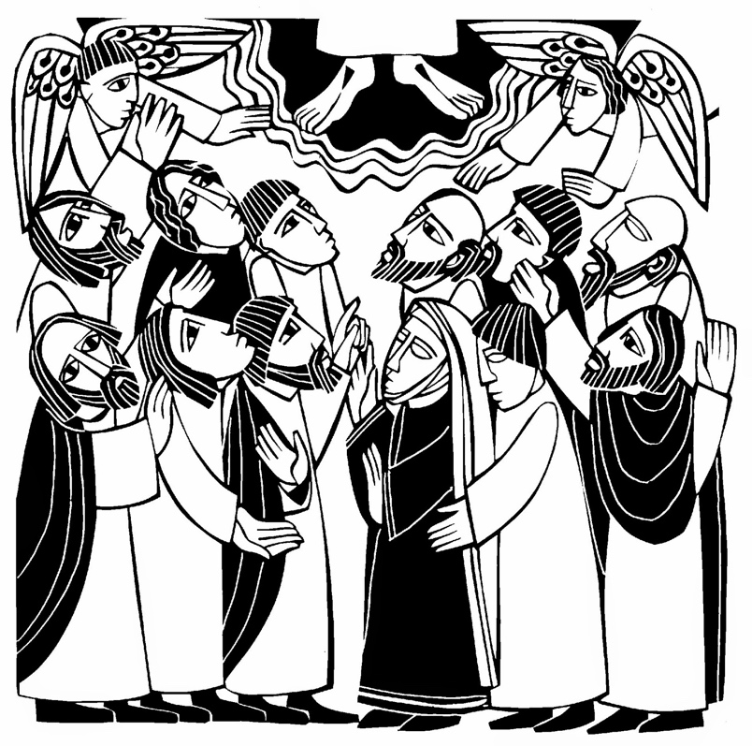

Ascension Day
Parish Mass

Hymn

God has gone up with a shout,
the Lord with the sound of a trumpet.

In the name of the Father, and of the Son,
and of the Holy Spirit.
Amen.
The Greeting

Grace, mercy and peace from God our Father
and the Lord Jesus Christ be with you,
and also with you.

Dear brothers and sisters in Christ, for forty days we have been celebrating with joyful hearts the resurrection of our Lord Jesus Christ, his bursting from the tomb and his defeat of the power of sin and death. He appeared to his disciples many times and told them about the kingdom of God.

Today we recall how he left this earth and returned to his Father, ascending into heaven to take his throne over all dominions and powers. Trusting in his reign over all creation, and submitting to his kingly yet loving rule, let us hear the story of his parting.

The Ascension Reading
A reading from the Acts of the Apostles (1:1-11)

At the end: Alleluia. Christ is risen.
He is risen indeed. Alleluia.

The Gloria
Glory to God, Glory to God, Glory to God in the highest.
Glory to God in the highest,
and peace to his people on earth.
Lord God, heavenly King, almighty God and Father,
We worship you, we give you thanks,
we praise you for your glory.
Glory to God, Glory to God, Glory to God in the highest.
Lord Jesus Christ, only Son of the Father.
Lord God, Lamb of God,
you take away the sin of the world;
have mercy on us;
you are seated at the right hand of the Father:
receive our prayer.
Glory to God, Glory to God, Glory to God in the highest.
For you alone are the Holy One, you alone are the Lord,
you alone are the most high, Jesus Christ,
with the Holy Spirit, in the glory of God the Father.
Glory to God, Glory to God, Glory to God in the highest.

The Collect

Grant, we pray, almighty God,
that as we believe your only-begotten Son our
Lord Jesus Christ to have ascended into the heavens,
so we in heart and mind may also ascend
and with him continually dwell;
who is alive and reigns with you,
in the unity of the Holy Spirit,
one God, now and for ever.
Amen.

The Gospel Reading

Alleluia, alleluia.
Go and make disciples of all nations, says the Lord.
Remember, I am with you always, to the end of the age.
Alleluia.

Hear the Gospel of our Lord Jesus Christ according to Luke.
Glory to you, O Lord.

At the end: This is the Gospel of the Lord.
Praise to you, O Christ.

Sermon

The Creed

We believe in one God, the Father, the Almighty,
maker of heaven and earth, of all that is,
seen and unseen.
We believe in one Lord, Jesus Christ,
the only Son of God,
eternally begotten of the Father,
God from God, Light from Light,
true God from true God, begotten, not made,
of one Being with the Father.
Through him all things were made.
For us and for our salvation he came down from heaven:
was incarnate from the Holy Spirit and the Virgin Mary,
and was made man.
For our sake he was crucified under Pontius Pilate;
he suffered death and was buried.
On the third day he rose again
in accordance with the Scriptures;
he ascended into heaven
and is seated at the right hand of the Father.
He will come again in glory to judge the living and the dead, and his kingdom will have no end.
We believe in the Holy Spirit, the Lord, the giver of life,
who proceeds from the Father and the Son.
Who with the Father and the Son
is worshiped and glorified.
Who has spoken through the Prophets.
We believe in one holy catholic and apostolic Church.
We acknowledge one baptism for the forgiveness of sins.
We look for the resurrection of the dead,
and the life of the world to come.
Amen.

Prayers of Intercession

Response: Lord, hear us.
Lord, graciously hear us.

Merciful Father, accept these prayers
for the sake of your Son, our Saviour Jesus Christ. Amen.

The Peace

Jesus says: “Peace I leave with you; my peace I give to you.
If you love me, rejoice because I am going to the Father”.
Alleluia.

The peace of the Lord be always with you,
and also with you.

Hymn

Preparation of the Altar

Blessed be God,
by whose grace creation is renewed,
by whose love heaven is opened,
by whose mercy we offer our sacrifice of praise.
Blessed be God for ever.

The Eucharistic Prayer

The Lord be with you.
And also with you.

Lift up your hearts.
We lift them to the Lord.

Let us give thanks to the Lord our God.
It is right to give thanks and praise.

The priest praises God for his mighty acts and all respond:
Holy, holy, holy Lord, God of power and might.
Heaven and earth are full of your glory.
Hosanna, hosanna, hosanna in the highest.
Blessed is he who comes in the name of the Lord.
Hosanna, hosanna, hosanna in the highest.

The priest recalls the Last Supper and then says:
Great is the mystery of faith.
Christ has died; Christ is risen; Christ will come again.
The priest continues with the doxology and all reply Amen.

The Lord’s Prayer

Looking for the coming of his kingdom, let us pray with
confidence as our Saviour has taught us:
Our Father, which art in heaven, hallowed be thy name;
thy kingdom come, thy will be done;
on earth as it is in heaven.
Give us this day our daily bread.
And forgive us our trespasses,
as we forgive those who trespass against us.
And lead us not into temptation,
but deliver us from evil.
For thine is the kingdom, the power and the glory,
for ever and ever. Amen.

The Fraction

Lord, we died with you on the cross.
Now we are raised to new life.
We were buried in your tomb.
Now we share in your resurrection.
Live in us, that we may live in you.
Agnus Dei (Lamb of God)

Lamb of God, you take away the sin of the world, have mercy on us.
Lamb of God, you take away the sin of the world, have mercy on us.
Lamb of God, you take away the sin of the world,
grant us peace.

The Invitation

I heard the voice of a great multitude crying, Alleluia.
The Lord our God has entered into his kingdom.
Blessed are those who are called to the supper of the Lamb. Alleluia.

If you usually receive communion in your own church, or you’ve done so in the past, you are most welcome to receive communion here today.
If you would prefer to receive a prayer of blessing, please bring this order of service with you to the altar rail.
If you’re not able to walk to the altar rail, please tell one of the sidespeople.

Post Communion Prayer

We thank you, Lord, that you have fed us in this sacrament, united us with Christ, and given us a foretaste of the heavenly banquet prepared for all peoples. Amen.

The Dismissal

‘Then the disciples returned to Jerusalem from the mount called Olives, which is near Jerusalem, a Sabbath day’s journey away. When they had entered the city, they went to the room upstairs where they were staying. They were constantly devoting themselves to prayer, together with certain women, including Mary the mother of Jesus, as well as his brothers.’

As we wait in silence,
make us ready for your coming Spirit.
As we listen to your word,
make us ready for your coming Spirit.
As we worship you in majesty,
make us ready for your coming Spirit.
As we long for your refreshing,
make us ready for your coming Spirit.
As we long for your renewing,
make us ready for your coming Spirit.
As we long for your equipping,
make us ready for your coming Spirit.
As we long for your empowering,
make us ready for your coming Spirit.

The Blessing

May the Spirit
who set the Church on fire upon the day of Pentecost,
bring the world alive with the love of the risen Christ.
And the blessing of God almighty,
the Father, the Son, and the Holy Spirit,
be among you and remain with you always. Amen.

Hymn

Dismissal

Waiting expectantly for the promised Holy Spirit,
go in the peace of Christ. Alleluia, alleluia.
Thanks be to God. Alleluia, alleluia.

Copyright material is included from Common Worship: Services and Prayers for the Church of England © The Archbishops’ Council 2000.
KM 5/2018

