1 Broad Street Walk
Wokingham
RG40 1BW

Tel: 07926 524605
Email: info@wokingham.foodbank.org.uk
Website: www.wokingham.foodbank.org.uk

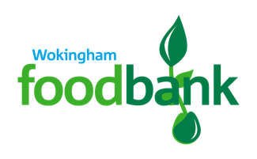

27th April 2021

Dear Richard, Vanessa and The Parish Rooms Trust,

On behalf of Wokingham Foodbank I am writing to thank you for supporting us to operate from the Parish Rooms at the start of the year.

At the Foodbank we experienced a challenging end to 2020 when Covid-19 numbers in our community were high. Concerns about safety for both clients and our volunteers meant that something really needed to change. Working from a building that facilitated easy social distancing and provided a car park for volunteer drivers to load up food parcels directly into their vehicles made our lives so much easier! I cannot understate how valuable it was for us to operate in a spacious and safe environment. It also provided us with a period of reflection to think about what type of space we would like to operate from in the future.

Over the 12 week period that we operated from the Parish Rooms we distributed food parcels to support 1009 residents, 418 of which were children. The level of demand for our services across Wokingham is still significantly higher than before the pandemic but with the support of our community we will always be here to help those in need.

With many thanks,

Annette Medhurst
Wokingham Foodbank Manager

