1 Broad Street Walk
Wokingham
RG40 1BW

Tel: 07926 524605
Email: info@wokingham.foodbank.org.uk
Website: www.wokingham.foodbank.org.uk

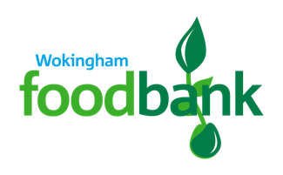

27th April 2021

Dear Richard,

On behalf of Wokingham Foodbank I am writing to thank the congregation of St. Paul’s and St. Nicholas for their generous ongoing support. The food donated from your Lent collection is a very welcome boost to our stocks.

A grand total of 212.15kg was donated and this will go a long way to support members of our community who are struggling with the costs of food and household essentials.

The last year has placed significant financial strain on so many people across Wokingham. While we are saddened that the level of demand for our support is still so high, we take great comfort that our community is generous and caring towards those in need.

With many thanks,

Annette Medhurst

Wokingham Foodbank Manager

