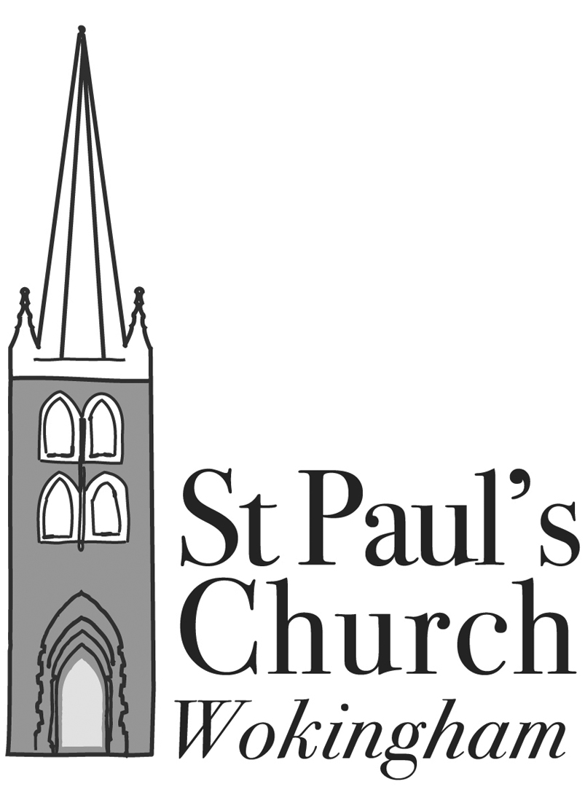
ST PAUL’S, WOKINGHAM

WITH ST NICHOLAS’, EMMBROOK

Annual Meeting of Parishioners
to be held in Church and on Zoom at 8.00 p.m. on Monday 5 July 2021

AGENDA

Apologies for absence

Acceptance of Minutes of Meeting held on 19 October 2020 Attached

Election of Churchwardens

Any other business – to be notified to the Secretary by the Sunday prior to the meeting (4 July 2021)

Annual Parochial Church Meeting
to be held on Monday 5 July 2021
AGENDA
- Apologies for absence
- Acceptance of Minutes of meeting held on 19 October 2020 Attached
- Matters arising from the Minutes
- Election of Pro-Wardens of St. Nicholas and Deputy Wardens of St Paul’s
- Changes in the Electoral Roll since the last annual meeting Reports
- Election of up to 9 Parochial Church Councillors
- Election of additional Deanery Synod rep to fill vacancy
- Appointment of Sidespersons
- Treasurer’s Report and Presentation of Financial Statements for 2020 Separate booklet
- Appointment of Independent Examiner
- Parish Report by the Rector, Fr Richard Lamey
- Report from Deanery Synod Reports
- Churchwardens’ report on the fabric, goods and ornaments of the church Reports
- Safeguarding
- Parish Rooms Trust Report and Accounts for 2020 Attached
- Any other business – to be notified to the Secretary by the Sunday prior to the meeting (4 July 2021)

Supporting documents:
- Minutes of 2020 APCM; Parish Rooms Trust Financial Statements and associated documents; Parish Rooms Trust Trustees Report;
- Parish Reports 2020;
- Annual Report and Financial Statements 2020

