The Confession [p2-3]
We live in a world of injustice. We are part of that world in our own lives and decisions- and we have not fought hard enough to defend the weak, to protect the environment, to live selflessly and for others. Before we can offer ourselves in service and receive all of the gifts God
longs to pour out upon us we need to be washed clean of our sin. We need to allow ourselves to be loved into wholeness. Like the Prodigal Son, we need to come home, and accept that we can be forgiven through the love of the loving, patient, running Father.

What event, action or word stops you hearing the forgiveness of God? What do you think most grieves the heart of God in our town, and nation? Trust in God’s love and promises and be healed.

The Liturgy of the Word [p4-6]
We meet with God and we open our hearts to his grace and guidance. He speaks to us through the Reading. Christ himself is present in the proclamation of the Gospel. Through the Sermon, through what is said and the silence between and around the words, we receive challenge and inspiration. In the Creed we are called back to our common faith in God. In the Intercessions we align our heart and longings with the heart and longings of God. In these precious moments of openness we listen for what God is saying to the gathered body, and to each one of us.

Blessed Lord, who caused all holy Scriptures to be written for our learning: Grant us so to hear them, read, mark, learn, and inwardly digest them, that we may embrace and ever hold fast the blessed hope of everlasting life, which you have given us in our Savior Jesus Christ… [Proper 28, BCP Collect]

What do you think God is saying to the Church today?
What is God saying to you today?
The Peace [p6]
We gathered as one people, one Church, one body at the start of the service and now we reaffirm our core foundational belief that Christ dwells in every one of us. We look each other in the eye and, whatever our differences of opinion, however different we look to each other, even if we have never met before, we see Christ there.

God has made us one in Christ. He has set his seal upon us
and, as a pledge of what is to come, has given the Spirit
to dwell in our hearts. Alleluia. [Common Worship]

Is there anyone here who you particularly need to make peace with?
Is there anyone at all you need to make peace with?
Heal what needs to be mended. See the eyes of Christ in others, in all.

The Liturgy of the Sacrament [p6-10]
The Eucharist is God’s love song woven throughout human history, woven through our history and our future both. Listen to God’s delight in creation. Listen again to the story of what Jesus Christ risked and won for you. Listen to the promise of the gift of the Spirit of God which is God himself with you always. This is Christ’s table. It is Christ himself who invites you. It is Christ himself who holds out the bread to you. Remember who you are. Remember whose you are. And let Christ’s love fill your heart, your veins, your thoughts, your living.

O God, who in this wonderful sacrament has left us a memorial of thy passion, grant us the grace so to venerate the sacred mysteries of thy Body and Blood, that we may ever continue to feel within ourselves the blessed fruit of thy redemption… [St Thomas Aquinas]

If God has done all of this for you, what is stopping you
from living like it? You are what, and who, you eat.
The Dismissal [p11]
The word Mass is from the Latin, mittere, which means the sending out, the scattering. It means: go and do it. See the world as God sees it, flawed and fallen but precious and redeemed as well. Be the body of Christ. Be the hands and feet of God in the world. Truly become the baptised people of God, sent into the world to shine as a light on a hill, to live out everything we have sung and said and heard and prayed in this precious time together.

Though a church may be used in many different ways, its purpose is always the worshipping of God. All that we do in worship aims to bring us closer to the living God. The incense sets apart and blesses that which is holy. The bells and candles allow our focus to be always and forever retuned to God. For this reason, all that we do and the way in which we do it invites us spiritually, mentally and physically to be drawn into the love that flows from the Trinity.
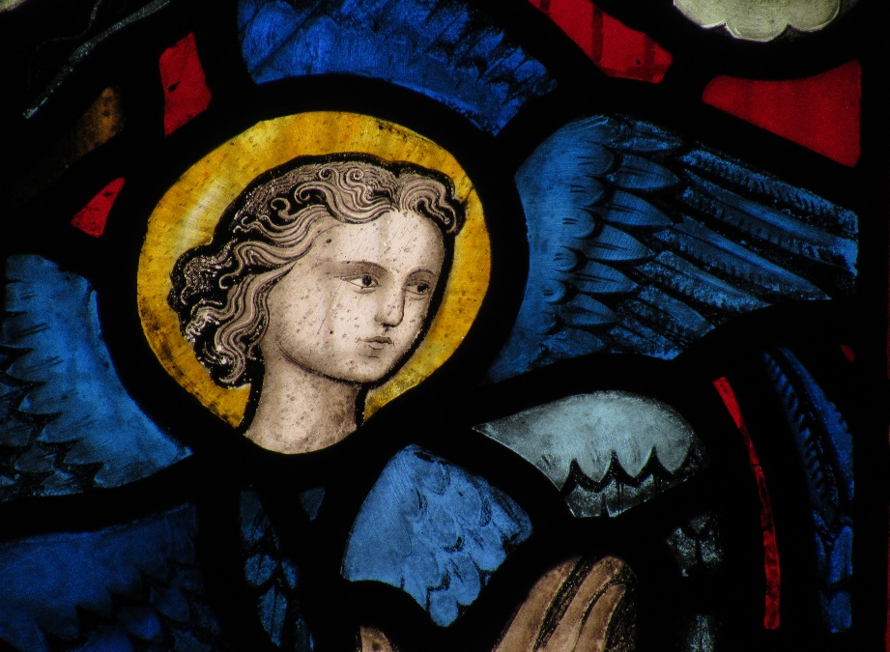
St Paul’s Church, Wokingham
A Short Guide to the Mass

Incense is deeply Biblical. It rises to heaven with our prayers. It smells sweet and beautiful like holiness. And it is used to draw our attention and to bless holy things- the altar table, the Gospel book, the gifts we bring to offer and we ourselves, God’s holy, redeemed, Easter people.

The Gathering [p2]
We come together as one equal people, of every age, political hue, and background. Some of us are joyful, some are grieving. Some of us are full of hope, some of fear. And here we have stepped out of all of the busyness of life, the winds which whirl around us, and, for a time, we remember who we truly are. We remember to see our lives and our dreams through the example of the life of Jesus, lived for us. We remember that above all, first and always, we are God’s redeemed children, one people, one family, one body, one Church. We remember that we are re-membered in this feast, shown to be who we truly are- God’s saints on earth, loved into wholeness and loved into service.

O Lord, open our lips: and our mouth shall proclaim your praise.
O God, make speed to save us: O Lord, make haste to help us.
Glory to the Father, and to the Son, and to the Holy Spirit;
as it was in the beginning, is now and ever shall be, world without end. Amen. [Book of Common Prayer]

What is weighing you down as you come to Church today?
What is causing your heart to sing?
Look around. We are one people in Christ Jesus our Lord.

