Our Mad Life 55
Patience needed!
To the astonishment and incomprehension of my fellow travellers I am writing this while waiting for our bus for yet another of my trips. We were due to leave the Cathedral at 8 am. Our home help rolled her eyes with a some-people-never-learn look when I said I needed to go at 7.30 am so that my luggage could be put on the bus roof. Incorrigible, I turned up and found some others had optimistically arrived at 6.30 am. Jocelyn, the university student who helps me from time to time and had carried my enormous suitcase, surveyed the situation and suggested 9 am as a possible departure. When 9 am came and went I asked if anyone knew where our bus was. The girl beside me said that the bus had just gone to the garage but she didn’t know where the garage was. 10am came and went and I remarked how incredibly patient the Malagasy are in these circumstances. Jocelyn felt that I needed to be calmed with some more information and came back and suggested I went back home and did my emails as the bus had indeed gone to the garage at 9am – but for a service and some repairs.

What I find so amazing about these waits is that nobody reads a book or writes or does anything apart from the occasional revamping of the ladies’ hair and excursions to buy snacks. Everyone just sits and talks and laughs with seemingly no thought or anxiety that this delay will mean doing the last bit of the journey by night, which most hate, and the resulting confusion at the other end. This being my third long journey in a week it is trying my patience!

My first trip was a site visit to St Andrew’s Church, Ampobibitika, which I was due to dedicate just over a week later. After the usual wait at the bus station we set off at 7.30 am and I was delighted to arrive by 4.30 pm when there was still plenty of daylight. I was well pleased with the walls and roof, but there were no floors and no doors. I expressed my anxiety about these being installed in time for the service. No problem – all was in hand. So I duly decided where exactly the altar table was to be and decided against the great flight of steps up to it that the Rural Dean wanted. All were optimistic and a devoted church member turned up and presented me with a bag of eggs in gratitude for the project. The next stop was the local church school which, for a variety of reasons, is a constant anxiety.

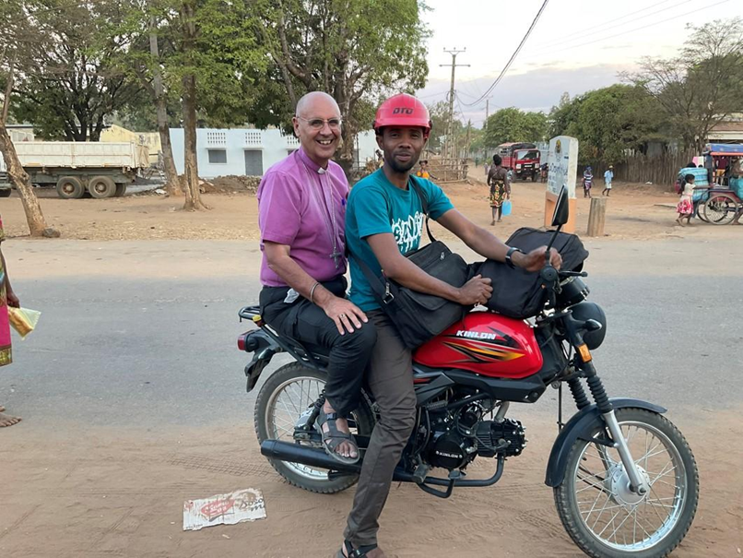

In order to call in along the way the Rural Dean insisted that he took me on his motorbike with me clinging on precariously with my large bag of documents threatening to strangle me as we bounced along the deeply rutted road. Eventually we reached Port Bergé where I was spending the night in order to do last minute plans for our Youth Rally. None of the eggs survived the journey intact.
To encourage the participation of the Youth I had offered to use some of your gifts for their fares. This seemed only fair since the MU members had their fares paid and they should be more able to pay than students. Numbers had subsequently grown magically. The cathedral group alone had reserved 93 places! Clearly they could not be accommodated at the Anglican church so the decision was taken to request the Roman Catholics for the use of their property which they very generously agreed to for a nominal fee: £5 per day for their spacious cathedral hall and payment for light and water for the use of several classrooms in the large secondary school behind their cathedral. I also stated that final numbers were to be established by the next Tuesday – only a full day before everyone would be setting out. Having heard the unrealistic cathedral numbers I insisted that this be a list of names. So early the next morning my return to Mahajanga.

On the Friday I was back to the bus station, this time with the archdeacon, as we had been invited to a Renewal Centre run by the Lutheran church, as two of our cathedral congregation were to be dedicated as Mpiandry (literally shepherds/guardians). This is an indigenous Renewal movement in the Malagasy Church with a huge evangelistic and healing ministry with a great emphasis on getting rid of demons. By the time a taxi-brousse appeared there were many more people than it could accommodate and one of the many things I won’t even attempt to do, is to fight my way in pushing and elbowing all and sundry, and, even in my youth I never had to agility to swing myself up and in through a window which is how one gets into the back seats. So the usual indeterminate wait for another resulted in our arrival after dark. Arrival meant being set down on the main road and then finding our way along sandy tracks to where the centre is. It was a question of heading in the general direction of singing.

Eventually we emerged to an astonishing sight of a ‘pop-up’ market selling everything you could possibly need for a week’s visit from firewood and charcoal to candles and fruit and meat, dried fish and lots of stands selling cooked food and tea and coffee all by the light of candles, solar powered torches and mobile telephone lights. Then in the centre of this was a large church which had an equally large overflow congregation. We edged our way round the periphery of this and by this time news of our arrival had reached those in charge and we were found and most warmly welcomed and entertained to dinner in what was obviously the first class of the pop-up cafes. Then it was time to join another service. Everybody was so courteous and the head of the Lutheran church and I were seated in lonely splendour in the sanctuary while again the church was packed to overflowing. When it came to the announcements I wondered if I had heard correctly when we were informed that the next Service would be at 4 am! By this time it was well after 9 pm and I declined the invitation to another hour of hymn singing. Outside I met up with the Archdeacon and we decided to skip the early service in favour of breakfast at 6 am.

I am constantly embarrassed by the generosity of people giving up their bed for me to sleep in. The head of the Lutheran church and his wife and family moved out of their bedroom and slept on mats outside the door while I occupied it. The hours of sleep were short but very very welcome. All too soon the crowd making their way to the 4 am service were noisily on the move.

The protocol was a bit beyond me but it was explained that if the head of the Lutheran church and I robed he would have to lead the 8.30 Communion Service and he was due to do the next day’s Sunday service so he had to hold back for that. So he and I took our seats in the small sanctuary while over a 1,000 people squeezed in for the Saturday morning Communion service.

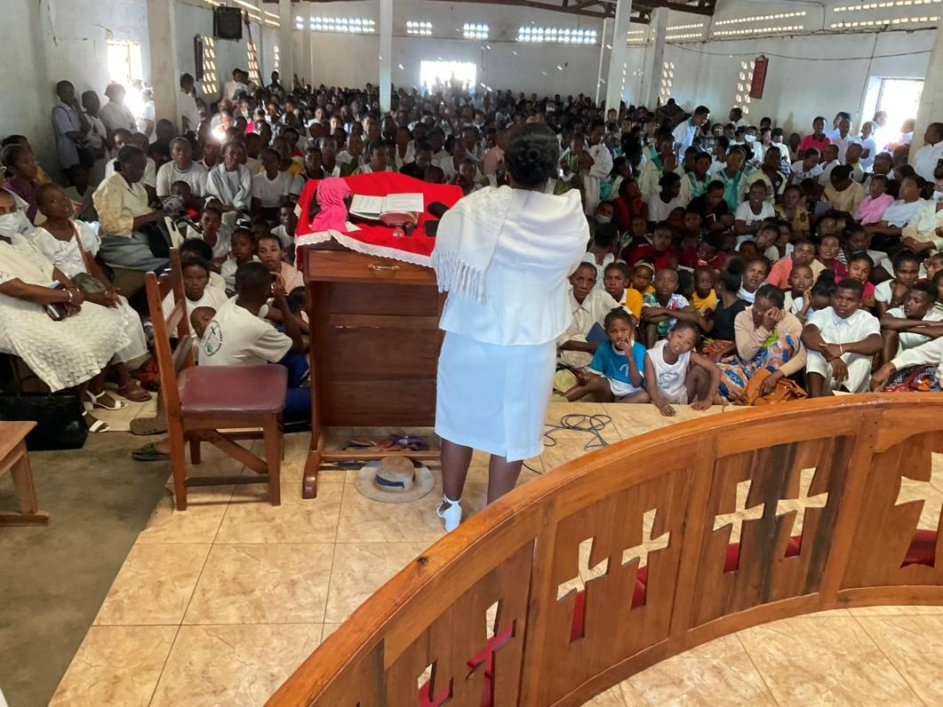
[photo of congregation – no face masks and definitely no social distancing!]

Again I was graciously welcomed and asked to speak. In the Lutheran Church it is absolutely forbidden to clap hands in a service, instead they wave their hands high in the air. Thus when I said anything that particularly pleased the congregation this mighty sea of waving hands went up. I had only ever seen anything remotely like that on TV from the Glastonbury festival! I can now understand how some people have a temptation “to work the crowd”! The Service lasted until 12.30 noon. I have been invited to come for the whole week next August and speak at the Sunday morning Service which has a much bigger congregation. I thanked them and, slightly relieved, explained I have a prior engagement in England, assuming that the postponed Lambeth Conference takes place.

And so back to the main road and the even more random challenge of hailing a taxi-brousse on the off chance of an available seat. Thanks to the numbers arriving for the Saturday night and Sunday morning services this wasn’t the problem I feared and we were safely back in Mahajanga for Evening Prayer at the cathedral.

The next day was my first appearance in the cathedral on a Sunday morning this year and, more importantly, was a celebration of the 26th anniversary of the founding of the diocese.

All last year while I was on my own here at Bishop’s House Mme Suzette, one of the ladies at the cathedral, cooked my Sunday lunch and either brought it here in person or sent her daughter with it. She absolutely refused any payment. On Sunday the news came that her husband had been in a serious road accident so after the morning service a group from the cathedral went round to visit. Six people had been killed in the accident and her husband’s leg was broken in two places and severely burned. Because of the burns he couldn’t have a plaster for the breaks. We found him on a mattress on the floor writhing in agony. He is a senior doctor but didn’t seem to have any of the creams readily available in European hospitals.

Once more I was deeply thankful that my journeys have been relatively straight forward. All I need is a lot more patience.

To finish my first paragraph, our bus booked for an 8 am departure actually departed just after noon. So what’s my problem with a four hour wait?!

Next time I will fill you in on that little trip.

Meanwhile my love and thanks to all.
Yours
+Hall

hall.speers@gmail.com

24 August 2021

