Old Testament Prophets Bible Study September 2021

- 7th September - overview of prophets in the Old Testament, dates, history, context. Cara.
- 14th September - Jonah, Amos, (Assyrian Empire, 9th-7th Century) Cara
- 21st September - Hosea, Micah (Assyrian Empire, 9th-7th Century) Derek
- 28th September - Zephaniah, Nahum (Assyrian Empire, 9th-7th Century) Penny
- 5th October - Habakkuk, Obadiah (Neo-Babylonian Empire, 6th century)
- 12th October - Haggai, Zechariah (Persian Empire, 6th-4th centuries).
- 19th October – Malachi, Joel (Persian Empire, 6th-4th centuries).
- 26th October– Ezekiel (6th century)
- 2nd November – Daniel (6th century)
- 9th November –Jeremiah, Lamentations (7th-6th centuries)
- 16th November – Isaiah (8th century) Richard & Cara
- 23rd November – Isaiah (8th century) Richard & Cara

Major and Minor Prophets Infographic | JordanLadikos.com
Tour of the Bible, part 4: the Major Prophets - Bible Gateway Blog
Learn the Bible for Free Online | BibleProject™
Exploring the Old Testament, Volume 4, The Prophets, Gordon McConville
Prophecy and the Biblical Prophets, John F.A. Sawyer
A History of Prophecy in Israel, Joseph Blenkinsopp

Makeup of the Old Testament

Christian Bibles broadly follow the order of the Greek Old Testament, also known as the Septuagint, or LXX. The books are then divided up and categorised:
Pentateuch – literally ‘five books’, the first five books of the Bible. In Hebrew these books are Torah, that is ‘law’ or ‘instruction.’ God’s laws and ways of life for God’s people.
Historical Books – these describe the story of Israel in narrative form. Joshua to 2 Kings are known as ‘Deuteronomistic History’ and tell of the time from the emergence of Israel in Canaan to the exiles of Israel then Judah. 1 Chronicles to Esther are known as the ‘Chronicler’s History’ and tell of the return and restoration of God’s people. Though we class them as historical books, in Judaism they are known as the former prophets and writings.
Poetry and Wisdom –
Job, an exploration of suffering.
Psalms, a poetic anthology of finely crafted hymns and prayers that express ancient Israel’s life and faith (e.g. kingship, temple, praise, lament, thanksgiving, petition). They have always been at the heart of Christian worship, which grew out of ancient Israelite temple and Jewish synagogue worship.
Proverbs, description and personification of God’s wisdom, through poetry, sayings and advise.
Ecclesiastes, a response to proverbs that says life isn’t quite as simple as fearing God and choosing wisdom, but that there is joy amidst the uncertainty and that ultimately God is in control.
Song of Solomon (sometimes Song of Songs), pretty much a really long love poem.

Prophetic Books – Major (Isaiah to Daniel) and 12 Minor Prophets.
Apocrypha - a collection of 19 books that were written roughly in the time between the Old Testament and the New, a few hundred years before Jesus was born. They are a mixture of both standalone writings or sometimes amendments to books already in the Old Testament. They used to be an integral part of Scripture for many early Christians, and they were written in Greek, then Latin and so were preserved in the Christian church. But because they were written in Greek, and not in Hebrew, they aren’t found in the Hebrew Bible, the Roman Catholics have them integrated into the Old Testament, and some translations, such as the NRSV, have them as a separate section, between the Old and New Testaments. They also aren’t quoted anywhere in the NT.

Prophets & Prophetic Literature

‘We have to speak clearly, no matter how uncomfortable that may be.’

These words were spoken by Greta Thunberg, when she was 16-years old, at a global climate change conference in 2019. She went on to say how she doesn’t care about being popular, she cares about the living planet. Her prophetic, visionary speeches tell hard truths that we don’t want to hear; some have described her as speaking with a prophetic voice. Prophecy in biblical terms is always a message from God. In the Old Testament, prophets were challenging voices, imparting messages from God that, though truthful, were difficult to hear, and they needed both wisdom to understand the message as well as wisdom to discern truth from falsehood. Prophets were there in times of crisis, speaking to the troubled conscience of a nation, as well as bringing some hope of salvation. The prophets as a body come to be regarded as the ones who called Israel to repent, however they don’t always come across in a good light; sometimes it is the prophets themselves who are seen as unfaithful servers. It is worth reflecting for ourselves on how we might know the difference between a false prophet and a true prophet, which is something explored in Deuteronomy and also in Jeremiah. Deuteronomy 13 says true prophets will turn you towards God, false prophets away from God.
As a collection of Scripture, we will be looking and studying the books and the prophets themselves as people who were convinced that they had words from God that were urgent, for the people then and there; and also for people since that initial time and for us now, as we read their words and are challenged to think ‘so what’? What can we take from them, what relevance do they have for us now?

Being a prophet in Ancient Israel

Being a prophet was difficult, but it was also a privilege. You have to have an encounter with God, to see and hear God’s word in order to proclaim it. A prophet’s authority must be with God.
It was a vocation with a starting point, a call to be a prophet, and with a commission, a particular task or message to proclaim.
But the message from the prophets, whilst always focused on God, wasn’t always one that people wanted to hear. Prophets don’t care about status, or societal privilege, they called out things that people didn’t always want to hear. They probed the problems of society and saw conflict as sometimes necessary to turn people back towards God. They cared about the ways in which people were damaging themselves and their relationship with God. They could highlight bad behaviour but would never make people depart from the law or try and turn them away from God, always towards God and right relationship with God and one another. Their message might have been hard, but it was also one of hope of restoration with God.

Major and Minor
The distinction comes due to the length of their writings, rather than their message. After the reign of Solomon, Israel divided into two nations. The Northern Kingdom stayed as Israel, with Samaria as the capital. The Southern Kingdom became Judah with Jerusalem as it’s capital. The prophets cover a time of roughly 800-400 BC. Some we know quite accurately by the details of rulers or events, others are less accurate and more difficult to place precisely.
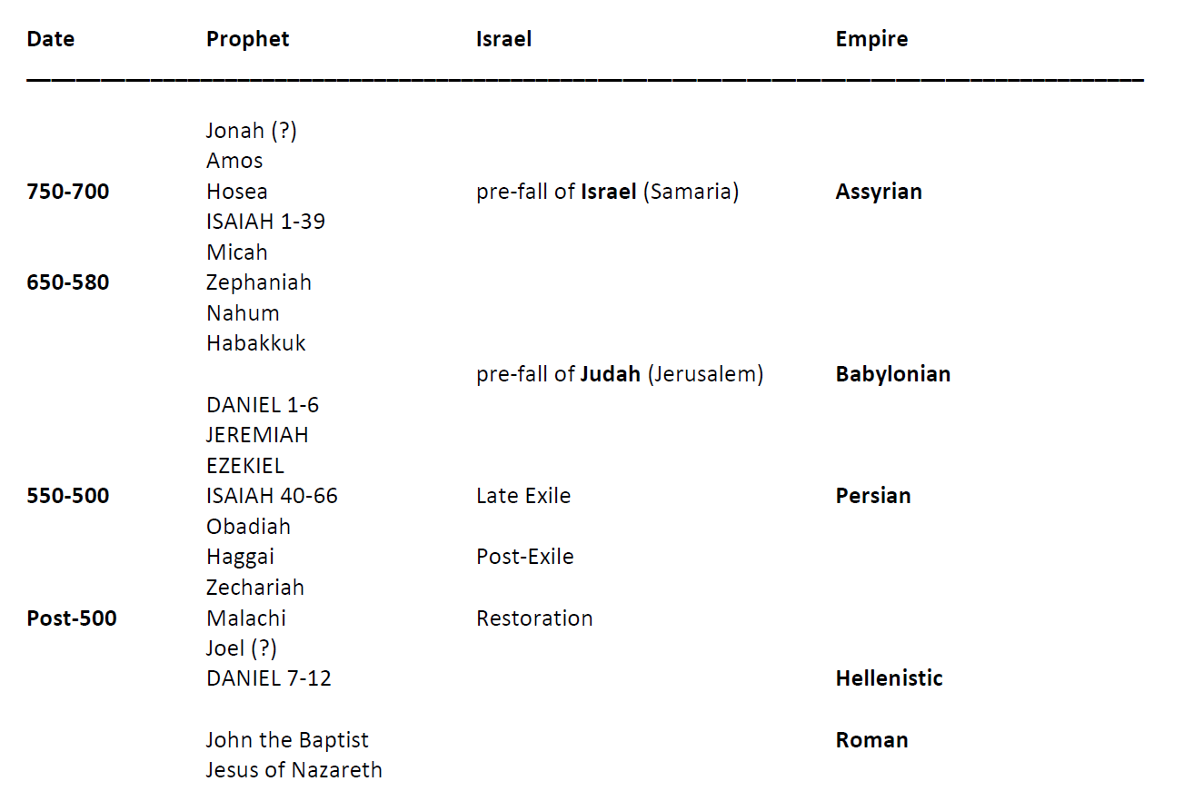

Major Prophets

Isaiah. Of the Major Prophets, Isaiah has arguably had the greatest influence on Jewish and Christian theology. Like many of the prophets, Isaiah delivered a message that few people wanted to hear: God’s people had allowed their hearts to grow corrupt, centred around empty religious practice. Isaiah called God’s people to return to true worship or face judgment. While calls for repentance and warnings of punishment characterize the first half of Isaiah, the second half emphasizes a message of hope and forgiveness.
Isaiah is a dense book, full of fascinating detail. Because Isaiah interacted directly with several of Judah’s kings, this book describes some of the significant moments in the reigns of Ahaz (Isaiah 7) and Hezekiah (Isaiah 37), among other rulers. But Isaiah is most famous for his descriptions of God’s Messiah, from Isaiah 53.
Jeremiah is nearly as famous as Isaiah, although for a different reason. We use the word “jeremiad” to describe gloomy, doom-saying texts because Jeremiah was the archetypal “doom and gloom” prophet. Jeremiah relentlessly confronted Judah about its moral failures and predicted dire consequences if the people did not repent—consequences that unfortunately came true. Jeremiah was not only ignored, but actively persecuted for delivering his unpopular message. He lived to see God’s judgment fall on Jerusalem—a vindication that filled him with sorrow, not joy.

Lamentations. The book of Lamentations is Jeremiah’s song of mourning over Jerusalem’s destruction. But to this sorrow is added a ray of hope. While Judah’s plight seems overwhelming, Lamentations closes with the hope that God remains sovereign and may restore his people: (5:19-22)

Ezekiel. Like Jeremiah, Ezekiel predicted Jerusalem’s destruction as a consequence of her sin, but Ezekiel’s message was delivered in a very different context than that of his counterpart in Judah. Ezekiel preached in Babylon, the ancient superpower that had conquered much of the ancient Near East. Ezekiel’s audience was the band of exiled Israelites who had already been captured and relocated to Babylon.
Ezekiel spoke much of God’s transcendent holiness. He condemned Israel for turning away from their holy God—but like Isaiah, he had harsh words for some of Israel’s pagan neighbours as well. Although God was using Israel’s pagan enemies as an instrument of divine judgment, God was not blind to those nations’ moral outrages and would visit judgment on them in turn.
But judgment and punishment are not the most memorable themes in the book of Ezekiel. Israel had failed, but God had not forgotten them and would one day restore and redeem them. This hope in an eventual restoration is vividly portrayed in the famous story of the “valley of dry bones:” (37:1-14)

Daniel is a Sunday school favourite due to some of his incredible experiences, notably being cast into a fiery furnace and thrown into a den of lions. He interpreted the writing on the wall. (origin of the phrase we use today) and interpreted a king’s dreams. Like Ezekiel, he was a captive in Babylon, although God rewarded his faithfulness by elevating him to a position of respect and authority, first with the Babylonian king Nebuchadnezzar and then with his conqueror Darius. Although Daniel is best known for the adventures described in the first half of the book, the second half relates a series of visions that emphasize God’s sovereignty and faithfulness.

Minor Prophets
Hosea had the dubious honour of having his life used as a living moral object lesson for Israel—instructed by God to marry an unfaithful wife, he spoke movingly and earnestly about God’s sorrow at Israel’s “adulterous affairs” with false gods and His willingness to forgive.
Joel’s recorded prophecies are short but direct. He described God’s coming judgment as an “invasion of locusts”—a clear and terrifying image for Iron Age Israelite society. However, Joel is best known for predicting the “pouring out” of the Holy Spirit which would occur hundreds of years later at Pentecost, as described in Acts 2.
Amos was a simple shepherd called to deliver a message nobody wanted to hear: Israel had grown complacent, spiritually lazy, and hypocritical. Injustice, in the form of slavery, greed, and mistreatment of the poor, was commonplace. Amos’ criticisms still strike home two thousand years later.
Obadiah consists of just one chapter. Obadiah’s message is quite specific to his time, describing the judgment that awaited the nation of Edom, which had done nothing to help Judah in her hour of need. Edom’s actions would be revisited upon them: their land and wealth would be lost just as Judah’s had been.
Jonah. The most famous of the Minor Prophets, Jonah was famously swallowed by a whale while attempting to flee God’s call. Jonah’s prophetic message is directed not at Israel, but at the sin-choked foreign city of Nineveh—a reminder that God’s love and forgiveness was not limited to one nation or ethnic group. God’s endless compassion could reach even the Assyrians, whose cruelty and military power had made them the terror of the ancient world.
Micah’s was a familiar message: Israel and Judah had turned away from God to follow false prophets and hypocritical religion, and disaster was coming if they did not repent. Micah tried to remind his audience that what God truly desired from men and women was not religious ritual, but faithful living. What God wanted wasn’t hard to understand:
Nahum. One of the more obscure prophets, Nahum foretold the ruin of the mighty Assyrian empire, which had hauled Judah into slavery and exile. His words were a warning that no city or nation was so powerful as to be beyond the reach of God’s judgment.
Habakkuk strikes a markedly different tone than many of the other prophets. Instead of preaching judgment, he asked questions—tough questions, like “Why does God allow evil to exist?” and “If God is sovereign, why do wicked people prosper?” He brought these questions to God in prayer and found consolation in God’s strength and power. Habbakuk shows us that ancient believers wrestled with the same difficult questions about sin, evil, and suffering that Christians ask today.
Zephaniah. Prophecying during the reign of king Josiah, Zephaniah warned Judah that if they did not turn away from false religion and pagan practices, God’s judgment would fall on them. But God’s day of judgment is portrayed not just as a day of suffering, but as a time of rejoicing, when God would return to rescue the oppressed and restore the broken. The wicked had cause to fear judgment, but the faithful could look ahead to it with hope.
Haggai served as a prophet while a small remnant of Jews, returning from exile, were struggling to rebuild Jerusalem and the temple. His message was one of encouragement and hope—God was still with His people, even though they had fallen far from the glorious days of David and Solomon:
Zechariah was a post-exile prophet like Haggai, and also directed his message to the surviving remnant returned from exile in Babylon. Zechariah stands out as an Old Testament messenger who spoke clearly about the promised Messiah, Jesus Christ:
Malachi. Also preaching to the returned exiles, Malachi offered a less happy message: after all they’d been through, God’s people still fell into disobedience. Israel’s priests and leaders were leading their flock astray, and only a faithful few remained who lived in accordance with God’s law. The book of Malachi concludes the Old Testament with a reminder of humanity’s need for a Saviour—and a promise that “for you who revere my name, the sun of righteousness will rise with healing in its rays.”

So what?
What do we do with the prophets, how do we read and understand them today?
Christianity has tended to read them as visions of the future that Christ then fulfils, and sees them as being able to speak beyond the original context of turning the people of Israel back to God. There is judgement and pleading and messages of destruction, but also glimmers of hope and of a saviour – Christ. For Judaism, the prophets prop up the laws, reiterate the way of God and the way in which we should live.
The prophets give us permission and an example of how to overcome boundaries, speak truth to power, be social visionaries. Though, the prophets claimed divine revelation which when people are described as a ‘modern day prophet’, this is not often what is meant, think back to Greta at the beginning.
As we read the books and discuss, we can have in our minds what might have been meant then, in that specific context, and what it might mean for us now. A call to turn back / turn towards God might well be the reminder we need for ourselves as well.

