Jonah

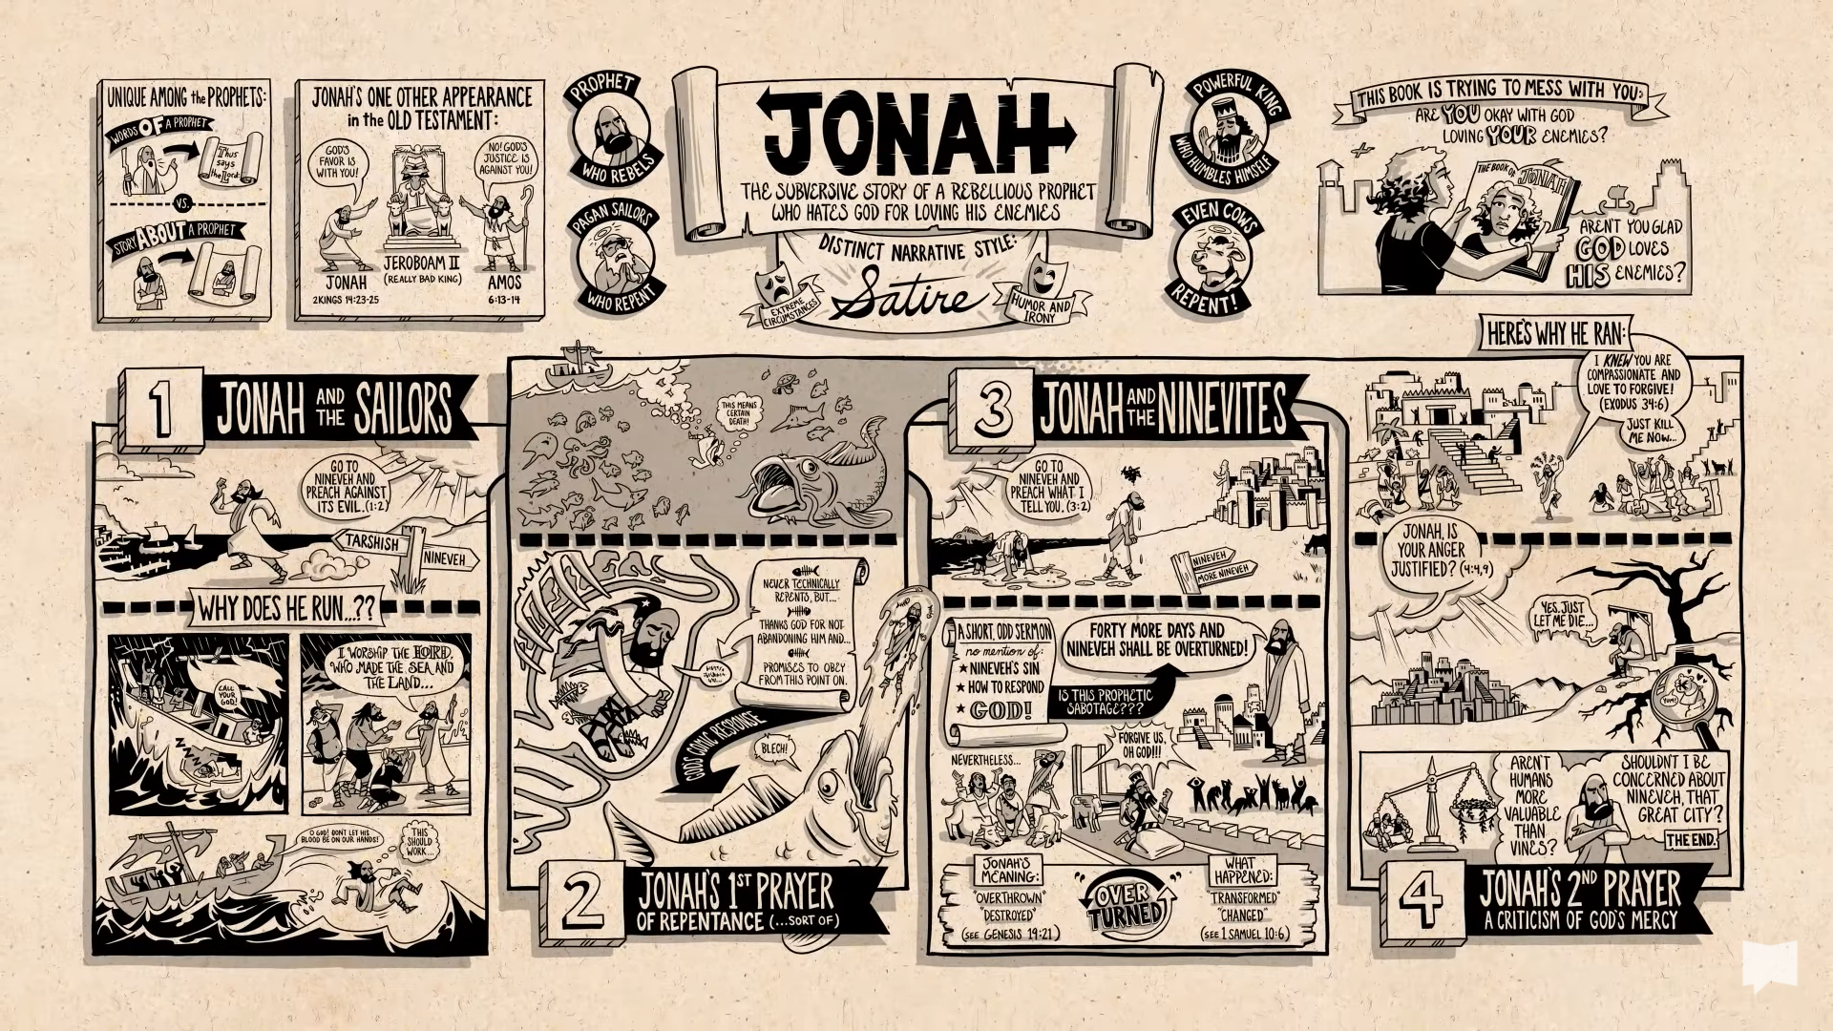
Watch: Jonah Bible Book Overview Video | BibleProject™

Who: Jonah is a prophet who is called to deliver a warning of judgement to a rebellious nation. He runs from his calling at every turn, showing little faith in God. But eventually he goes to the nation of Nineveh to deliver God’s message, where things start to get confusing.
Despite Jonah’s warning having the intended effect – Ninevah turning in repentance to God – Jonah is furious with God for sparing the Ninevites.

Date: There are no definite clues or facts, and many consider Jonah to be a fictional story rather than history, the happenings are very odd! But some Biblical scholars put him in the reign of Jeroboam II (786-746BC) as ‘Jonah son of Amittai’ is named in 2 Kings, though no mention of a mission to Ninevah.

Content: Jonah is unique amongst the books of the prophets, there is only one line of prophetic speech from Jonah, 3:4, ‘Forty days more and Ninevah shall be overthrown!’ The prophetic word plays only a small part of the story, and Jonah himself is never called a prophet in the book. The focus is on Jonah and his relationship with God far more than the events and people of Ninevah.

Themes:
Working out God’s sovereignty: We, and the original hearers and readers, and Jonah, and the sailors and people already know God is in control, but Jonah wrestles and fights throughout, as if working out what one sovereign God really means.

Retribution: Jonah knows his behaviour has caused the storm, but what happens because of our disobedience? How does God react?

God’s Forgiveness: Jonah was sent to tell the Ninevites that unless they repented, God would judge and destroy the city. They repented and God forgave. But what about God’s forgiveness of Jonah?

Structure:

1 Jonah is called by God and flees
2 Psalm of Thanksgiving
3 Nineveh repents and is saved
4 Jonah’s discussion with God

Passage to study:

A Psalm of Thanksgiving
2 Then Jonah prayed to the Lord his God from the belly of the fish, ² saying,
“I called to the Lord out of my distress,
and he answered me;
out of the belly of Sheol I cried,
and you heard my voice.
³ You cast me into the deep,
into the heart of the seas,
and the flood surrounded me;
all your waves and your billows
passed over me.
⁴ Then I said, ‘I am driven away
from your sight;
how shall I look again
upon your holy temple?’
⁵ The waters closed in over me;
the deep surrounded me;
weeds were wrapped around my head
⁶ at the roots of the mountains.
I went down to the land
whose bars closed upon me forever;
yet you brought up my life from the Pit,
O Lord my God.
⁷ As my life was ebbing away,
I remembered the Lord;
and my prayer came to you,
into your holy temple.
⁸ Those who worship vain idols
forsake their true loyalty.
⁹ But I with the voice of thanksgiving
will sacrifice to you;
what I have vowed I will pay.
Deliverance belongs to the Lord!”
¹⁰ Then the Lord spoke to the fish, and it spewed Jonah out upon the dry land.

Jonah is a continuous story, which incorporates a Psalm of Thanksgiving. Scholars have often thought that the Psalm was not an original part of the story; it seems odd that Jonah should pray a prayer of thanksgiving whilst inside the belly of the fish. Here he appears grateful and faithful, when in the rest of the story he is reticent and rebellious. In the story he wants to die, in the psalm he doesn’t.
However, the story needs the psalm. Jonah being in the belly of the fish is bizarre, it needs Jonah’s experience of distress and deliverance. It adds a richness to the whole story, a welcome contrast between Jonah’s reluctance, gratitude and anger.

Reflection: What can Jonah mean for us?
- If this book is considered to be a story rather than prophetic, what can it tell us about the call to do and proclaim God’s word? God didn’t destroy Nineveh because they repented, does this mean that Jonah’s prophesy did or did not come true?
- In what way are we, or the church, like Jonah? Is there a message you think God has for the church or for the world that we don’t want to convey?
- What is the main point on the story? Is it Jonah’s change of heart, or Nineveh’s, or God’s?

Amos

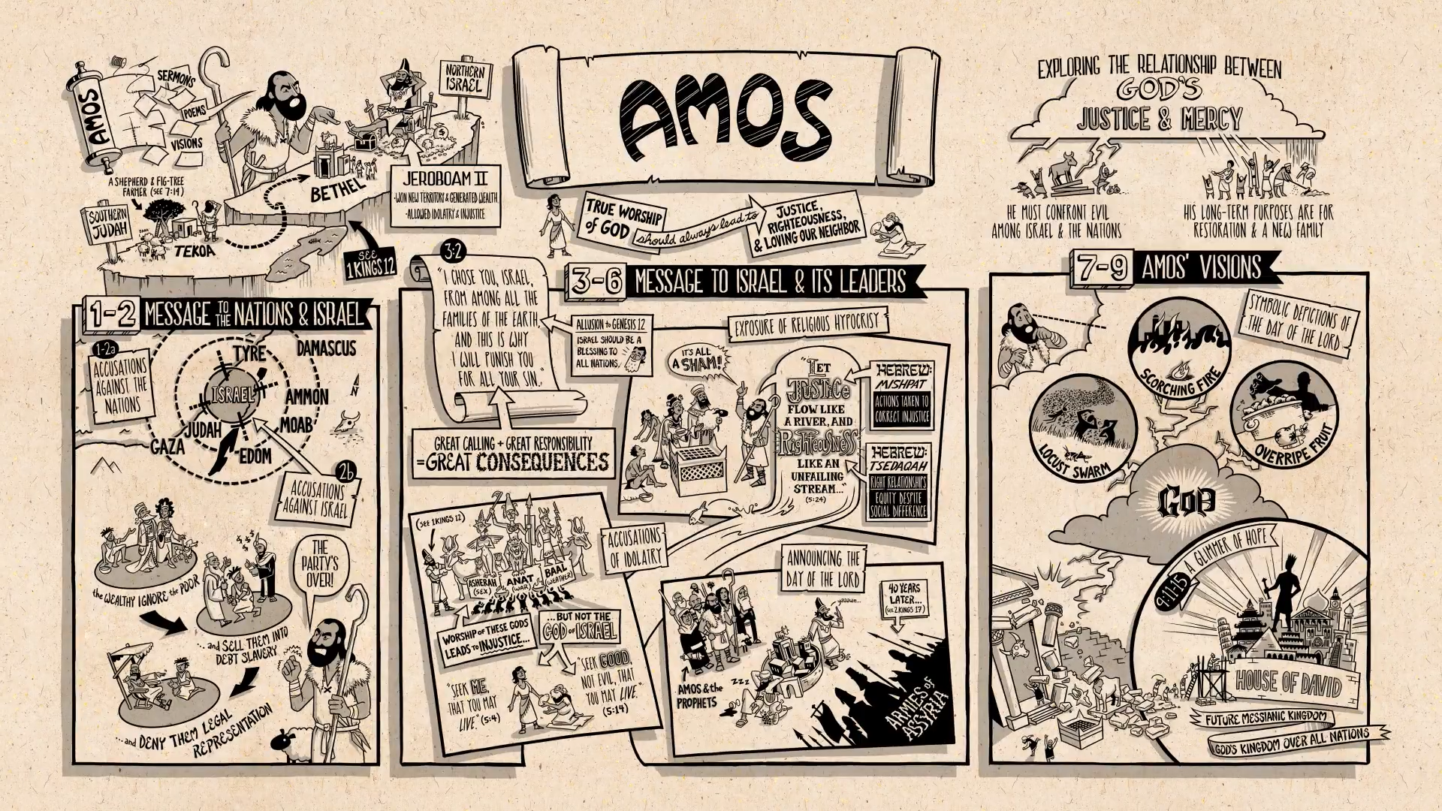
Watch: Amos Bible Book Overview Video | BibleProject™

Who: Amos was a simple shepherd called to deliver a message nobody wanted to hear: Israel had grown complacent, spiritually lazy, and hypocritical. Injustice, in the form of slavery, greed, and mistreatment of the poor, was commonplace. In 7:14, Amos says he is not a prophet, nor a prophet’s son (two ways of saying the same thing, in response to Amaziah, the priest of Bethel, whom Amos had attacked. Amaziah is trying to stop Amos prophesying, but Amos says he has been called by God, and cannot be stopped.
Date: One that we can say with a fairly certain degree of accuracy, as the book mentions that Amos’s ministry took place in the reigns of Jeroboam II of Israel (786-746 BC) and Uzziah of Judah (783-742 BC). The book is often dated about 760 BC because of reference to the earthquake (1:1), though some scholars argue for slightly earlier, some slightly later.
Content: Amos is called to announce God’s coming judgement on the northern kingdom of Israel. Though the kingdom has seen military success and prosperity, they are spiritually bankrupt. They have totally ignored the commands of the covenant and have instead begun worshipping pagan gods and losing sight of their call to live righteously and represent Yahweh to the nations. They have become infamous for cheating, stealing, and oppressing the poor in their community. Is there any hope for Israel?
Yes, because God is grieved by how far Israel has fallen, but Yahweh is a merciful God, and he gives them one last chance to turn back to covenant faithfulness. God doesn’t want empty religious practices from his people. He wants to see his love for people reflected through the Israelites and faithfulness to Yahweh alone, but this can only come through renewed hearts.
Themes:
Justice and righteousness, and the ‘good’ of God’s people. Worship of God is forged together with a love of justice, and worship without love is utterly vain.
Justice and creation. The idea of a creation order leads to the ethical responsibility of free creatures to keep the commands of God.
The universal God and the election of Israel. God’s standards of justice and righteousness apply to everyone, not just Israel but the whole of creation, the whole of humanity.
Structure:
1:1 - 2:16 Amos accuses foreign nations – and Israel and Judah
3:1 – 6:14 Judgement speeches and woe-oracles and accusations against Israel
7:1 – 9:15 Amos’s visions of the coming day of the Lord

1:1 – 2:16. Amos was a shepherd and fig tree famer who lived near the border between Northern Israel and Southern Judah. The North was being ruled by Jeroboam II, a successful military leader who won battles and generated wealth, but his wealth had led to apathy and he allowed idol worship for the Gods of Canaan which led to the neglect of the poor. As far as the prophets were concerned, Jeroboam was not a good ruler, and these are Amos’s messages to the nations and Israel. Amos names neighbouring nations with Israel in the centre, and Amos accuses Israel’s wealthy of ignoring the poor and allowing gross injustice. Amos says God will no longer put up with this.
3:1 – 6:14. Amos declares how God is fed up with Israel’s wealthy and leaders offering sacrifices and worship yet neglecting the poor. God says he is not happy because this worship is not acceptable, it’s a sham, because it’s disconnected from how they treat people. Amos calls people to true worship, one that transforms their relationship. Justice and righteousness are to permeate Israel’s relationship with God. Amos calls out worshipping of false Gods, and calls them back to worshipping the true and right God. God will send ‘The day of the Lord’ because Israel rejected Amos and the other prophets, and these predictions come true. 40 years later, the Assyrian Empire takes over.
7:1 – 9:15. A series of visions about the coming ‘Day of the Lord’, with Israel devastated by a locust swarm and fire and God striking the pillars of Israel’s great idol temple, and the building comes down, because justice and righteousness has not been fulfilled. But, there is hope. Out of the ruins of Israel, God will bring the future Messiah and will rebuild the family of God which will include other nations. The last paragraph explores God’s hope on the other side of judgement, as a way of explaining God’s relationship between justice and mercy.
Passage to study:

The Day of the Lord a Dark Day 5:18-24
¹⁸ Alas for you who desire the day of the Lord!
Why do you want the day of the Lord?
It is darkness, not light;
¹⁹ as if someone fled from a lion,
and was met by a bear;
or went into the house and rested a hand against the wall,
and was bitten by a snake.
²⁰ Is not the day of the Lord darkness, not light,
and gloom with no brightness in it?
²¹ I hate, I despise your festivals,
and I take no delight in your solemn assemblies.
²² Even though you offer me your burnt offerings and grain offerings,
I will not accept them;
and the offerings of well-being of your fatted animals
I will not look upon.
²³ Take away from me the noise of your songs;
I will not listen to the melody of your harps.
²⁴ But let justice roll down like waters,
and righteousness like an ever-flowing stream.

Righteousness refers to a standard of right equitable relationships between people no matter their social differences
Justice refers to concrete actions that you take to correct injustice and create righteousness.
This call to practise ‘justice and righteousness’ is now the dominant theme of the next few chapters. The combination means the right relations between people AND the action needed to bring it about.
The Day of the Lord will be darkness and not light, imagery of creation and salvation. But the Day of the Lord is one of judgement, not salvation.
Reflection: What can Amos mean for us?
- According to Amos, God judges Israel, because they say they worship God yet the wealthy treat the poor unjustly. How and why do we judge nations today, and should we? What difference does this make?
- Worship and God’s mercy are linked together. In what ways does your worship inform how you live your life in terms of justice and righteousness?
- Christians have often been told to ‘stay out of politics.’ How do prophets like Amos help us understand our place in politics and what is wrong/right?

