Our Mad Life 57
St. Andrew’s Church
Sunday, 22nd August at 8.30 am was the date and time set for both the concluding service of the Diocesan Youth Conference and the Dedication of the new church building at Ampombibitika. This involved all those attending the conference getting from Port Bergé to Ampombibitika.
The non-stipendiary lady priest at Ampombibitika has a sewing and embroidery business in Port Bergé and travels between the two places daily. She saw no logistical problem as it was only an hour and a half brisk walk, taking a few over-the-hill shortcuts – “Surely any self-respecting Scouts could manage that”. Everyone pointed out that they had their luggage and definitely needed buses. At that point I decided that, whatever everybody else was doing, I was not going by bus and made enquiries as to whether a tuc-tuc (here called bajaj) would go that far. Yes, it would - but only if there were four people in it, or the driver got four fares. Accordingly I asked my faithful Jocelyn to come to my room at 5.30 am to help me with my luggage.
My alarm went off just before 5 am and I was delighted to find the electricity on so I did a final clear up and packing. I have learned that some things are a must while one has light and so packing is much more urgent that washing as one can do that in the dark. Sure enough, a few minutes after 5 the town was plunged into darkness. At 5.30 we decided breakfast was our priority and found a market stall selling hot sosoa rice (rice boiled very soft with a lot of water – the normal breakfast here) and, for me, a cup of coffee. Fortified for the day we loaded the bajaj and bumped merrily along.
The church was already a hive of activities: some to my delight and some to my alarm.
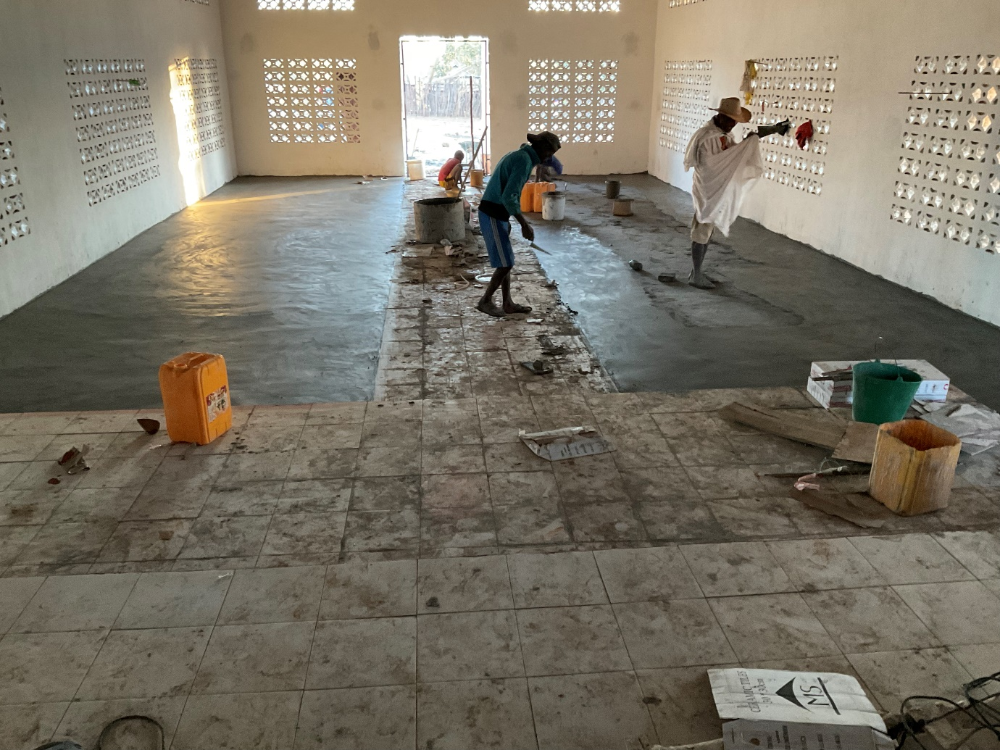
This was the interior of the church two hours before the Dedication was due to take place: floor incomplete, no doors (a serious omission in a service where the bishop knocks on the door with the crozier…) and not a stick of furniture (including no altar table).
Outside a great collection of pots were already on wood fires cooking the ox which had been killed the night before for the post Dedication celebrations. We set my suitcase on top of a pile of rubble in what will hopefully one day be the robing room. In an effort to get there my shoes sank gently into the cement. I shall be intrigued to see on my next visit if my footsteps are a permanent souvenir of the event! I was clearly in the way, but just then the message came that my breakfast was ready. Jocelyn was quick to say that it would be rude to mention we already had eaten and so off we went to a local house.
Most houses in this diocese are one or two room thatched buildings. The family were sitting outside on the ground and I was ushered inside where there was a table and two chairs wondrously decorated in white material with great bows on the chair backs such as one often sees at wedding receptions. This furniture was later to appear in church as altar and bishop’s throne. A huge bowl of rice was on the table and a large delicious omelette. Fortified afresh we returned to the church.
Contrary to my predictions, the buses with the Youth from Port Bergé had arrived on time. So also had the doors, albeit the wrong height. They had been casualties of the power cuts during the week as they had been unable to saw longer pieces of wood as the doors were to be taller than the standard size to enable the bishop to walk upright into church! The scene rapidly changed out of all recognition as the congregation and furniture entered simultaneously. The desks from the local school were brought and the villagers brought their chairs to supplement the benches from the old church. The Youth had all got bright red T-shirts celebrating the past few days’ activities. Some of the ladies were wearing their T-shirts from the MU Zaikabe. “Been there, got the T-shirt” is a phrase with greater significance for me these days – I receive a T-shirt at each major event.
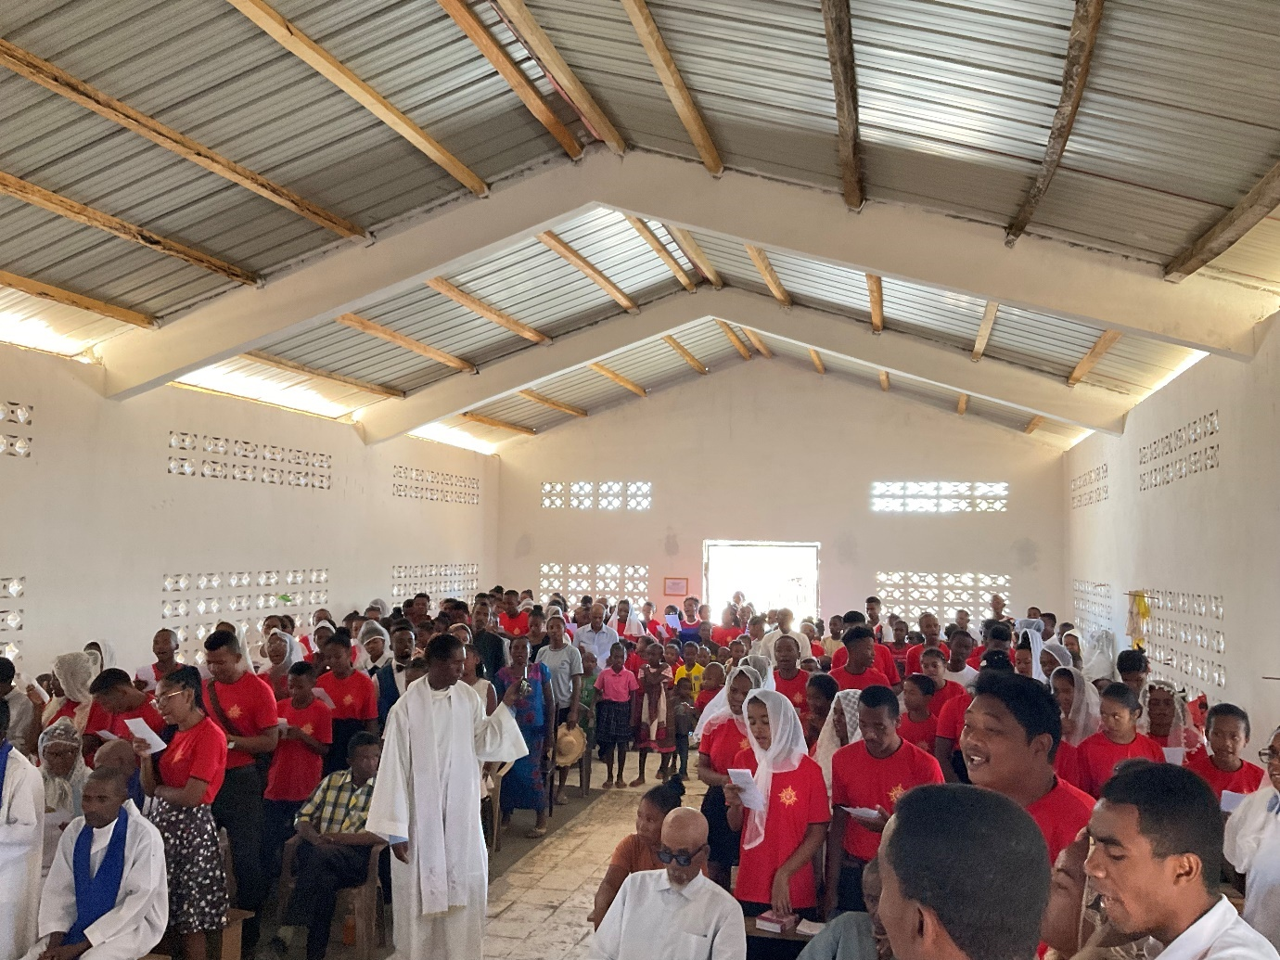
Astounding transformation! Then it was time to begin with the procession round the exterior of the building as I hallowed it at the four corners and cut the ribbon – an essential moment which always confuses me as I forget to include it in the Order of Service!

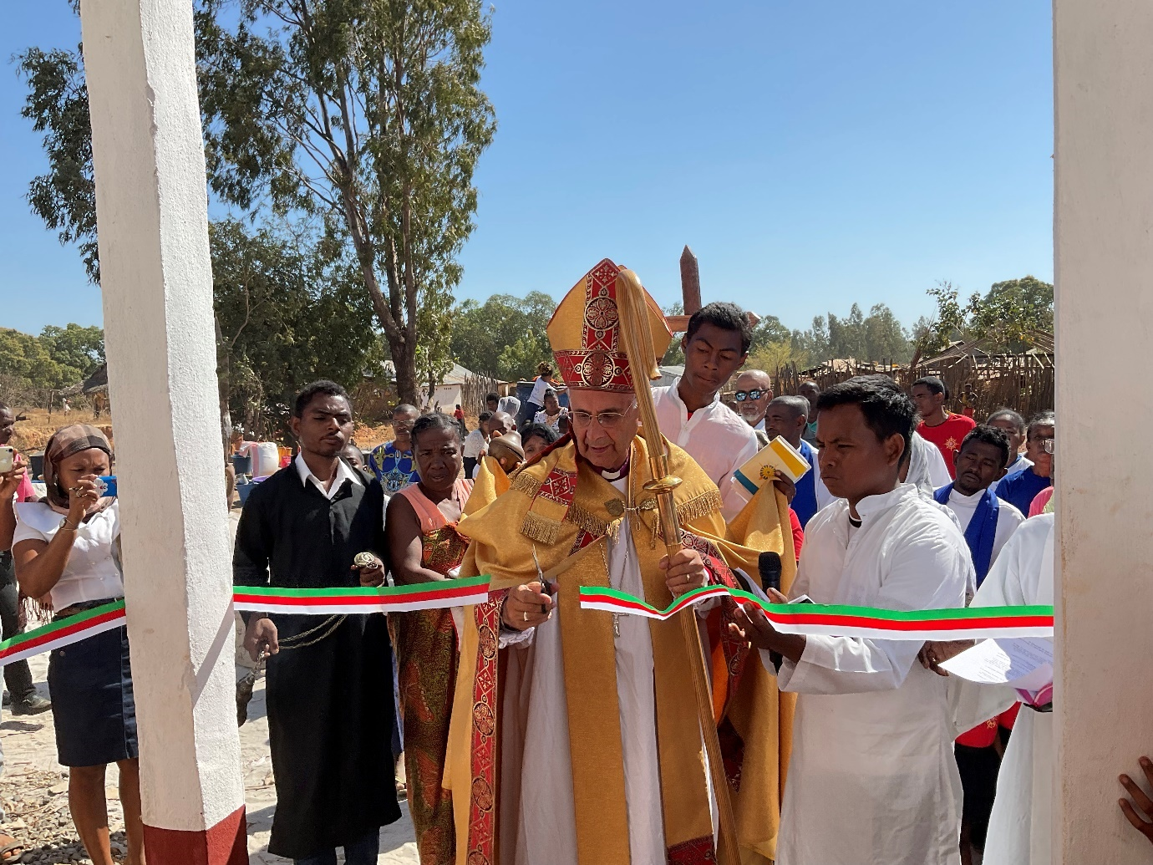
The service proceeded with Communion. When it came to the announcements, I was requested to come to the chancel step. My life is full of surprises. The next was a tremendous dance by MU members from the back of the church to the front bearing gifts. The Rural Dean, the architect and I had Lamba One (wrap around skirts) added to our attire and I received a large parcel.
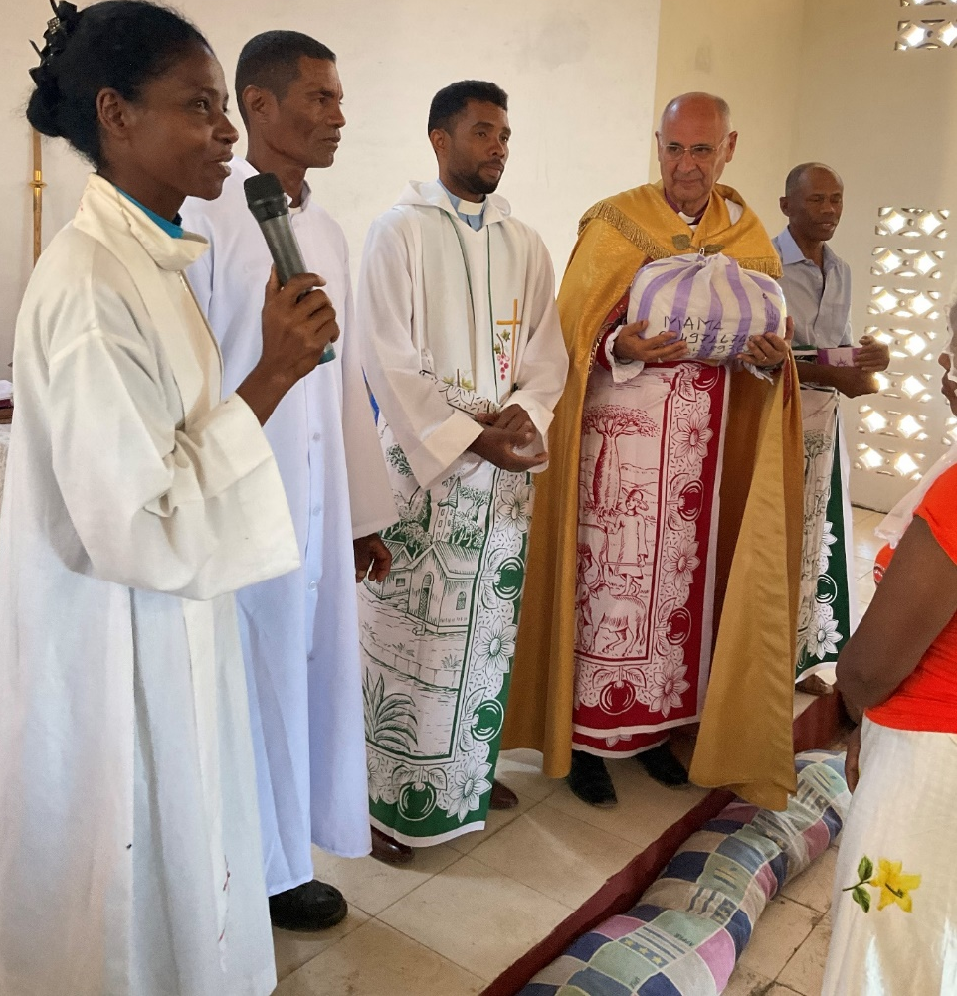
The Revde Nivo makes the presentation. I suspected my large gift was her own work. I didn’t open it until I got back to Bishop’s House and it was indeed a very splendid mosquito net for our bed. I tend to think of my sleeping arrangements as a very private part of my life. Here where many houses are one room this is quite the opposite and the bed is always the main and most ornate item in the room. Beds are ‘four posters’ with a spindly frame to support the mosquito net. The frame is hung with curtains as ornate as the household can afford with many layers of frills, and the actual net that protects one is tied up in the centre and let down at night. Sarah’s taste in furnishing is much admired but altogether too austere by local standards. Our bed had just plain net curtains which were tied back during the day. Our Emilienne was overjoyed by my new acquisition and insisted that it be installed immediately. So my sleeping arrangements are now suitable for viewing (not that I am going to encourage that any time soon!), but the news gets around.
By a strange coincidence I received another net this week. As part of the present government health strategy, every household has been supplied with a mosquito net. So I now have one for your bed when you come to visit. International flights to Madagascar are scheduled to resume in October. Adventure guaranteed.
At the end of the Church Dedication there were the usual speeches and I took the opportunity to remind those present that this wonderful new church was not the gift of the bishop as had been stated many times, but the result of sacrificial giving by those supporting the work in the diocese. Next followed the meal when everyone ate massive quantities of rice and beef.
Back into the taxi-brousses and off to Mahajanga arriving late at night. Once more profoundly thankful to have survived to tell the tale and so grateful to all who funded a very expensive week. Everything, except the water tower, was accomplished thanks to your generosity. The water tower was paid for by a grant from Lambeth Palace.
At the moment I am struggling with the schools and university reopening. To be more precise: seeing how far I can stretch to fund students: three at university, numerous clergy children, and the opening of a church school at Morarano and supporting a weak church school at Antanankova by giving scholarships to girls.
More of that next time, plus a weekend away with the Men’s Society.
God bless you all.
Yours
+Hall

hallspeers@gmail.com

1st September 2021

