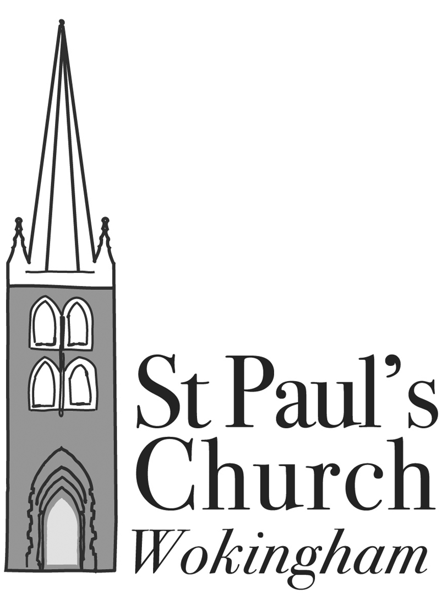
Dear Friends
Since the APCM in July I have been thinking a great deal about my new role as ‘Deputy Warden for Spirituality and Mission’ and what it might encompass!
Some weeks ago Fr Richard said in a parish email that I would be contacting people to “talk about prayer and the idea of having a retreat, and how the Church can do a better job of supporting you in your praying and journey with God”. Please don’t think that I am setting myself up as an expert! I am simply a fellow pilgrim on the road of faith. I have been fortunate to experience God’s love in so much of my life, as well as the mess and the pain of being human, and since I was very young I have been helped in my discipleship journey by many different members of the church family, here and in South Africa.
I hope to be able to share with at least some of you a little of the love and support that I have received over the years.
In recent weeks I have had conversations with a number of individuals who have discovered that a retreat is a great way of spending quality time with God, relaxing in His love, listening for his voice and seeking guidance, strength and inspiration. It can be difficult to set aside such a space in the normal surroundings of daily life, with the ongoing and competing demands of family or work, whereas in the more Christ-focussed space of a retreat, most of those interruptions vanish and one can simply enjoy being with Jesus, in the company of like-minded people.
Arranging a day retreat (or Quiet day) in our parish in the near future is high on my priority list. I believe that each and every one of us can benefit enormously from such an experience as we seek to play our parts in God’s plan more fully and effectively.
In the next few weeks I hope to circulate a short survey to help me get an idea of your response to this and other suggestions for enhancing our spiritual growth. Your suggestions and offers of assistance would be most welcome even before then – mary.cassidy@spauls.org.uk .

Yours in Christ
Mary Cassidy, September 2021

PS : A brief introduction to “making a retreat”
In case you are unsure just what might be involved in “making a retreat”, and therefore can’t decide whether or not it would be useful for YOU, I offer a few words of introduction in this postscript.
A retreat may be anything from a Quiet day (or even half a day) to a full thirty days in seclusion focussing on the Spiritual Exercises of Saint Ignatius. Obviously the latter is not for everyone, but a Quiet Day or a three day Retreat (often Friday night to Sunday after lunch) is manageable for many of us. (A long time ago, just a few months after having my second baby, I was enabled to go on the annual parish retreat by kind friends who made sure I had time to myself even though she accompanied me for the weekend. That loving gift was a really wonderful blessing.)
For the first timer, a Quiet day with formal prayer at the beginning and end, plus a talk or meditation to offer some food for thought, is a good sampler of the Retreat experience. The idea is for silence to prevail throughout the day, though a few people may be willing to be available for conversation if needed.
Retreats, and frequently Quiet days, are arranged away from one’s home church or usual environment. There is something about going somewhere different, making the pilgrimage physically and really setting the time apart, that is particularly helpful for many people in opening themselves to new experience of God’s presence.
Sometimes the day incorporates some craft or activity to occupy the hands while the heart focusses on God. A few years a go a group of mums of young children spent a wonderful day at St Columba’s doing just that, and they still remember and talk about it.
Whatever the format, time spent with our Lord is time well spent.
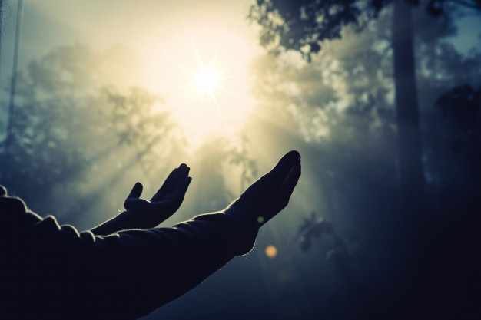
Finally (for now) I have been building a list of conveniently situated Retreat houses and organisations in case anyone is keen to arrange their own retreat. Many offer a mix of open guided retreats (organised by the House), booked parish or group retreats (input and bookings arranged by the group or parish) and individual private retreats (no formal input).
Do ask if you would like to find out more - mary.cassidy@spauls.org.uk .

