Our Mad Life 60
Still on the road (Part 2)
I’m a creature of habit. Currently this means a 5 am start unless a particularly loud mosque or poultry rouses me before that. Then it is either prayer or food, preferably in that order. So at Mandritsara I enjoyed saying Morning Prayer on the hotel balcony as the sun rose over the encircling mountains before the good Constant came to escort me to breakfast.
Then we all packed into what I think was the Catechist’s car. I recognised our driver/mechanic from a previous hair-raising expedition. After much tinkering with the engine we were on our way to inspect the site for the new clergy house and, eventually, church – the purpose of my visit. As we drove the local clergyman was extolling the virtues of the site with its proximity to the university etc. I had sent the archdeacon to view it at the time of purchase but after he returned it was discovered that the man selling the land he agreed to purchase didn’t actually own it. A different and expensive parcel of land was then purchased.
On the way we passed a Landrover with a white family in it including very blond children. A very rare and unusual sight here. My companions exclaimed at this. One said that they were like bread made from flour that hasn’t been baked enough, still white dough. So by that reckoning I am definitely half-baked! They were probably Baptist missionaries working at the Baptist hospital which is considered the best hospital in Madagascar outside the capital.
The Land:
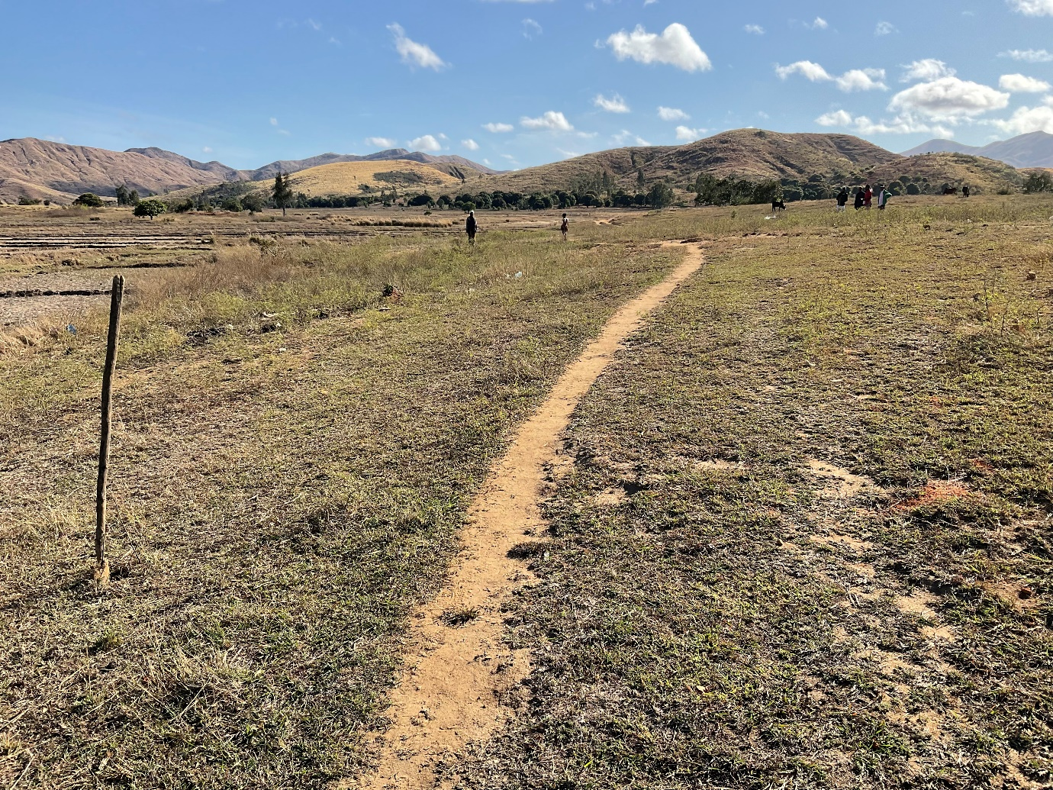
The spade in the foreground marks a corner and the people in the distance two more corners. Not my idea of a town site and not near anything that I could see, except rice fields. I asked for the paper work relating to the purchase and where the access to the road was. The papers were back at the priest’s residence and the seller had said there was no problem with access. I was shocked and cross. As far as I am concerned a parcel of land with no right of access is useless. Many years ago this priest had been responsible for the biggest fiasco in the diocese when land was bought to build a new church and, at the suggestion of a particular couple, he built it instead in their garden. When the couple died the family claimed, correctly, that the land was theirs and therefore the building was theirs. Each time I go north I see the ruins of the church and the village in question is without a church and still full of resentment.
Back at the priest’s lodgings, an upstairs room woefully inadequate for him and his family, he was able to produce one sheet of paper saying that the land had been bought. The necessary papers to make this legal and binding had not been procured because they had no money at the time of purchase to do so. (This was untrue – but I didn’t go there.) This led on to the subject of the parish income and the failure to pay the priest or even rent his room. It was clear to all concerned that the bishop was on the offensive and not going to be easily pacified. A large sponge cake was produced! Something that in other circumstances would indeed have delighted me, not having seen such a cake since I left Europe. However, more than cake was needed to get the plans and the parish back on track. I immediately cancelled the work due to begin on the house until things were sorted.
Three catechists, one of whom is chairman of the church council and one secretary were present for all of this.
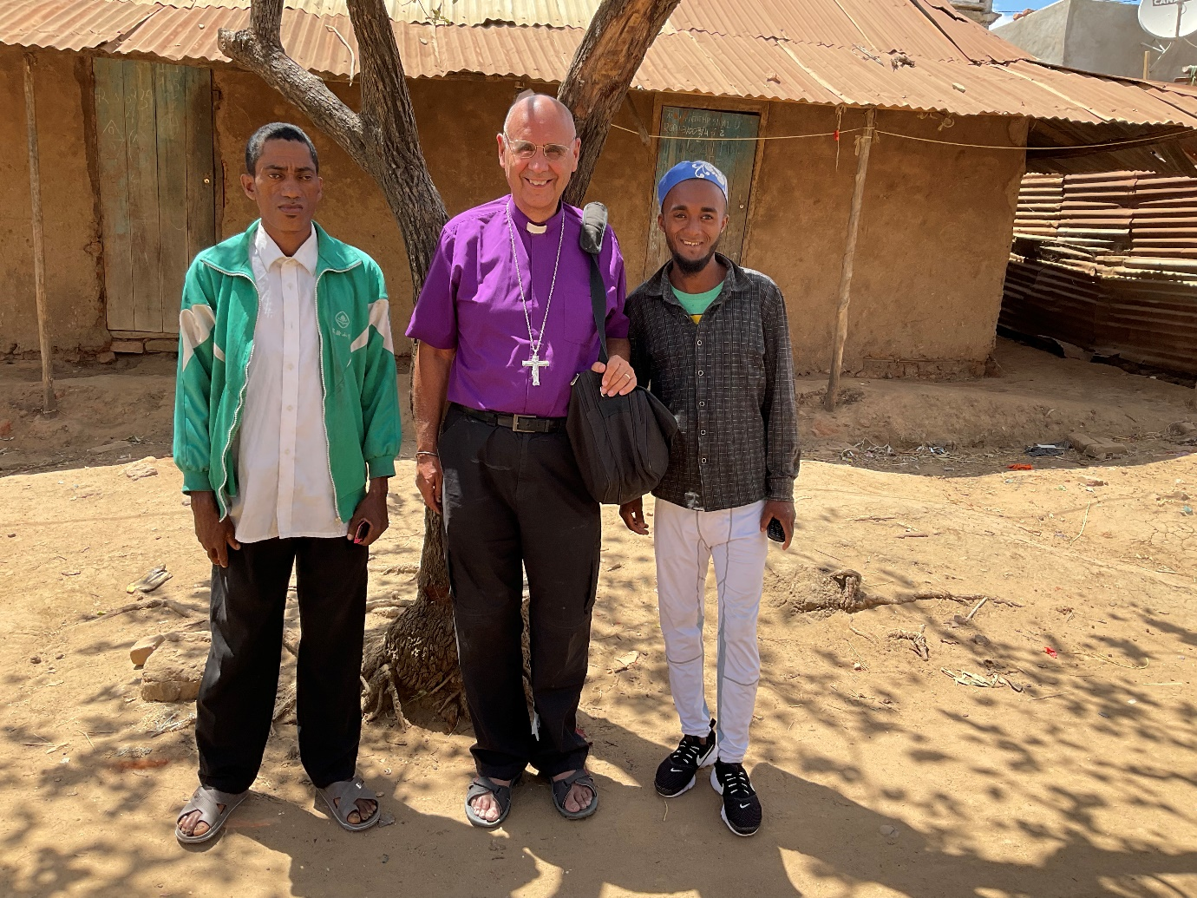
On the left, the chairman, Mr Jean Louis Lemeva, and on the right Mr. Alphonse Clodis, secretary.
Mr Lemeva is quite an inspiring worship leader and evangelist but not one’s ideal business partner. So back to the question of why the 21 churches in the parish had not paid their priest. The priest’s wife took over from her husband and presented a written account showing how little they had received, a miniscule amount in cash and a meagre offering in rice – much less than could sustain a family. The parish secretary then produced his version which tallied exactly showing that some churches contributed 15 kgs of rice per annum to the stipend. Our home help Emilienne’s family consume 15 kgs of rice per week! This is one of the most productive parts of the diocese rich in rice, vanilla and coffee. The intractable problems are transport and theft. The vanilla is worth more by weight than silver. It is almost 100 kms from where we were meeting to the livelier churches in the parish and the priest and catechists all travel by foot and carry what they can. If the bishop had a car he could…. But the bishop hasn’t and nobody had thought to investigate how much it would cost to transport rice by ox cart. It was requested that the Bishop and Archdeacon write to the churches suggesting a way forward.
The day’s business concluded with a Communion Service in another upstairs classroom where the Mandritsara congregation meets on Sundays. It had electricity but the one bulb was so weak nobody could read by its light but almost everyone present produced a mobile and used their torch application. The current equivalent of candlelight?
We booked our taxi-brousse places for the return journey to Port-Bergé for the next morning and were told to be at the departure place by 6 am. I was told not to worry, we would have breakfast at 6 am and get the taxi-brousse to ring when it was ready. In the morning I was packed and ready to leave the Hotel Sofia at an early hour when to my surprise the hotel staff, without any prior warning knocked on my door, came in, knelt down, and then asked for my blessing! The ultimate way to make a departing bishop leave with warm and loving thoughts.
During a delicious but rushed breakfast the taxi-brousse driver did indeed ring and so off at speed to the place only to be told that this particular one was only going half way but it we waited a few hours another would take us all the way! What a virtue patience is.
On the Sunday I was due at Ambario, travelling on the back of the rural dean’s motorbike. It was decided we would share the crash helmet; he would wear it going and I would wear it coming back. We travelled on the road to St Andrew’s, Ampambibitika, and then across country bouncing along making sure my crozier didn’t cut into my back! So far so good but then we came to the “fasikabe” – the big sand. For the last mile we had to walk as the thin motorbike tyres dug themselves deep in the sand with no forward movement.
My first view of Ambario across the ‘big sand’ which floods in the wet season and then access is by dug out canoe:
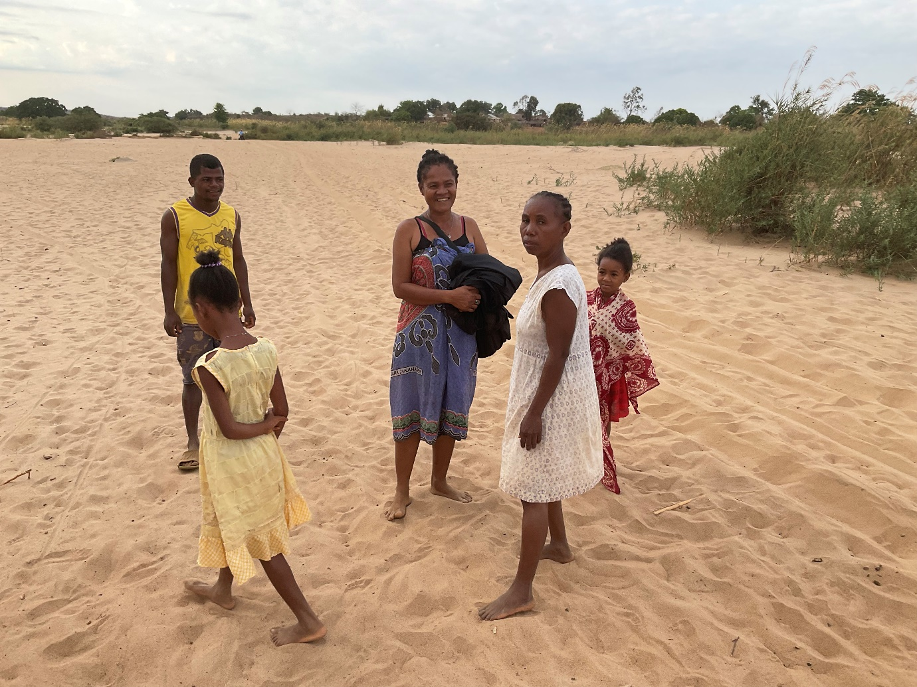
The tracks in the sand are those of ox carts which seem to manage all sorts of terrain. There was great excitement at my arrival. It was thought to be the first ever visit by a bishop. Another breakfast, no expense spared: rice and a spoonful of cold chips. It is now known that the bishop comes from where they eat potatoes and so these delicacies had been brought in. Then a tour of the village and so to church as it was now nearly 9 am.
The local church is run by an incredibly energetic and dynamic lady called Mme. Angéline. With her own hands she helped the men build the present temporary mud and thatch church. There was the most wonderful atmosphere of both reverence and celebration as we worshipped. I found the chanting of the Te Deum by memory by the whole congregation incredibly moving, the last verses being sung as solo and response.
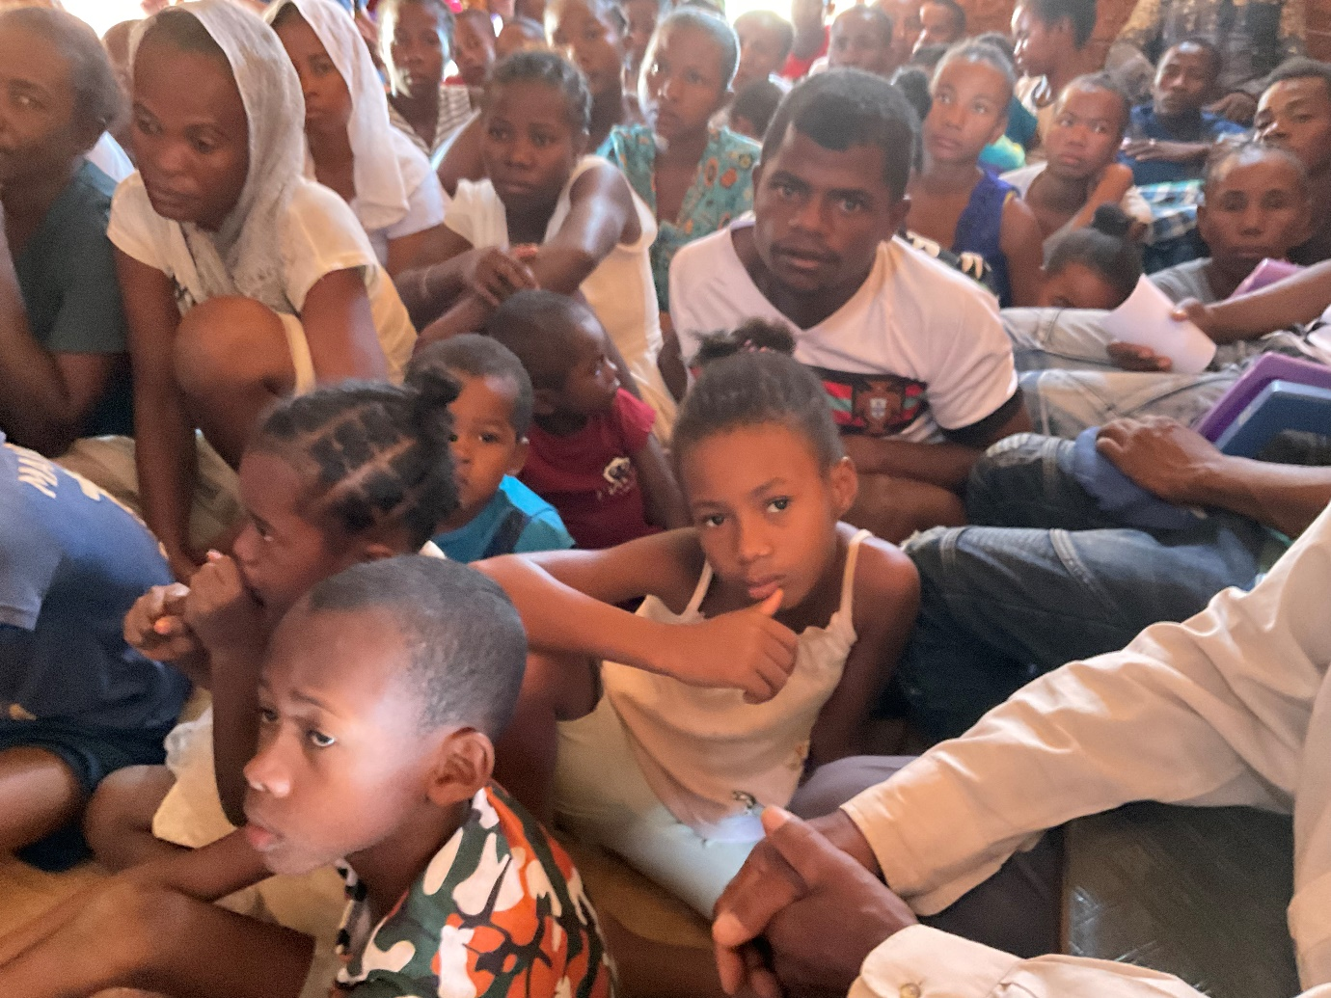
The congregation all seated on the ground waiting patiently for the Service to begin. When it came to receiving Communion there was a complicated manoeuvre as people had to go out and come in again to allow the flow of communicants. This was repeated at the end of the service as so many wanted a personal blessing by the bishop.
We even had a choir who danced as they sang and at the end of the speeches there was more singing and dancing and it felt too happy to be true. It was then suggested that I have a rest before lunch but that lasted only a few minutes as more requests for blessings came in and off I went to bless new houses that looked as if they had been there for ever though in fact one was still lacking the thatch on the roof ridge making it lovely and bright inside. Each blessing followed by singing and dancing.
I have to admit that I was relieved not to join the villagers on the ground for lunch. I sat inside a house in solemn state on a chair with the rural dean and the Revde Nivo. I was all too conscious that the downside of these wonderful trips is that, having got there, the journey has to be repeated to get home. I had been terribly conscious in church that I was the only one wearing shoes but I dare not take them off as there was no way my feet swollen both by the journey and the heat would fit into them again that day. However, this ended to my advantage when we set off on the return journey. The sand was scorching hot and I have never mastered the art of walking camel-like so as not to fill my sandals with sand. Those in bare feet were hurting while I staggered on. It had been an exhausting visit but also exhilarating and encouraging after the downer of mid-week. Would I spend the night going back to Mahajanga on the taxi-brousse? NO. I needed a night in bed before tackling that again.
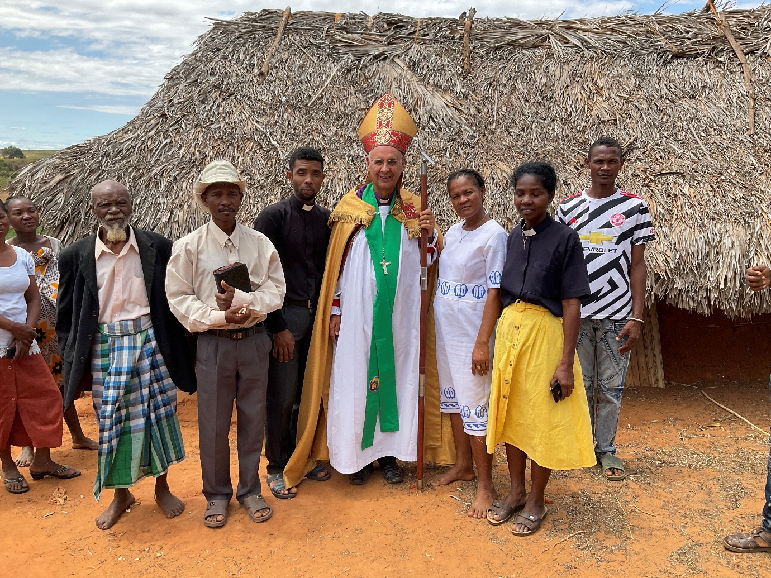
Ambario: The elder statesman of the village, the head of the civil parish council who is also the catechist, the Rural Dean, H.S., Mme Angéline in her MU uniform, and the Revde Nivo.
And so back on the taxi-brousse on Monday morning at an early hour and back to Mahajanga in the early evening. Great to be home – except the workmen I had left at Bishop’s House had fused the electricity knocking out my precious WiFi and the water system wasn’t working. But that is another story!
What a privilege it had been to see such stunning countryside, meet many lovely people, share in uplifting worship and travel safely. Once again, thank you to all of you who made this possible through your generosity, not least your prayerful support.
God bless.
+Hall

hallspeers@gmail.com

2 October 2021

