The Parish Church of St. Paul, Wokingham
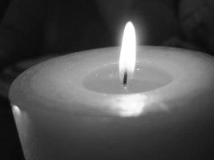

The Advent Service

of Words and Music

Sunday 28th November 2021 at 6.15pm

We stand for the hymns
and sit for the choir carols and readings.
At the end of each reading, the reader will say:
“This is the word of the Lord”
and we all respond
“Thanks be to God.”
Please stay in Church after the service
for refreshments and fellowship.

“Come, my breath and my life.

Come, the consolation
of my humble soul.

Come, my joy, my glory,
my endless delight.”
St Symeon the New Theologian

Choir O radiant dawn
(James MacMillan, b.1959)

(sung from the West End of Church)
O Radiant Dawn,
splendour of eternal light, Sun of justice:
come, shine on those who dwell in darkness
and the shadow of death.
The people who walk in darkness
have seen a great light:
for those who dwell in the land of gloom
a light has come.
Come, shine on those who dwell in darkness
and the shadow of death.

Reading Three Advent Antiphons

Processional Hymn (omit * verses)
19 Come thou Redeemer of the earth

Choir Advent Prose (501)

The Greeting and the Advent Bidding

The Advent Collect
Almighty God,
give us grace to cast away the works of darkness
and to put on the armour of light,
now in the time of this mortal life,
in which your Son Jesus Christ
came to us in great humility;
that on the last day, when he shall come again in his glorious majesty to judge the living and the dead,
we may rise to the life immortal;
through him who is alive and reigns with you,
in the unity of the Holy Spirit,
one God, now and for ever. Amen.

Lesson 1 Exodus 3.1-6

Moses and the burning bush

Choir Of the Father’s heart begotten
(arr. David Willcocks, 1919-2015)

Lesson 2 Isaiah 40.1-8, 11
All people are grass,
but the word of God shall stand for ever

Choir Gabriel’s Message
(Richard Runciman Terry, 1864-1938)

Poem Mother and Child, by Charles Causley

Congregational Hymn

6 Hark the glad sound! the Saviour comes

Lesson 3 Isaiah 52.7-10
Be joyful- the Lord has comforted his people

Choir The truth sent from above
(Ralph Vaughan Williams, 1872-1958)

Lesson 4 Malachi 3.1-5
Behold, I send my messenger to prepare the way before me: the Lord whom you seek will suddenly come to his temple

Congregational Hymn

14 The advent of our God

Lesson 5 Isaiah 61.1-3, 11
The Spirit of the Lord is upon me to proclaim liberty to the captives

Choir There is no Rose
(Philip Stopford, b. 1977)
There is no rose of such virtue
as is the rose that bare Jesu: Alleluya.
For in this rose contained was
heaven and earth in little space: res miranda.

Lesson 6 St Luke 1.26-45
Mary and Gabriel are met:
Elizabeth and Mary rejoice

Poem Gabriel’s Annunciation, by Jan Richardson

Choir Zion hears the watchmen’s voices
(Johann Sebastian Bach, 1685-1750)

Advent Prayers

The Lord’s Prayer
Our Father, which art in heaven,
hallowed be thy name.
Thy kingdom come, thy will be done,
on earth as it is in heaven.
Give us this day our daily bread.
And forgive us our trespasses,
as we forgive those who trespass against us.
And lead us not into temptation,
but deliver us from evil.
For thine is the kingdom, the power and the glory,
for ever and ever. Amen.

The Blessing

The grace of our Lord Jesus Christ be with you.
Amen. Come, Lord Jesus.

Recessional Hymn

3 Come, thou long-expected Jesus

[Please sit]

Choir Recessional (sung from the West End of Church)
O come, O come Emmanuel
(arr. A Parker and R Shaw)

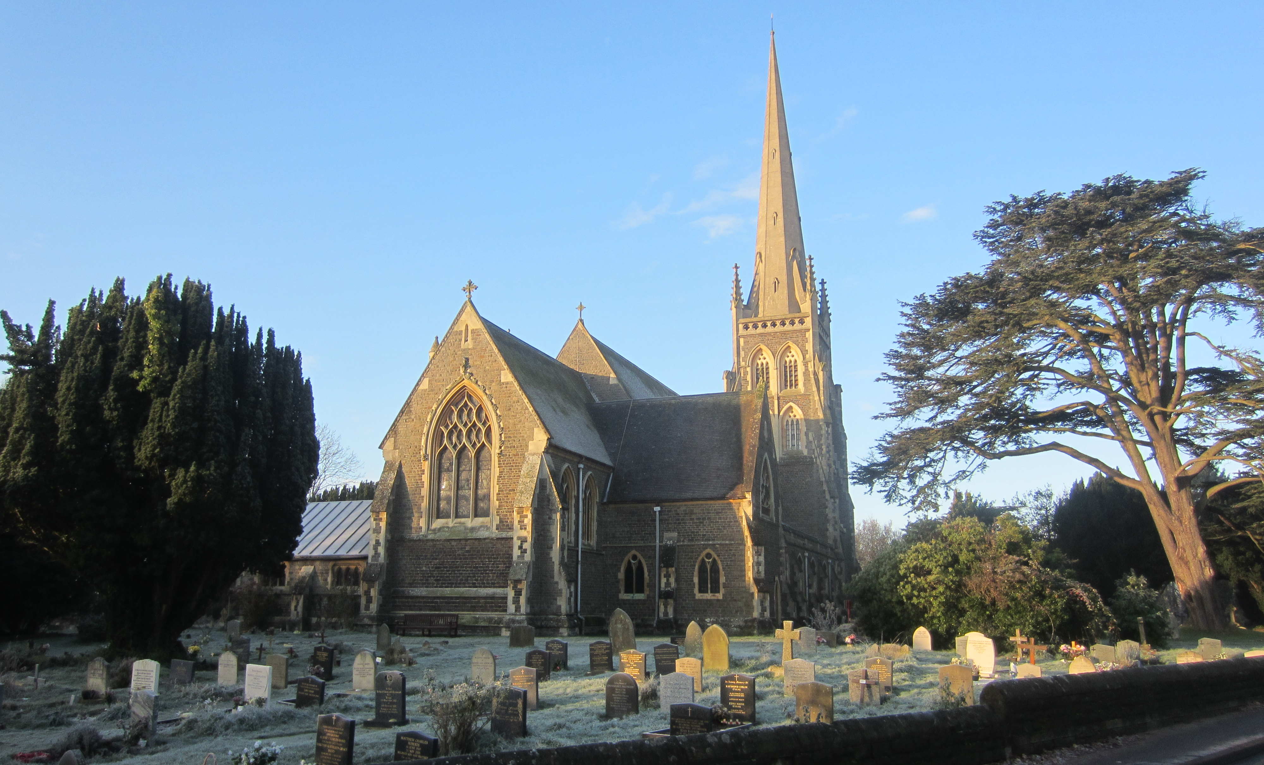

Since 1864 St Paul’s has been a beacon in the community
and a place of encounter with God, in joyful times,
in times of sadness and in all of the normal routine of life.

Our Missional Vocation Statement:
Shaped by God in the Eucharist,
we are called to make the richness of his love
known to everyone in the community.

For details of forthcoming events and information on anything to do with the life of the church,
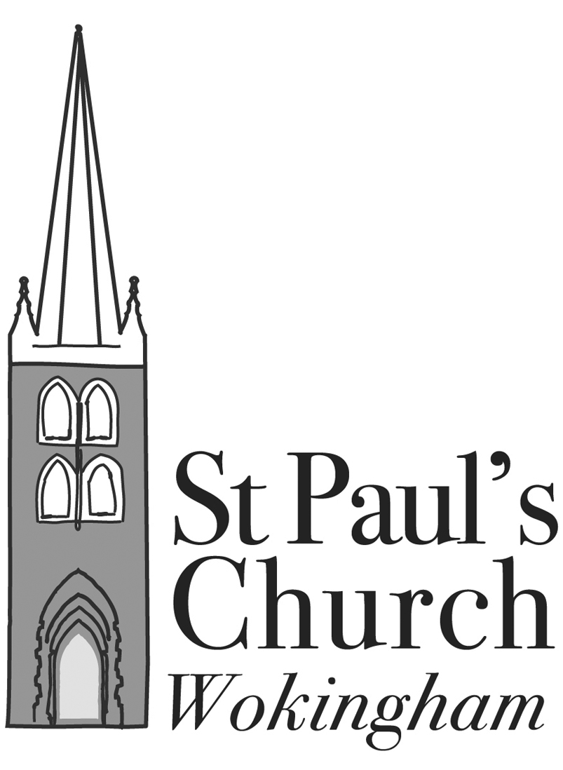
please check our website www.spauls.org.uk,
befriend us on Facebook
or ring the Parish Office on 0118 979 2122.

Christmas 2021 in the Parish of St Paul, Wokingham and St Nicholas, Emmbrook

Sunday the 19th of December
3.00pm Crib Service with First Steps St Paul’s
(come dressed as your favourite role in the Christmas story)
6.15pm Nine Lessons and Carols St Paul’s

Tuesday the 21st of December
6.15pm True Christmas Service St Paul’s
(quiet and reflective service for those who find Christmas difficult
or want some space in the days before the 25th)

Christmas Eve (24th of December)
3pm Crib Service St Paul’s Junior School Playground
(come dressed for Bethlehem- and the weather…)
5pm Crib Service St Paul’s Junior School Playground
(come dressed for Bethlehem- and the weather…)
9pm First Mass of Christmas St Nicholas’
11pm Midnight Mass St Paul’s

Christmas Day (25th of December)
8am Mass (traditional language) St Paul’s
9.30am All Together Mass St Paul’s

St Stephen’s Day (Sunday 26th of December)
9.30am Parish Mass St Paul’s
(only service in the parish today)

Feast of the Epiphany (Sunday 2nd January 2022)
9.30am Parish Mass St Paul’s
11am Parish Eucharist St Nicholas’

NB- because of the current situation with Covid, we have decided that the normal Christingle service is too risky this year- instead, we offer an outdoor Crib Service and are going into local Schools to talk about Christingle.

