The Parish of St Paul, Wokingham
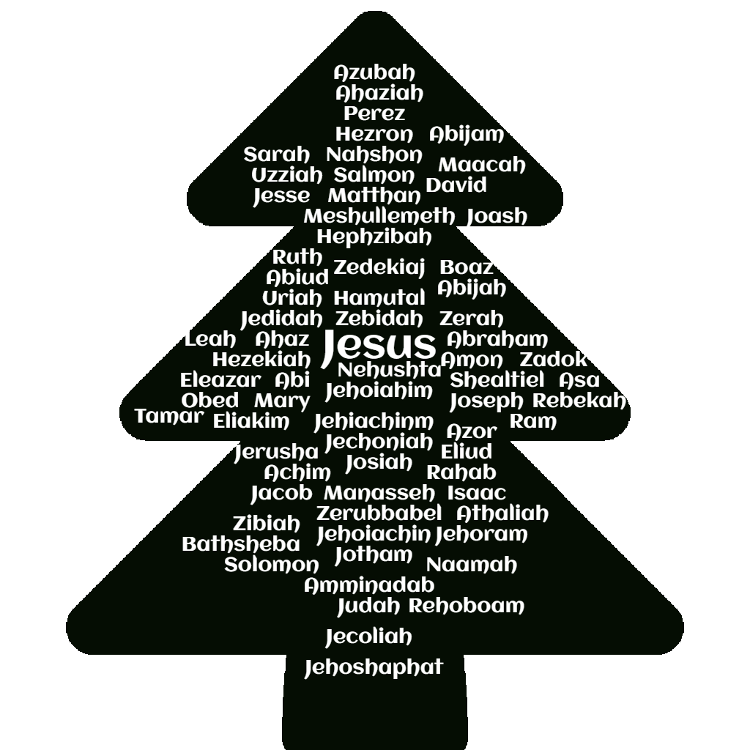
Advent Sunday 2021

During Advent we wait and make ourselves ready for Jesus.
We wait, in and through the busyness.
We wait, in the quiet stillness of starry nights.
We wait together, in church, at home, in school, at work.
We wait, with joy and hope, with laughter and with longing.
We wait and pray, Come, Lord Jesus, Come.

HYMN: 11, O Come, O Come, Emmanuel

The Gathering
In the name of the Father,
and of the Son, and of the Holy Spirit. Amen.
The Lord be with you: and also with you.

Words of welcome and introduction follow.

Making of the Advent Wreath
We make the wreath together with four candles around the wreath and one in the centre, decorated with evergreen leaves. One candle is lit on each Sunday of Advent, until finally the white candle in the centre is lit on Christmas Day.
Advent 1 The Patriarchs
Advent 2 The Prophets
Advent 3 John the Baptist
Advent 4 The Virgin Mary
Christmas Day Jesus

When the wreath is made, we pray:
Lord of light and love, be here with us this Advent

Lord of light and longing, this advent
we remember the grandparents of our faith
people like Abraham and Sarah
who waited for a child and for a place to call home.
People like Jacob, Leah and Rachel,
who showed us that God sees and notices each one of us.
We give you thanks for their faithful witness to your call.
Lord of light and love, be here with us this Advent.

Lord of light and longing, this advent
we remember the prophets of our faith
people like Moses, Miriam and Isaiah,
who waited for your truth and goodness
to be recognised in each and every one of us.
We give you thanks for the prophetic voices of our faith.
Lord of light and love, be here with us this Advent

Lord of light and longing, this advent
we remember those who point the way,
people like John the Baptist,
son of Zechariah and Elizabeth,
who taught his followers how to change their heart,
and baptised them with water,
waiting for you to baptise us with the Holy Spirit.
We give you thanks for the gift of new life through baptism.
Lord of light and love, be here with us this Advent

Lord of light and longing, this advent
we remember those who said yes to your call,
people like Mary and Joseph,
who were visited by angels
so that your message could be heard,
and waited patiently until they saw you face to face.
We give you thanks for the gift of life.
Lord of light and love, be here with us this Advent

We light the first candle with a prayer:
Lord of light and love, be here with us this Advent
as we remember all who have guided us with their faith.
Amen.

HYMN: 3, Come thou long expected Jesus

The Prayer of Confession:
we remember the times we have not longed for Christ with our whole heart

God so loved the world that he sent his only Son Jesus Christ
to save us from our sins and to bring us to eternal life.
This Advent, let us say sorry to God for the ways in which
we have not followed Christ as we should have.

For all the times where we have forgotten
to care for others and notice their needs,
Lord, have mercy. Lord, have mercy.

For all the times when we have rushed on by,
instead of pausing to give you thanks,
Christ, have mercy. Christ, have mercy.

For all the times that we have not longed for Christ
with our whole heart,
Lord, have mercy. Lord, have mercy.

Sung Kyrie

The Absolution, God’s promise of forgiveness
May God our creator forgive us our sins
and renew in us a sense of peace and joy
as we wait in hopeful expectation this Advent.
Through Jesus Christ our Lord. Amen.

The Collect
The Lord be with you: and also with you.

Almighty God,
the people of our past heard your voice and followed you;
they told their stories and retuned their hearts
to your ways of truth, justice and peace.
Help us to listen to all that they have to teach us
as we wait expectantly for your love and joy
to greet us once again in your Son, our Saviour, Jesus Christ,
Amen.

The Talk: We make our Advent Altar Cloth

The Gospel: Luke 1 26-38
Hear the Gospel of our Lord Jesus Christ according to Luke. Glory to you, O Lord.

In the sixth month the angel Gabriel was sent by God to a town in Galilee called Nazareth, to a woman named Mary, who was engaged to a man whose name was Joseph, of the house of David. And he came to her and said, “Greetings, favoured one! The Lord is with you.” But she was much perplexed by his words and pondered what sort of greeting this might be.
The angel said to her, “Do not be afraid, Mary, for you have found favour with God. And now, you will conceive in your womb and bear a son, and you will name him Jesus. He will be great and will be called the Son of the Most High, and the Lord God will give to him the throne of his ancestor David. He will reign over the house of Jacob forever, and of his kingdom there will be no end. He will be called Son of God.
And now, your relative Elizabeth in her old age has also conceived a son; and this is the sixth month for her. For nothing will be impossible with God.” Then Mary said, “Here am I, the servant of the Lord; let it be with me according to your word.” Then the angel departed from her.

The Prayers
At the end of each section, a response is used:
Lord, in your mercy: hear our prayer.
Merciful Father, accept these prayers
for the sake of your Son,
our Saviour, Jesus Christ. Amen.

The Liturgy of the Sacrament
The Peace
During the peace we hold out Christ’s peace to one another with a smile, a wave or the use of Sign Language. If you’re joining in from home,
do please put your message in the comment box on YouTube.

Hymn: 7, Hills of the North, rejoice

The Eucharistic Prayer (1)
The Lord be with you: and also with you.
Lift up your hearts. We lift them to the Lord.
Let us give thanks to the Lord our God
It is right to give thanks and praise
Holy, Holy, Holy.

It is always right to give you thanks,
God our Father, holy and strong, king for ever.
You made us and the whole universe
and filled your world with life.
Holy, Holy, Holy.
You sent your Son to live among us,
Jesus, Saviour, Mary’s child.
He suffered on the cross; he died to save us from our sins;
he rose in glory from the dead.
Holy, Holy, Holy.

You send your Spirit to bring new life to the world,
and fill us with power from on high.
And so we join the angels to celebrate and sing:

Holy, holy, holy Lord, God of power and might,
heaven and earth are full of your glory.
Hosanna, hosanna, hosanna in the highest.
Blessed is he who comes in the name of the Lord.
Hosanna, hosanna, hosanna in the highest.

Father, on the night before he died,
Jesus shared a meal with his friends.
He took the bread, and thanked you.
He broke it, and gave it to them, saying:
Take this and eat it; this is my body, given for you.
Do this to remember me.

After the meal, Jesus took the cup of wine.
He thanked you, and gave it to them, saying:
Drink this, all of you. This is my blood,
the new promise of God’s love.
Do this to remember me.
Jesus Christ has died. Jesus Christ has died.
Jesus Christ is risen. Jesus Christ is risen.
Jesus Christ will come again. Jesus Christ will come again.

Father, as we remember
his death and resurrection, send your Holy Spirit,
that the bread and wine we bring before you
may be for us Christ’s body and his blood.
Amen, Amen, Amen.

Pour your Spirit on us that we may love one another,
as we work for the peace of the earth,
and wait for Jesus to come in glory.
Amen, Amen, Amen.

For honour and praise belong to you, Father,
with Jesus your Son, and the Holy Spirit:
one God, for ever and ever. Amen, Amen, Amen.

The Lord’s Prayer
Our Father, who art in heaven,
hallowed be thy name.
Thy kingdom come, thy will be done,
on earth as it is in heaven.
Give us this day our daily bread.
And forgive us our trespasses,
as we forgive those who trespass against us.
And lead us not into temptation,
but deliver us from evil.
For thine is the kingdom,
the power and the glory,
for ever and ever. Amen.

We break this bread, to share in the body of Christ.
Though we are many, we are one body,
because we all share in one bread.

Lamb of God, you take away the sin of the world, have mercy on us.
Lamb of God, you take away the sin of the world, have mercy on us.
Lamb of God, you take away the sin of the world, grant us peace.

Draw near with faith and receive this sacrament of love,
and let it rekindle in your heart the blessing of peace.

Anyone who has been baptised is welcome to receive communion today. Please come forward as you are guided, keeping 2m away from others. The wafer will be placed in your hand in silence and then you are invited to return to your seat by going along the side aisle. If you would prefer to receive a blessing please bow your head when you get to the altar step.
If you are joining in at home you might find this a helpful prayer to use:

Thanks be to you, Lord, Jesus Christ,
for all the benefits you have given me,
for all the pains and insults you have borne for me.
Since I cannot now receive you sacramentally,
I ask you to come spiritually into my heart.
O most merciful redeemer, friend and brother,
may I know you more clearly, love you more dearly
and follow you more nearly, day by day. Amen.

Post-Communion Prayer
O Lord our God,
make us watchful and keep us faithful
as we await the coming of your Son our Lord;
that, when he shall appear,
he may not find us sleeping in sin
but active in his service and joyful in his praise;
through Jesus Christ our Lord. Amen.
The Notices

The Dismissal
Hymn: 9, Lo! he comes with clouds descending

The Blessing
May God who is light and love,
fill your hearts with longing for Christ, this Advent season and always. And the blessing of God…

Go in peace to love and serve the Lord.
In the name of Christ. Amen.

After the service people usually stay to listen to the organ piece.
The collection plate to support the work of the Church, along with the card reader, are by the door as you leave. You can text a donation to St Paul’s to 70450, texting STPAULS5
or STPAULS10 to donate that amount of money.
You’re then warmly invited to share in coffee and chat in the Parish Rooms
Common Worship: Services and Prayers for the Church of England,
material from which is included in this service, is copyright the Archbishops’ Council 2000.
Music license under CCLI 97309 or performed by kind permission of the copyright holder.

