Our Mad Life 63
Under Western Skies
Each day during my visit to Maintirano I had breakfast and lunch with the local clergyman, the Revd Patrick, in the church vestry. Each meal was prepared and served by his wife but never shared with her as she was always dealing with the children and at her little grocery stall on the roadside. The ‘rectory’ is a two-room edifice: the roof leaks and the wood is rotten.
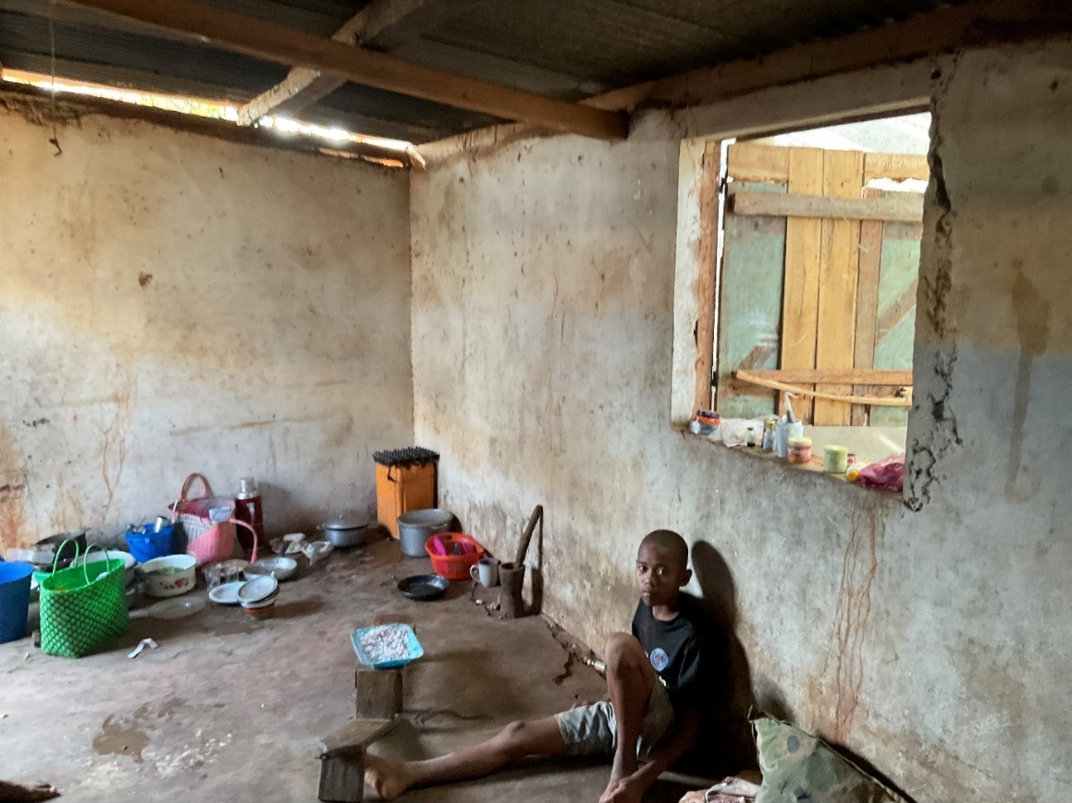
The ‘Rectory’ living room and kitchen. You can see why I think it a priority to rehouse the clergy and their families.
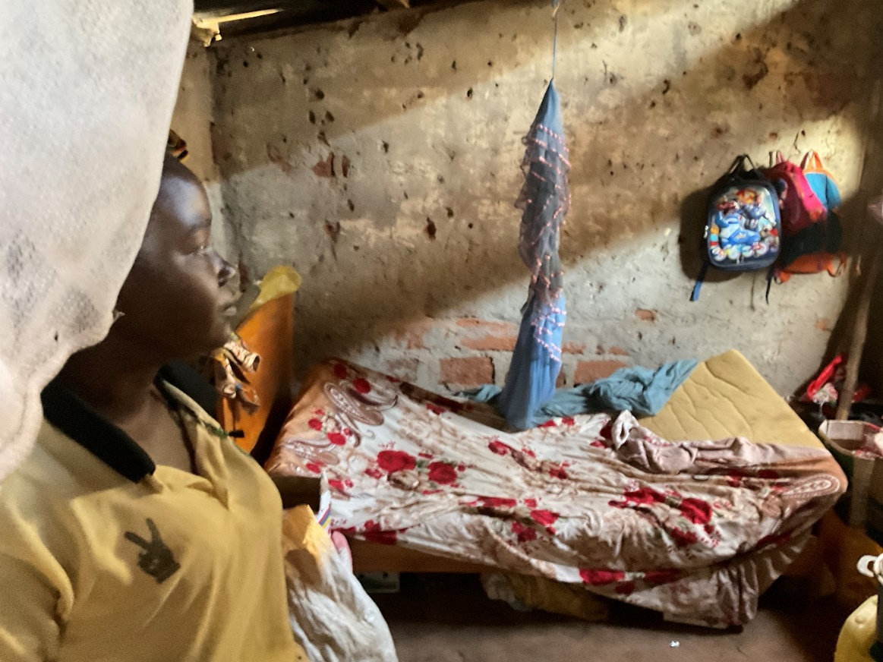
The Revd Patrick’s wife in the other room which is the bedroom and store.
Each meal was beautifully cooked and there was an orgy of cooking in preparation for the confirmation. A great quantity of samosas was fried, some cakes, and fruit juice prepared. On Sunday morning the confirmation candidates came to my hotel and then we processed slowly to church where we were greeted by a guard of honour of scouts and guides. The sound system worked intermittently as also did the accompanist who, standing at the keyboard, played with one hand producing random chords and discords. I didn’t guess any of the hymn tunes from her introductions. It didn’t seem to occur to anyone to turn down the volume as the congregation chanting the psalm nobly battled against her. My singing of the service is shaky at the best of times and her assistance didn’t improve my performance. I keep telling people that their participation in worship is the important thing, not the quality – but that didn’t lessen my own embarrassment in front of a couple of rows of distinguished guests. Similarly preaching is always a challenge but here with the added complication of a local dialect. The local clergyman had told me at some length of the blank looks he received when he went shopping when he first arrived, not knowing the words for fish, bananas, etc. I have taken to asking questions in sermons to check that some people are understanding and the occasional funny example to see if they laugh. I was hugely relieved when I got answers and laughs at the Confirmation. As always, the act of laying on of hands is very moving with a wonderful sense of unity of purpose and devotion.
In my last notes I mentioned names. I discovered that a candidate named Edouard was a young lady. At the end of the service there were the customary speeches and the Governor of Meloky impressed me with a speech in English. The confirmation candidates took delight in substituting my mitre with a local hat and the traditional wrapping of me in a lamba.
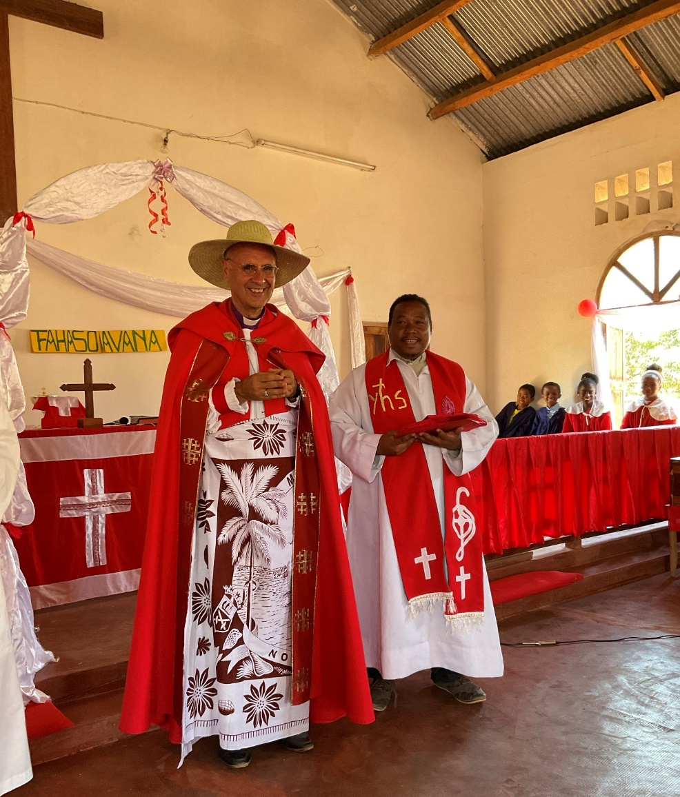
The food that had been so laboriously prepared over the last two days disappeared in the twinkling of an eye.
Less happy was my meeting with the church council in the afternoon. They had failed to have elections this year and among those who didn’t turn up was the treasurer. To put it mildly their book keeping and record keeping is a shambles. This has resulted in a lack of trust and rumours about the use of money. Add to that a couple of thefts. I have insisted that they open a bank account which is costing a lot but infuriatingly they are loathe to use it. This I must be sympathetic with as none of them has a personal account and so the banking system is completely foreign and hugely complicated for them. But I am sticking to my guns. If we are going to build a decent house the amount of money needed, which will be astronomical as far as they are concerned, has to be fully accounted for and not to be stored under that mattress!
A further complication is the fact that all the church windows, which are in fact wooden shutters, are completely rotten and literally falling to pieces. Exercising questionable episcopal authority, I have ruled that they are not to be replaced with wood but either iron grills or open brick work. The congregation favour the open brick work solution, not least because one of them is hoping to get the contract. Would I like to haggle with him?
“No.” All were taken aback by my instant and firm refusal and a bit shocked when I told them that was their responsibility and the number of windows repaired may depend on the price – money is limited.
My return journey was unsurprisingly like the outward one but each embarkation and disembarkation was progressively more challenging. To board at Maintirano one had to hop down from the quay onto the top of an oil drum arriving in a crouched position so as not to hit one’s head on the deck above. Then jump on to the actual deck. It is several years since I attempted such a jump and was astonished that I could do it. The great thing about my life here is the total lack of boredom and the humdrum. Another near sleepless night as those around me emptied their stomachs - well over half of those on my deck. I was counting.
I was stunned when the ship “double parked” on arrival at Mahajanga the following afternoon and we had to make our way across a cargo boat to the quay.
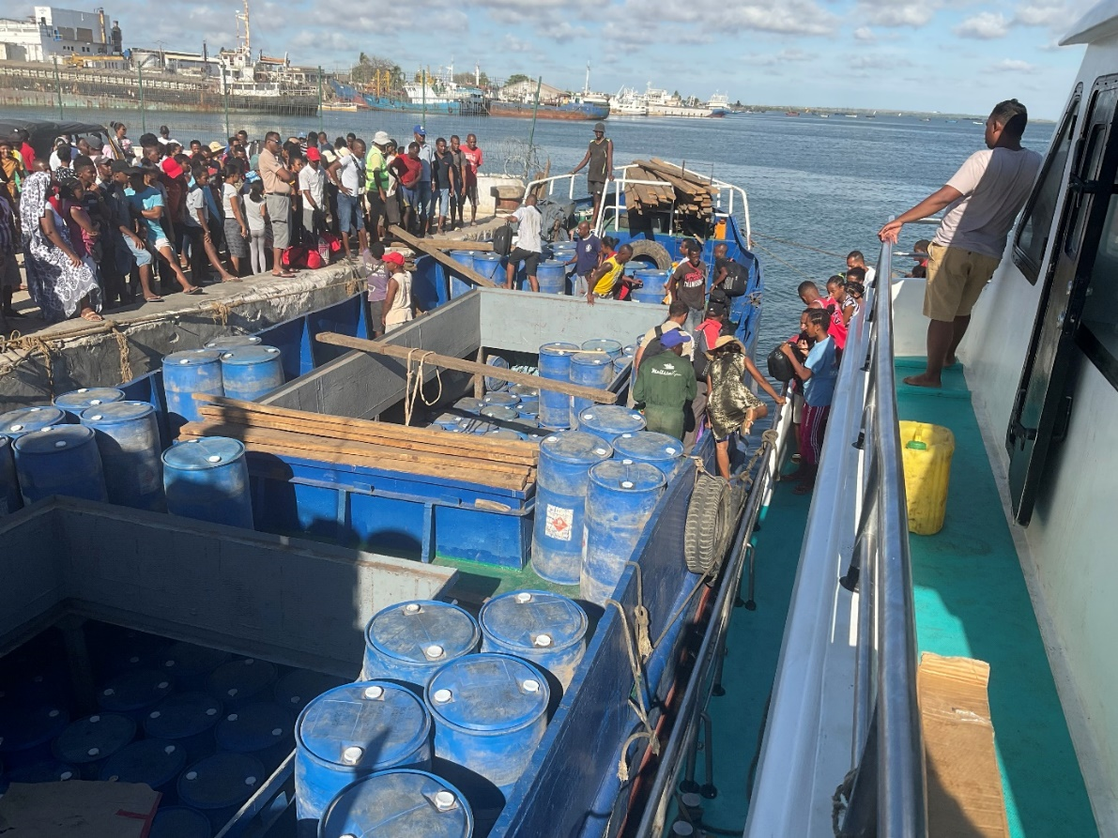
Over the rail onto a loosely hanging tyre. One instantly learnt to balance on the top of the tyre otherwise it swung away leaving one dangling between the ships. Over the rail of the cargo ship, across it, and so at last up to the quay. All this avidly watched by the crowd on the dock side and with even greater interest by those waiting to attempt getting off the ship. I can confidently say that I am fitter after my trip to Maintirano – but I don’t recommend this sort of exercise.
As always so much to give thanks for, not least the many lovely people I met, especially our Confirmation candidates. God bless them all and you.
And so back to the desk, grateful that it isn’t moving and I can communicate again with you, as I struggle with the many requests for help. Yesterday’s big one: a property suitable to be used as both church and clergy house has come on the market for £15,000 at Antsohihy where we desperately need a building. Could I find that and not jeopardise the other building commitments?
My overused word is “priority”. I struggle each day with that on so many fronts. But don’t we all? It is very simple to say one will seek God’s will (especially in Malagasy). The problem with this discernment process is that God almost always has many doors open for us. Pray that we may choose what is possible and best.
But right now, I must acquiesce to my body and have a few hours rest, so thankful that I can do it in the warmth of brilliant sunshine while most of you are wrapping up to keep warm and cope with the winter darkness.
Love and thanks
+Hall
hallspeers@gmail.com

6 November 2021

