Our Mad Life 64
Up to the capital, Tana
Preliminary conventions. When one speaks publicly here one first acknowledges permission to speak, then greets everyone, then makes an apology before proceeding with the business in hand. I am more or less up to speed with this at the start of a meeting, not least because I feel the need to apologise for my lack of fluency, not to mention subtlety, in the Malagasy language. However, in the course of a discussion I completely forget this etiquette and plough in with what I consider a salient point. So impolite! Yet at the same time I get fed up with the repetition of others’ long winded polite overtures…

This is uppermost in my mind after a week of meetings. We have just had the triennial general meeting of the Anglican Church in Madagascar. (Not to be confused with Provincial Synod which includes Mauritius and the Seychelles.)
Because of my full programme in Mahajanga I again found myself travelling overnight last Sunday. Our driver seemed intent on breaking the journey time record so we had some terrifying bounces over potholes and sleep was in very brief intervals. On the Monday morning I was very graciously entertained in order to be lobbied about various things. With the death of the bishop of the northern diocese of Antsiranana there are currently only 5 members of the House of Bishops which has the last word on all the major decisions so my vote was sought after! I had qualms about accepting hospitality in this way. However, in the event I didn’t feel compromised in any way and some of the people turned out to be old friends. But what a temptation this must be on the national political scene where large amounts of money, contracts, foreign holidays, etc are involved.

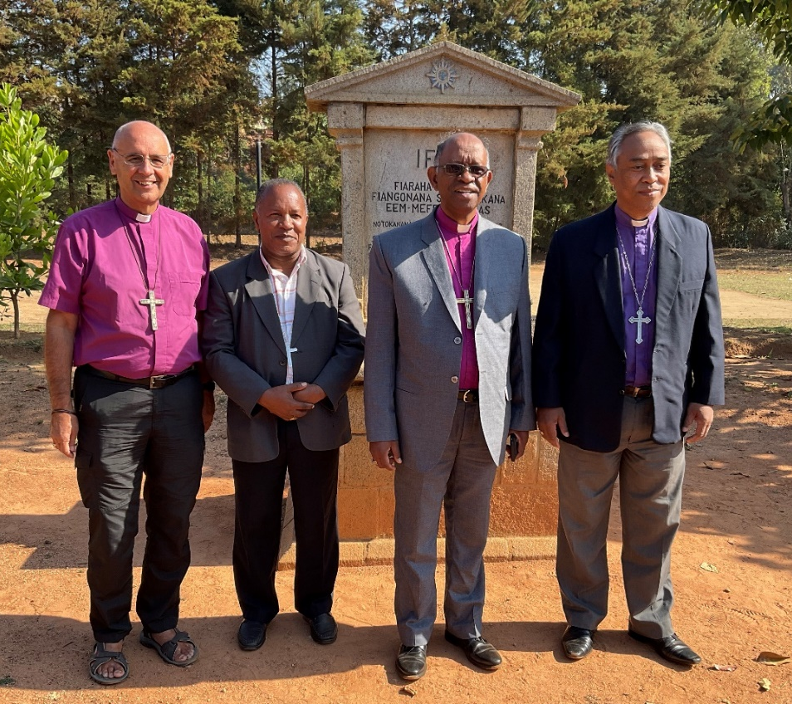
A depleted House of Bishops: SHS, Bishop Gilbert of Fianarantsoa, Bishop Samitiana of Toliara and Bishop Jaona of Antananarivo and chairman.
The conference centre, “IFLA”, was spacious with lovely views of Antananarivo, sadly shrouded in a perpetual haze of pollution in the distance. It was very basic but there was electricity, water, it was clean and I had a single room while the clergy and lay representatives were in dormitory accommodation. Not only was the food good and in generous quantities but we also had enormous mid-morning and mid-afternoon refreshments with people perpetually fussing over the bishops. Irreverently I always think of my father fattening up animals for market or the abattoir, thus slightly anxious as to where this is leading!

Our mornings began with the early birds crashing around from 4 am onwards and Holy Communion at 6 am. On the first full day the bishops had a very intense meeting after the day’s business and only ended at 11.30pm. It was my turn to lead the worship the next morning. I felt I was running on my last reserves of energy as I stumbled into action keenly aware of my accumulated sleep deprivation. Two of the bishops overslept and arrived late looking haggard. An outside observer might have concluded that the bishops had a night out on the tiles!

We heard heart-rending accounts of the famine in the south of the country as well as what the church is doing to alleviate the starvation and work on the provision of water. Most dramatic was the account of a village which had not had rain for four years. As a result of evangelisation, a great number decided to become Christian. After the bishop laid hands on the people at the Confirmation Service, there was a gust of wind and the heavens opened and there was a tremendous rain storm. It was difficult to stop the dancing to conclude the Service!

I gave the concluding blessing, exhausted after a marathon week and couldn’t believe my eyes when the men got up and danced exuberantly when all I wanted to do was lie down! It always takes me by surprise when people express their joy in spontaneous dancing. I do wish I could join in but I have the proverbial ‘two left feet’ and a pathetic sense of rhythm so I enjoy the spectacle and attempt to clap as appropriate.

Some very hard decisions were taken, among which was to close down the national development committee and dismiss its chairman. It was something I was very much in favour of as he was being paid 14 million ariary plus very generous expenses while the clergy are paid just over 2 million ariary and no expenses in most cases. This decision means that each diocese is in charge of its property and development programme and they are to be coordinated by Bishop Samitiana of Toliara. For us in Mahajanga diocese it is no change since we never received help from the national committee! (Those lobbying me were hoping to open a door that was already open had they but known.)

As we made our way back to Antananarivo city centre we sat in interminable traffic jams and it was all too obvious why the air quality is so poor as the queues of taxi brousses belched out their diesel fumes. After the rigours of the week it was a joy to be spending the weekend with the Anglican Sisters FMJK on the outskirts of the city. The day with them always starts with my celebrating and preaching at a 6 am Holy Communion, followed by breakfast in silence. At the end of breakfast, we all greet each other and each Sister says what her programme for the day is. Very civilised. When it came to my turn I said it was my day off, however I was eager to see all that was happening and catch up generally.

The Sisters run a “dispensary”/clinic and there is always a queue of patients in the morning. They see an average of 60 patients each day, but in the first wave of Covid that rose to a minimum of 100 daily. They have had no supplies of vaccine which I find extraordinary. It is available only at authorised government centres. Morning at the clinic starts with prayers in the waiting room which has a large mural of the Garden of Eden. A very European Adam and Eve peep out of the very Malagasy luxuriant tropical growth complete with lemurs swinging in the trees.

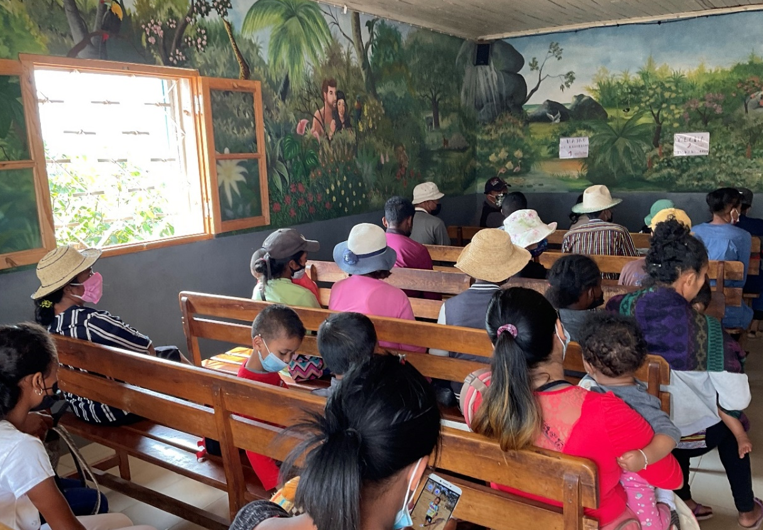

.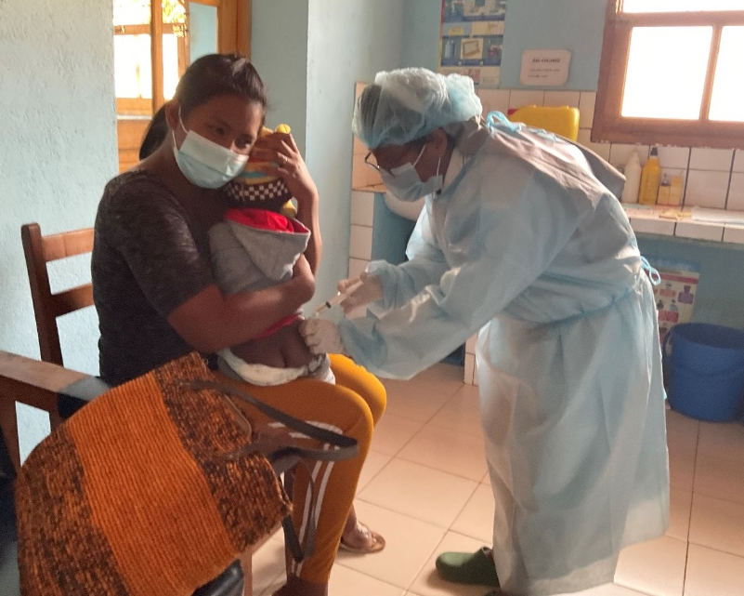
I was hugely impressed by the charm and care that was lavished on each patient by the Sisters and Dr. Patricia.

I am currently trying to help the Sisters with two projects: the supply of water and obtaining a communion bread ‘cooker’. For once money is not the major obstacle. The water level is sinking in the Sisters’ well and I am seeking expert help to advise us on the way forward. One of the side effects of the terrible drought and famine in the south is that we now have such expertise in the country. It is a matter of getting hold of them when they are in the capital and getting them out to the Sisters.

I have been on the receiving end of so much kindness this last week thus, as always, so much to be thankful for. There is now a full programme until Christmas (but not a single carol service, fancy meal or other frivolity as we keep a very strict Advent). I have a Confirmation every Sunday and have just had a request to combine a wedding with one of these!

May this season of preparation bring you the joy of messages of love from old and new friends and family while we turn our minds to the traditional “Four last things”: Death, Judgment, Heaven and Hell. Not as grim as it sounds as it makes for a different sort of preparation for celebrating the Birth of Our Lord.

Love and thanks to you all.
+Hall

23 November 2021
hallspeers@gmail.com

