Our Mad Life 65
Joy at Christmas
Advent is a such a tremendous season of hope as we prepare to celebrate the birth of Jesus and look to His coming in glory. It is such an incredible honour and joy to be with a different community each weekend for their Confirmation service. Each Confirmation is the climax of a period of preparation and so it is relatively easy to pick up on the theme of preparation, though one also quickly picks up on the fact that some are much better prepared than others.
St John the Baptist figures large in the set readings as one whose calling was to prepare the way for our Lord. In Malagasy the words used are those used every day of men working on our dreadful roads – hard work in the heat of the day which makes a dramatic difference to one’s journey, making remote places accessible more easily and very much more quickly. As I write this in Marovoay there is the constant hammering of the men laying the cobblestones beneath my window. Some of the roads just outside had become unusable by cars and ordinary 4x4s.
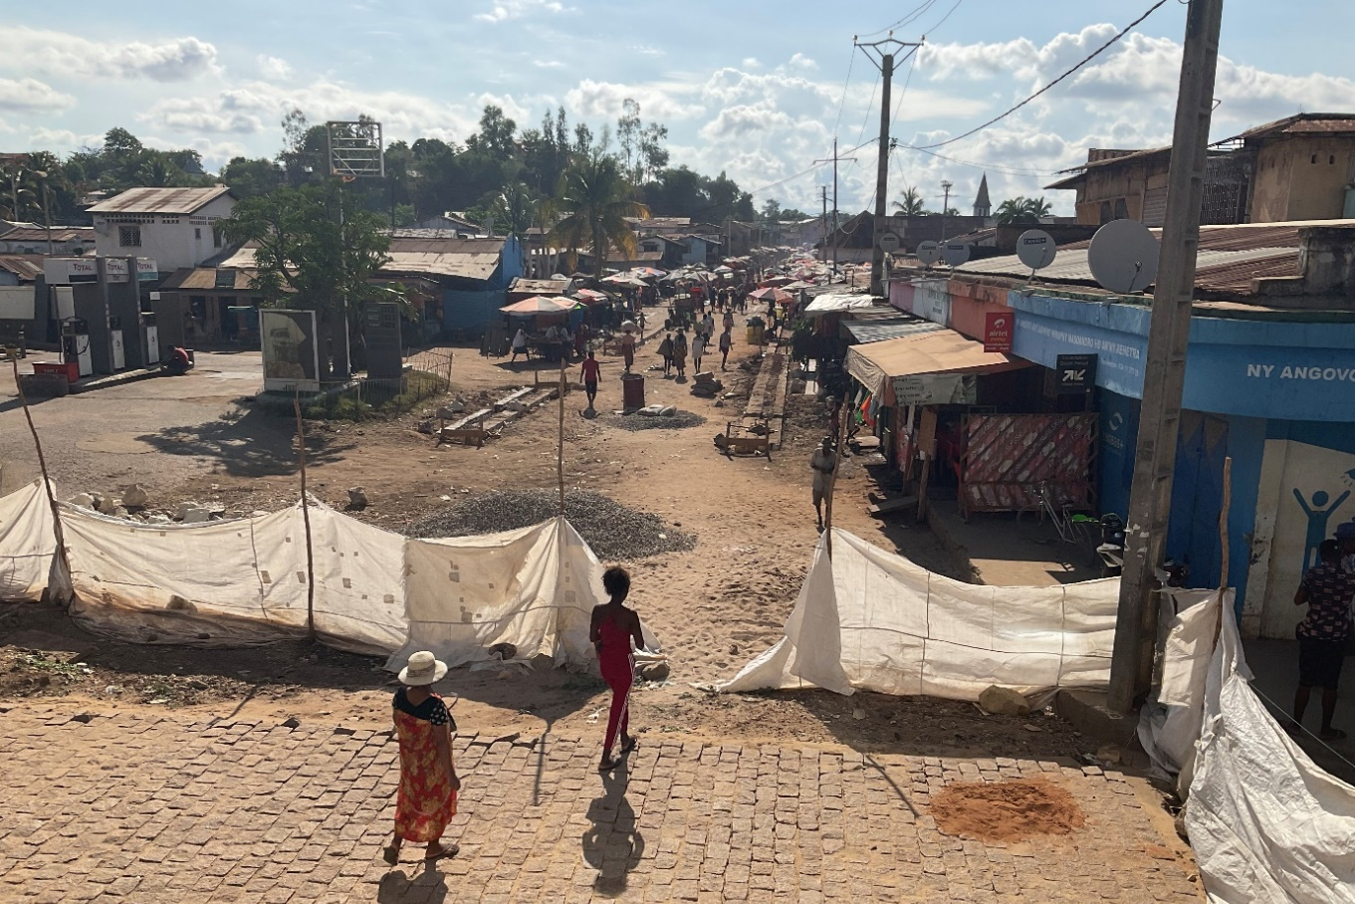
When I first visited Marovoay I was warned that it is one of the dirtiest towns in the country. I was still shocked when I saw it. Thus I was thrilled when, last month, we were able to undertake a project, in cooperation with the local council, to clean some drains. Over a couple of days 50 men and women got employment cleaning the worst of the drains in preparation for the rains which are now due. A huge amount of rubbish and sand was dug out and we were surprised to discover that long ago these drains actually had cement bases which are still intact. In some places this was three feet below the silted up level. The locals are delighted and amazed that the church initiated such a project. Happily, this has coincided with a massive road improvement scheme undertaken by the council and so the impact is tremendous. The Mayor of Marovoay is so pleased he wants me to facilitate a twinning with an English or Irish town!
An almost identical project has been undertaken in a poor part of Mahajanga. The full benefit of these projects will not be experienced until the rain comes.
Nobody here can imagine that most of you are living in dread of the next lot of regulations concerning covid and Christmas and New Year events. At the previous Sunday’s Confirmation, at St. Andrew’s, Ampombibitika, I was told firmly that “there is no coronavirus here” and so, not only did the congregation pack in like sardines (with an overflow outside), but we also shared a common cup for Communion! This I found difficult but as I participated in the communal meal afterwards I could see that my scruples about the shared chalice were a bit absurd when we were all repeatedly dipping our spoons in a communal basin of boiled chicken…
The service had been incredibly long. I entered church at 8 am and unrobed after 1.00 pm. We had 4 baptisms, 19 confirmed, the licensing of a new reader, and a Wedding during a Sung Eucharist and seemed to sing at least half the hymn book. I am painfully learning that these events are far removed from the “attending a service” mentality I have been used to all my life. These are huge events that, for the participants, take up at least a weekend. Many have travelled a full day and so have to sleep at the church the night before and often the night after so they expect the big happening to be something considerably more substantial than a hour and a bit in church. The Malagasy are well used to travelling as a family, carrying the rice needed, and sleeping on the floor. All the larger churches are equipped with huge cooking pots and before a confirmation begins the wood fires are already lit and the cooking commenced.
I arrived at Marovoay on Friday afternoon which I felt was slightly over the top but I didn’t want to spend Saturday morning in a state of extreme anxiety about getting a taxi-brousse there in time for the rehearsal on Saturday afternoon. I was in time for the Friday evening 6.15 pm Communion Service which was attended by over 50 people, a lot of whom were to sleep in the church recovering from their journey and in preparation for the aforementioned rehearsal! When I arrived for the 5.30 am Saturday service I had to robe in church as the vestry was fully occupied by ladies in various stages of wakefulness and dressing.
Meanwhile the churches are preparing their Nativity plays with all the realism that teenagers in lead roles can bring to the action. After evening service last night I watched a rehearsal and inexplicably several of the little ones decided that the best viewpoint was snuggled up to the bishop (perhaps intuiting I was missing my grandchildren) so I sat there like a mother hen with her chicks with my arms round tiny boys and girls as they got caught up in the action. I got beseeching looks during Joseph and Mary’s interminable search for overnight accommodation accentuated by Mary’s frequent collapse from exhaustion – played to full effect. The frequent appearance of angels caused delight and their outstretched arms were mimicked but, as far as the little boys were concerned, the best and real fun bit was Herod’s soldiers killing the boys and my little neighbours fell on the floor gleefully stabbing and writhing. I hope the staged event is more to do with the birth and less a sad reflection of what is going on in many parts of the world and that the message of peace and good will does shine out.
The actual Confirmation service broke my previous record (and stamina) as it lasted 5 hours! At the end every family present got a moment of glory as they came to the front and proudly sang the first verse of their favourite hymn (no carols were chosen) but I lost count of how often we sang the first verse of number 3 in our hymn book!

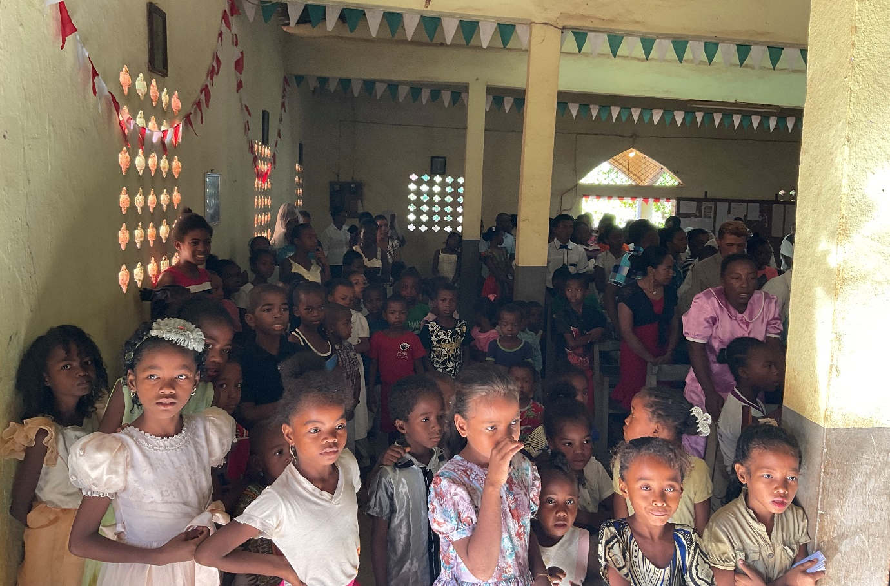
After that came a half hour of photographs with groups and individuals. All this at 38C!! I felt I looked like the missing link between Nicholas of Smyrna and Santa Claus as I was surrounded by tinsel, fairy lights and balloons.

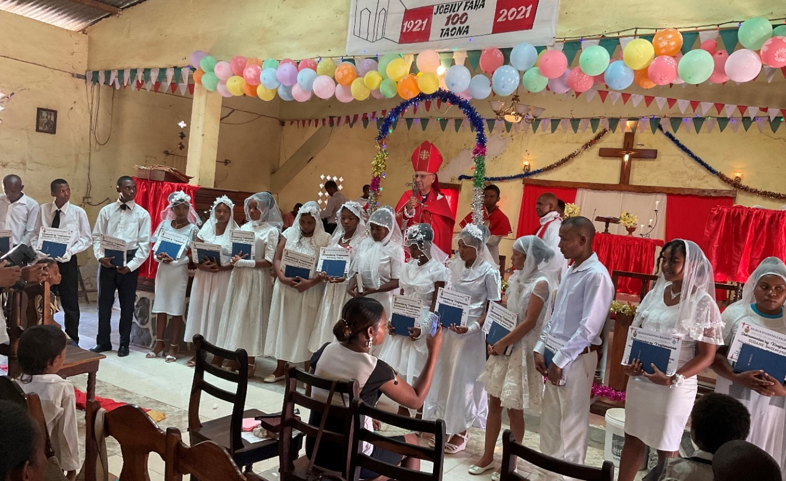

Thank you for the many kind words of encouragement and Christmas Greetings that Sarah and I have been receiving.
May you have reason for joy this Christmas, time to celebrate and be full of hope for 2022.
Yours
+Hall
hallspeers@gmail.com

