The Parish of St Paul, Wokingham
The 9.30am Eucharist
for Candlemas
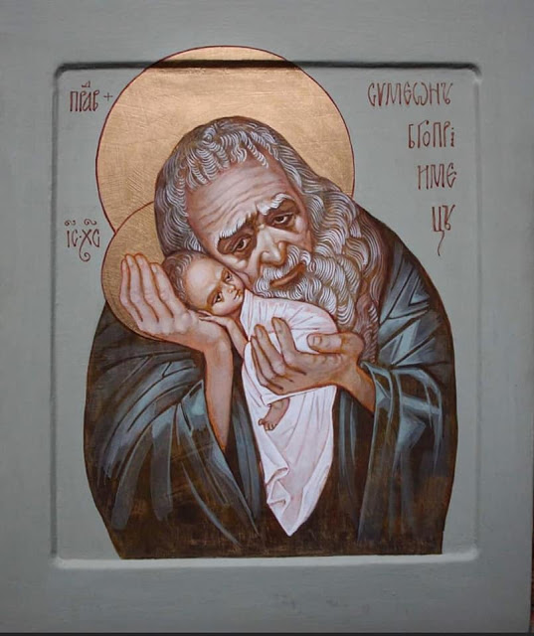
The feast of Candlemas is a time of change- the end of our celebration of Christmas, the start of our preparation for Lent and Easter.
Today we remember the presentation of Jesus in the Temple
as an infant. Today the shadow of the Cross falls onto the crib
as Mary is told that “a sword will pierce your own soul also.”

Before the service we gather as one, conscious that we are united with people all over the world in this moment and in our shared purpose, which is our shared longing to come face to face with the living God who calls us to follow him.

The Gathering
In the name of the Father, and of the Son,
and of the Holy Spirit. Amen.
The Lord be with you: and also with you.

Dear friends, forty days ago
we celebrated the birth of our Lord Jesus Christ.
Now we recall the day on which he was presented in the Temple,
when he was offered to the Father and shown to his people.
As a sign of his coming among us, his mother was purified,
as we now come to him for cleansing.
In their old age Simeon and Anna
recognized him as their Lord, as we today sing of his glory.
In this Eucharist, we celebrate both the joy of his coming
and his searching judgement,
looking back to the day of his birth
and looking forward to the coming days of his passion.

May the light and peace of Jesus Christ be with you:
and also with you.
Let us give thanks to the Lord our God.
It is right to give thanks and praise.
Blessed are you, Lord our God, King of the Universe.
You make our darkness to be light.
For with you is the well of life and in your light shall we see light.
Blessed be God for ever.
Words of welcome and introduction follow.

The Prayers of Penitence
Hear the words of our Saviour Jesus Christ:
“I am the light of the world.
Whoever follows me will never walk in darkness
but shall have the light of life.”
Let us therefore bring our sins into his light
And confess them in penitence and faith.

A time of silence is kept as we recall our sin and our need of God.

Father eternal, giver of light and grace,
we have sinned against you and against our neighbour,
in what we have thought,
in what we have said and done,
through ignorance, through weakness,
through our own deliberate fault.
We have wounded your love
and marred your image in us.
We are sorry and ashamed,
and repent of all our sins.
For the sake of your Son Jesus Christ,
who died for us,
forgive us all that is past;
and lead us out from darkness
to walk as children of light. Amen.

Lord, have mercy. Lord, have mercy.
Christ, have mercy. Christ, have mercy.
Lord, have mercy. Lord, have mercy.
The Absolution
Almighty God, who forgives all who truly repent,
have mercy upon you, pardon and deliver you from all your sins, confirm and strengthen you in all goodness,
and keep your in life eternal, through Jesus Christ our Lord. Amen.

The Gloria,
from the Mass of Villerville by Chris Merchant
Glory to God in the highest,
and peace to his people on earth.
Lord God, heavenly King, almighty God and Father,
we worship you, we give you thanks,
we praise you for your glory.
Lord Jesus Christ, only Son of the Father,
Lord God, Lamb of God,
you take away the sin of the world:
have mercy on us;
you are seated at the right hand of the Father:
receive our prayer.
For you alone are the Holy One,
you alone are the Lord,
you alone are the Most High, Jesus Christ,
with the Holy Spirit,
in the glory of God the Father. Amen.
The Collect
The Lord be with you: and also with you.
A moment of silent prayer follows.

At the end of the Collect: Amen.
The Liturgy of the Word
The Reading
This is the word of the Lord.
Thanks be to God.

The Gospel
Today the Lord is presented in the Temple
in substance of our mortal nature. Alleluia.
Today the Blessed Virgin comes to be purified
in accordance with the law. Alleluia.
Today old Simeon proclaims Christ as the light of the nations
and the glory of Israel. Alleluia. Praise to Christ, the light of the world.

Hear the Gospel of our Lord Jesus Christ according to Luke.
Glory to you, O Lord.
And at the end…
This is the Gospel of the Lord. Praise to you, O Christ.

The Sermon

The Prayers
Let us pray to the Father through Christ who is our light and life.
At the end of each section, a response is used:
Lord, in your mercy: hear our prayer.
(or) Lord, hear us: Lord, graciously hear us.

Merciful Father,
accept these prayers
for the sake of your Son,
our Saviour, Jesus Christ. Amen.
The Liturgy of the Sacrament

The Peace
The Lord be with you: and also with you.
In the tender mercy of our God,
the dayspring from on high has broken upon us,
to give light to those who dwell in darkness and the shadow of death, and to guide our feet into the way of peace.
The peace of the Lord be always with you: and also with you.

During the peace we hold out Christ’s peace to one another
with a smile, a wave or the use of Sign Language. Do please put your message in the comment box on YouTube if you’re at home.

The Preparation of the Altar
Father, in Christ there has sprung up a light for the righteous;
accept the gifts we bring before you
and grant that Christ may shine in us
to the praise and glory of your name. Amen.

Pray, my brothers and sisters,
that our sacrifice may be acceptable to God the Almighty Father.
May the Lord accept the sacrifice at your hands,
for the praise and glory of his Name,
for our good and the good of all his Church.

The Eucharistic Prayer
The Lord be with you: and also with you.
Lift up your hearts: we lift them to the Lord.
Let us give thanks to the Lord our God:
it is right to give thanks and praise.

It is indeed right and good,
always and everywhere to give you thanks and praise
through Jesus Christ, who is one with you from all eternity.
For on this day he appeared in the Temple
in substance of our flesh to come near to us in judgement.
He searches the hearts of all your people
and brings to light the image of your splendour.
Your servant Simeon acclaimed him
as the light to lighten the nations
while Anna spoke of him to all who looked for your redemption. Destined for the falling and rising of many,
he was lifted high upon the cross
and a sword of sorrow pierced his mother’s heart
when by his sacrifice he made our peace with you.
And now we rejoice and glorify your name
that we, too, have seen your salvation
and join with angels and archangels
in their unending hymn of praise:
Holy, holy, holy Lord, God of power and might,
heaven and earth are full of your glory.
Hosanna in the highest!
Blessed is he who comes in the name of the Lord.
Hosanna in the highest!

And later…
Great is the mystery of faith:
Christ has died,
Christ is risen,
Christ will come again.
The Lord’s Prayer
Believing the promises of God,
let us pray with confidence as our Saviour has taught us:
Our Father, which art in heaven,
hallowed be thy name.
Thy kingdom come, thy will be done,
on earth as it is in heaven.
Give us this day our daily bread.
And forgive us our trespasses,
as we forgive those
who trespass against us.
And lead us not into temptation,
but deliver us from evil.
For thine is the kingdom, the power
and the glory, for ever and ever. Amen.

The Fraction
We break the bread of life,
and that life is the light of the world.
God here among us,
light in the midst of us,
bring us to life and light.

Agnus Dei
Lamb of God, you take away the sin of the world, have mercy on us.
Lamb of God, you take away the sin of the world, have mercy on us.
Lamb of God, you take away the sin of the world, grant us peace.

The Invitation
Christ is the true bread which has come down from heaven. Alleluia!
Lord, give us this bread always. Alleluia!

Christ is in our midst.
He is and always will be.

The president says “The Body of Christ, broken for you”
and “The blood of Christ, shed for you” at the altar.
Those present in Church are invited to come forward
down the main aisle to receive communion, or a blessing.

The Post-Communion Prayer
Lord, your fulfilled the hope of Simeon and Anna,
who lived to welcome the Messiah:
may we,
who have received these gifts beyond words,
prepare to meet Christ Jesus
when he comes to bring us to eternal life:
for he is alive and reigns, now and for ever. Amen.

The Notices & Banns of Marriage,
after which the Christmas wreath is extinguished
the Christmas star is turned off,
and the crib is carefully emptied
We thank you God for this time of turning.
We pray that you will guide and lead us
as we turn away from Christmas celebrations,
from the coming of the one light,
from tree lights, starlight and candlelight.
As we journey towards the gathering storm,
towards the garden lantern light,
the fire light,
and then no light at all
help us to hold on to the Christmas Christ Light
and to look and watch
for the Resurrection Light to dawn.

The Blessing and the Final Hymn

The Dismissal

The Nunc Dimittis
A light to lighten the Gentiles,
and to be the glory of thy people Israel.
Lord, now lettest thou thy servant depart in peace:
according to thy word.
For mine eyes have seen: thy salvation;
which thou hast prepared: before the face of all people;
to be a light to lighten the Gentiles:
and to be the glory of thy people Israel.

Glory be to the Father, and to the Son, and to the Holy Spirit;
as it was in the beginning, is now
and ever shall be, world without end. Amen.

A light to lighten the Gentiles,
and to be the glory of thy people Israel.

The Dismissal,
as we turn our faces to the world
and towards Lent and Holy Week
Father of light, here, now, our joyous celebration
of the Saviour’s birth comes to an end.
Help us to carry him in our hearts every day.
Help us to live our lives in his light and example.

Lord Jesus, here our focus turns from your wondrous birth
to your courageous death, your tragic burial
and the unexpected dance of Easter dawn.
Help us to live as your Christmas people.
Help us to live as your Easter people.

Holy Spirit of love, fill our hearts
as we turn away from the manger to the world.
Shine in us as a light every day.
Help us to live out all we have seen and found
and sung and heard together.

Let us then go in the light and peace of Christ.
Thanks be to God.

You can text a donation to St Paul’s to 70450,
texting STPAULS5
or STPAULS10 or STPAULS20
to donate that amount of money.
Do please stay for coffee after the service if you can.
