Our Mad Life 67
The shock of sudden loss
Just after I wrote to you about our Happy New Year coronavirus struck.
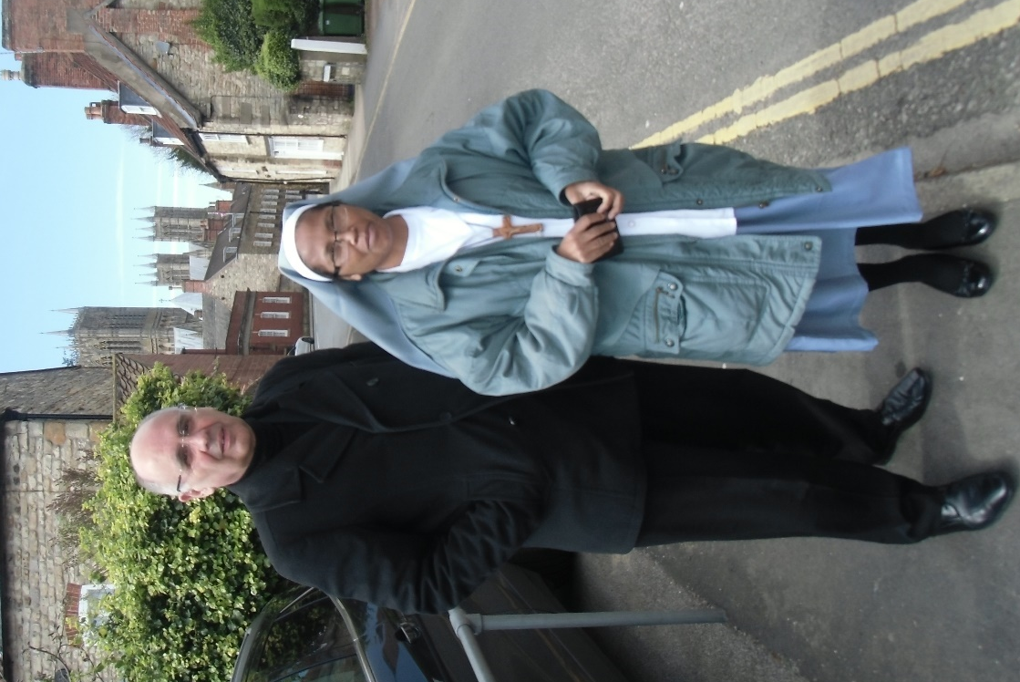
On the Monday Sister Isabelle, the devoted and dynamic leader of our Anglican Sisters, felt unwell and on Friday morning 7th January she died of Covid-19. Due to the stringent covid emergency regulations where the Sisters live, her body could not be taken to her family tomb and she had to be buried the same day in the Convent garden. Due to the immediate burial many friends including myself could not attend. Bishop Jaona of Antananarivo spent the day with the Sisters. This is a traumatic event for the Sisters and a shock for us all.
The next day the priest at Ambatoharanana, where Sarah and I used to live and where we originally set up the community, also died. His father had assisted me in the theological college and been in charge of the local parish so we had known Jean Jacques most of his life. We thank God for the lives of two people who dedicated themselves to helping others. During the pandemic Sr. Isabelle had been working full time at the health clinic, full of encouragement and compassion for all who came.

Sister Isabelle visited Lincoln Cathedral in 2018
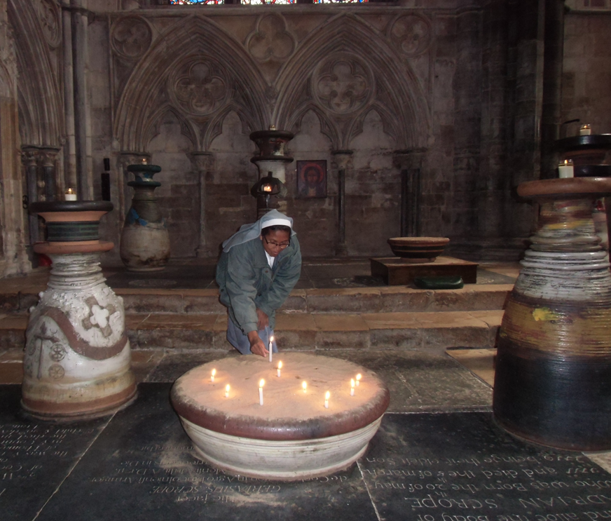
Dazed as we all are by sudden deaths the stream of life carries us forward.
With the sudden wave of covid various regulations are back in place but seem to be widely ignored here in Mahajanga after the first week. We are limited to 100 in church, supposedly socially distanced and wearing face masks. We are celebrating the Week of Prayer for Christian Unity at the moment and last night I counted over 50 in the choir which was seated in a side aisle, and the congregation far outnumbered them. We are however enthusiastic users of antiseptic hand gel. Tonight saw another choir of the same size and several hundred in church and we all used hand gel after putting our collection in the boxes at the front of church.
At the November meeting I attended in the capital the Bishop of Antananarivo asked the bishops if we could be free on 14th/15th January. This was before the election of the new bishop for Antsiranana so I guessed that this was a possible time for the consecration. In the event the election was unsuccessful and there is no new bishop of Antsiranana and won’t be for some time. So I assumed nothing was happening that involved me. Then I got a call from the Bishop of Antananarivo on the 12th asking me to be in the capital for meetings on the 14th. That meant setting off at 5.30am the next morning. Meanwhile our rains started. The journey is getting longer each day as parts of the road get swept away or buried in mud. I was booked to stay with the RC Cenacle Sisters but arrived long after everyone had gone to bed and had to spend a further half hour rousing people to unlock the gate.
At the House of Bishops’ meeting in the morning I was struggling to keep up and keep concentrating. My criticisms of inconclusive discussions must be tempered by that awareness! While on my travels I had missed an important message saying that the bishops and their wives would have an audience with the President of Madagascar in the afternoon. The Malagasy are wonderful at turning themselves out smartly and dressing up as befits the event. I look so dowdy and scruffy beside my colleagues. Besides my ‘good suit’ is safely in a cupboard in England. Covering up with a cassock was not an option. A further surprise for me, not moving in diplomatic circles, was that we would be received in the presidential palace on the edge of the city (not the old colonial residence in the city centre). Flashy cars were provided and we set off.
As one would expect there were stringent identity checks before we were admitted and then we drove into the spectacular entrance across a bridge over a Capability Brown type lake and up a straight and broad road to the outer gateway of the palace through which one could glimpse an enormous fountain playing in the centre of a huge courtyard and beyond that a great entrance complete with red carpet and soldiers. There were footmen to guide our cars to sweep round to the red carpet, one at a time, so that the car stopped precisely at the edge of the carpet. On alighting, men in what looked like eighteenth century military uniforms drew and held aloft their swords, as we made our way up the immaculate red carpet. As far as I was concerned it felt more story book than reality – the only thing missing were the trumpets! I wondered what the correct protocol was: ignore all these men, smile graciously at the individuals or just have a good look at the show!
All was designed to impress and I certainly was. Pastiche? Well on this scale it is still astonishing and quite overwhelming. We were guided along the great cavern of the entrance hall but before reaching the flight of stairs above which was a much larger-than-life size portrait of the present President we were guided right at a splendid copse of Christmas trees into a vast reception room. Here we were briefed on the protocol. The seating arrangement was explained. On reaching the end of the carpet we were to bow to the president and then take our seats. We lined up accordingly and were led to the “throne room” where in the middle was seated the President. My first reactions were, what a lonely looking figure, and, I recognise this scene from the TV news! The next surprise was the sudden appearance behind us of a battalion of photographers and journalists and security men – all keeping their distance from us. Bishop Jaona made an elegant if somewhat predictable speech wishing the President a happy and successful new year and this was seconded by Bishop Gilbert. As I looked at a gigantic mural of rice fields and mountains I thought how boring it must be for the President if he has these audiences all through January.
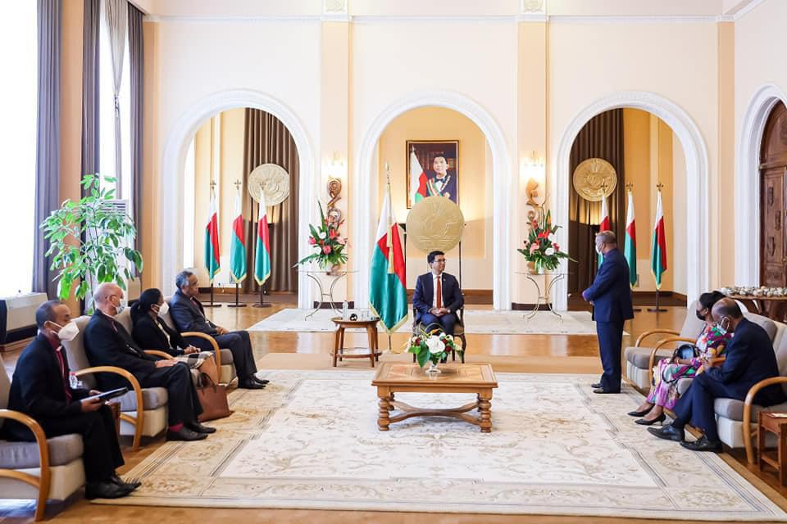
At the end he pointed to the table beside each chair and wished us a happy New Year and asked us to accept from him a bar of chocolate with a photograph of himself on the wrapper. Mine was Cocoa Nibs & Sea Salt flavour – as usual sounds better in French: éclats de fèves et fleur de sel marin. I gave the Blessing and we returned to the red carpet.
Just as we reached the steps outside the press corps again dramatically appeared blocking our exit and interviews and statements were made. We left in the usual palace style – travelling too fast with warning lights flashing as the police had cleared the main road outside for our departure. A few kilometres down the road we pulled in, switched off the warning lights and changed gear to normal again.
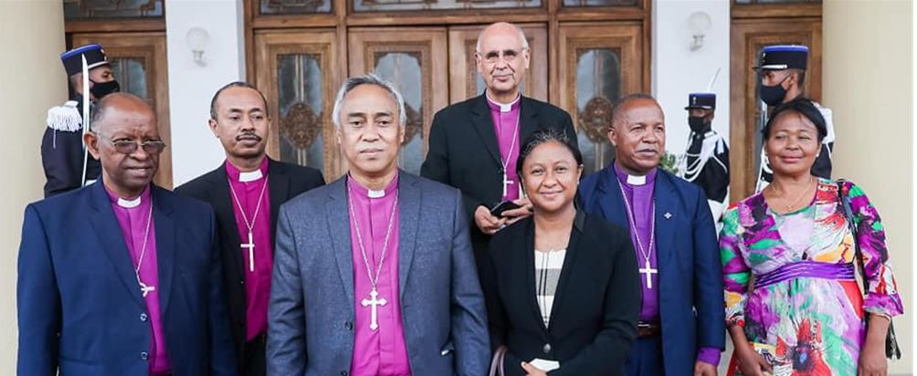
This surprisingly made the national TV news and got very considerable Facebook coverage. Great street cred but everyone has a different take on it. The young man who cuts my hair said he watched the news and realised he should have cut my hair the week before. I wouldn’t describe the event as speaking ‘truth to power’ but more a useful communication exercise for both parties.
Another night on the bus in worsening road conditions and although I rang to say I couldn’t possibly be in church for the 8.30 am service, please start without me, I arrived to find everyone had insisted on waiting almost an hour for me to arrive. It was another “Bonne Année” event and I had to be there.
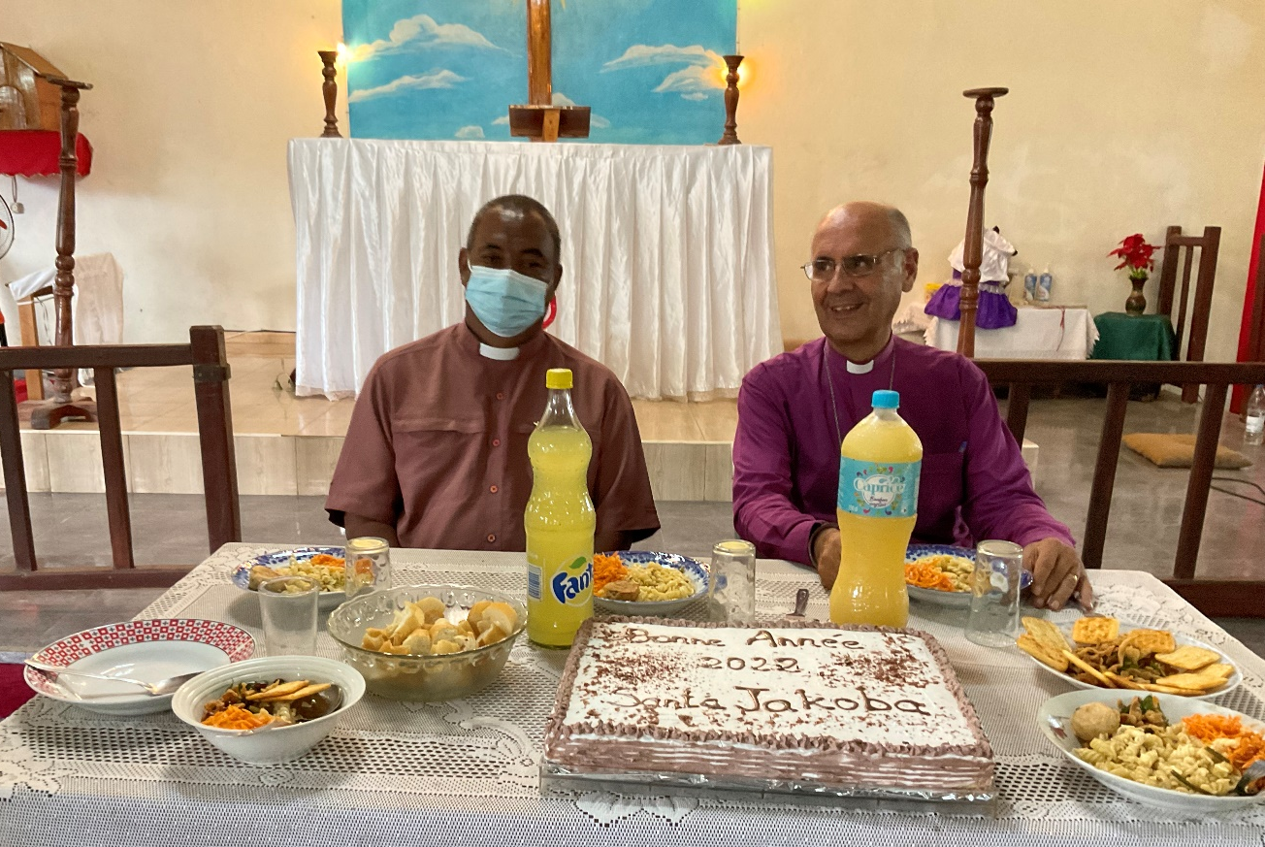

Life has been something of a rollercoaster event this year already. To add to that I am booked to leave Mahajanga on 30th January on my way to the UK.
I will leave behind a country now suffering from disastrous floods in the centre and northern parts of the island. In the capital where houses are built on steep terraces retaining walls have been collapsing and the stadium is now housing the thousands of homeless.
This comes with love, thanks and prayers.
Yours
+Hall
hallspeers@gmail.com
24 January 2022

