The Parish of St Paul, Wokingham
Diary Dates for Spring into Summer 2022

As we emerge, blinking, from restrictions back into a faintly familiar world we once knew it is a really feature of this phase that we can plan things with a reasonable hope of being allowed to do them, and can put things in the diary for us to look forward to. Here are some of the main highlights of the next few months to look forward to…

Sat 5/2 Zoom Parish Quiz 7.30pm
Email margaretanndavies@hotmail.co.uk
Always a fun evening, raising money for St Paul’s Church Restoration Fund.

Tues 8/2 Exploring the Faith Course 7.15pm?
We will be running a 6-week course thinking about the faith and exploring all and any questions you might have as a way of leading up to the Confirmation Service on the 20th of March. It would also be a good thing to come along to for anyone who just wants to recap or spend some time as we head towards Lent in thought. Please let a member of the Clergy know if you would like to find out more.

Sun 13/2 Collecting for Wokingham Foodbank
St Paul’s and St Nick’s separate their Foodbank collection from the Harvest Festival to stagger when the Foodbank receive all of their donations- so we will be collecting at the 9.30 All Together Service and then at St Nick’s at 11am.
Sun 27/2 Launch of the Parish Giving Scheme
Which is essentially a more efficient way of donating money to the parish and claiming back Gift Aid- Joshua Townson (Generous Giving Advisor) will preach at 9.30 and 11.

Tues 1/3 Visit by Bishop Steven to the Deanery
After a day spent in the Deanery, Bishop Steven will finish off with an address and questions at Luckley House School at 7.30pm- everyone is warmly invited to come along to hear our Diocesan Bishop in person, after they have finished their 6th pancake…

Wed 2/3 Ash Wednesday, the start of Lent
There will be services in the morning and the evening in the parish- the first House Mass back after lockdown at 10.30am and then a Service at St Paul’s at 8pm.

Sat 19/3 Lenten Quiet Day at Woosehill Church
The Advent Quiet Day was a huge success, and the same team are organising a Lenten one- it is the perfect way of centring and focusing in your keeping of Lent as it leads to Holy Week.

Sun 20/3 All Saints’ Confirmation Service 3.30pm
We will be hosting, supporting and joining in with the Confirmation Service by Bishop Olivia of Reading- do speak to a member of the Clergy if you would like to find out more about what it means to be confirmed and if you would like to do it.

Palm Sunday 10/4 to Easter Day 17/4
There are services every day, and for all ages, throughout this, the most special and precious week in the whole year, starting with the Palm Procession and Mass on Palm Sunday, and then the evening Service of Words and Music for Holy Week, leading through Maundy Thursday and Good Friday to services at Dawn and 9.30 and 11am on Easter Day as we celebrate the resurrection of Jesus.

Mon 25/4 APCM and AGM 8.00pm
This meeting is a key one in the life of the Church, as we elect our Wardens and hear back reports on how the last year went and what the priorities are moving forward.

Sun 5/6 Queen’s Platinum Jubilee Weekend
Details tbc, but a probable patriotic Concert in Church at 6.30pm.

Sun 3/7 Parish Events on a Sunday
We are planning to have the return of the legendary parish BBQ at lunchtime, and then to sing hymns in the Churchyard in the early evening since it was such fun last summer. Put it in your diary now!

Other special midweek Masses at 8pm…
26/5 Ascension Day: 16/6 Corpus Christi
29/6 St Peter and St Paul,
followed by Pimms in the Churchyard

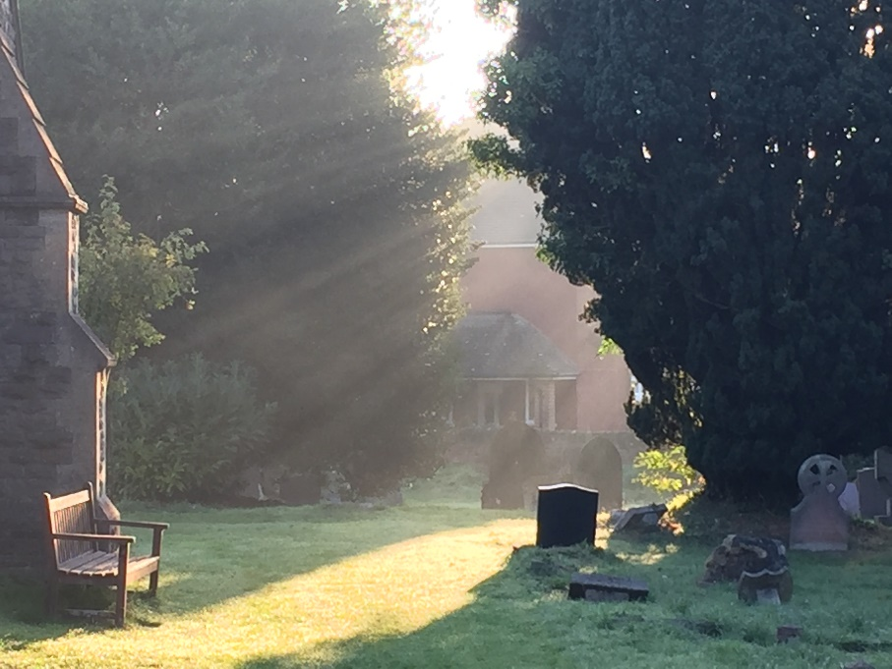

For details or information check our website or FB page, or contact Louise Cole (Parish Administrator)
church.office@spauls.co.uk 0118 979 2122

