Responding to the
Conflict in Ukraine
with Prayers for Peace

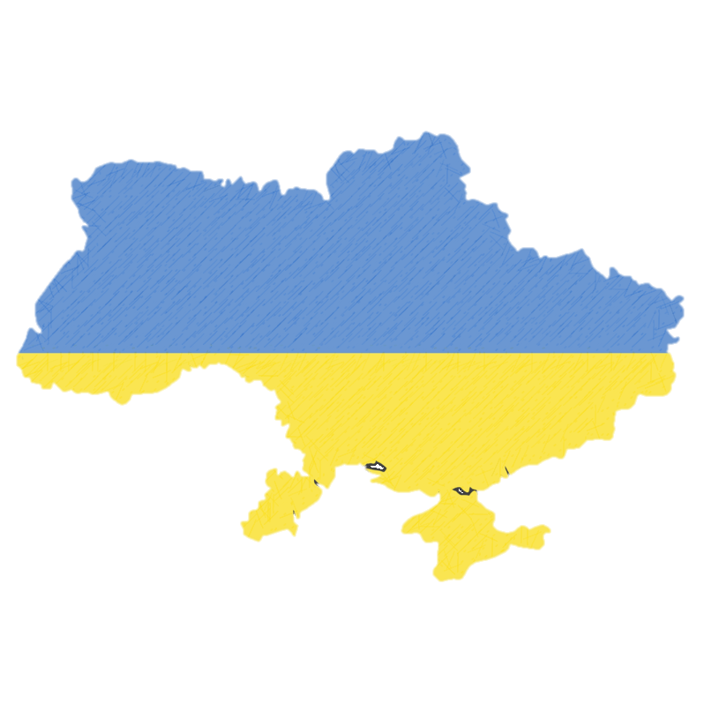
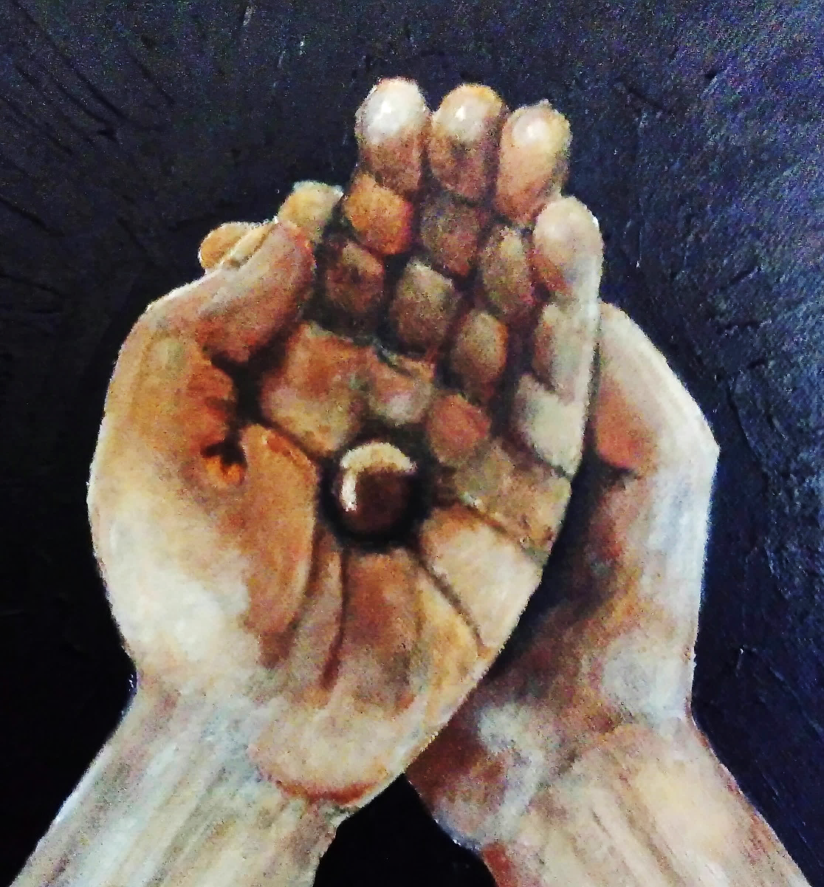

These resources have been compiled as an initial and swift response to a complex and rapidly changing situation.
This booklet may well be updated over the coming days and weeks, and suggestions for improvement are welcome. While it will remain an inadequate response to a horrifying and overwhelming crisis, it is offered in the hope that something in it may be helpful to you as you think through your own response in prayer and action.
Every blessing, as always,
Ally
Ally Barrett
College Chaplain
chaplain@caths.cam.ac.uk

Looking after ourselves and one another at Catz
St Catharine’s is an international community, so events miles away from Cambridge will impact us; we often have opportunities to try to make a difference but at other times we can feel powerless. The unfolding events in Ukraine will leave many members of the Catz community feeling anxious and afraid, and in need of extra kindness. This is something that we can all offer one another.
The Health and Wellbeing Team is available to support anyone for whom the events in Ukraine are particularly distressing. Please email us if you need support yourself or if you are worried about someone you are supporting: welfare.team@caths.cam.ac.uk.
If you are feeling overwhelmed by the news and commentary about the conflict, it may be helpful to identify and focus on a small number of trustworthy sources of information. It’s OK to find a balance between engaging with what is happening and looking after your mental wellbeing. Doing something practical in response to the crisis may also help: this might include writing to your MP, making a donation, or reaching out to a friend who is personally affected.
Donations
You may wish to contribute financially to humanitarian responses to the conflict (if you are able to do so - not everyone can). Various national and international charities have set up specific funds including the Red Cross, Unicef, and the UN Refugee Agency (and many more).
Care for Refugees
You may wish to write to our local Cambridge MP, Daniel Zeichner (daniel@danielzeichner.co.uk), to encourage him to support policies that will make the UK as hospitable as possible both to refugees escaping Ukraine and to Ukranian citizens already living, working or studying in the UK, as well as ways that the UK can contribute financially to the support for refugees being offered by some of Ukraine’s closer neighbours.

How should we pray about the situation in Ukraine?
We may struggle to find the ‘right’ words for prayer; be assured that God hears the inarticulate thoughts of our hearts as well as those things we have found the words for, though there are some suggested prayers later in this booklet. Scripture is also full of examples of God’s people crying out in anger at the suffering they experience and witness in the world; we, too, are encouraged to offer God our sorrow and anger as well as our requests.
We may wish to include in our prayers:
- those who are injured or bereaved, who have lost their home or fled their homeland; those who are far from and afraid for their loved ones;
- peace and justice in Ukraine and all places of conflict and violence;
- wisdom and courage for the leaders of the nations and all whose decisions will have significant repercussions in Ukraine and beyond;
- a cessation of violence and the protection of human life;
- those who are offering humanitarian aid, and churches and other organisations in Ukraine who are supporting their local communities;
- those working to gather and share news and information, that truth may prevail and be a force for good, and that those who are speaking the truth would be protected from harm;
- those who are ashamed of their own nation’s actions or inactions.

A Day of Prayer and Fasting
The Pope has called for a day of prayer for peace (and for those whose mental and physical health allows it, a day of fasting) on Ash Wednesday, and the Church of England, together with many other major denominations in the UK and around the world, is supporting this call.
This is an opportunity to focus our attention during Lent on the needs of the world, and our own responses to the world’s brokenness. Prayer and fasting are just part of our response to the suffering of humanity and of all creation; we are also called to be peace-makers and active agents of God’s kingdom in the world, through our words and our actions.
If you are wondering about taking part in this day of prayer and fasting, and would like to talk about what this might mean in practice, please do contact the Chaplain: chaplain@caths.cam.ac.uk. Fasting is a broad term that covers a range of practices. It is not necessarily healthy for everyone (physically, mentally or spiritually); please seek advice if you are not sure whether it is suitable for you.
From the Church of England Archbishops of Canterbury and York
God of peace and justice,
we pray for the people of Ukraine today.
We pray for peace and the laying down of weapons.
We pray for all those who fear for tomorrow,
that your Spirit of comfort would draw near to them.
We pray for those with power over war and peace,
for wisdom, discernment and compassion to guide their decisions.
Above all, we pray for all your precious children, at risk and in fear,
that you would hold and protect them.
We pray in the name of Jesus, the Prince of Peace. Amen.

A prayer from the United Reformed Church
God of all, with alarm and concern we bring before you
the military intervention in Ukraine.
In a world you made for peace and flourishing,
we lament the use of armed force.
We mourn every casualty of this conflict,
every precious life extinguished by war.
We pray comfort for those who grieve and those who are fearful.
Hear our longing that leaders and nations will honour the worth of all people
by having the courage to resolve conflict through dialogue.
May all our human failings be transformed
by your wonderful grace and goodness.
We ask this in the name of Christ,
the author of peace and sustainer of Creation. Amen.

Three prayers from Night Songs, asking for God’s protection

Lighten our darkness, we beseech thee, O Lord; and by thy great mercy defend us from all perils and dangers of this night; for the love of thy only Son, our Saviour, Jesus Christ. Amen.

Keep watch, dear Lord, with those who work, or watch, or weep this night, and give your angels charge over those who sleep. Tend the sick, Lord Christ; give rest to the weary, bless the dying, soothe the suffering, pity the afflicted; and all for your love's sake. Amen.

Be present, O merciful God, and protect us through the silent hours of this night,
so that we who are wearied by the changes and chances of this fleeting world
may repose upon thy eternal changelessness; through Jesus Christ our Lord. Amen.

A prayer from the Methodist Church
Holy and Gracious God
We pray for the people of the Ukraine and the people of Russia;
for their countries and their leaders.
We pray for all those who are afraid;
that your everlasting arms hold them in this time of great fear.
We pray for all those who have the power over life and death; that they will choose for all people life, and life in all its fullness.
We pray for those who choose war; that they will remember that you direct your people to turn our swords into ploughshares and seek for peace.
We pray for leaders on the world stage;
that they are inspired by the wisdom and courage of Christ.
Above all, Lord, today we pray for peace for Ukraine.
And we ask this in the name of your blessed Son. Lord have mercy. Amen.

This following was shared by Ely Cathedral: the prayers were translated into their native language by two Ukranian year 10 pupils from King’s School, Ely.

Two hymns for troubled times
(for personal reflection)

O God of all salvation
In every darkened hour
Look down at your creation
With pity and with power.
In all the pain we’re seeing,
For stranger as for friend
We’ll cling with all our being
To love that cannot end.

O God, your loving passion
Is deeper than our pain,
Look down, and in compassion
Bring us to life again.
When we are found despairing,
When all seems lost to sin,
We’ll hear your voice declaring
That love alone will win.

O God, when hate grows stronger,
With fear to pave its way,
The cry, ‘Lord, how much longer?’
With broken hearts we pray.
In all that is dismaying
In humankind’s freewill,
We’ll join our voices, praying
That love will triumph still.

O God, whose love will never
Be silenced, stalled or stilled,
Set us to work wherever
There’re bridges to rebuild.
We’ll take our life’s vocation
To make, like heav’n above,
In this and every nation
A kingdom built on love.
Tune: King's Lynn
or The Passion Chorale
or any suitable 7676D tune

Hope for the world's despair
We feel the nations' pain
Can anything repair
This broken earth again?
For this we pray
in every place
a spark of grace to light the way.

Wisdom for all who bear
The future in their hand
Entrusted with the care
Of this and every land.
When comes the hour
O Lord, we pray
inspire the way
we spend our power.

Honour for all who've paid
War's painful, bitter price
When duty called they made
The greatest sacrifice.
Their memory
will never cease
to cry for peace
and harmony.
Ease for the troubled mind
In endless conflict caught
Each soul that cannot find
The peace beyond all thought.
May they be blessed
with healing balm
for inner calm
and perfect rest.

Love for the human heart
When hate grows from our fears
And inwardly we start
To turn our ploughs to spears.
Help us to sow
love's precious seed
in word and deed that peace may grow.

Tune: Love Unknown
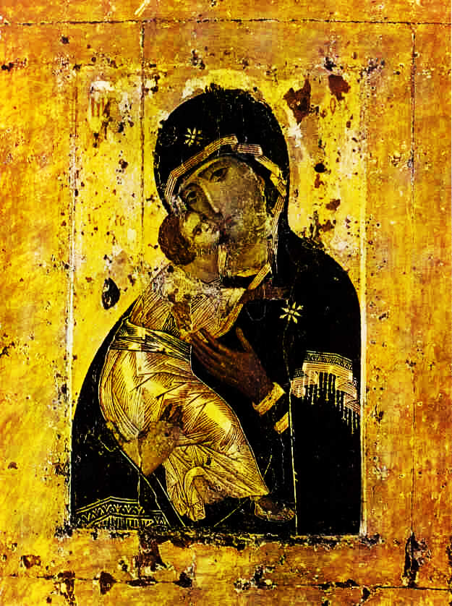
The Virgin of Kyiv is an icon originally dating from 1132 and was written in Constantinople for the Kyiv royal family. It was removed by Prince Andrei around the 1160s before his destruction of Kyiv as he struggled to unite the territories under his rule of parts of what would become Russia.
It is significant for the sense of care that is evident in the face of the virgin, and as an early example of the Christ child snuggled in to his mother. This style is known as Eleusa (tenderness or showing mercy) and was then unusual by the icon writing protocols of the Byzantine traditions.
Mary, tender mother of mercy,
we pray with you for the peace of Kyiv.

