The Parish Church of
St. Paul, Wokingham



The Liturgy of
Ash Wednesday

“The sacrifice of God is a broken spirit: a broken and contrite heart, O God, thou wilt not despise.”
Psalm 51.17
The Gathering

At the entry of the procession we stand and a hymn is sung.
We remain standing as the celebrant says
In the name of the Father, and of the Son,
and of the Holy Spirit. Amen.

The Greeting

Grace, mercy and peace from God our Father
and the Lord Jesus Christ be with you: and also with you.

Words of welcome and an introduction follow.

The Collect
The Lord be with you: and also with you.
Let us pray for grace to keep Lent faithfully.
A moment of silent prayer follows.

Almighty and everlasting God,
you hate nothing you have made
and forgive the sins of all who are penitent:
Create and make in us new and contrite hearts,
that we, worthily lamenting our sins
and acknowledging our wretchedness,
may obtain of you, the God of all mercy,
perfect remission and forgiveness;
through Jesus Christ our Lord, who lives and reigns
with you and the Holy Spirit, one God, for ever and ever. Amen.

The Liturgy of the Word
The Reading
We sit for the reading from the Old or New Testament.
This is the word of the Lord. Thanks be to God.

The Antiphon Ad te levavi (“To you, I lift up my soul”) is sung.

Gospel Reading
Please stand and face the Gospel procession,
which represents the presence of Christ in our midst.

When the Gospel is announced Glory to you, O Lord.

At the end of the Gospel reading Praise to you, O Christ.

The Sermon

The Liturgy of Penitence

Let us now call to mind our sin and the infinite mercy of God.

The Litany follows:
God the Father, have mercy on us.
God the Son, have mercy on us.
God the Holy Spirit, have mercy on us.
Holy, blessed and glorious Trinity, have mercy on us.

From all evil and mischief;
from pride, vanity, and hypocrisy;
from envy, hatred, and malice; and from all evil intent,
Good Lord, deliver us.
A number of petitions follow, all with the response
Good Lord, deliver us.

The Litany concludes
Give us true repentance;
forgive us our sins of negligence and ignorance
and our deliberate sins;
and grant us the grace of your Holy Spirit
to amend our lives according to your holy word.
Holy God, holy and strong,
holy and immortal, have mercy upon us.

After a period of silence
Make our hearts clean, O God;
and renew a right spirit within us.

Father eternal, giver of light and grace,
we have sinned against you and against our neighbour, in what we have thought, in what we have said
and done, and in the good we have not done,
through ignorance, through weakness,
through our own deliberate fault.
We have wounded your love,
and marred your image in us.
We are sorry and ashamed, and repent of all our sins.
For the sake of your Son Jesus Christ,
who died for us, forgive us all that is past;
and lead us out from darkness
to walk as children of light. Amen.

The Imposition of Ashes
The Ashes are blessed and the Priest invites us to come forward
and receive the ashes on our foreheads as a sign of our penitence.
The Choir sing while the ashes are imposed.

Dear friends in Christ,
I invite you to receive these ashes as a sign of the spirit
of penitence with which we shall keep this season of Lent.

God our Father,
you create us from the dust of the earth:
bless these ashes that they may be for us
a sign of our penitence and a symbol of our mortality;
for it is by your grace alone that we receive eternal life
in Jesus Christ our Saviour. Amen.

Remember that you are dust and to dust you shall return.
Turn away from sin and be faithful to Christ.

Once all have received Ashes the Priest prays:
God our Father,
the strength of all who put their trust in you,
mercifully accept our prayers;
and because, in our weakness,
we can do nothing good without you,
grant us the help of your grace,
that in keeping your commandments we may please you,
both in will and deed;
through Jesus Christ our Lord. Amen.

The Liturgy of the Sacrament

The Peace
Since we are justified by faith,
we have peace with God through our Lord Jesus Christ,
who has given us access to his grace.

The peace of the Lord be always with you: and also with you.

The Preparation of the Gifts
A hymn is sung and the gifts of bread and wine are brought to the altar on behalf of the congregation.
Pray my brothers and sisters, that our sacrifice may be acceptable to God the almighty Father.
May the Lord accept the sacrifice at your hands,
for the praise and glory of his Name,
for our good and the good of all his church.

Lord, help us to resist temptation
by our Lenten works of charity and penance.
By this sacrifice may we be prepared to celebrate
the death and resurrection of Christ our Saviour
and be cleansed from sin and renewed in spirit.
Through Jesus Christ our Lord. Amen.

The Eucharistic Prayer
[We remain standing for the whole prayer, unless unable to do so.]
The Lord be with you: and also with you.

Lift up your hearts. We lift them to the Lord.

Let us give thanks to the Lord our God.
It is right to give our thanks and praise.

The priest says the Eucharistic Preface,
reminding us of God’s grace and actions. Then we sing together
Holy, holy, holy Lord, God of power and might
Heaven and earth are full of your glory.
Hosanna in the highest!

+ Blessed is he who comes in the name of the Lord.
Hosanna in the highest!

We praise and bless you, loving Father,
through Jesus Christ, our Lord;
and as we obey his command, send your Holy Spirit,
that broken bread and wine outpoured
may be for us the body and blood of your dear Son.

On the night before he died he had supper with his friends
and, taking bread, he praised you.
He broke the bread, gave it to them and said:
Take, eat; this is my body which is given for you;
do this in remembrance of me.

When supper was ended he took the cup of wine.
Again he praised you, gave it to them and said:
Drink this, all of you; this is my blood of the new covenant,
which is shed for you and for many for the forgiveness of sins.
Do this, as often as you drink it, in remembrance of me.
So, Father, we remember all that Jesus did,
in him we plead with confidence his sacrifice
made once for all upon the cross.
Bringing before you the bread of life and cup of salvation,
we proclaim his death and resurrection
until he comes in glory.

Praise to you, Lord Jesus!
Dying you destroyed our death!
Rising you restored our life!
Lord Jesus, come in glory!

…through Christ, and with Christ, and in Christ,
in the unity of the Holy Spirit, all honour and glory are yours, O loving Father, for ever and ever. Amen.

We sit or kneel.
The Greater Silence follows as we reflect on all we have heard
and on what we are about to receive, God himself in bread and wine.

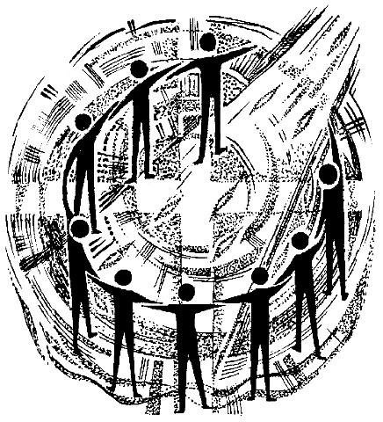

The Lord's Prayer
Lord Jesus, remember us in your Kingdom and teach us to pray
Our Father, who art in heaven,
hallowed be thy Name;
thy kingdom come; thy will be done,
on earth as it is in heaven.
Give us this day our daily bread.
And forgive us our trespasses,
as we forgive those who trespass against us.
And lead us not into temptation;
but deliver us from evil.
For thine is the kingdom, the power and the glory,
for ever and ever. Amen.

The Breaking of the Bread
The Celebrant breaks the consecrated bread.

Every time we eat this bread and drink this cup
we proclaim the Lord's death until he comes.

The Agnus Dei
Lamb of God, you take away the sin of the world,
have mercy on us.
Lamb of God, you take away the sin of the world,
have mercy on us.
Lamb of God, you take away the sin of the world,
grant us peace.

The Invitation to Communion

This is the Lamb of God who takes away the sin of the world.
Blessed are those who are called to his supper.
Lord, I am not worthy to receive you,
but only say the word and I shall be healed.

The president and people receive communion.
If you normally receive communion in your own church,
or if you have been baptised, then you are welcome to receive communion here because Christ’s invitation is to all.
If you would prefer to receive a blessing,
please come forward with everyone else holding this order of service.
If you are unable to come to the altar rail,
please tell one of the sidespeople.
Please join in the singing of the hymn during communion-
the hymn number is on the board on the pillars.

Post Communion Prayer
We stand. The Celebrant prays the Post Communion prayer.

God of our pilgrimage,
you have fed us with the bread of heaven.
Refresh and sustain us as we go forward on our journey,
in the name of Jesus Christ our Lord. Amen.

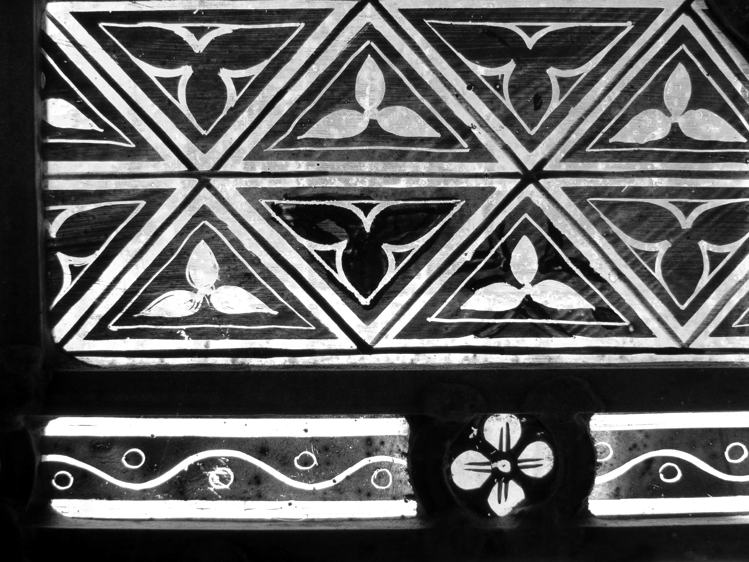

The Dismissal
The Blessing
We stand and bow our heads.
The Lord be with you: and also with you.

May God the Father,
who does not despise the broken spirit,
give to you a contrite heart. Amen.

May Christ,
who bore our sins in his body on the tree,
heal you by his wounds. Amen.

May the Holy Spirit,
who leads us into all truth,
speak to you words of pardon and peace. Amen.

And the blessing of God almighty,
the Father, the Son, and the Holy Spirit,
be among you, and remain with you always. Amen.

A recessional hymn is sung. As the procession reaches the west end
of the Church, we turn to face the door and the world.

The Dismissal Gospel

The Mass is ended. Go in peace to love and serve the Lord.
In the name of Christ. Amen!

The Organ Voluntary is part of our offering of worship.
Please pray during it and enjoy the stillness, or leave Church quietly if you need to. If this is one of your first visits to St Paul’s,
please introduce yourself to one of the Clergy
who would be delighted to have a chat.
The Call to Keep a Godly and faithful Lent
Brothers and sisters in Christ: since early days Christians have observed with great devotion the time of our Lord's passion and resurrection and prepared for this by a season of penitence and fasting. By carefully keeping these days, Christians take to heart the call to repentance and the assurance of forgiveness proclaimed in the gospel, and so grow in faith and in devotion to our Lord. I invite you, therefore, in the name of the Church, to the observance of a holy Lent, by self- examination and repentance; by prayer, fasting, and self- denial; and by reading and meditating on God's holy word.

Two Prayers of Reflection
We do not presume to come to this your table,
merciful Lord, trusting in our own righteousness,
but in your manifold and great mercies.
We are not worthy so much as to gather up the crumbs
under your table. But you are the same Lord
whose nature is always to have mercy.
Grant us therefore, gracious Lord, so to eat the flesh
of your dear Son Jesus Christ and to drink his blood,
that our sinful bodies may be made clean by his body
and our souls washed through his most precious blood,
and that we may evermore dwell in him, and he in us. Amen.
Prayer of Humble Access

Father in Heaven,
protect us in our struggle against evil.
As we begin the discipline of Lent,
make this season holy by our self-denial.
Grant this through our Lord Jesus Christ
who lives and reigns with you and the Holy Spirit
one God, for ever and ever.
Roman Catholic Opening Collect for Ash Wednesday

