St Paul’s Church, Wokingham

Jesus healing the woman
with a haemorrhage
and raising the daughter of Jairus, by Julia Stankova

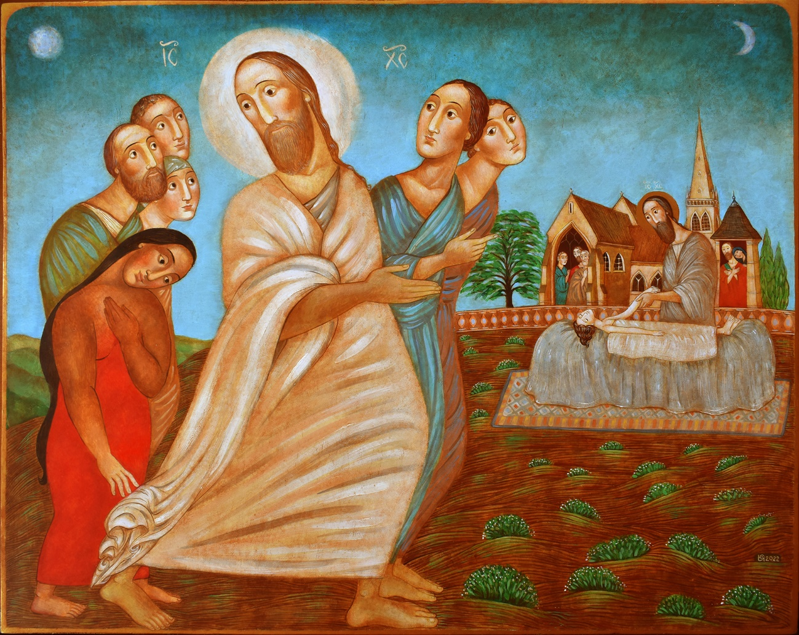

Icon commissioned by the parish to remember the long, difficult months of the pandemic, and the outpouring of community and love which it inspired, and also the repair of the building after the arson attack of Passiontide 2021

Extract from Sermon at the 9.30 Mass on Sunday
the 27th of June 2021 when this reading is set,
by the Rector, Richard Lamey

Imagine.
A bench, looking out over hills which crash like tired waves onto the valley floor below. The air, dry. The hour, early, before the sun has fully hit its stride. The vegetation, pale, dusty.
Two people meet at the bench, two women, by appointment, by arrangement. They meet regularly but not often, because they are both busy, now - but they meet because sometimes it is good to not be a celebrity. Sometimes it’s good to just be you, sometimes it’s good to talk to someone who gets it, who was there, who met him too and whose life also was utterly transformed. There was before, the old life. And then there was after, a solid line, the turn of a page, a definite moment: a touch, a smile, heart talking to heart.
Sometimes it’s good to sit with someone who looked in his face and met his eyes and saw hope dance and stars spiral into galaxies and knew love stretching back to a moment before anything and forward to the ending of time, holding every thing with love to spare.
Sometimes it’s good not to have to tell the story again, joyous though the story is. Sometimes it’s good not to have to remember the before, the long years of agony and the quiet sorrow of sinking into the grave, the road you were on before love touched you, or you touched love, or love took your hand.
And sometimes it’s good to remember, to dwell on it, to ensure that every moment and glance and breath is captured and recorded in a memory so real that you barely need to close your eyes to be back there, with him.
So they meet, and embrace, and smile, and sit, holding hands on the bench - her right hand which stretched out to steal healing from the hem of a cloak as it strode past her, bending low among the eddies of rush and bustle out of a hope more desperate than she’d even realised- and her left hand which he gently took as he lifted her from the sick bed which had become her death bed and back to life –
Talitha cum.
The Background of the Icon
The subject of the icon is Jesus healing the woman with a haemorrhage which is found in all three of the Synoptic Gospels - Matthew 9:20–22, Mark 5:25–34, Luke 8:43–48. It is a miracle which has been very much on our mind over the last years and one which is not regularly seen in icons, adding to its challenge and invitation. The healing of this woman, after long years of pain, endurance and courage, forms a complimentary and inspiring pair with the healing of Jairus’ daughter - they belong together in the Gospel and they belong together in the icon.

God placed the story at the heart of the congregation as we rebounded from the arson attack. In June 2021 I came into Church and found a woman I did not know sobbing at the altar rail. I sat and we talked and we prayed. She was facing surgery for fibroids which had been limiting her life for 7 years. Her coming to Jesus in prayer in St Paul’s on that day, only a week before the set Sunday Gospel was this reading, seemed and seems a clear and wonderful prompting of the Holy Spirit.

We might also enter the healing as a way of engaging with the Church’s frequently unjust treatment of individuals and groups on account of their gender, race, disability, age and sexuality. This story, in particular, focuses on the absolute and unconditional welcome Jesus freely offers to women in a society which did not. It is a story which helps us to give thanks for the determination and faith of those who have suffered injustice and still keep coming back to a God who longs for us all to be whole. It is a healing miracle which always feels precious and important, especially amid the ongoing impact of Covid, calling us back to Jesus who longs and works for the healing of the world and of each and every one of us.

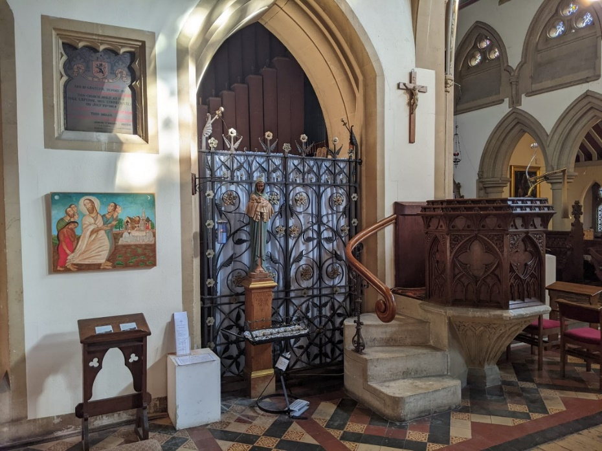

The Reading (NRSV): Luke 8.40-56
When Jesus returned, the crowd welcomed him, for they were all waiting for him. Just then there came a man named Jairus, a leader of the synagogue. He fell at Jesus’ feet and begged him to come to his house, for he had an only daughter, about twelve years old, who was dying.
As he went, the crowds pressed in on him.
Now there was a woman who had been suffering from haemorrhages for twelve years; and though she had spent all she had on physicians, no one could cure her. She came up behind him and touched the fringe of his clothes, and immediately her haemorrhage stopped.
Then Jesus asked, “Who touched me?” When all denied it, Peter said, “Master, the crowds surround you and press in on you.” But Jesus said, “Someone touched me; for I noticed that power had gone out from me.”
When the woman saw that she could not remain hidden, she came trembling; and falling down before him, she declared in the presence of all the people why she had touched him, and how she had been immediately healed.
He said to her, “Daughter, your faith has made you well; go in peace.”
While he was still speaking, someone came from the leader’s house to say, “Your daughter is dead; do not trouble the teacher any longer.” When Jesus heard this, he replied, “Do not fear. Only believe, and she will be saved.”
When he came to the house, he did not allow anyone to enter with him, except Peter, John, and James, and the child’s father and mother. They were all weeping and wailing for her; but he said, “Do not weep; for she is not dead but sleeping.” And they laughed at him, knowing that she was dead.
But he took her by the hand and called out, “Child, get up!” Her spirit returned, and she got up at once. Then he directed them to give her something to eat. Her parents were astounded; but he ordered them to tell no one what had happened.

