The Parish of Wokingham, St Paul
with St Nicholas and Woosehill Church
invites you,
as part of your Lenten journey
towards Good Friday,
to join a
Quiet Day
beginning with Holy Communion and exploring
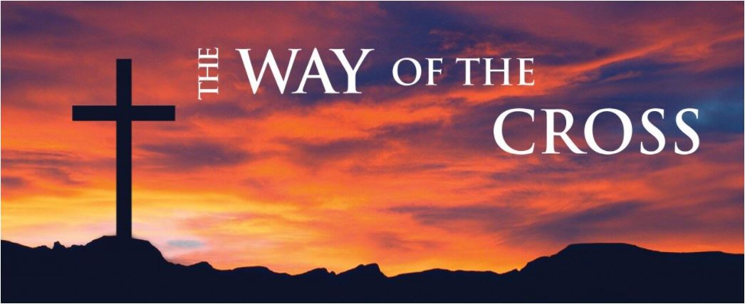

Saturday 19th March 2022
11.00-16.30
at Woosehill Church
32 Chestnut Ave, Wokingham RG41 3RS
Enquiries or to book, email mary.cassidy@spauls.org.uk

