The Parish of Wokingham, St Paul
with St Nicholas and Woosehill Church
Welcome to our
Quiet Day
exploring
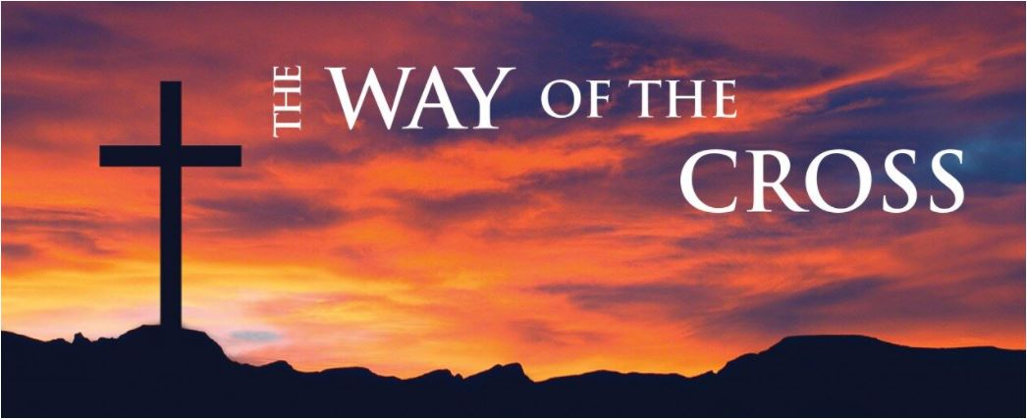

under the guidance of the Revd Jane Kraft
Saturday 19th March 2022
11.00-16.30
at Woosehill Church
32 Chestnut Ave, Wokingham RG41 3RS

Prayer Stations offering points of focus

“This is my body which is given for you”
(The Altar)
Reflection on the Last Supper

“My Father if this cannot pass unless I drink it, your will be done”
Christ’s agony in the Garden of Gethsemane -
darkness and light

“They brought Jesus to the place called Golgotha …and they crucified Him”
Crosses
Crucifixion
Nails

“Take up your cross and follow me”
The Way

Creativity resources
(Ground floor, next to the kitchen)
Colouring, collage, drawing or other creative expressions of prayer and reflection
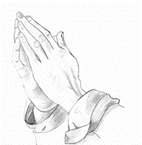
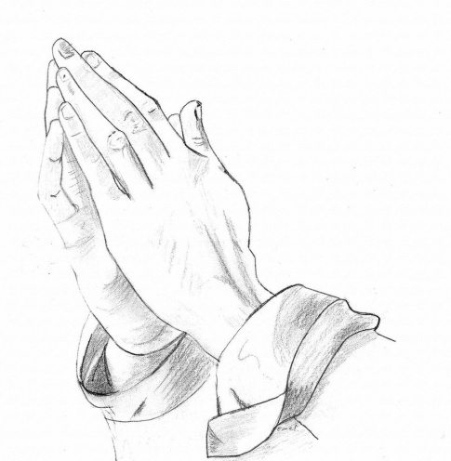

PROGRAMME FOR THE DAY
11.00 |  | Hot drinks on arrival
11.15 |  | Holy Communion and address, leading into
 |  | Silence, prayerful activities and reflection
13.15 |  | Lunch. Hot drinks available in the kitchen  (One upstairs room and the church will remain in silence, quiet conversation may take place in the “Creative station” room or outdoors)
14.00 |  | Second address (in the church). Thereafter  free to sit quietly, continue activities, walk etc
15.45 | 16.15 | Closing “plenary” – coming out of silence, anything to share; Final prayer
16.15 |  | Tidy up before cleaning takes place  Please complete and return a Feedback form.

Jesus said,
‘If any want to become my followers, let them deny themselves and take up their cross and follow me.
For those who want to save their life will lose it, and those who lose their life for my sake will find it’. ~ Matthew 16.24

Lord, you accepted your cross and began your final journey; it had to be done.
May I accept my cross,
understanding that my journey cannot be made without it.
O Saviour of the world, by your cross and precious blood you have redeemed us; save us, and help us, we humbly beseech you, O Lord.

Living Christ, for our sake you laid aside your power and glory and took on our humanity, to live in poverty here on earth and to suffer death upon the cross. Teach us the lesson of your humility
and empty our lives of all pride and selfishness.
O Saviour of the world, by your cross and precious blood you have redeemed us; save us, and help us, we humbly beseech you, O Lord.

Loving Saviour, as we draw near to you under the shadow of the cross,
give us a new understanding of your sorrow over us,
true repentance for our sins for which you suffered,
and an ever deeper gratitude for your redeeming love.
O Saviour of the world, by your cross and precious blood you have redeemed us; save us, and help us, we humbly beseech you, O Lord.

Redeemer Lord,
You gave yourself for me upon the cross.
I now give myself to you
All that I have
All that I am
All that I hope to be.
O Saviour of the world, by your cross and precious blood you have redeemed us; save us, and help us, we humbly beseech you, O Lord.

