Ladies’ Air Race 1931

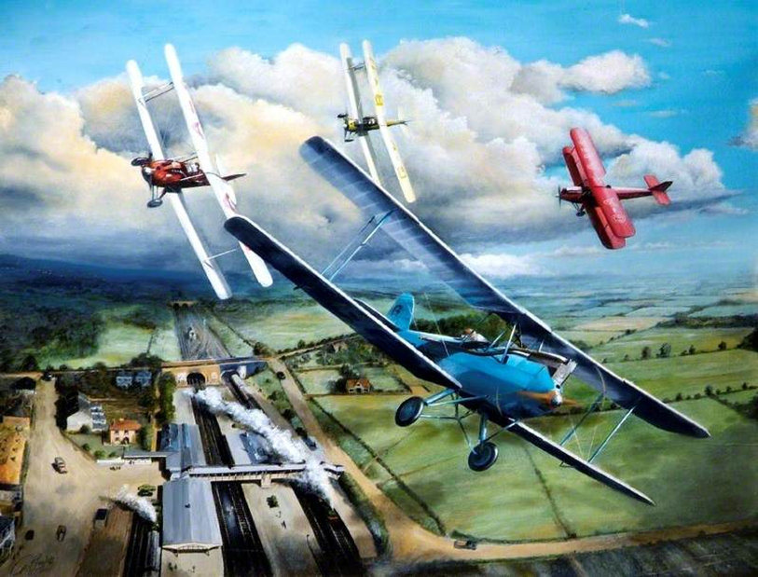

A ladies’ air race was held on May 16th 1931, the official opening day of Woodley Aero Club. The course was –Start Woodley Aerodrome, round the spire of St. Paul’s Church, on to Twyford Station then return to the starting place. Three of the eight competitors were Wokingham’s pilot and navigator Winifred Spooner; her good friend Amy Johnson, who was the first woman to fly solo from England to Australia in 1930, and Pauline Gower who later established the women's section in the Air Transport Authority that was responsible for ferrying military aircraft from factory to air force bases during the Second World War.

Artist Geoff Becket’s painting, Ladies Race shows the planes flying over Twyford Railway Station. (He gave me permission to use his painting provided his name was mentioned.)

Jim Bell

