Our Mad Life 68
Winter and I have arrived
Greetings from Mahajanga. Last night after Evening Prayer the Archdeacon said to me, “Winter has arrived.” I wondered if I had heard correctly as it was 6.45 pm and the temperature was still over 30C. He is now well accustomed to my uncomprehending look when I don’t follow what he is saying so he followed it up with, “It’s pitch dark already”. The days are indeed noticeably shortening but I certainly wouldn’t describe living at this temperature as ‘winter’.

No sooner had Sarah informed you that I was safely back and out of quarantine than the government decided to end quarantine except for those who prove covid positive at the airport.
My flight from London to Paris was uneventful, especially since I was out for the count some of the time having left Lincolnshire at 2 am. The reduced numbers of those travelling made the transit at Paris straight forward with lots of friendly staff giving directions. I still resent getting off an aircraft and immediately having to go through security having just done so before boarding. How could I have acquired anything illegal in the air? Such is the life of travellers these days.

It was a great relief to touch down in Madagascar at 11.30 pm. Next came the inevitable passport check which was all done in a friendly and pleasant way. However, I then had to join a queue for my next PCR test. I was number 301 in the queue. It was 3 am by the time my number was called. No wonder it was slow as there must have been lots of people like me who did not have the dates and places and type of my covid vaccinations and boosters instantly to hand. Being in quarantine I had to travel into the city to my hotel by the provided official taxi costing 80,000 ariary. My taxi-driver told me that he got 40,000 ariary of that. The fare from Antananarivo to Mahajanga was 40,000 ariary for over 550 kms.

The Sakamanga (Blue Cat) hotel I was delighted to find unchanged since my last quarantine visit. From my window I could glimpse the swimming pool where the cock pheasant still toured the tables of the diners and the black parrot could still be heard squawking demands to the staff. Since I was strictly warned not to leave my room day one of quarantine was definitely a “Pyjama day”. Early that evening my bedroom telephone rang and a voice announced in very clear English, “You are free” – no prosaic mention of covid or negativity!

So once more the next night was spent on the overnight bus to Mahajanga discovering how much damage the cyclonic rains had done to the road. Suffice it to say that the journey took an extra four hours as we negotiated rough ground where the surface had been washed away.

Emilienne, whom I had left in charge of Bishop’s House, was on the look-out for my arrival so I was warmly greeted as I unloaded the tuctuc. As we arrived at the top of the stairs to our apartment, I was aghast to see that the bedroom floors had wall to wall mattresses! Had she moved in her entire extended family in my absence?!

It was then revealed that I had thirty ladies in residence. The Mothers’ Union members from the southern half of the diocese were in town for their annual Lady Day celebrations. I certainly felt back in the thick of it. Unlike their English sisters the MU members here take it as read that if you have a meeting of mothers you therefore have children. I never discovered how many children were in residence as, unlike their mothers, they were very quiet and unobtrusive. The upside of this was the catering. I didn’t have to worry about lunch but simply join the ladies at the cathedral.
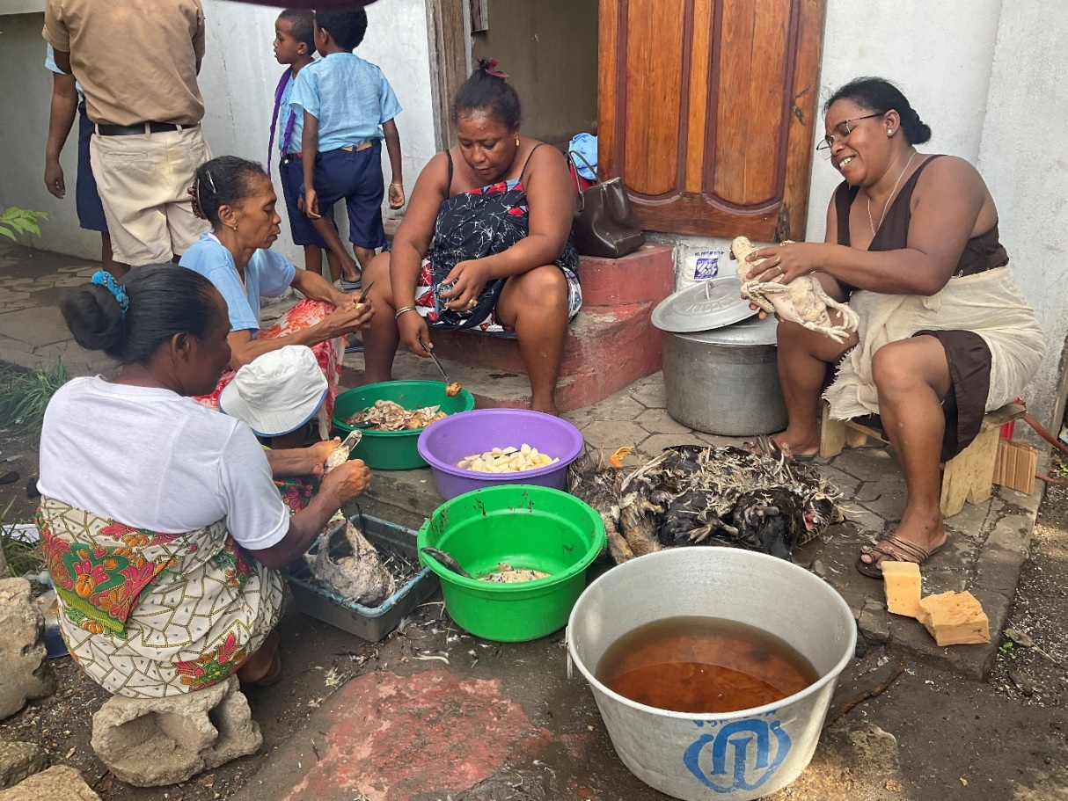
Chicken for Sunday lunch.

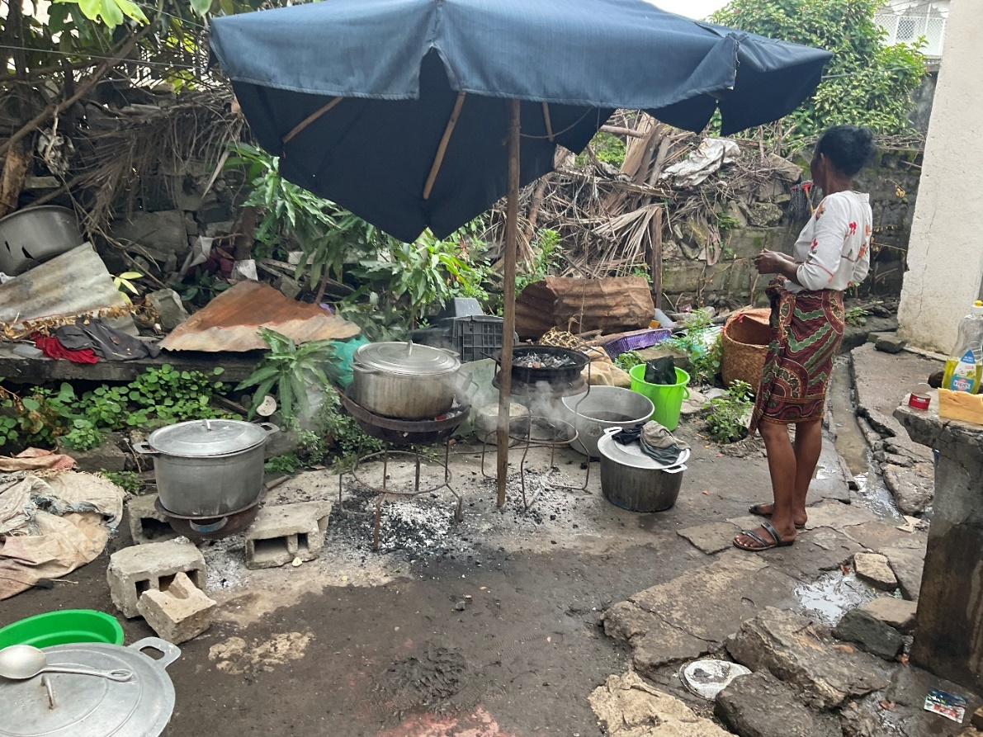
The cathedral kitchen leaves something to be desired!

Given that I had already had little sleep on three nights that week I was not best pleased to be woken at 1.30 am on Saturday night/Sunday morning by the very loud voices of my guests. As I was due to celebrate their concluding service at which new members were to be enrolled I had a private grumble but managed to get back to sleep only to be woken just after 4.30 am by everybody getting ready for church. It turned out that the 1.30 am episode were ladies complaining that it was too hot and stuffy and some of them moving to sleep outside! This was complicated by the fact that, in my absence, the outside lights and the lights on the stairs had fused and had not been mended.

It was a real joy to be back in the cathedral for Sunday service. Lots of young people singing their heads off, the MU members all excited and wanting to dance and the Men’s Society having a good old grumble… Vibrant verging on rowdy!

The following week had an overcrowded timetable each day. The Scouts booking me for their St George’s weekend at Marovoay, the Development Committee looking at a huge range of projects including an MU initiative in sheep farming wanting start-up funding and a crab selling project…

The 29th March is the anniversary of the uprising against the French colonial forces in 1947 and is marked by many public events. In Mahajanga these started with a great ecumenical service in a big RC church. A guard of honour of Guides and Scouts lined the central aisle from the sanctuary out into the street and there were choirs from different denominations. Not having been here last year because of the closure of Malagasy frontiers and the previous year’s events cancelled due to lockdown I was not up to speed on the nature of the event. I was embarrassed to discover that, as this year’s president of the Council of Churches I was one of the two speakers at the end of the service – the other being the Préfet who, on these occasions, has a role similar to a British Lord Lieutenant. My time in England had not improved my use of the Malagasy language. The Préfet gave a well-prepared speech but the same could not be said of mine. Malagasy people are very forgiving of the abuse of their language and generously appreciative of one’s efforts.

The 31st March was the third anniversary of my consecration as Bishop of Mahajanga and I was very touched when many young people and a choir of university students from St James’ Church attended the evening Communion Service in the cathedral to mark the event. Again a remarkable act of generosity of time and talents. All very heart warming. Even here the young, especially in the city, are addicted to their social media and so the service was livestreamed on Facebook which I keep forgetting to look at.

Another public event last week that required my presence was the installation of the “Procureur Général près la Cour d’Appel de Mahajanga”. This was a splendid affair with a procession of the judges in their robes, all the MPs of the province and sundry dignitaries. A very efficient Master of Ceremonies greeted one on the steps and announced the arrival to the guard of honour. I have now learnt that the best response to all this is smiles all round. I didn’t have to tell my acquaintances about the event as it was televised. Afterwards there was a mouth-watering spread of patisserie and gateaux which I missed because by then it was time to get back to the Stations of the Cross at the cathedral. What intrigued me most was that all the judges who conducted the proceedings were ladies. The gentlemen, with the exception of the new Procureur, had nothing to say. So different from the Anglican church here.

Meanwhile, there are Zoom meetings preparing for the Lambeth Conference and lots of domestic things to cope with. I have never been one of those people who manage “to clear their desk” and have well organised time off. Sadly, I don’t seem to have learned from experience so I am still ploughing through a backlog of work from my time away from the diocese. In all this I am hugely conscious of your support enabling all that is happening here and the huge privilege of leading the work. Thank you.

And now to Holy Week and Easter. A time to reflect on the nature of suffering, death and the joy of Easter. May we each find blessing in it.

+Hall

hallspeers@gmail.com

7 April 2022

