The Parish of St Paul, Wokingham with
St Nicholas, Emmbrook and Woosehill



Palm Sunday Order of Service

Before the service we gather as one, conscious that we are united
with people all over the world in this moment and in our shared purpose,
which is our shared longing to come face to face
with the living God who calls us to follow him.
Incense rises like our prayer and is deeply Biblical.
The thurible is used to cense holy things- the altar, the Gospel Book,
the elements on the altar, and us, God’s holy people.

Hosanna to the Son of David, the King of Israel.
Blessed is he who comes in the name of the Lord.
Hosanna in the highest.

Grace, mercy and peace from God our Father
and the Lord Jesus Christ be with you: and also with you.
Introducing the Service

The Palm Gospel

Two Hymns are sung as a reminder of our usual procession those at home are invited to join in the singing

The Blessing of the Palms
starting with Blessing of Palms by Jan Richardson, then…
God our Saviour,
whose Son Jesus Christ entered Jerusalem
as Messiah to suffer and to die,
let these palms be for us signs of his victory;
grant that we who bear them in his name
may ever hail him as our King, and follow him
in the way that leads to eternal life; who lives and reigns
with you and the Holy Spirit, now and for ever. Amen.

The Collect for Palm Sunday
Let us pray for a closer union with Christ
in his suffering and in his glory:
Almighty and everlasting God,
who in your tender love towards the human race
sent your Son our Saviour Jesus Christ
to take upon him our flesh
and to suffer death upon the cross:
grant that we may follow the example
of his patience & humility,
and also be made partakers of his resurrection;
through Jesus Christ your Son our Lord,
who is alive and reigns with you,
in the unity of the Holy Spirit, one God,
now and for ever. Amen.
The Liturgy of the Word

The Old Testament Reading
This is the Word of the Lord. Thanks be to God.

The Gospel Reading

The Sermon: a short reflection on Palm Sunday

The Intercessions
Lord, in your mercy: hear our prayer.

At the conclusion of the prayers we say
Merciful Father,
accept these prayers
for the sake of your Son,
our Saviour Jesus Christ. Amen.

The Liturgy of the Sacrament

The Peace
Once we were far off, but now in union with Christ Jesus
we have been brought near through the shedding
of Christ’s blood, for he is our peace.
The peace of the Lord be always with you: and also with you.
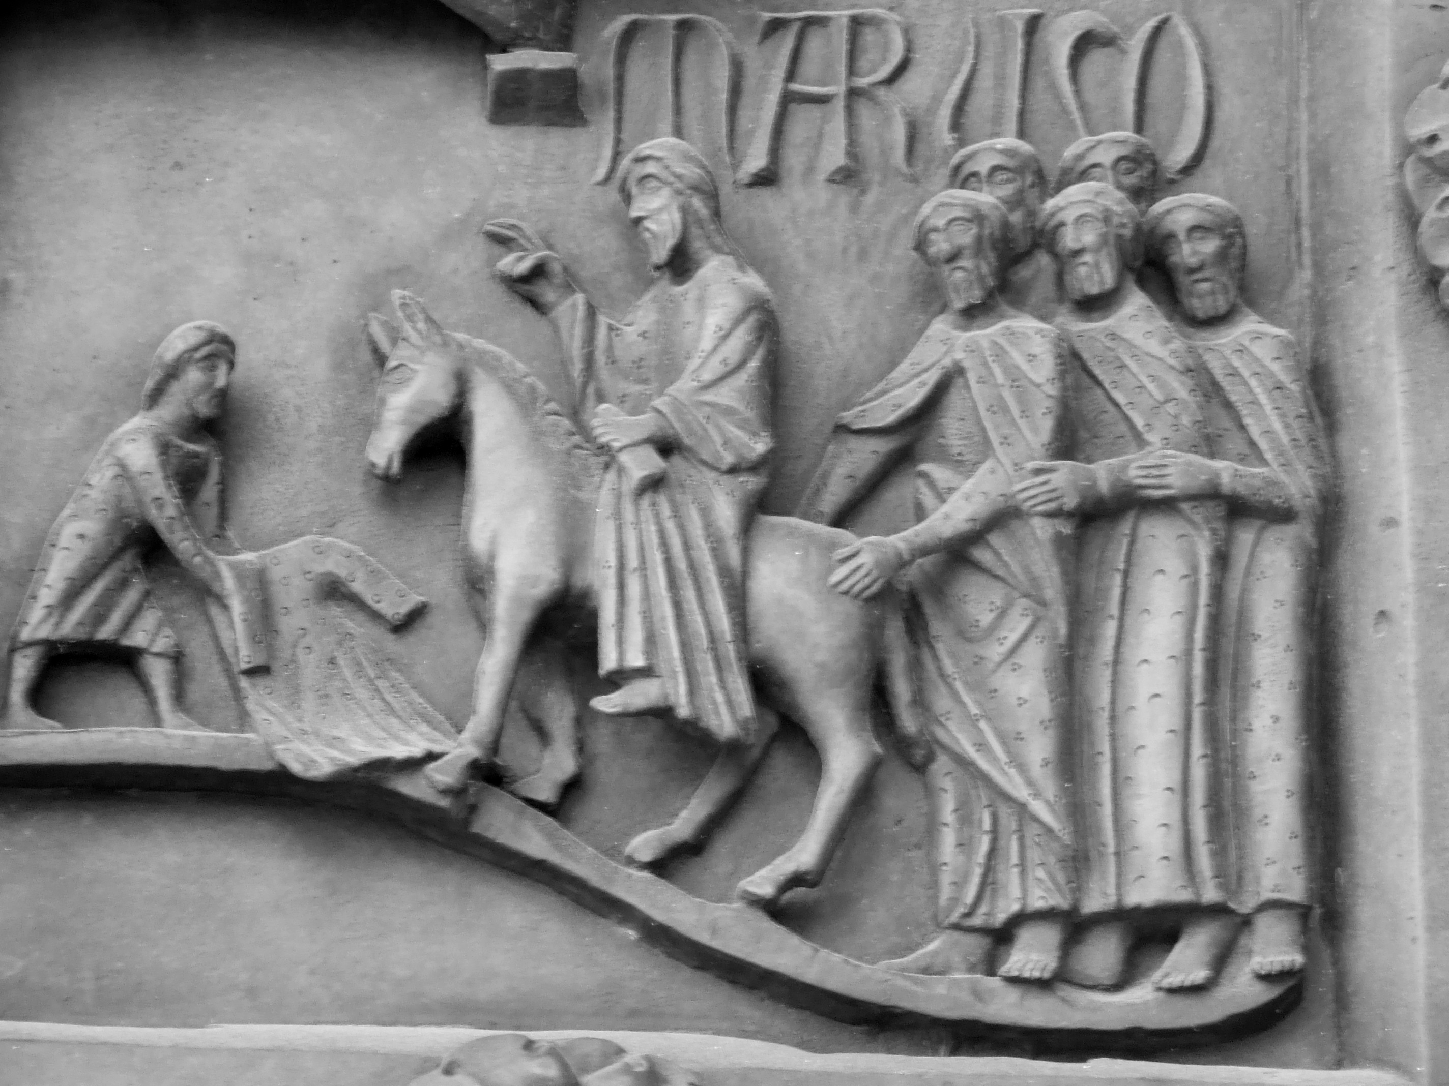
During the peace we hold out Christ’s peace to one another with a smile,
a wave or the use of Sign Language.
If you’re joining in from home
(or even in Church)
do please put your message
in the comment box on YouTube.
An Offertory Hymn is sung.

The Preparation of the Altar
Blessed are you Lord God, King of all Creation.
Of your goodness we have this bread to offer,
fruit of the earth and work of human hands.
It will become for us the Bread of Life. Blessed be God for ever.

Blessed are you Lord God, King of all creation.
Of your goodness we have this wine to offer,
fruit of the vine and work of human hands.
It will become for us the Cup of Salvation. Blessed be God for ever.

Pray, my brothers and sisters, that our sacrifice
may be acceptable to God the Almighty Father.
May the Lord accept the sacrifice at your hands,
for the praise and glory of his Name,
for our good and the good of all his Church.

Be present, be present, Lord Jesus Christ, our risen high priest:
and make yourself known in the breaking of the bread.

The Eucharistic Prayer (D)
The Lord be with you: and also with you.
Lift up your hearts. We lift them to the Lord.
Let us give thanks to the Lord our God.
It is right to give thanks and praise.
Almighty God, good Father to us all,
your face is turned towards your world.
In love you gave us Jesus your Son
to rescue us from sin and death.
Your Word goes out to call us home
to the city where angels sing your praise.
We join with them in heaven's song:
Holy, holy, holy Lord, God of power and might,
heaven and earth are full of your glory.
Hosanna in the highest.
Blessed is he who comes in the name of the Lord.
Hosanna in the highest.
Father of all, we give you thanks
for every gift that comes from heaven.
To the darkness Jesus came as your light.
With signs of faith and words of hope
he touched untouchables with love
and washed the guilty clean.
This is his story.
This is our song: Hosanna in the highest.
The crowds came out to see your Son,
yet at the end they turned on him.
On the night he was betrayed
he came to supper with his friends
to celebrate the freedom of your people.
This is his story.
This is our song: Hosanna in the highest.
Jesus blessed you, Father, for the food;
he took bread, gave thanks, broke it and said:
This is my body, given for you all.
Jesus then gave thanks for the wine;
he took the cup, gave it and said:
This is my blood, shed for you all for the forgiveness of sins.
Do this in remembrance of me.
This is our story.
This is our song: Hosanna in the highest.
Therefore, Father, with this bread and this cup
we celebrate the cross on which he died to set us free.
Defying death he rose again
and is alive with you to plead for us and all the world.
This is our story.
This is our song: Hosanna in the highest.
Send your Spirit on us now that by these gifts
we may feed on Christ with opened eyes and hearts on fire.
May we and all who share this food
offer ourselves to live for you
and be welcomed at your feast in heaven
where all creation worships you,
Father, Son and Holy Spirit:
Blessing and honour and glory and power
be yours for ever and ever. Amen.

The Lord’s Prayer
Lord Jesus, remember us in your Kingdom and teach us to pray:
Our Father, who art in heaven,
hallowed be thy name;
thy kingdom come;
thy will be done;
on earth as it is in heaven.
Give us this day our daily bread.
And forgive us our trespasses,
as we forgive those who trespass against us.
And lead us not into temptation;
but deliver us from evil.
For thine is the kingdom, the power and the glory,
for ever and ever. Amen.

The Fraction
Every time we eat this bread and drink this cup:
we proclaim the Lord’s death until he comes.

Lamb of God, you take away the sin of the world, have mercy on us.
Lamb of God, you take away the sin of the world, have mercy on us.
Lamb of God, you take away the sin of the world, grant us peace.

This is the Lamb of God who takes away the sin of the world.
Blessed are those who are called to his supper.
Lord, I am not worthy to receive you,
but only say the word, and I shall be healed.

Christ is in our midst: he is and always will be.

The celebrant will say “The Body of Christ, broken for you” at the altar.
Please come forward as you are guided, keeping 2m away from others.
The wafer will be placed in your hand in silence and then you are invited
to return to your seat by going along the side aisle.
If you are joining in at home, you might find this a helpful prayer to use:
Thanks be to you, Lord, Jesus Christ,
for all the benefits you have given me,
for all the pains and insults you have borne for me.
Since I cannot now receive you sacramentally,
I ask you to come spiritually into my heart.
O most merciful redeemer,
friend and brother, may I know you
more clearly, love you more dearly
and follow you more nearly, day by day. Amen.

The Post-Communion Prayers
Faithful God, may we who share this banquet
glory in the cross of our Lord Jesus Christ,
our salvation, life and hope,
who reigns as Lord for ever and ever. Amen.
God of our pilgrimage,
you have fed us here with your word and with your love.
Refresh and sustain us as we go forward on our journey,
in the name of Jesus Christ our Lord. Amen.

The Notices
including the call to keep Holy Week faithfully

A Dramatised Reading of the Gospel for Holy Week
(copyright WGRG, Iona Community, Glasgow: reproduced by permission)

The Blessing
May the Father
who so loved the world that he gave his only Son,
bring you by faith to his eternal life. Amen.

May Christ,
who accepted the cup of sacrifice in obedience to the Father’s will,
keep you steadfast as you walk with him the way of his cross. Amen.

May the Spirit,
who strengthens us to suffer with Christ that we may share his glory,
set your minds on life and peace. Amen.

And the blessing of God almighty…

The Dismissal
The Lenten Wreath
(throughout Lent and Holy Week we regularly extinguish
a candle as Good Friday grows nearer)

The Dismissal
Go in peace to love and serve the Lord.
In the name of Christ. Amen.

The scene is set for the pivotal week in human history.
All of the pieces are in place-
and we are invited, called, required to walk the road with Jesus
as it leads from Maundy Thursday to Good Friday,
and from there to Holy Saturday and thence
to the unexpected and unabated joy of Easter Day.
Jesus does all of this for us, for you-
and we are invited simply to be there, to be with him.

Please look on the Parish website for details of Holy Week Services www.stpauls-wokingham.org.uk or ring the Parish Office on 0118 979 2122.

After the service you are welcome to listen to the music and then to leave via the South Door. There will be a collection plate and debit card machine as you leave if you would like to make a donation to support the work of the parish.
Do please use the handgel as you leave as well.

And if you have been joining in at home, then do join in with the Zoom coffee morning after the service- you’d be very welcome.
You can text a donation to St Paul’s to 70450, texting STPAULS5
or STPAULS10 to donate that amount of money.

Unfortunately there is no opportunity to share in coffee and to catch-up with each other after the service at the moment- but why not put the kettle on
and ring someone and ask what they liked about the service, how God spoke
to them through it and how they are doing in general.

Today the Crowd shout
“Hosanna to the Son of David”

Soon the Crowd will shout
“We have no King but Caesar.
Crucify Jesus and release Barabbas”
Two Prayers for use after the Service

Lord our God,
grant me grace to desire you with my whole heart;
that so desiring you, I may seek and find you;
and so finding you, I may love you;
and so loving you, I may hate those sins
from which you have delivered me,
through Jesus Christ our Lord. Amen.
St Anselm of Canterbury

Jesus, when you rode into Jerusalem
the people waved palms with shouts of acclamation.
Grant that when the shouting dies
we may still walk beside you,
even to a cross. Amen.
New Zealand Prayer Book



