Our Mad Life 69
Visits and Visitors
Mahajanga city prides itself on being a tourist centre. The majority of the visitors are Malagasy from the capital but we also have a few very good luxury hotels catering for the international tourists, especially French and the much fewer Germans. This aspect of the city only impinges on me when I am at the Cathedral on a Sunday morning welcoming visitors or when I am in the happy position of going out for a meal. From now on as the weather in the capital gets cooler we will see more and more visitors enjoying our warmer and reliably dry climate.
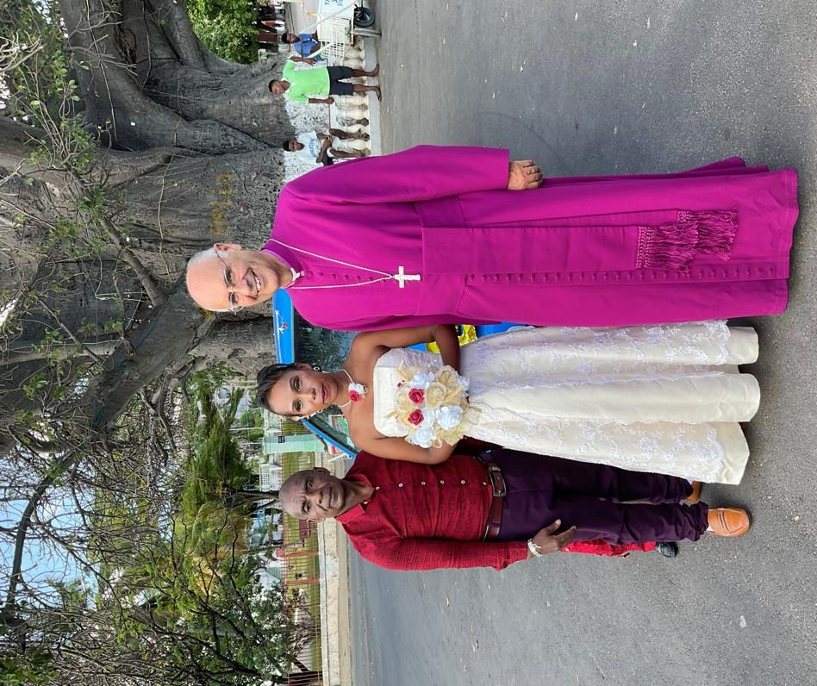
This wedding took place on 7 May and the location of this photo is absolutely obligatory. It is under the iconic symbol of the city, a giant baobab tree beside the sea. The groom is a former Roman Catholic priest who now wishes to be ordained as an Anglican for obvious reasons.
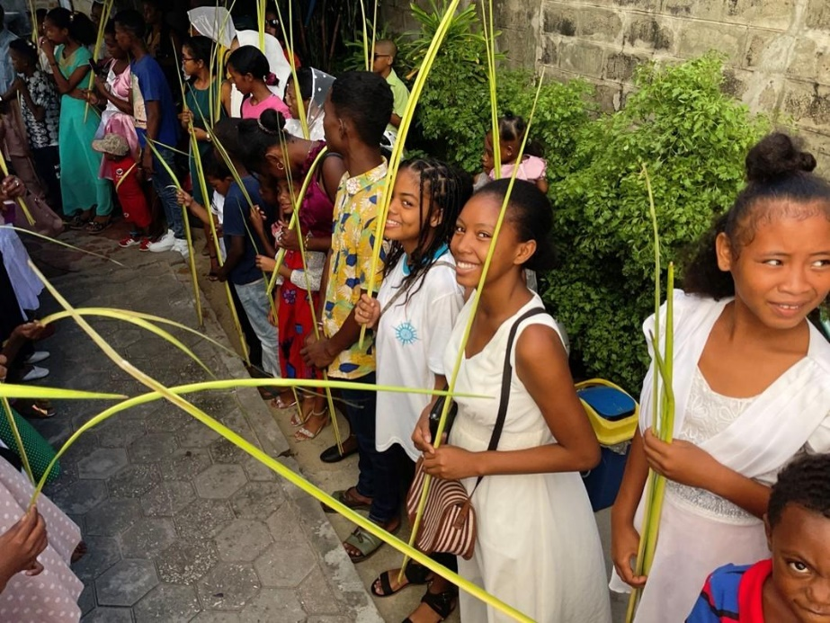
It now seems a long time since Palm Sunday, Holy Week and Easter. (Apologies for not having written recently.) On Palm Sunday the cathedral congregation assembled at Bishop’s House for the blessing of the palms and processed to the cathedral. The younger scouts marshalled the procession and clearly loved their moment of authority as they stopped the traffic. However, for many of us the events were overshadowed not only by war in Europe but also a local bereavement.
The Rev. Patrick is in charge of the parish of Maintirano, in the far south of the diocese and his Mother came to visit him and her grandchildren. The Thursday before Palm Sunday she died suddenly. According to Malagasy tradition she had to be brought home to Mahajanga for burial. The huge complication was that there is an absolute taboo in Maintirano on transporting corpses by boat and there are no roads going north from there towards Mahajanga. Thus the family had to hire a taxi-brousse and set out north east towards the capital. On the first night of the journey they were robbed. On the second day they were caught in violent rain and the taxi-brousse had to be pushed through deep mud. Then their driver decided he had had enough and they had to find another taxi-brousse for the next leg of the journey. This happened again. Meanwhile the corpse was on the roof in a rough plank coffin. They arrived a week later in Mahajanga on Maundy Thursday and I was among a large crowd awaiting them. What they had been through showed on their faces and clothing.
The coffin was lowered off the roof and carried into the house. It was a hot day- almost 40C – and the stench was overpowering. The coffin was then opened to reveal a gruesome sight of the decayed body. I was full of admiration for the Mothers Union members as they fulfilled their obligation of taking the body and wrapping it in a shroud which they give to members.
As you can imagine all this added to one’s reflections on death on Good Friday and the gift of eternal life celebrated on Easter day.
Easter Monday is a great holiday here and thousands take to the road to the beaches north of the city. Churches and organisations and extended families travel according to their means. For the majority this is a long walk setting off at or even before dawn. The cathedral had organised a taxi-brousse which was insufficient for the numbers travelling and their luggage. A major part of the treat is a generous picnic and of course at this temperature one needs lots of water. The cathedral youth (and not so youthful) cannot travel without a sound system so we also had to contend with huge amplifiers, batteries, etc.. Suffice it to say we eventually reached our destination, the “Petite Plage” where we had reserved a compound over the road from the beach. Immediately on arrival all tucked into food. I had brought a large sandwich so I feasted on that. Various families offered me plates of spaghetti, etc. but I had more than I could manage.
Then the music centre was set up and all mingled and a few of the young ones went onto the beach where the tide was far out. I was astonished when a little over an hour later it was announced that it was lunchtime! I was even more astonished when the faithful Emilienne appeared with table cloth, china and enormous cooked lunch. Neighbours offered me duck and when I declined they were so sorry I didn’t like duck – so I had just a little. I forget what came next. The group in front of me insisted I had a plate of their pasta and fish. When the meal was over several commented that they had not offered me salad as everyone knows the bishop doesn’t eat lettuce. For a moment – but only a moment – I was tempted to add to the list. Overfed, exhausted by Holy Week and Easter I promptly went to sleep in spite of being right next to the sound system. I woke up to find that many had done likewise or gone to the beach. At 4 pm it was time for the great trek home.
I didn’t have long to wait for my next outing. On the Saturday morning I had to be at the cathedral by 5 am to set off with the Scouts to Marovoay where I was to inaugurate the celebrations marking the centenary of Scouting in Madagascar which climaxed with the presentation of a new flag and the distribution of centenary scarves/neckers, one of which was solemnly placed around my neck. ‘Am I the oldest person to receive their first item of scout uniform?’ I asked the congregation. More singing, more dancing and more food. You wouldn’t think I am in a country with a famine in the south.
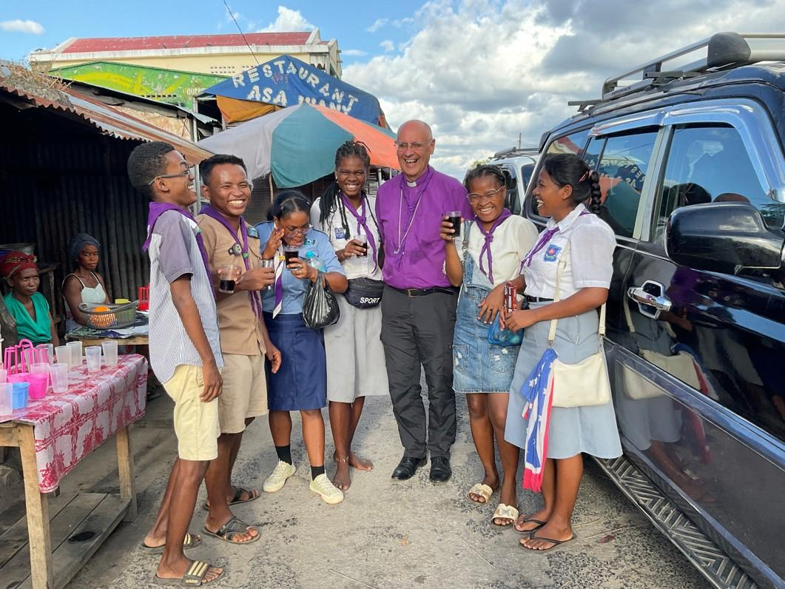
A very happy weekend was missed by the local clergyman, Gaston, as he was in Antananarivo being awarded his Masters degree by the Protestant University there.
The following weekend was the Youth of the South of the Diocese meeting at St. James in the suburbs of the city so although I spent the full days with them I could commute home to bed and QUIET. On the Saturday morning there were supposed to be reports from the various groups. Nothing had been prepared and they were all very taken aback when I said, in no uncertain terms, that this was unacceptable, especially since this and the same silly discussion had been an identical repeat of what has happened annually since I arrived in the diocese. Did they want me to deliver rules as to how to proceed or did they wish to sort themselves out – my preferred option. After a heated discussion they decided that they must take responsibility themselves. Interventions like this on my part I always imagine is going to drastically decrease my popularity but, in a way I don’t understand, it does the opposite.
Back at Bishop’s House when I should have been writing to you I was in something of a panic trying to organise our Archbishop’s first “Pastoral visit” to the diocese. He is also Bishop of the Seychelles. The sum total of my information was that he would arrive by aeroplane chartered through the Mission Aviation Fellowship with his wife, the Provincial Secretary and Canon Charles Raven of the Relay Trust which was funding the visit. They would arrive at Mahajanga airport at 7.40 am, the Archbishop would celebrate and preach in the cathedral at 9 am in French and then his wife would meet the Mothers Union members while the others would come to Bishop’s House to meet the diocesan standing committee, all have lunch and be back at the airport by 2.30 pm! The party would then fly on to Toamasina and each of the dioceses and at the end would meet up with the House of Bishops to discuss the way forward on various critical issues. I printed out 60 copies of the Communion Service in French and discussed in detail the menu with Emilienne. They arrived as planned but yesterday I got a message saying the Archbishop was exhausted and the Bishops meeting was cancelled!
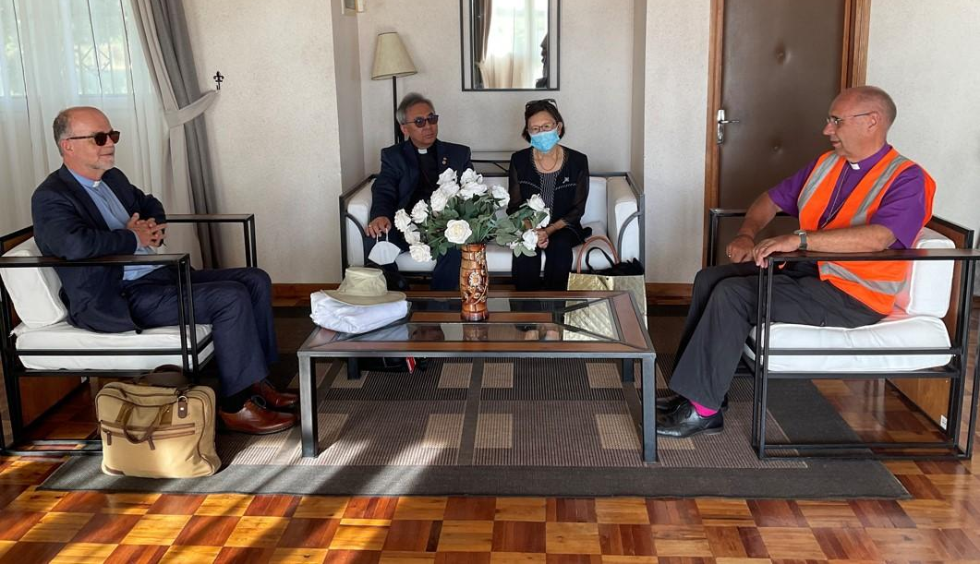
The distinguished visitors are received in the VIP lounge at Mahajanga airport. From l to r Canon Charles Raven, the Archbishop and his wife Doreen.
I will write again telling you how it all went after I get back from the capital. Having bought my tickets I have decided to go as I need to visit the Sisters there, our ordinand at the university and do various other quite urgent business.
Thank you for your concern and support.
+Hall

hallspeers@gmail.com
9 May 2022

