Our Mad Life 70
A Flying Visit

Happily for my visitors my colleagues and congregations are a lot more generous and enthusiastic with their arrangements for welcomes than I am. When the Provincial Secretary notified me of the Archbishop’s visit I only organised two cars to take the Archdeacon, the president of the Mothers Union and myself to the airport and then bring the visitors back to Bishop’s House.
One of the rural deans, Constant, spent the previous night here. He went to look for something to eat and when he didn’t appear I went out to see where he was, as it was getting late and I wanted to lock up. When I opened the gate I looked up the street and had one of those “Oh no, I can’t believe it” moments as the now familiar shapes and faces of the Mothers’ Union from Marovoay emerged wearily but joyfully from the darkness. It wasn’t so much their uninvited unexpected numbers that caused a sinking feeling, as the vision of what was hoped for the next day. I had a sudden awareness of the sort of morning they had come for and for which I had made no preparations. But they are ideal guests as they really do look after themselves – given space and mattresses (though perfect guests wouldn’t wake me at 4 am with chatter and laughter).
No problem sleeping in, I was at the baker’s by 5.15 am and pushed the boat out buying a range of delicacies for a breakfast to welcome the archiepiscopal party. Constant and I had our breakfast before 6 am Morning Prayer so that we could be early at the airport in case the plane arrived early which I thought was more than likely as it was scheduled to leave the capital at 6 am. At the cathedral I was relieved to discover that the Archdeacon had anticipated my oversights and there was a throng of ladies and transport of various sorts to get them to the airport with some paper flags welcoming the Archbishop and lots of flags to welcome his wife.
At the airport a grumpy member of staff asked if we were the people who had caused the VIP lounge to be prepared. She said very firmly only three people were allowed out to greet the plane –and they had to wear high-vis jackets which she supplied. She conducted us to said lounge which I hadn’t known existed. It turned out to be a separate building in beautiful condition and quite elegantly furnished on the edge of the landing strip. By the time all this was sorted the plane had landed so I strode out to it accompanied by the Archdeacon and a very nervous MU president.
I was taken aback when first out of the aircraft was a smiling European woman and two children. Who were they? Nobody had warned me and I certainly had no transport, lunch or programme for them! They seemed vaguely surprised when I warmly welcomed them to Mahajanga. I discovered they were the pilot’s wife and children who had just come for a day out. Then Archbishop James emerged followed by the Revd. Berthier (the Provincial Secretary), Mrs Doreen Wong (the Archbishop’s wife) and Canon Charles Raven of the Relay Trust. After sorting luggage, taking only what was required for the morning, we made our way to the VIP lounge, had introductions and sat down for rather stiff speeches of welcome.
By this time the crowd outside could be heard singing their welcome and so we emerged to a loud reception. Mrs. Wong was on her first visit and clearly non-plussed when MU members rushed forward, raised her arms and wrapped her in a lamba-one “souvenir de Mahajanga” while the other guests were receiving theirs. Eventually we all got into our vehicles and set off to Bishop’s House. In spite of my detailed instructions not to do anything until we arrived, Emilienne had a huge pot of coffee ready. However our guests were coming to terms with the temperature and wanted only cold drinks.
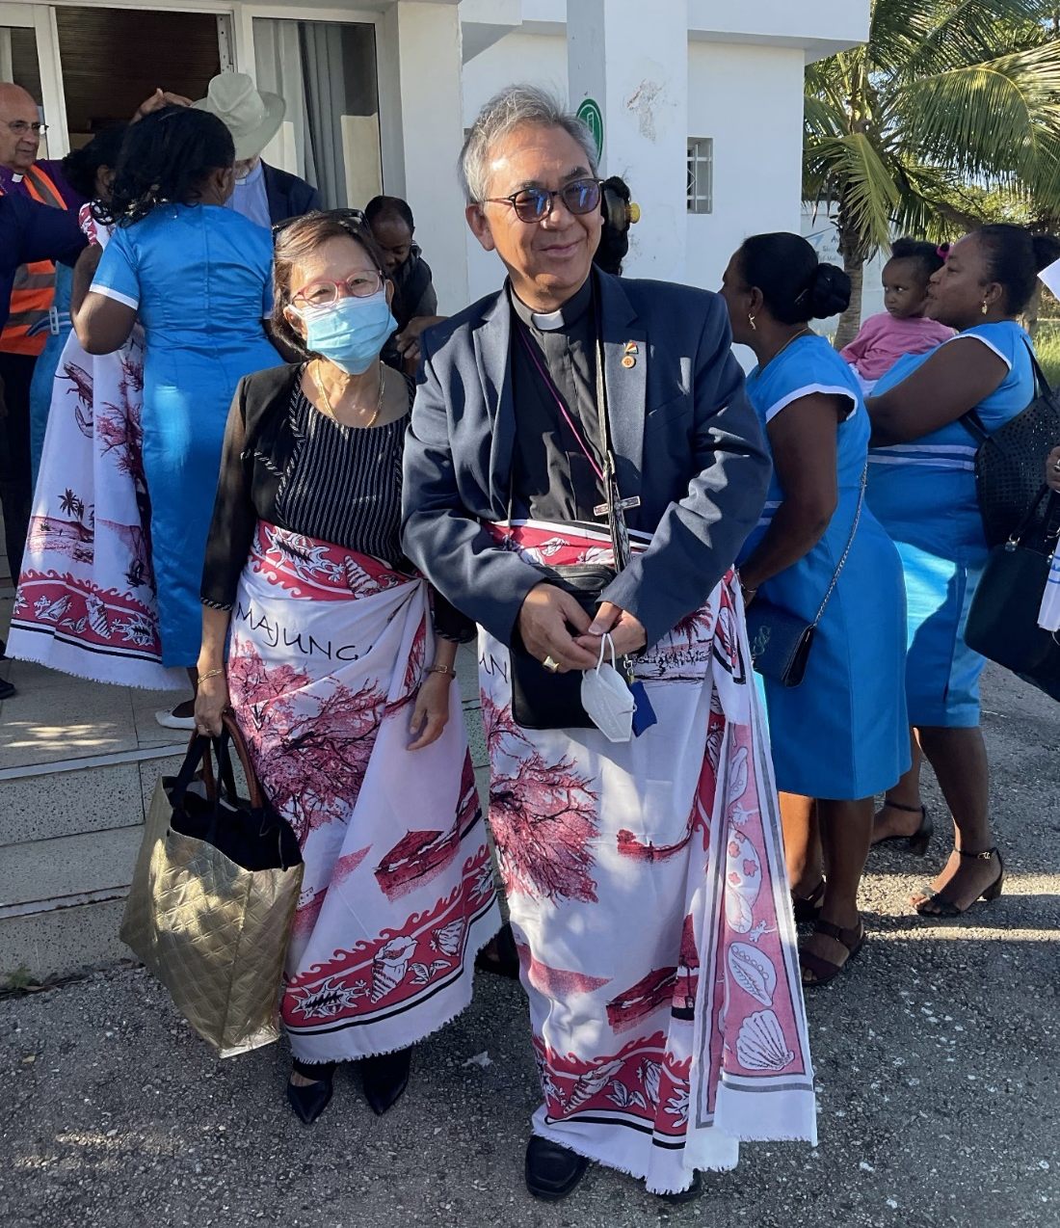
The Archbishop of the Indian Ocean and Mrs. Doreen Wong.
And so to the cathedral where again the Archdeacon had pulled out all the stops and the cathedral servers were well represented. The Archbishop had asked that the service be in French and I had printed service sheets in French for the congregation. Hymns, bible readings, etc were in Malagasy. The Archbishop was clearly very ill at ease when the servers brought him the incense at the beginning of the service. Following instructions from the Provincial Secretary he very awkwardly did a tour of the altar. He preached in French and the Provincial Secretary translated. As is our custom here joy was expressed by dancing at the end of the service. “What would Keble and Pusey think of this?” Canon Raven whispered to me.
Mrs. Wong had requested to meet some Mothers’ Union members and they had put on a generous reception in the cathedral gallery to which she was taken. They were disappointed and mystified when she looked at every item of food and asked what was in it. On hearing the contents she declined each one and also the fruit juice on offer. Here one shows respect for distinguished guests and marks special events by eating beef. Unfortunately nobody had told us that Mrs. Wong is a strict vegetarian.
Meanwhile back at Bishop’s House we were down to business in French, Malagasy and English and I was quizzed about the life of the diocese. The result of all that was the encouraging statement by Canon Raven that we “ticked all the boxes” as candidates for major funding from the Relay Trust and we must “think big”. All of which took us merrily to lunchtime.
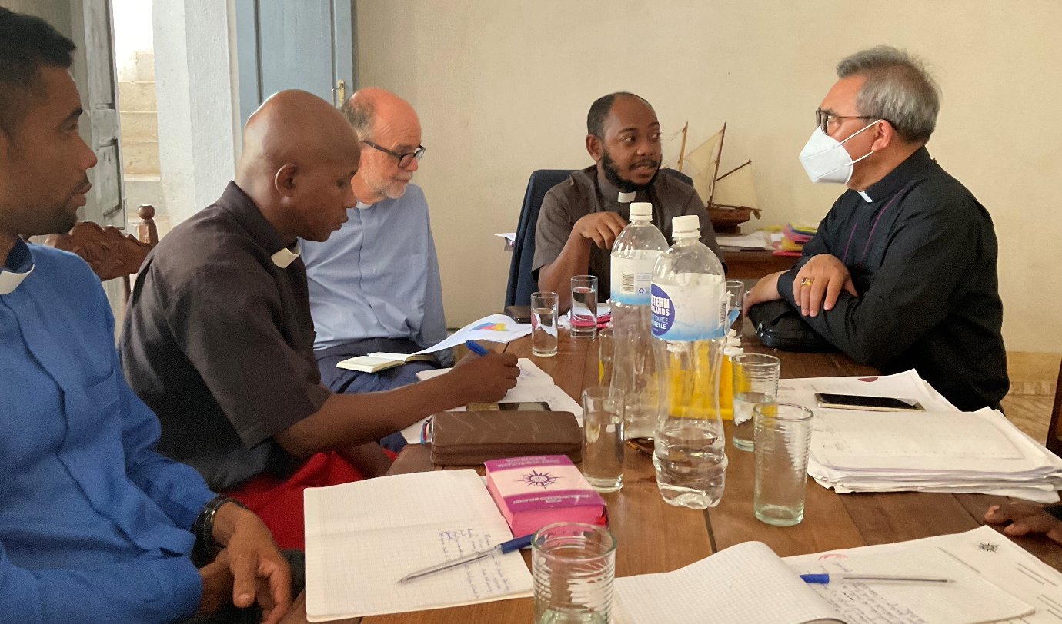
L to R: Rev Constant, Rev Gaston, Canon Charles Raven (Relay Trust), Rev Berthier (Provincial Secretary and Rector of Toliara Theological College) and Archbishop James.
Emilienne had done a tremendous job in preparing fresh tuna steaks in a coconut sauce with rice and salad. Mrs. Wong was next to me and I was rather anxious when she took a miniscule piece of fish, two spoons of rice and declined the salad. It was only after she had gone that we heard she was vegetarian. Happily her eyes lit up at the sight of the fruit salad. With that the visitors took their leave and flew off to the east coast and another big welcome.
Business at Bishop’s House continued with a Development Committee meeting which had a very full agenda: the preparations for opening of our new Lycée/secondary school at Port Bergé, the ongoing programme of building houses for the clergy, new churches, and the management of our new ricefields. Also there are micro finance projects: two places sewing fancy mosquito nets, crab production, loans to the rural deans for their motorbikes, etc… The cost of living everywhere is rising sharply and I continue to get requests to pay school fees in addition to the several students we are supporting at university.
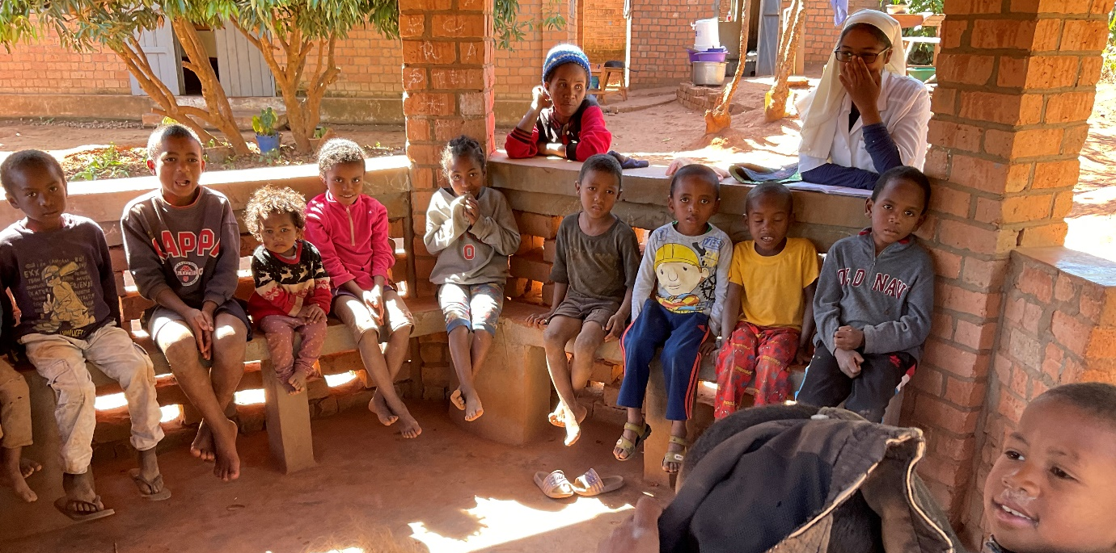
Some of the poor children who receive a free lunch at the Anglican Convent
It is very depressing to see Britain switching its aid policy focus from fighting poverty to promotion of British trade and investment. Next year the Commonwealth Development Corporation is renamed British International Investment – supposedly matching China’s policy. What an example to follow!
However, on we go, sustained and supported by your goodwill, generosity and prayers, for all of which I am deeply grateful.
God bless.
+Hall
hallspeers@gmail.com

21 May 2022

