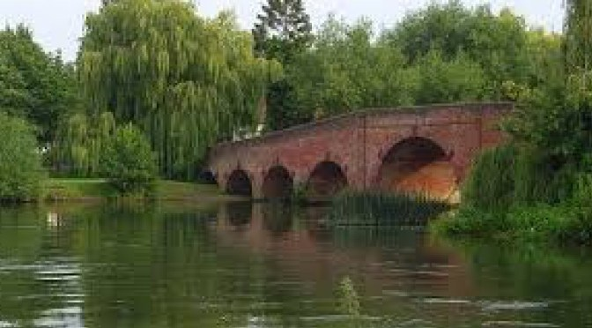

Sonning Deanery
Going Green

Sonning Deanery Synod have set aside £5,000 for match funding for PCC projects within the Deanery which aim to reduce the Carbon Footprint of the Parish or support and work towards the Diocesan commitment to a carbon neutral future. Grants will be made of up to £1,000 per project, per parish, per year.

PCCs wanting to apply for a Grant
should send details of their proposal to the Deanery Secretary, along with a supporting PCC motion.

Proposals should be sent to the Area Dean: the Rev’d Canon Richard Lamey 0118 327 9116: rector@spauls.co.uk

