Pentecost Sunday
The Parish of St Paul’s Church, Wokingham

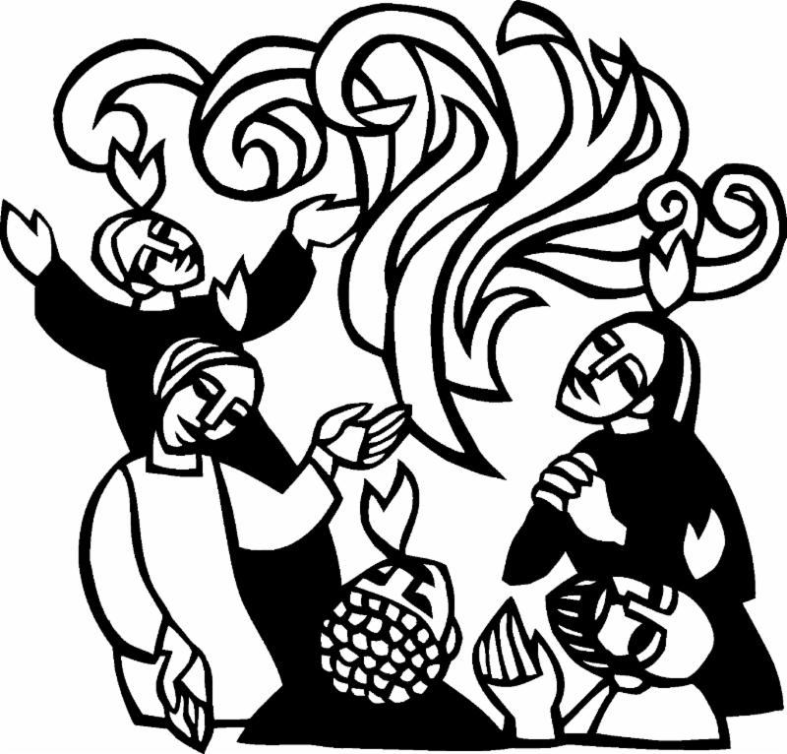

Some material is taken from Common Worship: New Patterns for Worship 2nd edn
© The Archbishops’ Council 2008; Fire and Bread, WGRG, edited Ruth Burgess, 2006, p148.
Other material is original. Music license under CCLI 97309
or performed by kind permission of the copyright holder.
The Gathering

Opening Hymn

In the name of the Father, and of the Son,
and of the Holy Spirit. Amen.

Grace, mercy and peace from God our Father
and the Lord Jesus Christ be with you: And also with you.

Alleluia. Christ is risen. He is risen indeed. Alleluia.

Introduction and Welcome

Jesus Christ, whom we worship,
is our crucified, risen and ascended Lord.
We have walked with him through his journey of love.
We have faced the agony of his suffering and death on a cross.
We have rejoiced at his bursting free from the bonds of death.
We have enjoyed his risen presence with us
and his revelation of himself through the breaking of bread.
We have seen his return to the throne before which every knee shall bow and every tongue confess that this Jesus is Lord.
And now, with the followers of his own time,
we await the coming of the promised Holy Spirit,
his gift to his people,
through whom we make Christ known to the world.

Responsory

As we wait in silence,
fill us with your Spirit.
As we listen to your word,
fill us with your Spirit.
As we worship you in majesty,
fill us with your Spirit.
As we long for your refreshing,
fill us with your Spirit.
As we long for your renewing,
fill us with your Spirit.
As we long for your equipping,
fill us with your Spirit.
As we long for your empowering,
fill us with your Spirit.
Silence is kept.

A Reading from Acts 2 (1-13)

Gloria in Excelsis: a song of praise to God
for his wonderful goodness, from the Mass of Villerville

Glory to God in the Highest,
and peace to his people on earth.
Lord God, heavenly King, Almighty God and Father,
we worship you, we give you thanks,
we praise you for your glory.
Lord Jesus Christ, only Son of the Father,
Lord God, Lamb of God,
you take away the sin of the world;
have mercy on us;
you are seated at the right hand of the Father:
receive our prayer.
For you alone are the Holy One,
you alone are the Lord,
you alone are the most high, Jesus Christ,
with the Holy Spirit,
in the Glory of God the Father. Amen.

The Collect Let us pray that the Spirit will work through our lives to bring Christ to the world.

Holy Spirit, sent by the Father, ignite in us your holy fire;
strengthen your children with the gift of faith,
revive your Church with the breath of love,
and renew the face of the earth,
through Jesus Christ our Lord. Amen.

The Liturgy of the Word

The Gospel
Alleluia, alleluia.
Come, Holy Spirit, fill the hearts of your faithful people
and kindle in them the fire of your love.
Alleluia.

Hear the Gospel of our Lord Jesus Christ according to John.
Glory to you, O Lord.
At the end:
This is the Gospel of the Lord.
Praise to you, O Christ.

The Sermon

The Creed: a statement of faith
Do you believe and trust in God the Father,
source of all being and life, the one for whom we exist?
I believe and trust in him.

Do you believe and trust in God the Son,
who took our human nature, died for us and rose again?
I believe and trust in him.

Do you believe and trust in God the Holy Spirit, who gives life to the people of God and makes Christ known in the world?
I believe and trust in him.

This is the faith of the Church. This is our faith.
We believe and trust in one God, Father, Son & Holy Spirit.

The Intercessions

The Liturgy of the Sacrament

The Peace

God has made us one in Christ.
He has set his seal upon us and, as a pledge of what is to come,
has given the Spirit to dwell in our hearts. Alleluia.
The peace of the Lord be always with you: and also with you.
We offer one another a sign of peace.
During the peace we hold out Christ’s peace to one another, picturing the whole people of God gathered together in this moment.
Do please put your message in the comment box on YouTube,
or text a friend, whether you are in Church or at home.

Offertory Hymn

The Preparation of the Gifts
Blessed be God, who feeds the hungry, who raises the poor,
who fills our praise. Blessed be God for ever.

Pray my brothers and sisters
that our sacrifice may be acceptable to God the almighty Father.
May the Lord accept the sacrifice at your hands,
for the praise and glory of his name,
for our good and the good of all his Church.

Pour upon the poverty of our love
and the weakness of our praise,
the transforming fire of your presence. Amen.

The Eucharistic Prayer (G)
The Lord be with you
and also with you.
Lift up your hearts.
We lift them to the Lord.
Let us give thanks to the Lord our God.
It is right to give thanks and praise.

Blessed are you, Lord God,
our light and our salvation;
to you be glory and praise for ever.
From the beginning you have created all things
and all your works echo the silent music of your praise.
In the fullness of time you made us in your image,
the crown of all creation.

You give us breath and speech,
that with angels and archangels and all the powers of heaven
we may find a voice to sing your praise:
Holy, holy, holy Lord,
God of power and might,
heaven and earth are full of your glory.
Hosanna in the highest.
Blessed is he who comes in the name of the Lord.
Hosanna in the highest.

How wonderful the work of your hands, O Lord.
As a mother tenderly gathers her children,
you embraced a people as your own.
When they turned away and rebelled
your love remained steadfast.

From them you raised up Jesus our Saviour, born of Mary,
to be the living bread,
in whom all our hungers are satisfied.

He offered his life for sinners,
and with a love stronger than death
he opened wide his arms on the cross.
On the night before he died,
he came to supper with his friends
and, taking bread, he gave you thanks.
He broke it and gave it to them, saying:
Take, eat; this is my body which is given for you;
do this in remembrance of me.

At the end of supper, taking the cup of wine,
he gave you thanks, and said:
Drink this, all of you; this is my blood of the new covenant,
which is shed for you and for many for the forgiveness of sins.
Do this, as often as you drink it, in remembrance of me.

Great is the mystery of faith:
Christ has died:
Christ is risen:
Christ will come again.

Father, we plead with confidence
his sacrifice made once for all upon the cross;
we remember his dying and rising in glory,
and we rejoice that he intercedes for us at your right hand.

Pour out your Holy Spirit as we bring before you
these gifts of your creation;
may they be for us the body and blood of your dear Son.

As we eat and drink these holy things in your presence,
form us in the likeness of Christ,
and build us into a living temple to your glory.

Remember, Lord, your Church in every land.
Reveal her unity, guard her faith,
and preserve her in peace.

Bring us at the last with the Blessed Virgin Mary,
St Paul and St Nicholas… and all the saints
to the vision of that eternal splendour
for which you have created us;
through Jesus Christ, our Lord,
by whom, with whom, and in whom,
with all who stand before you in earth and heaven,
we worship you, Father almighty, in songs of everlasting praise:
Blessing and honour and glory and power
be yours for ever and ever. Amen.

The Lord’s Prayer
Being made one in the power of the Spirit, let us pray
together as our Saviour has commanded and taught us:
Our Father, which art in heaven,
hallowed be thy name.
Thy kingdom come, thy will be done,
on earth as it is in heaven.
Give us this day our daily bread.
And forgive us our trespasses,
as we forgive those who trespass against us.
And lead us not into temptation,
but deliver us from evil.
For thine is the kingdom,
the power and the glory,
for ever and ever. Amen.

The Fraction
We break this bread, to share in the body of Christ.
Though we are many, we are one body,
because we all share in one bread.

Lamb of God, you take away the sin of the world, have mercy on us.
Lamb of God, you take away the sin of the world, have mercy on us.
Lamb of God, you take away the sin of the world, grant us peace.

God’s holy gifts for God’s holy people.
Jesus Christ is holy, Jesus Christ is Lord,
to the glory of God the Father.

Christ is in our midst. He is and always will be.

If you usually receive communion in your own church, or you have done so in the past, you are most welcome to receive communion on this holy day.
If you would prefer to receive a prayer of blessing
please bring this order of service with you to the front.
If you’re at home, please use this time to talk to God- heart touching heart.
Use this prayer if you find it helpful, and do enjoy the music which will be offered at this point in the service as an aid to prayer and worship.

Thanks be to you, Lord, Jesus Christ,
for all the benefits you have given me,
for all the pains and insults you have borne for me.
Since I cannot now receive you sacramentally,
I ask you to come spiritually into my heart.
O most merciful redeemer, friend and brother,
may I know you more clearly, love you more dearly
and follow you more nearly, day by day. Amen.

Post- Communion Prayer:
we thank God for his love, revealed in this feast
God of power and grace,
may the boldness of your Spirit transform us,
may the gentleness of your Spirit lead us,
may the gifts of your Spirit equip us
to serve and worship you, now and always. Amen.

The Notices and Banns of Marriage

A Reading from Acts 2 (14-18)

The Dismissal
Blessing
May the Spirit, who hovered over the waters when the world was created, breathe into you new life and hope.
Amen.
May the Spirit, who made herself known as a comforter
and advocate, guide you in joy and peace.
Amen.
May the Spirit, who set the Church on fire upon the Day of Pentecost, bring the world alive with the love of the risen Christ.
Amen.

And the blessing of God….
Amen.

An Organ Voluntary

The Dismissal
we turn to face the West End of Church,
as we are sent into the world to live lives to God’s glory

The Commission
As part of God’s Church here in Wokingham,
I call upon you to live out what you proclaim.

Filled with the Holy Spirit,
will you dare to walk into God’s future,
trusting him to be your guide?
With the help of God, we will.
Will you dare to minister to each other in need,
giving freely of your time and abilities?
With the help of God, we will.
Will you dare to pray for each other until your hearts beat
with the longings of God?
With the help of God, we will.
Will you dare to carry the light of Christ
into the world’s dark places?
With the help of God, we will.

Filled with the Spirit’s power,
go in the light and peace of Christ. Alleluia, alleluia.
Thanks be to God. Alleluia, alleluia.

If you’d like to find out about everything that is happening in the parish, please email church.office@spauls.co.uk and we will happily put you on our regular mailing list. There will be a collection plate and debit card machine as you leave if you would like to make a donation to support the work of the parish.
You can text a donation to St Paul’s to 70450, texting STPAULS5 or STPAULS10 or STPAULS20 to donate that amount of money.
Do please use the handgel as you leave as well.

