The Parish Church of
St. Paul, Wokingham

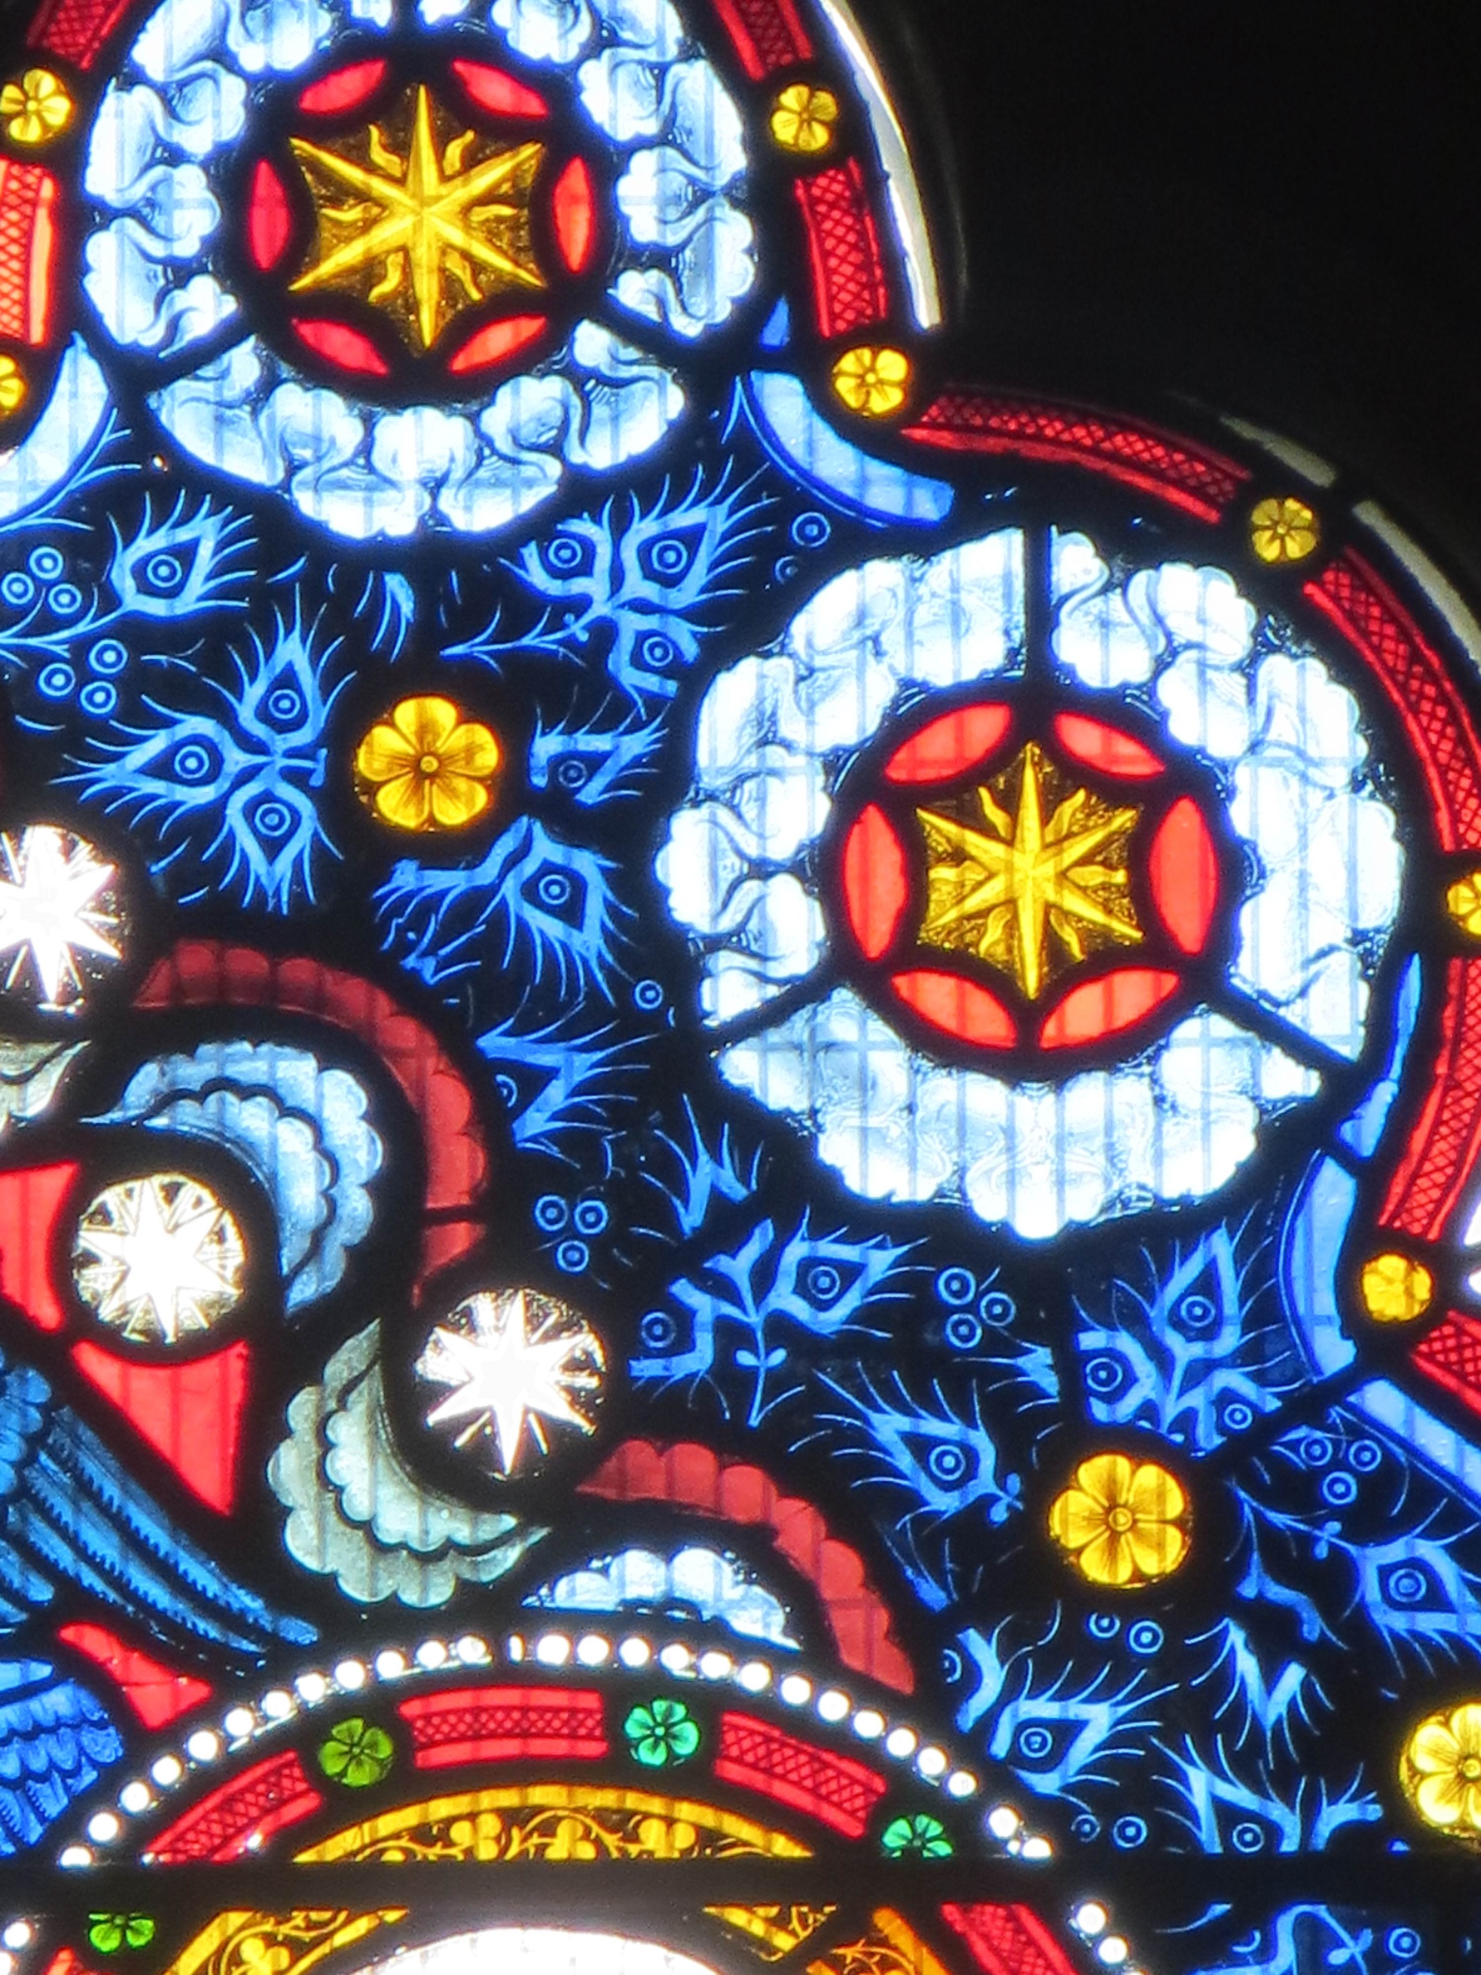

Parish Mass
in Ordinary Time

During the Eucharist we
- gather together as one family
- say sorry for our sins and receive God’s forgiveness
- proclaim and respond to the word of God
- remember before God the Church and the world
- share in the peace of Christ
- pray the Eucharistic Prayer
- receive communion
- depart with the blessing of God, to live lives to his glory.
The Gathering
At the entry of the procession, we stand and a hymn is sung.
The hymn numbers are displayed on the boards on the pillars.

In the name of the Father, and of the Son,
and of the Holy Spirit. Amen.

(Either)
The Lord be with you: and also with you.
(or)
Grace, mercy and peace from God our Father
and the Lord Jesus Christ be with you: and also with you.

Words of welcome and introduction follow.
This prayer may be used:

Almighty God, to whom all hearts are open,
all desires known, and from whom no secrets are hidden:
cleanse the thoughts of our hearts
by the inspiration of your Holy Spirit,
that we may perfectly love you
and worthily magnify your holy name;
through Christ our Lord. Amen.

Prayers of Penitence
The priest introduces the Confession.
A time of silence is kept as we recall our sins and shortcomings.

(Either)
Almighty God, our heavenly Father,
we have sinned against you, through our own fault,
in thought and word and deed,
and in what we have left undone.
We are heartily sorry, and repent of all our sins.
For your Son our Lord Jesus Christ’s sake,
forgive us all that is past;
and grant that we may serve you in newness of life
to the glory of your name. Amen.
(or)
O King enthroned on high,
filling the earth with your glory:
holy is your name, Lord God almighty.
In our sinfulness we cry to you
to take our guilt away,
and to cleanse our lips to speak your word,
through Jesus Christ our Lord. Amen.

Lord, have mercy. Lord, have mercy.
Christ, have mercy. Christ, have mercy.
Lord, have mercy. Lord, have mercy.

The Absolution
(Either)
Almighty God, who forgives all who truly repent,
have mercy on you, + pardon and deliver you from all your sins,
confirm and strengthen you in all goodness,
and keep you in life eternal;
through Jesus Christ our Lord. Amen.
(or)
The Lord enrich you with his grace,
and nourish you with his blessing:
the Lord defend you in trouble and keep you from all evil;
the Lord accept your prayers
and + absolve you from your offences,
for the sake of Jesus Christ, our Saviour. Amen.

The Gloria
Glory to God, Glory to God, Glory to God in the Highest,

Glory to God in the Highest,
and peace to his people on earth.
Lord God, heavenly King, Almighty God and Father,
We worship you, we give you thanks,
we praise you for your glory.

Glory to God, Glory to God, Glory to God in the Highest.

Lord Jesus Christ, only Son of the Father.
Lord God, Lamb of God, you take away the sin of the world;
have mercy on us;
you are seated at the right hand of the Father:
receive our prayer.

Glory to God, Glory to God, Glory to God in the Highest.

For you alone are the Holy One, you alone are the Lord,
you alone are the most high, Jesus Christ,
with the Holy Spirit, in the Glory of God the Father.

Glory to God, Glory to God, Glory to God in the Highest.

The Collect
The Lord be with you: and also with you.
Let us pray.

The Liturgy of the Word

The Reading
At the end of the reading:
This is the word of the Lord. Thanks be to God.

The Gospel
We turn to face the Gospel as it is brought into the midst of the people.
The Lord be with you: and also with you.
Hear the Gospel of our Lord Jesus Christ according to x.
Glory to you, O Lord.

At the end of the Gospel reading:
This is the Gospel of the Lord. Praise to you, O Christ.

The Sermon

The Creed
(Either)
We believe in one God, the Father, the Almighty,
maker of heaven and earth, of all that is,
seen and unseen.

We believe in one Lord, Jesus Christ,
the only Son of God,
eternally begotten of the Father,
God from God, Light from Light,
true God from true God, begotten not made,
of one being with the Father;
through him all things were made.
For us and for our salvation he came down from heaven,
was incarnate from the Holy Spirit and the Virgin Mary
and was made man.
For our sake he was crucified under Pontius Pilate;
he suffered death and was buried.
On the third day he rose again
in accordance with the Scriptures;
he ascended into heaven
and is seated at the right hand of the Father.
He will come again in glory to judge the living and the dead, and his kingdom will have no end.
We believe in the Holy Spirit,
the Lord, the giver of life,
who proceeds from the Father and the Son,
who with the Father and the Son
is worshipped and glorified,
who has spoken through the prophets.
We believe in one holy catholic and apostolic Church.
We acknowledge one baptism for the forgiveness of sins,
We look for the resurrection of the dead,
and the life of the world to come. Amen. (Nicene Creed)

(or)
Do you believe and trust in God the Father?
I believe in God, the Father almighty,
creator of heaven and earth.

Do you believe and trust in his Son, Jesus Christ?
I believe in Jesus Christ, his Son, our Lord,
who was conceived by the Holy Spirit,
born of the Virgin Mary,
suffered under Pontius Pilate,
was crucified, died and was buried;
he descended to the dead.
On the third day he rose again;
he ascended into heaven,
he is seated at the right hand of the Father,
and he will come to judge the living and the dead.
Do you believe and trust in the Holy Spirit?
I believe in the Holy Spirit,
the holy Catholic Church,
the communion of saints,
the forgiveness of sins,
the resurrection of the body,
and the life everlasting. Amen. (from the Apostles’ Creed)

The Prayers
At the end of each section, this response may be used:
Lord, in your mercy: hear our prayer.
(or)
Lord, hear us: Lord, graciously hear us.

Merciful Father, accept these prayers
for the sake of your Son, our Saviour, Jesus Christ. Amen.

The Liturgy of the Sacrament

The Peace
The peace of the Lord be always with you: and also with you.

We sing the Offertory hymn, during which the gifts are brought forward from God’s people to God’s altar.

The Preparation of the Altar
(Either)
With this bread that we bring we shall remember Jesus.
With this wine that we bring we shall remember Jesus.
Bread for his body, wine for his blood,
gifts from God to his table we bring.
We shall remember Jesus.
(or)
Blessed be God, who feeds the hungry, who raises the poor,
who fills our praise. Blessed be God for ever.

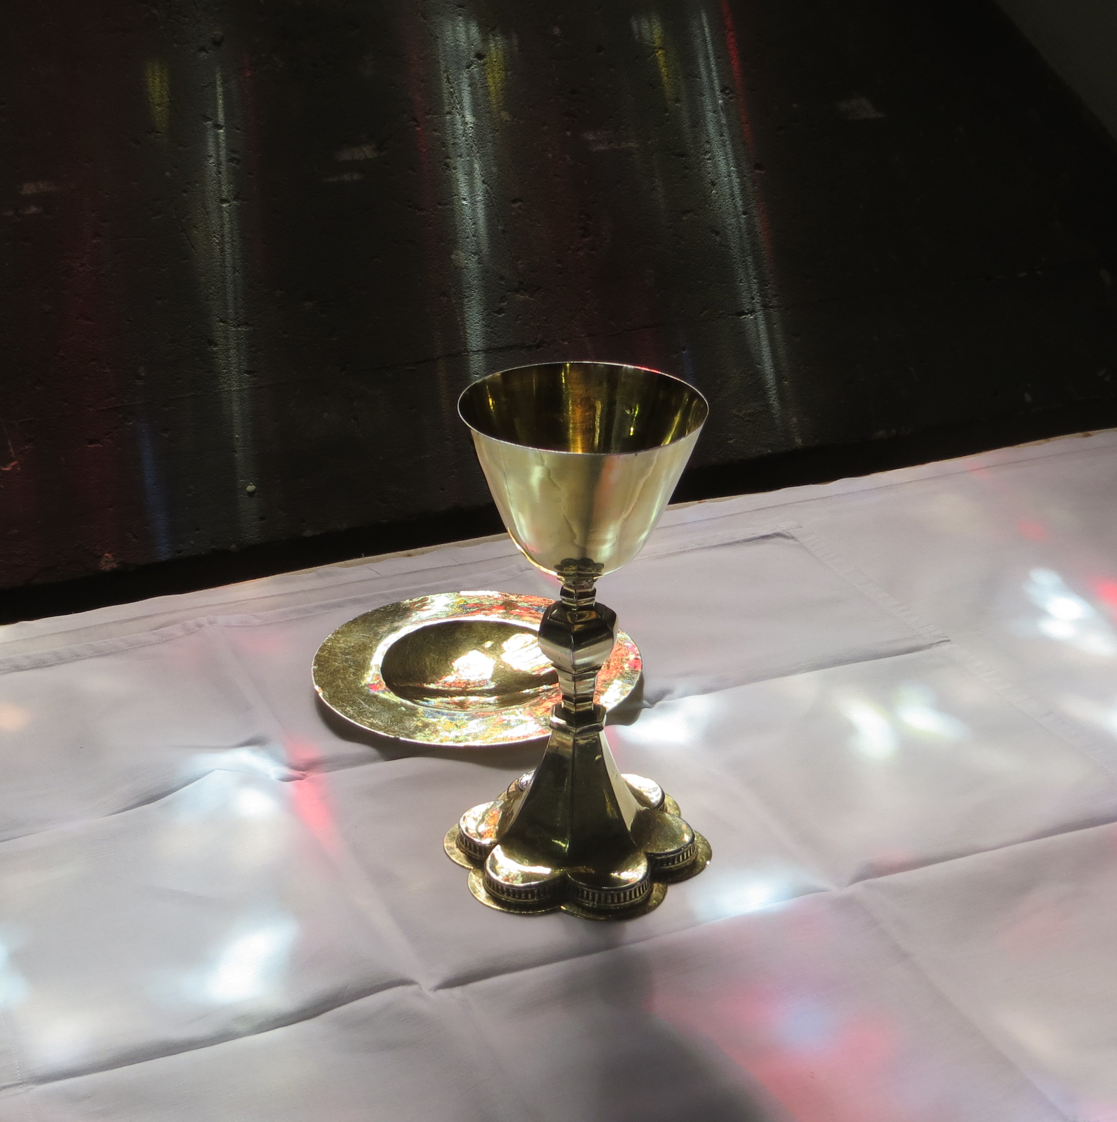
Pray, my brothers and sisters,
that our sacrifice may be acceptable
to God the Almighty Father.
May the Lord accept the sacrifice
at your hands, for the praise and glory
of his Name, for our good
and the good of all his Church.
The Eucharistic Prayer
The Lord be with you:
and also with you.
Lift up your hearts.
We lift them to the Lord.
Let us give thanks to the Lord our God.
It is right to give thanks and praise.

The Eucharistic Prayer, which remembers all Jesus has done for us
and asks him to fill our hearts and lives with his love, continues.
We sing together:

Holy, holy, holy Lord, God of power and might,
heaven and earth are full of your glory.
Hosanna, hosanna, hosanna in the highest.
+ Blessed is he who comes in the name of the Lord.
Hosanna, hosanna, hosanna in the highest.

Then, after we have remembered the words Jesus used at the Last Supper:
(Either)
Praise to you, Lord Jesus:
Dying you destroyed our death,
rising you restored our life,
Lord Jesus, come in glory.
(or)
Great is the mystery of faith:
Christ has died, Christ is risen, Christ will come again.

The Eucharistic Prayer climaxes:
(Either)
Blessing and honour and glory and power
be yours for ever and ever. Amen.
(or, simply)
Amen.

The Lord’s Prayer
Our Father, which art in heaven,
hallowed be thy name.
Thy kingdom come, thy will be done,
on earth as it is in heaven.
Give us this day our daily bread.
And forgive us our trespasses,
as we forgive those who trespass against us.
And lead us not into temptation,
but deliver us from evil.
For thine is the kingdom, the power and the glory,
for ever and ever. Amen.

The Fraction
(Either)
We break this bread to share in the body of Christ.
Though we are many, we are one body
because we all share in one bread.
(or)
Jesus says, I am the bread of life,
whoever eats this bread will live for ever.
Lord, our hearts hunger for you.
Give us this bread always.

Agnus Dei (Lamb of God)
Lamb of God, you take away the sin of the world,
have mercy on us.
Lamb of God, you take away the sin of the world,
have mercy on us.
Lamb of God, you take away the sin of the world,
grant us peace.

The Invitation
(This)
God’s holy gifts for God’s holy people.
Jesus Christ is holy, Jesus Christ is Lord,
to the glory of God the Father.
(or)
Jesus is the Lamb of God who takes away the sin of the world.
Blessed are those who are called to his supper.
Lord, I am not worthy to receive you
but only say the word, and I shall be healed.
(or)
Draw near with faith.
Receive the body of our Lord Jesus Christ which he gave for you
and his blood which he shed for you.
Eat and drink in remembrance that he died and lives for you
and feed on him in your heart by faith with thanksgiving.

If you usually receive communion in your own church, or you’ve done so in the past, you are most welcome to receive communion here today.
If you would prefer to receive a prayer of blessing please bring
this order of service with you to the altar rail.
If you’re not able to walk to the altar rail, please tell one of the sidespeople.

Post-Communion Prayer
Almighty God, we thank you for feeding us
with the body and blood of your Son Jesus Christ.
Through him we offer you our souls and bodies
to be a living sacrifice.
Send us out in the power of your Spirit
to live and work to your praise and glory. Amen.

The Notices and the Banns of Marriage

The Dismissal

The Blessing
…and the blessing of God Almighty,
the Father, the Son and the Holy Spirit,
fill your hearts, and rest upon you and remain with you
this holy day and always. Amen.

A final hymn is sung. As the procession reaches the West End of the church we turn to face the priest, and, as well, the world to which we will return.

Go in peace to love and serve the Lord.
In the name of Christ. Amen.

Common Worship: Services and Prayers for the Church of England, material from which is included in this service, is copyright the Archbishops’ Council 2000.

You are warmly invited to join us for refreshments in the Parish Rooms
after the service.

Please take a weekly Pews News and a monthly Spire Magazine home with you today so you know what’s happening in the life of the parish and what you can be part of. Regular updates are also put on the parish website and on the parish Faceboook page, and the Parish Administrator will always be
in the Office on a weekday morning to answer any questions.

And if you are here for the first time, or still feel new, or have any questions at all, please talk to a member of the clergy or a Warden
so we can meet you properly.

God bless, strengthen and inspire you in the week that lies ahead.

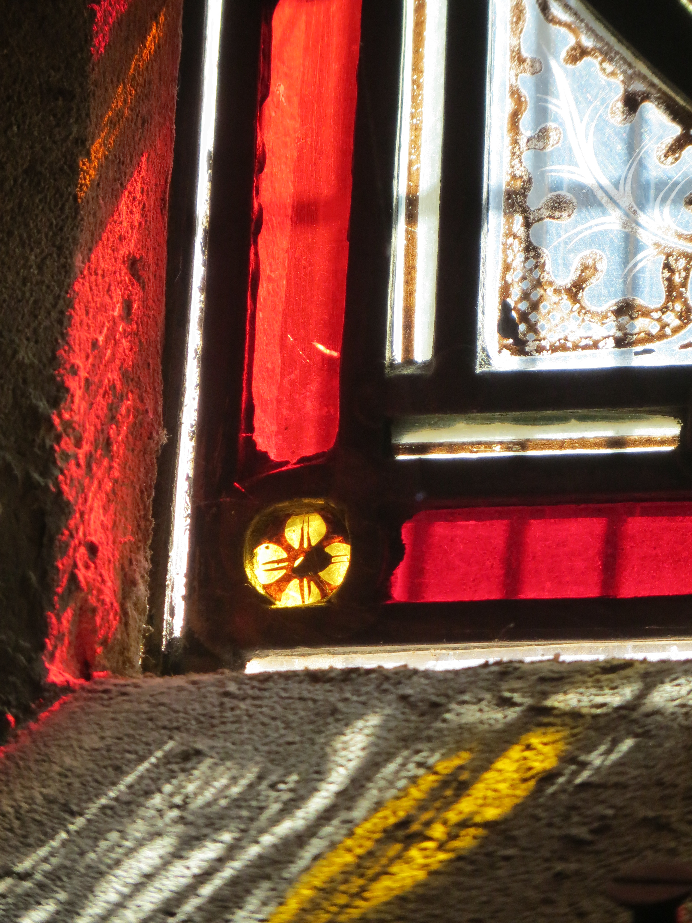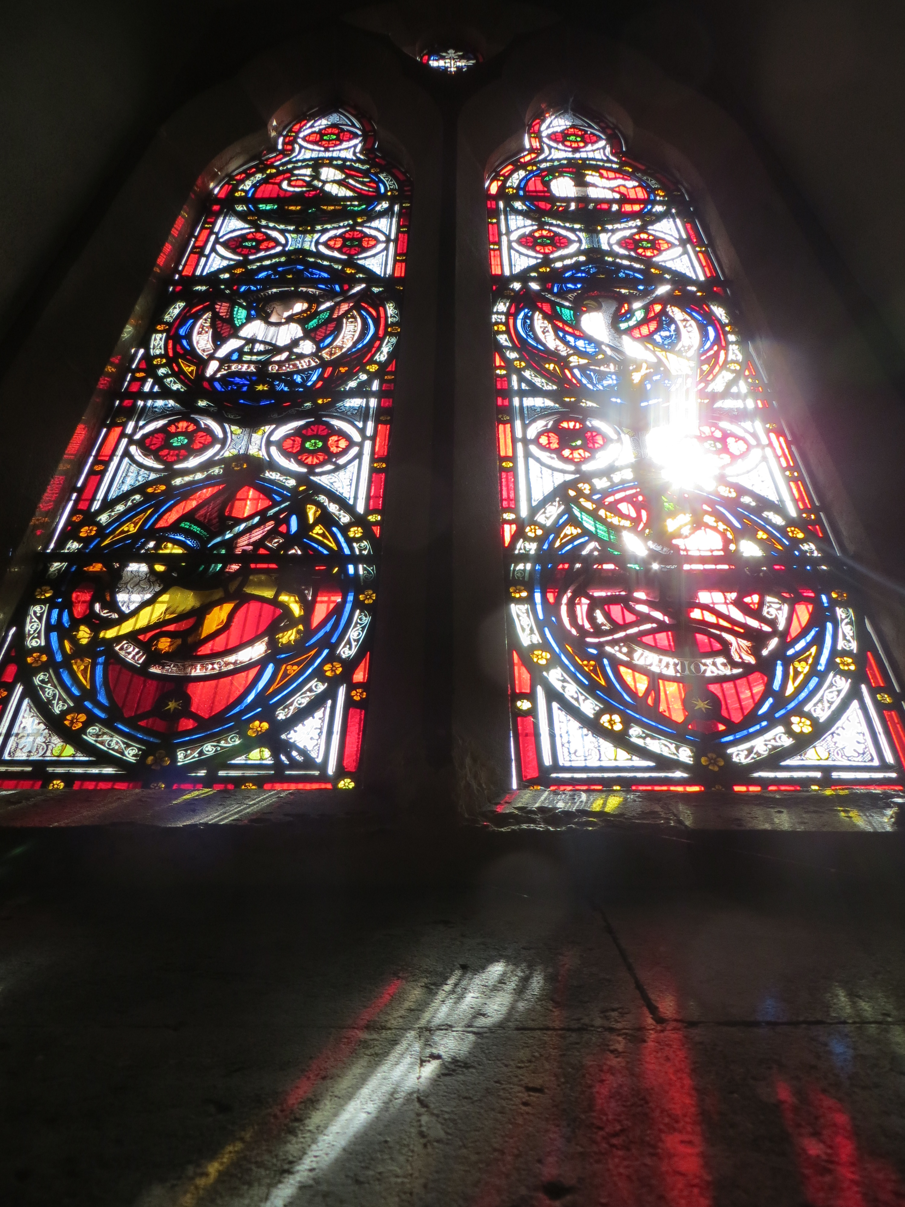

God of truth, we have seen with our eyes
and touched with our hands the bread of life.
Strengthen our faith
that we may grow in love for you
and for each other:
through Jesus Christ, our Risen Lord. Amen.

