Our Mad Life 76
The Lambeth Conference
At long last I break my silence after what has been for me a whirlwind of events. As I write I am conscious that for most of you events of the last couple of months are currently overshadowed by the death of Her Majesty Queen Elizabeth II and the national and international outpouring of sadness and thanksgiving for her unequalled reign and devotion to her people, the Church and the Commonwealth.

For me the Lambeth Conference was unforgettable. Sarah and I drove down to Canterbury on 26th July and duly settled into our luxurious student accommodation in the University of Kent in its spacious campus on a hill top providing panoramic views of the city and cathedral. We had a heavy welcome pack which included an umbrella for what was the hottest and driest of English summers. Over a thousand of us wandered around finding our bearings and food. All was superbly and generously organised with a host of volunteers from Kent and around the world to guide and manage us. In effect this meant that every meal time, transfer from one place to another and getting lost provided the opportunity to meet fascinating people from over a hundred nations represented there.

I was immediately struck by how many delegates came from countries with either direct persecution of Christians or anti-Christian and anti-religious minorities legislation. A lot of the discussions also centred around climate change. This was in marked contrast to the media reports which gave the impression we were disagreeing on everything and obsessed by gay marriage. We were divided into small groups for Bible study and discussion of the “Lambeth Calls”. It was made very clear at the outset that this was not a Synod and thus had no power to legislate and make decisions that were binding on any Province of the Anglican Communion. Each major topic would be introduced, discussed and then issue a “Call” to all the dioceses throughout the world to implement it.

Each morning a different Province was responsible for the vibrant worship and this was for me one of the highlights of the Conference. After breakfast was Bible study and group work. My group had a very conservative bishop from South Sudan, a lady bishop from New York, a bishop from Tanzania, the new bishop of Salisbury, the bishop of Grantham and the bishop of Bangalore who only appeared once in all our many sessions! The spouses had their own groups and own programme while we bishops discussed the Lambeth Calls.

On the first working day we were issued with head-sets as everything had simultaneous translation into French, Spanish, Portuguese, Swahili, Arabic, etc.. and little voting machines. A lot of the talks and parts of all the services were in different languages.

The first “Call” was on Evangelisation and one had to press ‘1’ on the voting machine to express total agreement with the statement, or ‘2’ to agree but request rewording or ‘3’ to request it being redrafted. There was, not surprisingly, very broad agreement but the press next day reported that the majority of Anglican bishops were not in favour of Evangelisation! This misrepresentation was justified by adding together those who requested rewording and modification and stating that they did not agree with the Call to Evangelisation. In actual fact there was 100% agreement about the priority of Evangelisation everywhere – but not on the precise wording. Following this experience of inaccurate reporting it was decided to abandon the voting machines!

There was, it has to be admitted, a general anxiety about how the Call on “Human Dignity” would proceed as this included the vexed question of same sex marriage. How did I vote, many wanted to know? Well, we didn’t vote. After much behind the scenes negotiation the Call was skilfully and sensitively handled by the Archbishop of Canterbury and, instead of the fierce disagreements eagerly awaited by the press, there was an unanimous standing ovation and with a profound sense of “disagreeing well” we adjourned for a cup of tea. This however was achieved in part by the most conservative African and Australian bishops boycotting the Conference.

One of the more absurd moments of the Conference was three hours spent being marshalled in a field in blistering heat for our collective photograph to be taken.

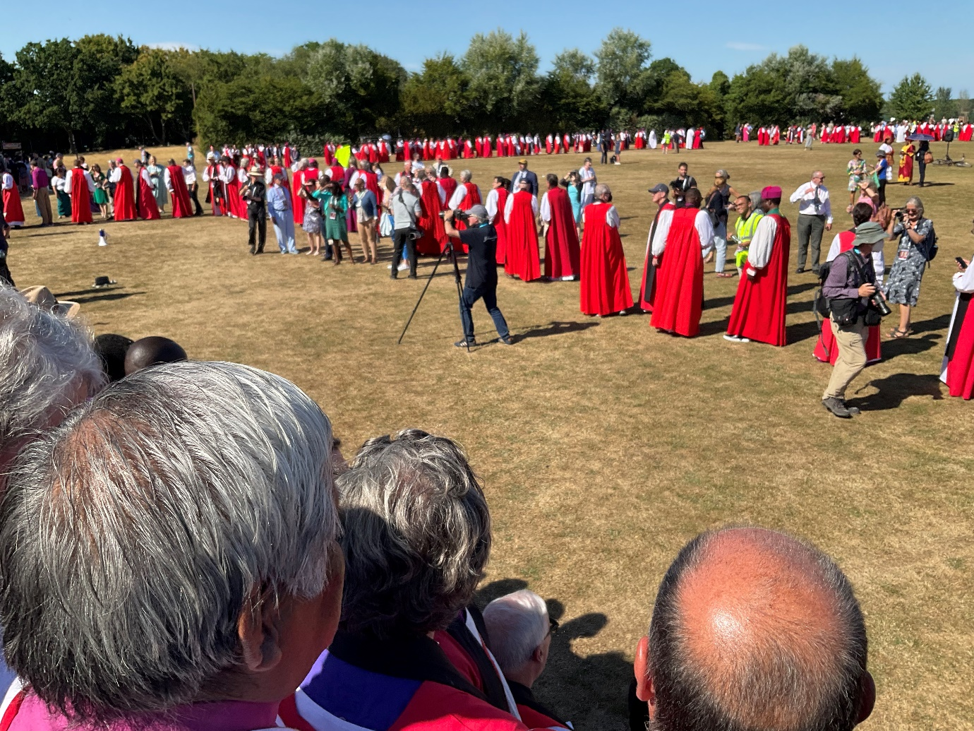
The queue making its way painfully slowly onto the staging.

A new feature was the sizeable number of female bishops who have been consecrated since the last Lambeth Conference. I shouldn’t have been, but was very surprised by the number of very dynamic lady African bishops who played a major and impressive part in the proceedings.

One of the amazing feats of organisation was a day out at Lambeth Palace, which included a sit down lunch – in one sitting – for over a thousand people and a boat trip down the Thames (avoiding the evening rush hour traffic) to North Greenwich and thence back to Canterbury.

The wonderful sense of friendship and fellowship grew daily and I left Canterbury much inspired, hopefully much better informed, enthused and tired.

However, next day it was farewell to Sarah and off to Madagascar aboard Ethiopian Airways via Addis Ababa.

One of the reasons for my prompt departure was that I wanted to be back in Mahajanga for the National Conference of the Men’s Society which takes place every few years and this time was meeting there. The Opening Service saw the cathedral packed with men from all over Madagascar. The Bishop of Fianarantsoa was due to lead this but he and the other bishops were all delayed in arriving and at the last minute I found myself presiding and having the honour of welcoming the Prime Minister, who is an Anglican, and addressing all involved. Like so many politicians the Prime Minister was pleasant company but I can’t claim that any of my comments about the state of the Church, nation, global warming, etc. received any meaningful response.

I will tell you next time about the clergy and wives training and diocesan synod that followed on from that.

I have had my private moans about fatigue caused by public duty put into perspective by heartfelt responses of all sorts of people here to the dedication, integrity and dignity universally admired in Her Majesty the Queen. Above all her quiet but eloquent witness to her faith has been a shining example and will be a continuing inspiration.

Love and Prayers
+Hall

hallspeers@gmail.com

17th September 2022

