Our Mad Life 77
Volleyball and Vertigo
Immediately after the national conference of the Mens’ Society I set off with the clergy and their wives from across the diocese to the Petite Plage just north of Mahajanga for a week of Training and Fellowship.
All these meetings back to back was to save travelling expenses and time. The return journey to Maintirano in the south is now not achieved in less than three weeks by the time one waits for sailings, which in turn wait for full cargo and the high tides. Following the burglary during her last trip away from home the priest’s wife at Maintirano didn’t dare leave home – plus the uncertainty of being able to return home in time for the start of the new school year.
To my surprise her place was taken, without forewarning, by the wife of the priest at Maevatanana whom we hadn’t seen since that last major “freebie” which was the MU national conference three years ago. Having received her fare home from it she took herself off to the east coast to her other “husband” and their son… I was speechless! She wasn’t; she joined in everything with panache without the slightest hint of embarrassment. At the end, having got the lie of the land, she put in a request for a grant to start up a business and a bill for the tuition of the priest’s two illegitimate daughters (dating from one of her previous long absences). She discovered that there are limits to my generosity and some rules to be complied with.
I gave up within minutes of arrival at the conference centre of allocating the sleeping accommodation and was more than grateful when one of the rural deans, who had arrived early, announced that it was a simple job and he would do it. He did so to everyone’s satisfaction. What I couldn’t cope with was that two of the three cooks we paid turned up with grandchildren. I have got used to mothers arriving with babies and toddlers but I still have no idea what the expectations are on sleeping accommodation. Happily, the RC Sister in charge of the conference centre had designated a lovely en suite bedroom for the bishop and her word was law.
Prior to the event, on the insistence of the diocesan treasurer, I had meticulously worked out a menu, priced this according to the quantities required and ordered it all including the charcoal for the cooking stoves. As always I had not included extra mouths to feed since I thought I knew how many I had invited. My learning curve never seems to flatten out.
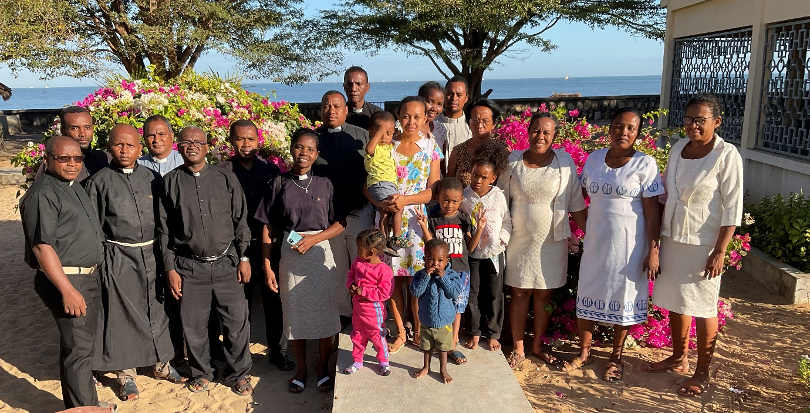
The group. My ‘problem’ spouse is resplendent in her white MU uniform
When the bus arrived at the seaside with the clergy and spouses and all the luggage, including the large cooking pots for the rice, there were whoops of delight as all explored the site and the beach it was situated on. Nobody had been there before and all were thrilled by it.
Our daily programme was simple: 6 am Morning Prayer, breakfast, a Bible study on the first epistle of Peter, discussion groups, mid-morning break and snack after which I led a session on one of the “Lambeth Calls”. At noon I celebrated Communion and preached. Our cooks worked hard and there were generous amounts of excellent food. In fact, I overheard one of the clergy describing the event with a list of how much weight each participant put on in the week! I can’t imagine when they weighed themselves – or how.
After lunch was free time until the afternoon snack. I had worried a lot about how to organise team building games, etc. All quite unnecessarily, as a marvellous time was had by all with tug of war, football and of course, swimming.
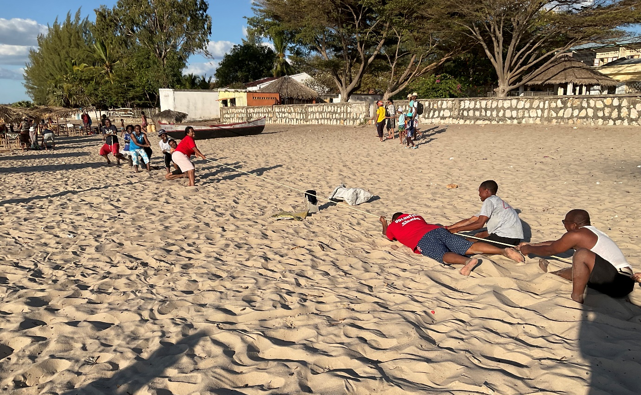
After Evening Prayer we discussed another Lambeth Call which always led into far ranging discussions. There was a unanimous request that I book the same place for a week next year.
And so to Diocesan Synod the next day. I always preach on the gospel appointed for the day. It was the story of the disciples having toiled all night and caught nothing being requested by Jesus to launch out into the deep and let down the nets for a catch. It seemed an appropriate way to launch the synod to call the members to launch out into the deep …
The days were again full starting with the 6 am service (no morning or afternoon break!) and ending with 6 pm Evening Prayer. The big change that was fiercely debated and voted through is that the diocesan finances are to be centralised. Each parish, starting in December, must send its quota to Bishop’s House and the next month the priest will receive his stipend in proportion to the money received. Again much of the debate arose from the Lambeth Calls and here the week together at the Petite Plage showed its worth with informed discussion. It was late on the Saturday night that we got the final synod report to the printers who worked to have it ready by the end of the Sunday morning concluding service! The proceedings came to a final end with a lunch at Bishop’s House in high spirits. We ended by singing “Auld lang syne” – Malagasy version which has several verses, each with a different action of togetherness.
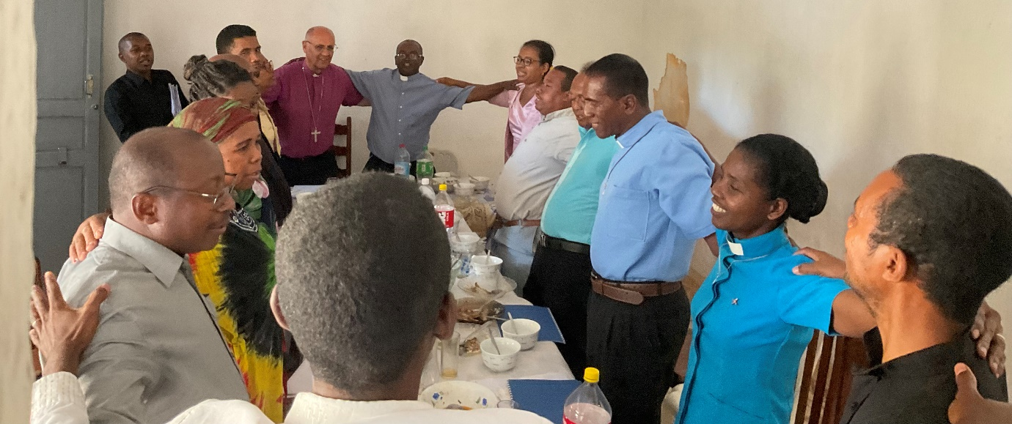
And so concluded a month that had started in Canterbury and continued without a break with the Men’s Society National meeting, eight days of clergy and spouses’ training and the residential Diocesan Synod. I was really exhausted and, after a tidy up took myself off to recuperate at a beach hotel for two days. Alas, too little too late! The next day I had an extreme attack of vertigo at a graduation party here in Bishop’s House. As I was violently ill there was no disguising the fact – to the great alarm of the guests.
My protestations to the contrary were completely ignored and a doctor was summoned who instantly injected me and declared I needed three days total bedrest and no food in her private clinic!! Thus my first Sunday without engagements found me in bed on a drip, and total rest that morning included having over 50 visitors. Facebook had done its worst, as far as I was concerned. Back at Bishop’s House on Tuesday night I was feeling weak but I made a spectacular recovery once I had some food and was feeling fit on the Sunday and able to lead a three hour long Confirmation service. What a relief. So much to be thankful for.
Who can doubt that your support and prayers have carried me through. THANK YOU.
Love and Prayers
+Hall
hallspeers@gmail.com

Circulated 5th October 2022

