Jane’s Christmas Pudding
The phrase “Christmas seems to start earlier every year” is now being heard in the shops and supermarkets all over the country. For me the Christmas preparations begin in October it is the month when I make the Christmas puddings so that they have 2 months to mature before the big day. In the church of England Stir up Sunday is a nickname given in the last Sunday before the season of Advent. It gets its name from the beginning of the collect for the day in the Book of Common Prayer, which begins with the words, "Stir up, we beseech thee, O Lord, the wills of thy faithful people". This same prayer has been retained in Common Worship but as the post communion prayer on the Sunday before Advent which is also the Sunday when we celebrate Christ the King. It has traditionally become associated with the time for making, “stirring up”, the Christmas puddings. I personally like to leave my puddings longer than 4 weeks before they are eaten. So just in case you feel you would like to have a go at making your Christmas pudding this year:
Now is the time and here is my recipe
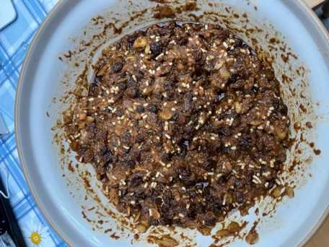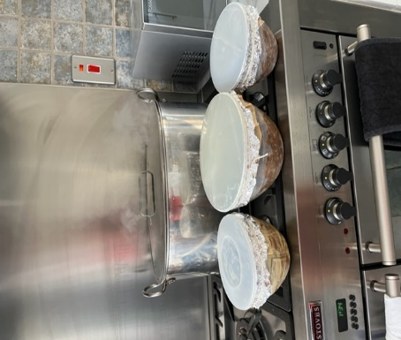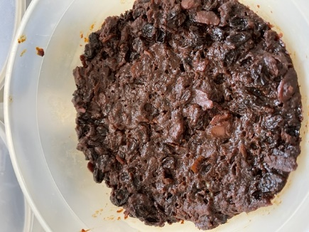
The mixture standing over night Puddings ready to steam The finished pudding
Ingredients.
4 oz Self raising flour, ½ tsp mixed spice, ¼ level tsp ground nutmeg, ½ tsp ground ginger, ½ tsp salt, 8oz fresh white breadcrumbs, 8oz shredded suet (I use vegetarian suet), 3oz shredded blanched almonds, 16oz raisins, 13oz sultanas, 6oz muscovado sugar1 large grated bramley apple peeled cored and finely grated, 2carrots peeled and finely grated. grated rind and juice of 1lemon and 1 orange, 2 level tablespoons black treacle. 4 eggs beaten, ½ pint brandy.
Method
Sift together dry ingredients. Wash raisins and sultanas and mix with all the other ingredients until well blended. Cover with clingfilm and leave to stand overnight. Turn into well-greased pudding basins filling each ¾ full. Cover with greaseproof paper and aluminium foil and tie with string. Boil/steam for 10 hours. Remove from the heat. Take off the covers and leave overnight. The next morning cover with fresh greaseproof paper and foil, retie with string and store until Christmas Day. Makes 3 medium size puddings. Serve with custard or cream or brandy butter or all three.

