Our Mad Life 78
New clergy and daily life
Since last writing the big event in the church in Mahajanga has been the ordination of two new deacons: Helarcin and Erick Stanislas.
People here are very loath to use names. Most ladies are known as ‘the Mother of X’. Even husbands will call their wives “Mother of X” which sounds so unfriendly to me. Anyone who holds office in an organisation is referred to and addressed by their title. I have been to a meeting where all but two present were addressed as ‘President’. Add to this people changing their name! Our new deacon, son of the Archdeacon, is known to his parents and siblings as Erick. However, since the birth of his son Ericko (my Erick) he now wishes to be known as Stanislas. How different from the universal use of first names now in Europe! Talking of cultural differences I have caused surprise and confusion here by a flat and emphatic refusal to the suggestion by several well wishers that I get one or more of the young men to share my bed in case I have another attack of vertigo. A different understanding of Safeguarding!
Before the ordination I took the two men on retreat at a very well appointed RC Convent of the Sisters of the Sacre Cœur. It was a great privilege to spend those days together in prayer and study without any visitors, office work or household chores. On the Sunday the cathedral was packed with the extended families as well as local churchgoers. Some of the RC Sisters from the retreat house also came. The congregation was further increased by all those watching on-line.

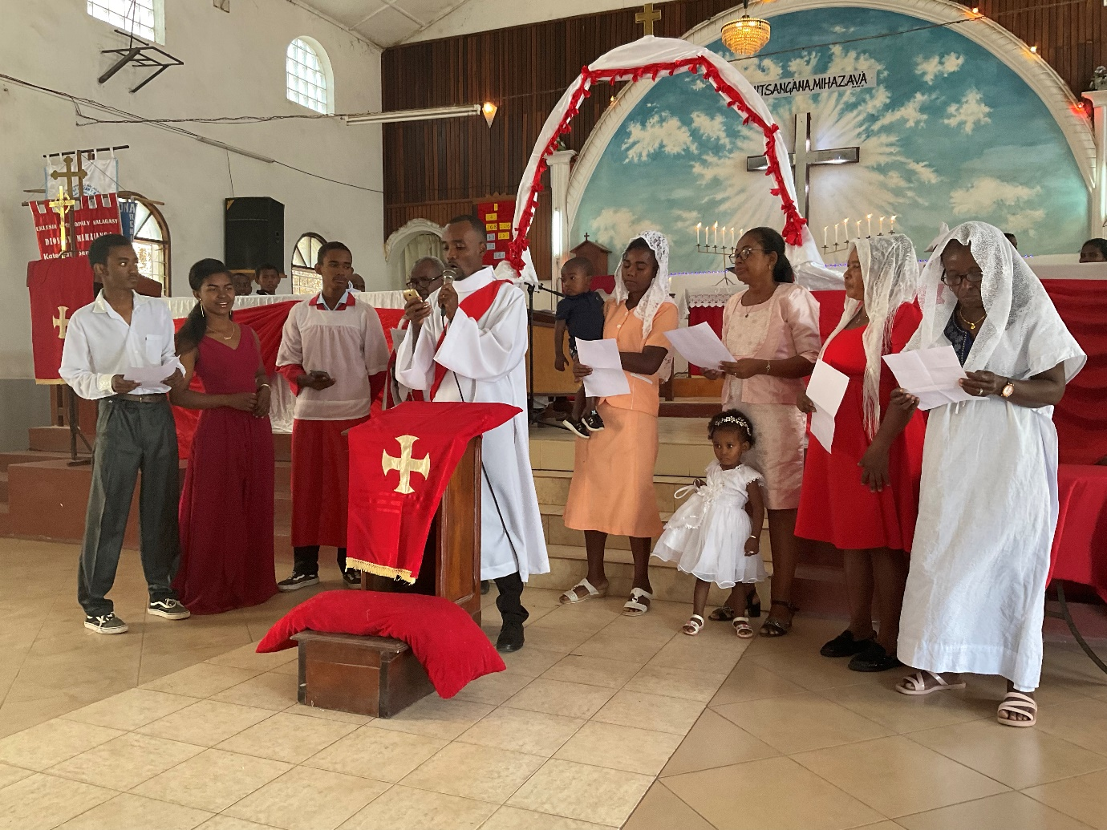
Stanislas singing, his wife, Nirina, and their little son Ericko directly behind him, his step mother and his young sister, Elinah, next to her and his mother on the extreme right. You will note the prevalence of red.
The Archdeacon was insistent that everybody got a chance to sing but Helarcin and his wife thought they had enough to do without having to rehearse an anthem. They had my sympathy. On the other hand Stanislas seized the opportunity and immediately after the ordination he sang with great panache with the Archdeacon and all his extended family as his backing group. The congregation loved it and there was thunderous applause.
After lengthy photographs the deacons held a reception for a hundred people in front of Bishop’s House. I was very impressed by the organisation. All the food had been cooked by the two wives and their friends and the drinks were home made fruit juices. I confess that after seven hours on my feet I had a siesta instead of attending Evensong.
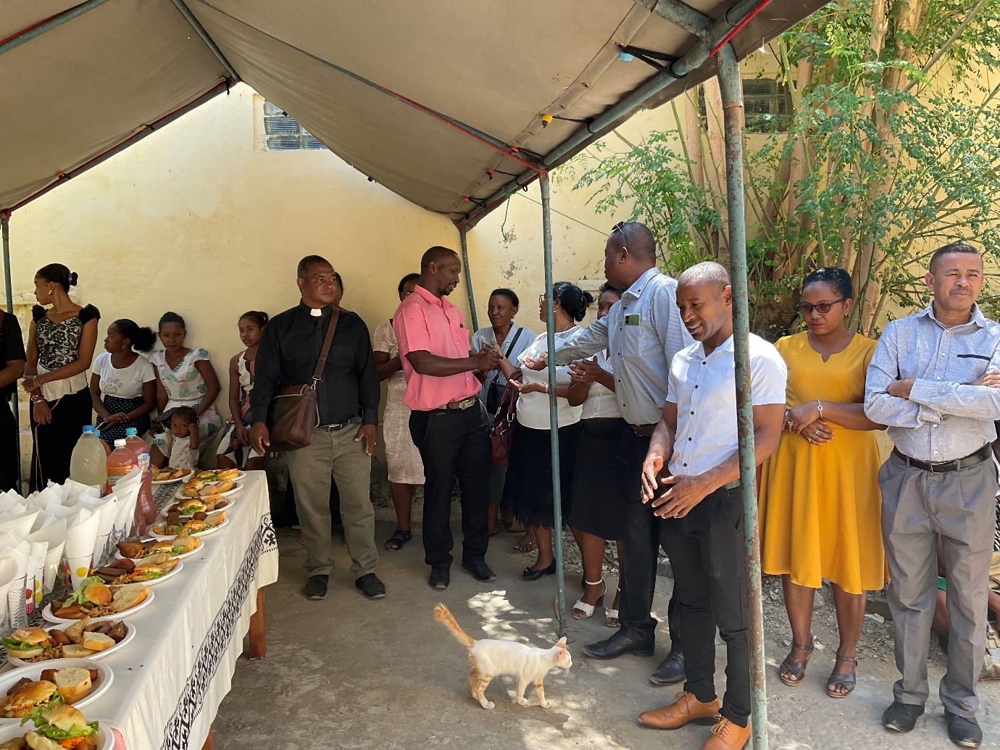
However, the day was not over and I was summoned by Helarcin to a splendid family dinner party on our downstairs verandah. That is normally a bare and uninviting place but as we sat there in the warm darkness of a tropical night with lots of food and jolly company it all seemed exotic and fun. I was so conscious of what a blessing the day had been and how very fortunate I was to be at the centre of all this.
I have sent Stanislas to Mandritsara in the mountains in the far north east of the diocese. The parish is huge and in chaos following a disastrous ministry by the last priest whom I suspended after theft which he admitted to. In fact the diocese had to repay the stolen money to avoid him being imprisoned. There had already been complete pastoral breakdown so I had no hesitation in taking disciplinary action. However, it was obviously wrong to leave the priest and his family destitute so I appointed him as a part time school teacher in a church school and gave him a house at one of the schools. He and his family are delighted at their change in circumstances.
The Rev Stanislas and his little family are in a rented room with no facilities so my current absolute priority is building a house for them on land which we bought two years ago.
Meanwhile the schools are flourishing which means a constant demand for new desks. The school at Antanankova which looked a bit of a lost cause two years ago has now over 90 students and Port Bergé has almost 600 students. New class rooms are in use at the school in Morarano. Another church school has opened at Andambalo. As there is not enough income to pay a teacher four teachers are taking it in turn to teach and earning their income in the rice fields.
Meanwhile Helarcin, a graduate in law, has started work as part-time cathedral curate and part time administrative assistant to the bishop. So far he has been brilliant in both roles. I have enjoyed more than I expected having the family here in Bishop’s House. The two little boys are close in age to my grandsons in Bath so it is both fascinating to watch their development and a constant reminder that I am missing family… Joy has just had his second birthday and loves coming in to see what I am doing and sits opposite me at my table and watches intently and coughs when I cough.
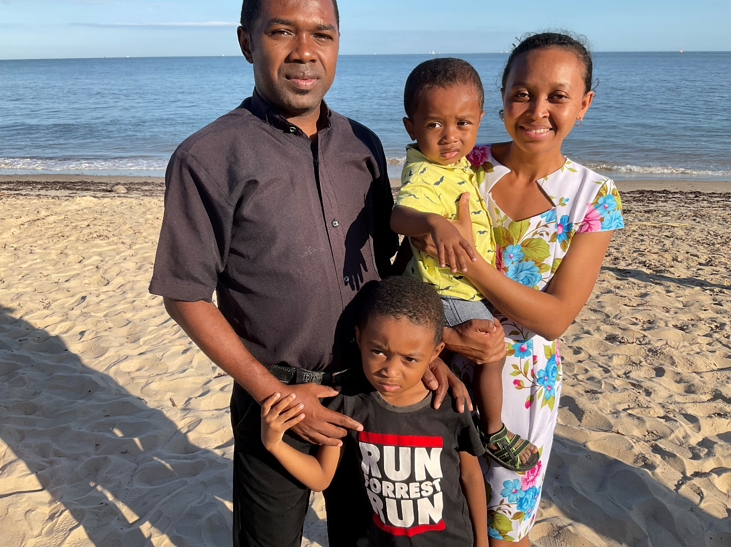
Helarcin and his wife Angela and their boys, Reitchy and Joy (pronounced Jo-ey).
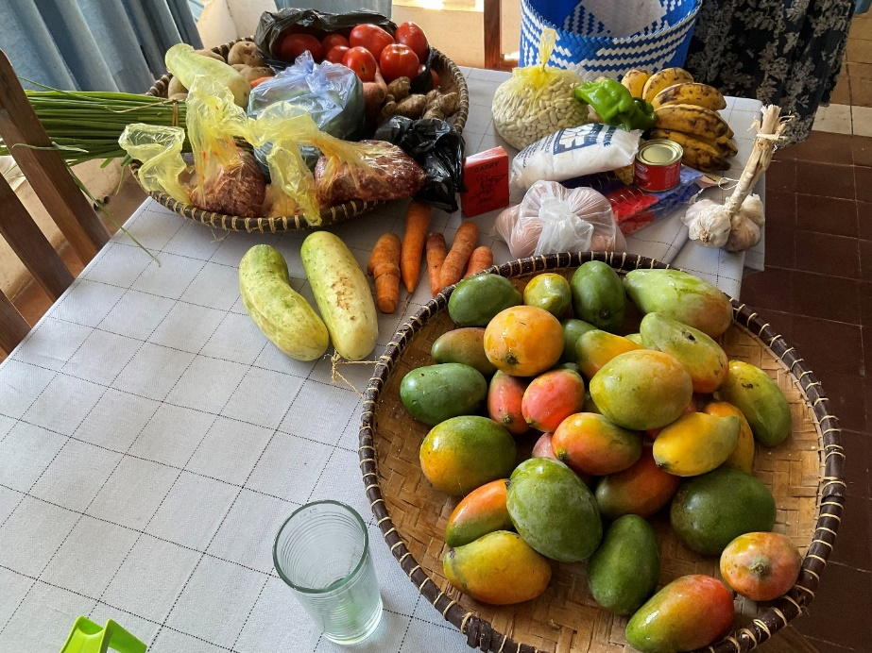

Emilienne is also enjoying the company. Unlike Angela who goes to the market every morning Emilienne has reduced this chore to a weekly shop. This is the result of such a shopping spree: that lot cost £13 but it doesn’t include cooking oil, rice and other basics. However, that is a third of the monthly pay packet of some teachers. I don’t know how they survive.
As you see the mangoes are ripe and come in many varieties. For all this and more I give thanks and, as always, am very keenly aware of your support.
God Bless you.
+Hall

hallspeers@gmail.com

All Saints, 1 November 2022

