Our Mad Life 79
Summertime
As your days get shorter the summer days here grow longer and the rooster next door wakes me earlier and earlier. Now he is generally in full voice by 3 am. I do wish he would become someone’s meal. I often think of Jesus saying to Peter, “Before the cock crows twice you will deny me three times.” The denials either came very early or in very rapid succession if the cocks in Jerusalem were like their current Malagasy relatives. There was a lovely period of respite while the neighbours kept ducks instead of hens.

Meanwhile something seems to have happened to the mosque’s loudspeaker as it has dramatically decreased in volume which, as far as I am concerned, is a matter for considerable thanksgiving as it now calls the faithful to prayer just after 4.15 am. My alarm goes off at 5 am which is still early by my standards but is now after dawn and a very pleasant temperature. Except on Tuesdays and Sundays (when I start the day with Morning Prayer) a cold shower starts the day’s rituals. Again, the joy of summer weather is that the real chill has gone off the water. This is a great luxury both in terms of facility and water use. None of the clergy have anything like that. Most people buy their water by the jerrycan and it is expensive and often brown. I have just had a request from the new deacon in Mandritsara for a water allowance as their water has gone up in price. My immediate response is to sink a new well beside the house we are building.

By 6 am I am in the cathedral for Morning Prayer (Holy Communion on Tuesdays) which has a small but unpredictable congregation. Equally unpredictable is the number of hymns and canticles sung: some mornings the whole thing is sung and some days nothing is sung except a hymn. I embarrass myself by yawning in the midst of hymn singing. 6 am is not considered early for anything here; the secondary schools begin at 6 am and the primary schools at 7 am or 7.30 am.
Everyone waits for me to leave the church at the end of the service when I take my place outside and each member of the congregation kisses the episcopal ring and kneels for a blessing. When that tradition ceased with the pandemic I assumed that it had gone for ever, but somehow it has crept back. Only this week I reaffirmed that the custom is not obligatory. Why would the bishop not want to give us each a personal blessing? I am asked in reply. And so it goes on.

Next stop is the bakery. It is such a treat to have bread (French stick) hot from the oven for breakfast: half for me and half for Emilienne. I thought I would delegate the trip to the bakery to the Rev Helarcin but have discovered that he lingers about twenty minutes chatting at the cathedral and he and his family don’t eat bread. They have rice three times a day. The breakfast rice is cooked until it is very soft, almost a soup. Because it comes with so much liquid they don’t feel the need for anything to drink. Therefore no tea or coffee. This I find strange as I am addicted to my morning coffee and they come from a coffee growing area and Helarcin’s wife trades in coffee beans. So we have the extraordinary sight of the coffee delivery at Bishop’s House coming in huge sacks on a rickshaw.

Emilienne has managed to break a succession of cafetières I brought from England so I now make my coffee in the local manner using a bag which is simply rinsed out after use. The resulting coffee is very acceptable. I am sure the rich flavour is partly determined by the daily use of the same bag. Real coffee connoisseurs tell me that the taste is all to do with the roasting, but they haven’t used my well seasoned bag!

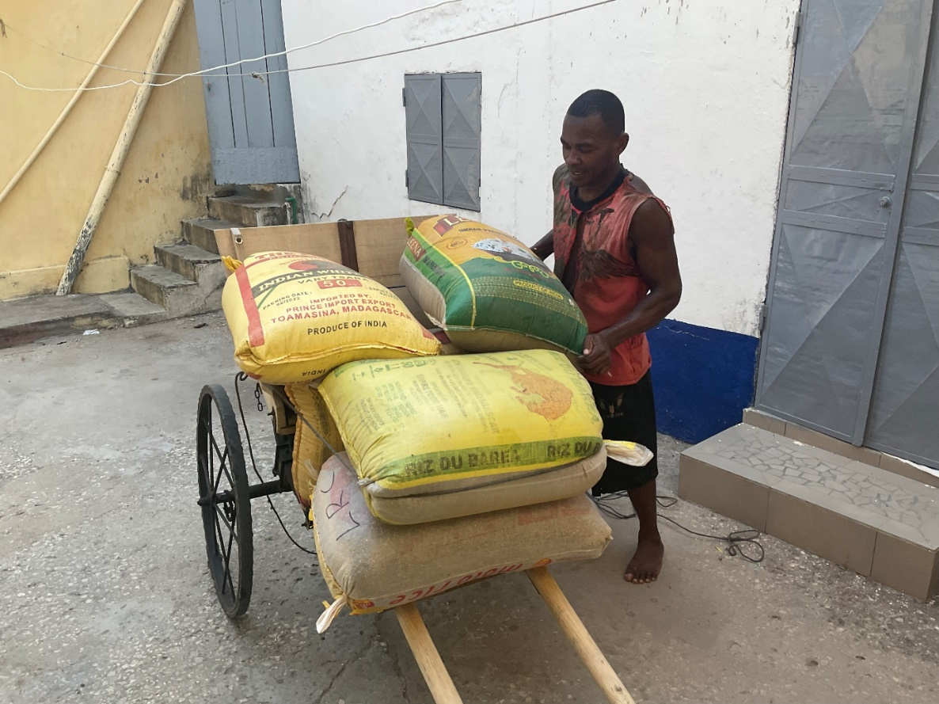
Sacks of coffee arriving

I am currently in another round of Bishops meetings and am actually writing this in the lovely calm atmosphere of the Sisters’ Convent just outside Antananarivo, having travelled here overnight on the bus.

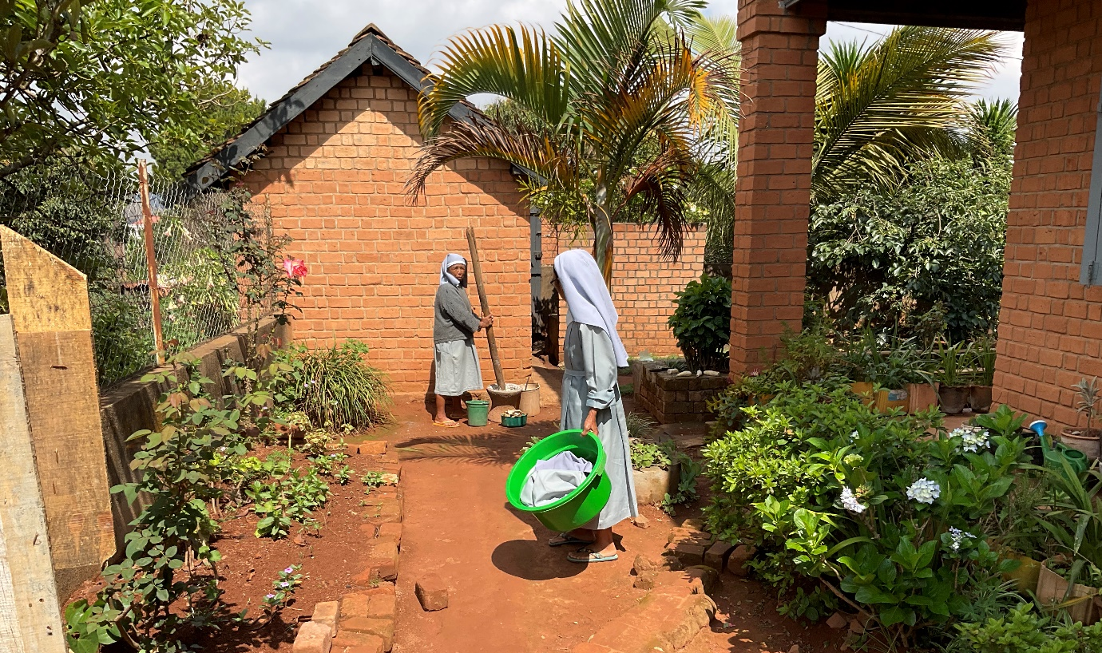

Everyday life at the convent. Threshing the rice and doing the laundry. The Sisters currently give 60 deprived children breakfast and lunch. They now want to build and run a school for these children.

Last week my diocesan development committee met. There is always too much on the agenda but it is exciting and at times difficult as we try to stick to our priorities.
Number one priority currently is building a house for the Rev Stanislas in the far north east of the diocese. The well that I was so quick to suggest is much more expensive than usual as one of the reasons for the water shortage in the town is that there is rock on or just below ground level.

You may remember that the Mothers Union had a wonderful project to register births. Unless you are registered you don’t officially exist and so have no right to education or health care. After initial enthusiasm on the part of the local authorities, and promises of co-operation right up to the day the project was due to begin, suddenly they called a halt “because next year there is a presidential election due and only the registration of voters is now to take up officials’ time”. We also discovered that one of the reasons why births were not registered in one area is that some officials are charging huge amounts for birth certificates. You cannot vote unless registered, of course.

Nothing daunted, in spite of having spent over two years and quite a bit of money on this project, the MU are putting this on the back burner and pressing on with another ‘resilience’ programme. They are currently distributing solar-powered lamps to homes without access to electricity or who cannot afford electricity. The vast majority of homes in the diocese are lit by one candle at night which is inadequate for children doing school work as well as normal household activity, and a fire risk. This has been enabled by a special grant from the American Episcopal Relief fund.

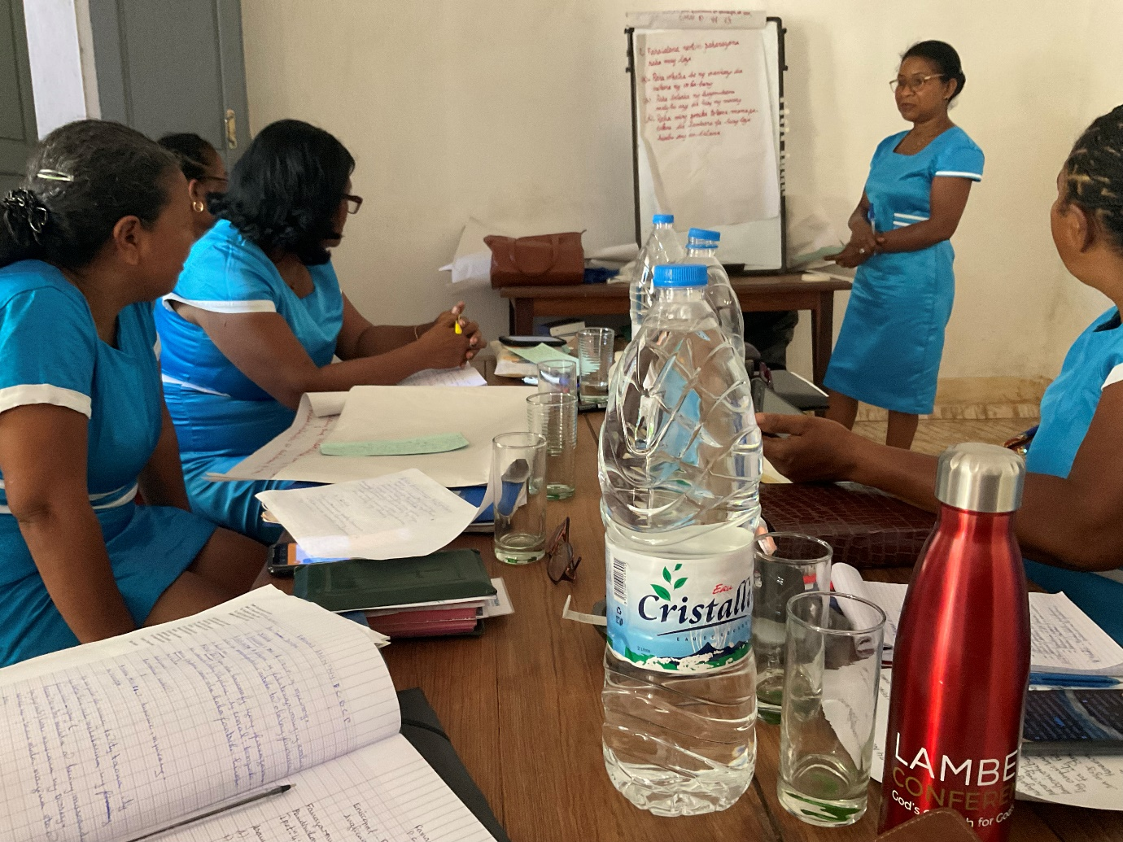
MU Diocesan committee Bible Study

As if this is not enough the MU is also heading up a reforestation project, starting tree planting this month with saplings provided free by another charity.

The new church of St John the Baptist, Manantseva was the result of evangelisation of the village by Mothers Union members. They were delighted with their new church but the leader came to me saying that, in spite of her prayers for men to come forward, the Lord just kept sending them women and children.

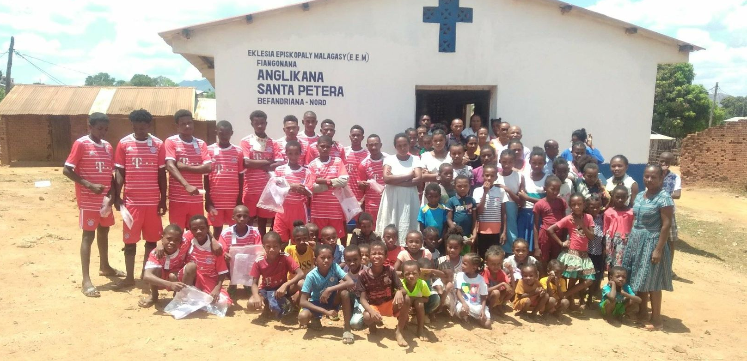

She decided that what they needed was a football team and could I sponsor the kit? Thanks to my friends I was able to do this and here they are at the neighbouring church of St. Peter’s, Befandriana, with members of the congregation.

Meanwhile there has been mounting excitement as the churches in the Marovoay region, all denominations, have organised a competition of “danse evangelique” and our team made it to the semi-finals and then to the finals. I have just heard that we won! You will not be surprised to know that the enthusiastic Rev. Gaston was their tutor.

It feels strange to wish you a Merry Christmas as we observe a very strict Advent and there is no tradition of Christmas cards or Christmas presents or Christmas dinner. I know many of you are stressed by the commercialisation of Christmas and getting ready – but I do miss it!

May you have a Blessed Christmas as together we celebrate the Nativity.
God Bless.
+Hall

hallspeers@gmail.com

5 December 2022

