Our Mad Life 80
Farewell to 2022 and Happy New Year 2023
Since last writing I have had an exciting time with Confirmation visits. Most memorable was my visit to Port Bergé. After a long exhausting day bumping along in the taxi-brousse the Rev Helarcin and I arrived and went to my usual abode there, the Hotel Plaza. It is a series of one room chalets right in the town centre. I like it because it is clean and quiet. Having now stayed in most of the rooms I am no longer disappointed to find that the well equipped bathroom has only water in one tap and one has to be careful to keep the water container full as the water comes on at 9 pm and stops at 5 am on the dot. The electricity for the town has also limited hours but not so well defined.
The Rural Dean warmly welcomed us and said that Evening Prayer was in 15 minutes in the church. Did I need to rest or would I like to come? Although very tired I understood this meant – we hope you are coming but we will understand if you can’t. So off we went on his motorbike to find a packed church waiting to welcome the bishop.

Morning Service was at 5.30 am. Again the church was full. After breakfast at a market stall we set off in a tuctuc to inspect the work on a new church building at Bemilolo. At one stage on the journey there were eight people in the tuctuc: one perched each side of the driver, four in the passenger seat and two in the luggage shelf behind the seat! The legal limit is three passengers.

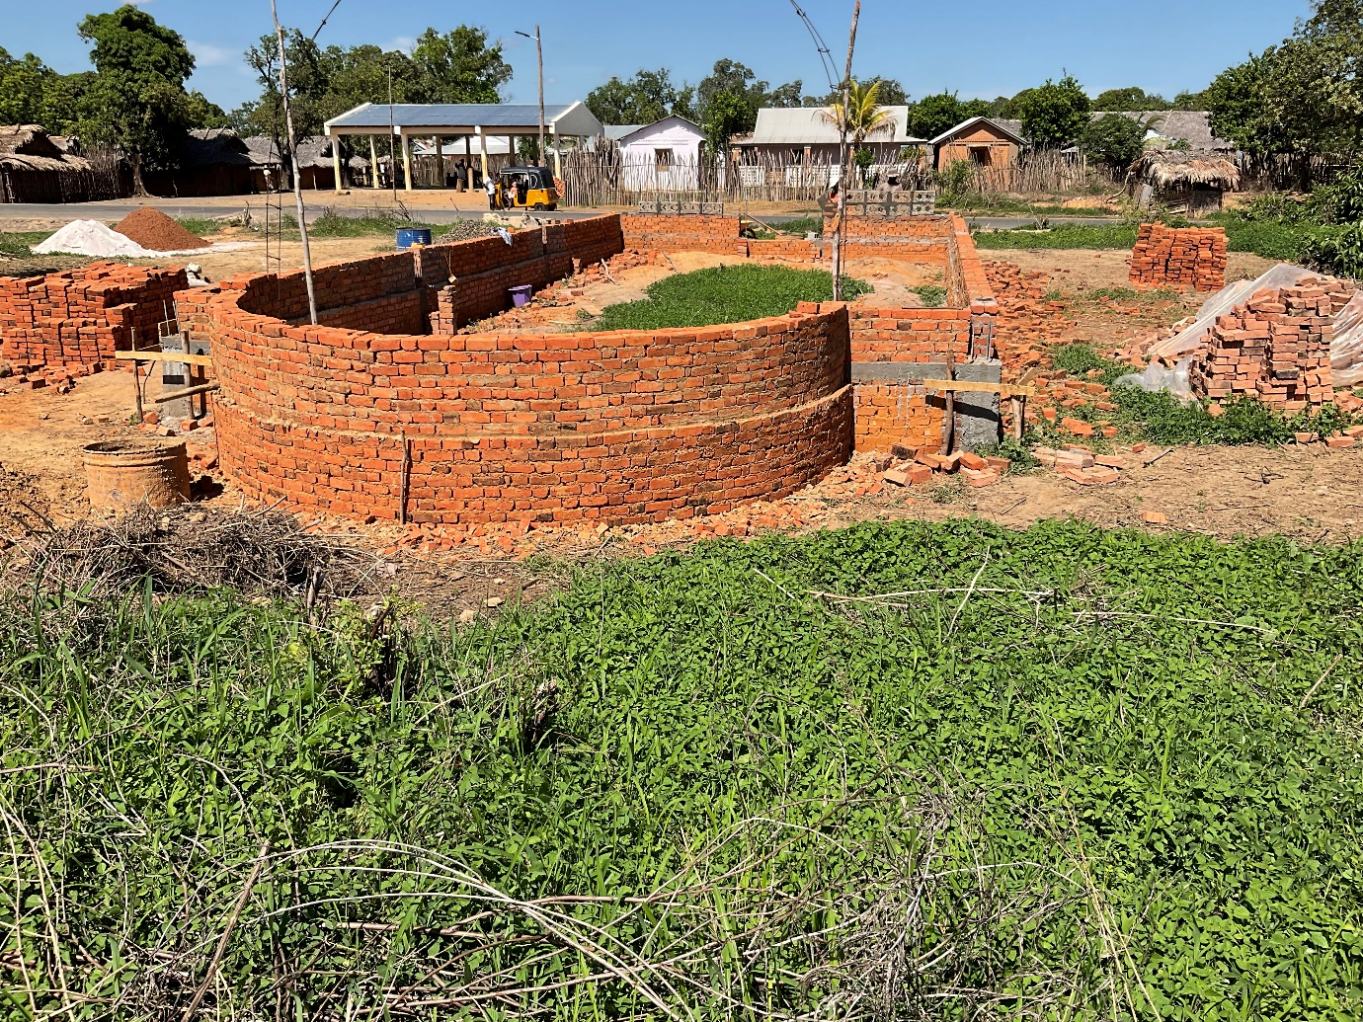

Since I took this photograph the side walls are almost up to roof level. It is a great site on the main road north from the capital and opposite the village market place. After having walked around the extensive grounds we visited the church school at Antanankova. This has been something of a problem in the past but we appointed a new headmaster, Mr Claris, last year and it is now another success story.
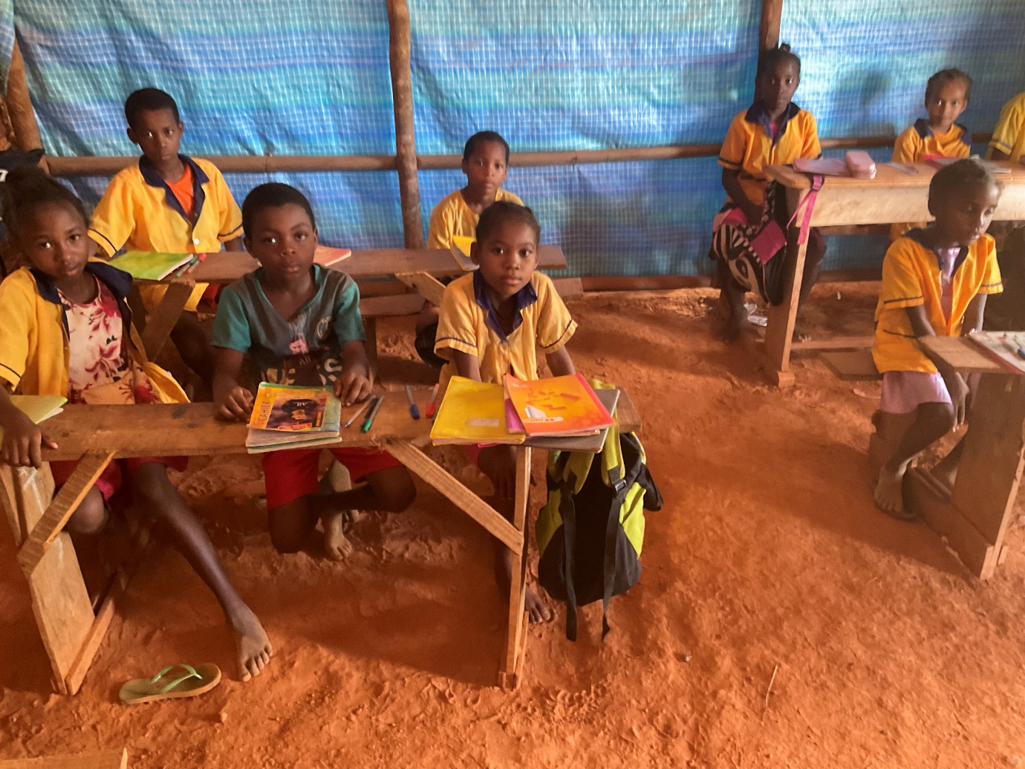

Now that the rains are coming, could the bishop find funds to add cement floors?

Next on the programme was a bracing walk on the hillside, nearer Port Bergé, again on the main road, to look at land that the diocese had recently purchased. I had always wanted to stop here because a few hundred yards away is a beautifully painted notice like a large grave headstone headed “KEW” and underneath “CRITICAL ECOSYSTEM” and the dates September 2017 to December 2020. In the past I have seen a Landrover in the region with ‘Kew Gardens’ emblazoned on the sides. I asked my companions what they knew about it. Nothing. The tuctuc driver was the most interested and said that he had often seen the writing but never slowed down to read it. Nobody had heard of Kew Gardens. Later in the day I heard that Europeans came there to look at the “Biby”. A biby is anything that is alive and moves any size between an ant to a dog. “Perhaps there are lemurs, the Europeans are always looking for them.” My own investigations revealed nothing except a considerable number of splendid slow moving large chameleons totally unfussed by our presence. The Mothers Union is starting to plant trees there which I hope will be a huge boon to the ecosystem.

By now it was extremely hot so we went to my hotel room where a very generous packed lunch was served. Typical of such occasions I occupied the only chair while everyone else sat on the floor. Here many normally sit on the floor to eat.

Next stop was Port Bergé church school for Assembly and the dedication of another two classrooms and an open air ‘podium’. Over 600 children, the teachers in their red uniform and some parents were at Assembly. I was so impressed by their good behaviour and delighted by how responsive they were. I was also relieved that Assembly was held in Malagasy though it is a French speaking school.
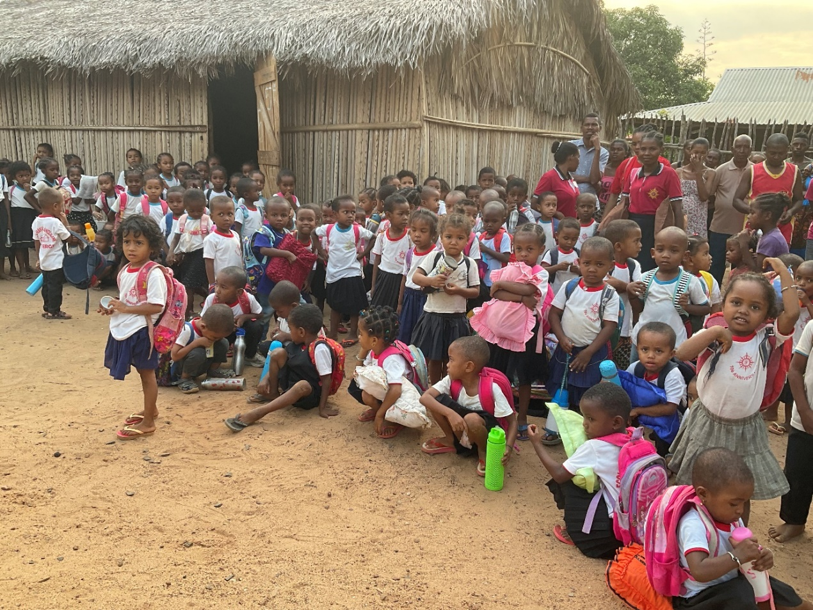

Official engagements for the day concluded with another packed church service. That was Friday, and Saturday started similarly. This time our tuctuc ride took us to St. Andrew’s Church, Ampombibitika. There I was to speak about evangelisation and mission to the lay leaders of the parish before they elected their new SA.FI.FI. (Evangelisation) committee. Elections are much enjoyed and follow a rigid pattern with each vote being waved in the air and the writing on it read out by one person and checked by another.

After lunch was a session with the adult baptism candidates (15) and confirmation candidates (38). Simultaneously there was great excitement on the roadside outside the church as the ox for the Sunday lunch was being killed. Mr Claris was in charge.

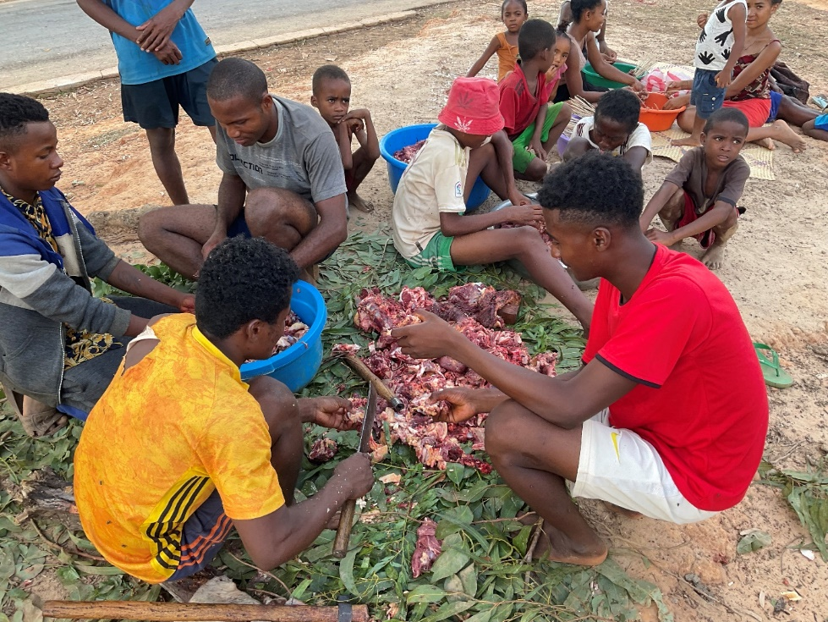
By the time I came out of church he and many of his pupils were busy chopping it into small pieces and some putting tiny pieces of fat and meat alternately on skewers for the evening meal. By that stage over 200 people had already arrived for the service the next day. All had to be fed and bedded down in the church. What an incredible air of excitement and expectation! Mindful of a heavy Sunday ahead I made my apologies and returned to the Hotel Plaza.

And so to Sunday. Breakfast was provided at the church for all who had arrived early. One taste of the meat I was served told me I had made a big mistake tasting it so I declined anymore and filled up with rice. The service eventually began at 8.30 am. The Rural Dean had taken the opportunity of my visit to include the licensing of new Readers/Catechists and the installation of the new SA.FI.FI. committee. The millions of flies that had gathered over the ox carcase were now dispersed everywhere, not least in the sanctuary. How does one maintain one’s dignity while swatting the flies on one’s face, and those hovering over the bread and wine and everything else? Nevertheless it was a very splendid service with a great sense of worship extending even to those who couldn’t get into the church. It was 2 pm by the time I took off my robes. My longest and hottest service to date – and I hope a record that I will not break!

Monday morning saw us once more at the taxi-brousse station for a long day on the road. The effects of the Sunday breakfast were continuing to cause me anxiety and so I declined any food for the day. By the time I arrived in Bishop’s House my stomach was indeed in a poor way. Tuesday and Wednesday were spent feeling sorry for myself and causing general alarm by my condition, not least in the parish preparing for my arrival the next weekend. However, by Thursday I felt better and was ready to face the taxi-brousse again on Friday.

Christmas Eve, as I sat for hours in a pew watching the various performances, reminded me that a very considerable perk of being bishop is that one has a reserved seat and it is usually cushioned. At 7.30 pm the cathedral adult choir assembled and performed a mime of the Nativity interspersed with anthems. That was predictable but quite enjoyable. Immediately after that came the Christmas story performed by the Youth. All 22 scenes which had inexplicably long gaps between them while we stared at the makeshift curtains across the church. By the time Midnight Mass began I was as conscious of fatigue as of the Joy of Christmas. However, after 4 hours in bed I was ready to rejoice, though slightly taken aback when my first well-wisher called in at 6 am. I was celebrating and preaching as my colleagues had flu, fever and feeling under the weather. The familiar carols were blasted out and one felt it was indeed Christmas, God-with-us.

I was quite pleased to be on my own at lunch time, as a siesta was my top priority. Indeed people called in at lunch time and found me fast asleep and kindly left me to my slumbers.
The cathedral carol service was at 3 pm: ten lessons and 15 congregational carols. That was followed immediately by the Sunday School “Arbre de Noël” which is a sort of children’s variety show with poems, dances and singing followed by a visit of Fr and Mrs.(!) Santa Claus and prize giving. That ended at 7.30pm but I had slipped away just after 6 pm to speak to Sarah and our family.

There is no concept of Boxing Day so the 26th December was an ordinary working day – except for most of the clergy who had collapsed with fatigue, etc..! Unfortunately my precious colleague Helarcin was also unable to work due to repeated epileptic seizures. Very worrying for him and his wife and an anxiety for us all. If any of you happen to be a specialist in this area, please contact me. I am not convinced that he has been given the appropriate medication. Generally, there is an enormous amount of illness here at the moment, especially fever, which is attributed to the extreme heat.

My big New Year resolution is to retire this year. So this means a lot of change and a desire to see a lot of projects either completed or well established. A huge amount has been achieved thanks to your generous support financially and prayerfully. Thank you.

May you and yours have a Happy and Peaceful 2023.
God Bless.
+Hall

hallspeers@gmail.com

New Year’s Eve 2022

