Our Mad Life 81
On the Move
Since last writing to you I feel that I have been constantly on the move.
For reasons I haven’t fully fathomed the New Year’s Eve celebration at the cathedral was poorly attended and most of us retired before midnight. In the morning, 1st January 2023, we had the first fierce rain storm of the Rainy Season. When the rain eased I made my way to St. James’ to lead their service and prepare for the following Sunday which was planned to be a grand festival to dedicate the new clergy house and inaugurate St. James’ as an independent parish (it has been a daughter church of the cathedral). I was amazed to discover the ox for the feast had already been purchased and was bellowing sadly in the churchyard. The catechist was late as he was recovering from the long walk involved in the arrival of said beast. At the congregational meeting which followed the service there was an urgent request for volunteers to feed the ox until Saturday. Surprisingly (to me) there is never any shortage of men ready to kill the animal and butcher it.
But events had taken a sudden but welcome turn for me. A message from the Relay Trust announced that they had sent a grant for the purchase of a 4 x 4 Toyota Hilux. This had been promised early last year but I had begun to think it would never happen. We rushed to the bank and pleaded with the manager to let us know immediately the money arrived. He did. Andry, the chairman of the diocesan development committee, sprang into action and found that a major importer in the capital had one in stock but it was going up in price by 20 million ariary on Friday night. Our bank manager again made sure that the money was transferred immediately to the dealer. Transfers often take ages and sometimes don’t happen without a prompt. Andry volunteered to see the whole business through: going with me to Antananarivo, doing the paper work and driving back to Mahajanga. How generous was that! My little part was to book the seats on the overnight taxi-brousse on the Thursday night. I went to the booking office to discover that, unusually, all seats were fully booked for the next week as it was the end of the holiday. Also due to travel with us was the Archdeacon’s son who had to get back to university for the start of term. However, the Archdeacon knew a man in charge of bookings and he assured us that he could get three seats the next afternoon. As always, it is not what you know but who you know that gets things done.
So we set off for Antananarivo, me secretly hoping that it would be my last ever all night journey by taxi-brousse. We arrived very early in the morning and Andry and I eventually got to the dealer, still well before opening time. There in the forecourt was our dream vehicle:

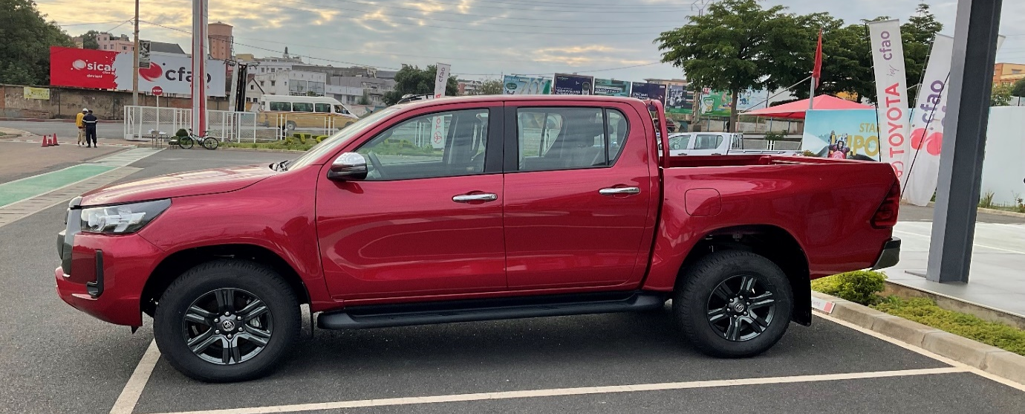
It is very spacious and everyone thought it was an appropriate colour for a bishop. When the formalities were concluded Andry left me with the Sisters who rightly insisted that I go to bed and catch up on some sleep. The next morning, Saturday, they were all up well before the crack of dawn to provide me with coffee and breakfast and wave us off at 5.30 am.
We had been on the road for about an hour when I got a phone call from Bishop Gilbert of Fianarantsoa informing me that the Archbishop had called a meeting of the House of Bishops for Monday morning in Antananarivo at 9 am. I explained that I was just leaving Antananarivo and couldn’t turn back as I had to lead a big event in Mahajanga the next day. Thus the only way I could attend was to travel back overnight on Sunday! He told me that he and the bishop of Toamasina were in the same position…
We arrived at Bishop’s House late afternoon and I was shocked to find that the gates were almost too narrow to admit the Toyota. It could just be got in through much careful manoeuvring with only a few inches to spare. Getting out wasn’t any easier.
And so the bishop arrived in style at the festival at St. James’ in the morning – nobody much interested in him, but the vehicle the centre of attention of an admiring crowd. This was the first time a priest or bishop of the diocese of Mahajanga was in possession of a vehicle!
Our service went ahead according to plan with a large congregation and robust singing. The parish was duly inaugurated and then the congregation sang the Te Deum (from memory) as we processed to the dedication of the new house for the clergy.

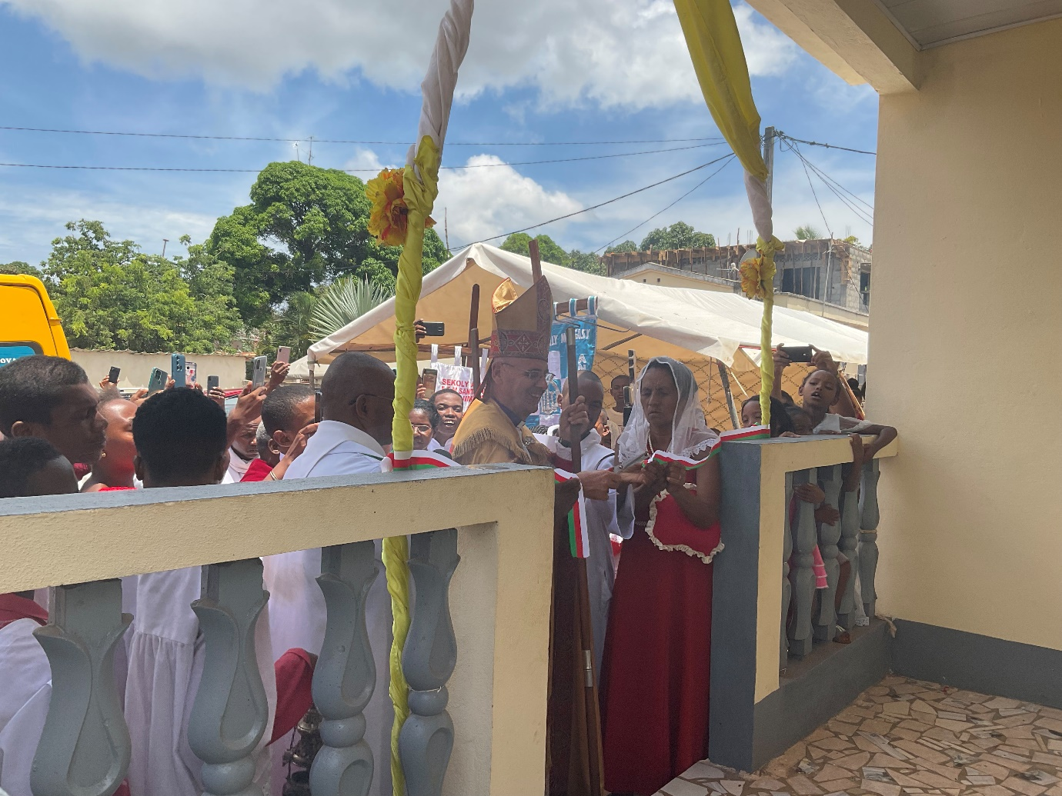
Cutting the ribbon. Note the number of mobile phones recording the proceedings including one broadcasting it all via Facebook.
The ox tasted a lot better than it looked. But as soon as the meal was over I had to make my apologies and return to the house to repack my bag and set off on another overnight trip to Antananarivo – but NOT by taxibrousse. Such was the distance we had covered in the first weekend the vehicle was due its first free service! Since we had all had a hearty lunch my driver decided we didn’t need a stop for refreshments. On the good bits of road we discovered how fast we could go and so at 1.30 am I found myself, after a very comfortable drive, in Antananarivo having dinner. In spite of all I was therefore able to actually lie down and have a sleep before attending the Archbishop’s meeting. And guess what? I was first there. What a tired collection of bishops. With such short notice none of us had been able to cancel our Sunday engagements. It was worth it. A lot of business was done and there was a much greater level of mutual understanding face to face (except for the bishop of Mauritius who joined us by zoom and kept losing his connection).
Tuesday morning was the now habitual 5.30 am departure and another long day on the road. After a series of meetings in Mahajanga I was again on the road to the capital on Saturday en route to England.(Mahajanga to Antananarivo is 570 kms.) When I arrived with the Sisters the children informed them, the Sisters’ bishop is here. It had all been miraculously incident free travelling in the luxury of the Toyota. The day before my last journey the road had been cut for most of the day and the rains had done a lot of damage. Although we travelled at walking speed through knee deep mud and over rough ground where the tarmac had been washed away it was plain sailing in the 4 x 4.
So now I am writing to you from the chilly winds of Lincolnshire, happily overeating and enjoying being back with Sarah and the family. Again, so very much to be thankful for.
What I haven’t mentioned is that the Revd Helarcin, our new deacon, is still very ill and I am very concerned for him. Please remember him and his wife, Angela, in your prayers.
I return to Madagascar, via Ethiopia, on 22rd February.
Thanks, love and prayers
+Hall
hallspeers@gmail.com

6 February 2023

