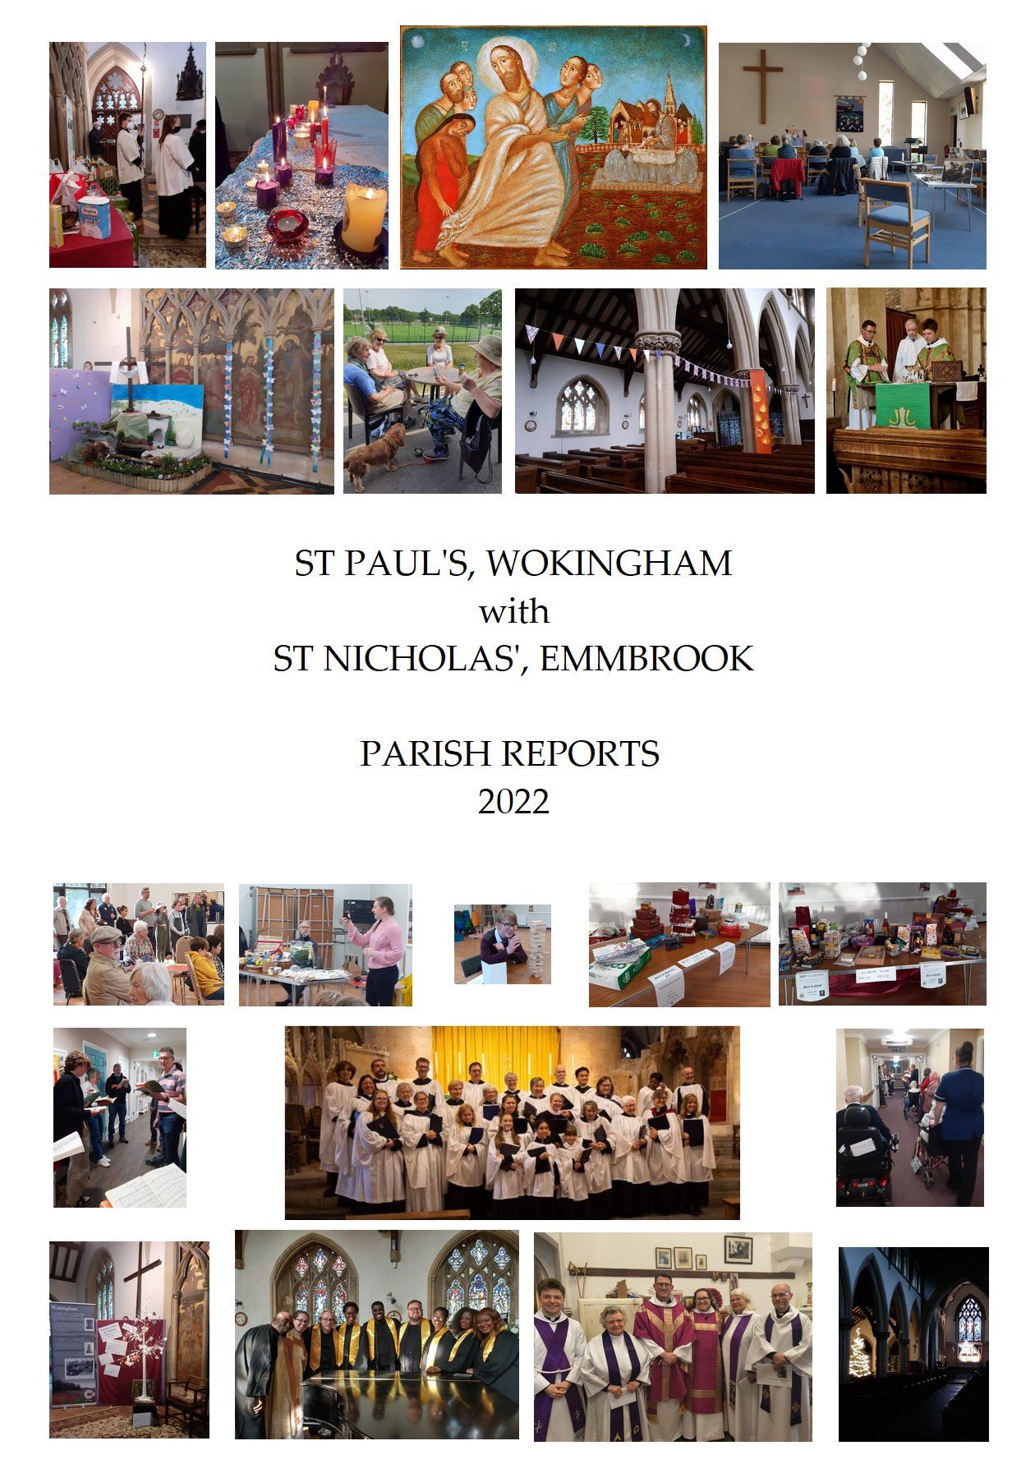

Parish Reports 2022
Contents, or What To Look Forward to

Parish Life
Further reflections on the Covid Pandemic p 3 Rector’s Review p 4
Churchwardens’ Report on Fabric and Inventory p 6
The Parochial Church Council p 7
Safeguarding p 8
St Nicholas’, Emmbrook p 8
Woosehill Church p 9
Electoral Roll p 10
Stewardship in the Parish p 10
The Churchyard p 11

Community
5,6,7,8 Group p 13
Schools work p 13

The Wider View
Deanery Synod Report p 15
Sweden – our Link with Växjö p 15

Introductory Note
The Annual Report prepared with the Financial Statements for the Charity Commission contains information on many aspects of parish life, including the PCC sub-committees. Parishioners are encouraged to read it in order to get a fuller picture of the life and work of the Parish in 2022. It is supplemented by the following reports.
And thank you, thank you, thank you for all you bring and offer and share and treasure and bring and… none of this would be possible without you and your heartfelt response to God’s love.

Further reflections on the Covid Pandemic

Some ongoing impacts of the pandemic:

At the end of 2022 it feels strange to be looking ahead and hoping and expecting that the days of Covid lockdown and mass restrictions and social distancing are, we pray and hope, over. There is obviously a clear and painful personal legacy for lots of people but there is also a corporate and communal legacy which we need to be conscious of and which is worth capturing. Here are some of the key impacts at the end of 2022, nearly three years after the first lockdown:

- St Nick’s has reintroduced the chalice for those who want to receive the wine from the common cup but St Paul’s has not made this decision yet and are still receiving in one kind only. The decision will come in 2023 at some point but it feels as if the size of the congregation and continuing concerns around infection, and a desire to travel together in every way we kind, means that we have not returned to the chalice yet.
- We have got a lot better at seizing the opportunity as it arises and not trying to plan too far ahead. Two examples of this are relaxed social groups which meet regularly. One is a group, broadly, for people working from home who might welcome the chance to meet for coffee in town and who might want to talk a little about faith and discipleship. The other is a walking group which meets every week and always ends up in a coffee shop- it is not only for those who have been widowed in the past few years but it is a group which is proving a safe and encouraging people for people who are grieving to go along to and to become part of. Both groups have arisen quite naturally and are flourishing.
- It has been an absolute joy to be able to open the doors of Church at Christmas to let everyone who wants to to come along and sing carols and be together. In 2020 we had very few people in Church with the emphasis being online- in 2021 we restricted numbers and held our biggest services in the playground at St Paul’s Juniors- and in 2022 we have been able to just let people come and sing.
- Livestreaming is here to stay- it is a vital part of our connection with the community, not least with those who are not able to come to Church on a Sunday morning any longer. People at Alexandra Grange and Abbeyfield Nursing Homes watch it together, as do some of our friends who are resident at West Oak. It is also something we can offer to people away on holiday and recovering from operations. About 22 devices join us live on a Sunday morning as we worship, which equates to about 35 people or so- and means that about a quarter of those worshipping on a Sunday morning as part of St Paul’s are on the Livestream.
- A lot of other churches are saying this as well but it definitely feels- post Covid- as if we are struggling to fill leadership positions in the Church. It might be that we just need to find a new way of asking people to think about volunteering, or it might be that we need to rethink some of the roles- but either way, the challenge is there for us as a Church and as a Church family.

The Rector’s Review of 2022
2022 was a year of careful, cautious recovery as a community and parish and nation after two years of the pandemic. There were massive signs of hope and encouragement during the year- completing the restoration project after the arson attack of Holy Week 2021, installing and blessing the icon of the Woman with a haemorrhage which Bishop Olivia came to do, having the Church open for Easter and Christmas for the first time since 2019 among them.

There was a lot to enjoy, and a lot of stuff which is coming back together which we were able to relish. The Churchyard Team, under Andy Clark’s leadership, continued to do a superb job of maintaining the Churchyard and broadening the variety of plants and insects. Louise Cole held thigs together wonderfully as Parish Administrator and Vanessa Hemmi continues to do a great job of rebuilding bookings in the Parish Rooms, especially our regular users. The J-Club leadership team reformed and we set up a new franchise on a Wednesday of the Monday 5, 6, 7, 8 Group which is proving very popular. There is plenty of further information on all of these things, and many others, in the pages which follow.

The three key themes of the year were that we continued to travel together in every way that we could, while seizing the moments of opportunity and grace which came past us, together forming a church which is led and inspired and enabled by a small team of very committed and able people.

There were also real sadnesses and frustration during the year. Several people were ill with Long Covid, among them Cara, our Curate, who was signed off for several months in 2022. Covid is something we are having to live with as a society, of course, but it can also be an illness which lingers and lessens and remains for a time.

And there were some key deaths among our number in the same year that Her Majesty the Queen died only a few months after we celebrated her Platinum Jubilee. (Other ‘highlights’ of the year were the way that people flocked to Church to light a candle and leave a message, and hosting the Borough Civic Service and, more personally, being invited to Introduce the Proclamation of the new King in a packed Wokingham Marketplace).

Jackie Alexander was, for very many years, a vital part of the parish, organising the Welcome Club, supporting, encouraging, joining in, a good and reliable friend. Pam Subden was a friend to many at St Nick’s and is greatly missed by the community there. Fr Roy Holmes was first a Server in the parish and then a priest here for 35 years. His health had not been good for many years and he was getting worse- but it was still a shock to hear that he had died just after Christmas 2022. These are words from the Sermon I preached at his funeral in St Paul’s in January 2023:

“The service this morning reflects the fact that, as well as being a son and brother and uncle and friend and colleague and husband, Roy was a priest and this was his place, his community, the altar he presided at. He was ordained priest in 1987, 35 years ago. The chalice and Gospel Book placed on his coffin are a reminder of the call he fulfilled to show God’s love in word and sacrament. The fact that so many priests who knew him and worked with him and were shaped by him are taking part in the service this morning is a reflection of a core part of Roy’s identity. God called him to follow. God called him to feed his sheep- and he did. The coffin of a priest is always turned round to face the congregation, taking the same position in death that he did in life- facing the people God called him to serve, to lead, to share God’s love with in Word and Sacrament, not least in the Eucharist, this meal we are part of today, which is the love of God held out to everyone, a reminder of what God has done for us in Jesus and how precious and wonderful we each are in his eyes.”

That call to respond to God’s invitation to the Eucharist and then to live out that love in the world every day, wherever we are, whoever we are with, is our mission, our duty and our joy.
Fr Richard Lamey, Rector

Parish Life

Churchwardens’ Annual Report on the Fabric of St Paul’s Church 2022
Under Paragraph 5 (1)-(3) of Care of Churches and Ecclesiastical Jurisdiction Measure 1991, the Churchwardens are required to deliver the Annual Fabric Report to the PCC, and on behalf of the PCC to the APCM (with any amendments made by the PCC), including an account of all actions taken or proposed during the previous year for the protection and maintenance of the fabric and all articles appertaining to the church.
Fabric
There has not been a lot of changes made to the church fabric during 2022, although that was not for the want of trying. We continued to try and get someone to repair the roof covering on the north and south aisles, but have not been able to find anyone to act as the main contractor (the firm providing the covering will only act in the capacity of a sub-contractor). We have also failed to repair the damage to the north aisle parapet. The only quote received was judged as extortionate by our architect, who advised delaying the repair until we are doing other work on the roof. This will have to be seriously considered during 2023. We were able to celebrate the restoration of the fire damage, that occurred the previous year, with a special service of re-dedication, with the Bishop of Reading, in March. This also included the official unveiling of the new icon at the front of the north aisle. Later in the year, thanks to the efforts of Mary Cassidy and Jan Norbury, the fire damaged cover for the altar was replaced with a new red cover. Jan was also able to provide similar covers for the other altars, and a new curtain on the flower and cleaners cupboard. We still appear to be getting some ingress of water under the flashing on the edge of the Walter Chapel roof, but there is significantly less paster falling from the area. We expect this to be resolved in early 2023. During 2022 our architect Richard Oxley retired, so we have had to appoint a new architect in preparation for the Quinquennial Inspection that we will be required to carry out this year. The new Architect will also be taking control of both the roof and the lighting projects. We will also be looking at schedule of work still outstanding from the previous Inspection as well as anything revealed from this year’s Inspection. This means that 2023 could see us spending quite a significant sum on the church fabric. Aside from the building work, we are still managing to provide the live streaming of most of our regular services as well as some funerals and weddings. This has fallen into a regular pattern for our Sunday morning 9:30 at St Paul’s, with a team of 4 taking turns to run the operation each Sunday (we would always welcome anyone that is interested to join the team). We generally have 20 to 30 viewers online for these regular services with around 70-100 viewing the recording in the week after the service. On the technology side we have also installed a Bluetooth receiver to allow the clergy to provide music for occasional services directly from their mobile phones or tablets, without the need for cumbersome leads, or for someone to be in the vestry to press buttons. Finally, Security; as you are all probably aware, after a number of incidents in church, pre-pandemic, where items were moved or removed we installed a CCTV camera which recorded anyone coming into church and walking up the nave. This proved invaluable in identifying the arsonist in 2021. We enhanced that with another camera pointing towards the main door to improve the coverage. This helped identify a group of boys who were causing minor damage in church on a number of occasions (this has stopped following intervention by the police). After we had restored the fire damage last year, we decided to further improve the areas we are able to monitor by installing a camera to cover the altar and choir area, where most of the damage had occurred. We also reviewed the usage policy and based on that we have avoided certain areas where people may want to pray privately, and also scheduled the cameras to not record during services. A CCTV policy document is posted on the noticeboard and on our website, giving further information on usage
Peter Wells, Churchwarden

The Parochial Church Council
The PCC have had 6 meetings since the last APCM in April 2022. At all the meetings the financial position of both the church and the Parish Rooms Trust was monitored.
In May 2022, we welcomed one new and one returning member. We agreed the 4-month financial reports and the 2022 Safeguarding Policy together with Safeguarding rules and a list of church activities that those rules should apply to. We discussed how to build better contacts with those living in the new housing on Matthewsgreen Road. We agreed that the Tithings groups and Pastoral Visitors needed a reset. It was noted that Covid restrictions continued to be eased gradually in services.
In July 2022, among other things, the PCC discussed topics for discipleship courses, considered the Easter attendance figures and discussed the reintroduction of the Chalice. We also approved the 6-month financial accounts.
In October 2022 (postponed due to the Queen’s funeral), we agreed a Lone Workers policy and risk assessment, a choir risk assessment and an ex-offenders policy. We agreed wedding fees for 2023.
In November 2022, the PCC reviewed and agreed the Health and Safety policy. It was noted that the Churchyard was looking in good order and the annual payments to our Mission Partners was agreed. We considered the draft Budget for 2023 and Fr Richard advised the PCC of the plans for Christmas services. Following problems with anti-social behaviour, it was decided to increase our CCTV coverage and a CCTV policy was agreed which followed Church of England guidance.
In January 2023, the PCC agreed the Christ Church Protocols which provide a framework for collaboration between All Saints, Christ Church and St Paul’s. Fr Richard gave the PCC a review of Christmas and it was noted that attendance had now just about got back to 2019 levels. A Worship Questionnaire was sent round to all the congregation which included a question about the reintroduction of the Chalice. Time was also set aside for a discussion on the proposal by the Church Commissioners to set aside a fund of £100 million principally to recompense those communities affected by slavery in past generations. It was also noted that there are a number of vacancies still needing to be filled.
In March 2023, the PCC approved the Annual Report and Accounts 2022 and the Parish Rooms Trust Report and Accounts and the Churchwarden’s Report in readiness for presentation to the APCM. A new architect was appointed and consideration given to the need for more volunteers in many areas of church life.
Lesley Ruddock (PCC Secretary)

Safeguarding
DBS checks have been made throughout the year for both new volunteers and those whose certificates were due for renewal. This means we currently have DBS checked volunteers in all areas of our work with children, young people and vulnerable adults. In addition, last autumn, everyone working with these groups, together with PCC members, were invited to complete their Basic and Foundation Safeguarding Training which they are required to do every three years. Safeguarding continues to be an agenda item at every PCC Meeting and regular Safeguarding Review meetings are held every two to three months.
Chris Barker, Safeguarding Officer

St Nicholas’ Pro-Wardens’ Report

During 2022, as Covid restraints were eased, we were able to reintroduce many of our traditions.
The restrictions at our Eucharist were eased gradually, culminating in the congregation receiving the chalice at the First Mass of Christmas.
House Mass in Emmbrook resumed on Ash Wednesday. This has always been an important part of our worship and it was lovely to be able to celebrate and share fellowship in this way after so long.
We have been able to meet again for St. Nicholas’ Council, Fellowship Groups, we enjoyed a Shared Lunch in December to mark our Patronal Festival and children joined us on a Sunday again, which was lovely.
We sadly had to say goodbye to our friends May Stoneham and Pam Subden, who were faithful members of the St Nicholas’ family. May they rest in peace and rise in glory.
Margaret Davies, a loyal and very active member of St. Nick’s, left for pastures new to be with her family in Dorset. She has been much missed but we wish her and Don well on their exciting new venture.
We generously supported the parish charities and other appeals during the year and joined in and helped at many Parish events.
Our thanks as always to Fr. Richard, Judi, Cara and Jane for their ministry to us and their care, love and support.
We are extremely grateful to each and every one of the St. Nick’s family for their help and commitment both practically and prayerfully. Everyone has an important part to play.

Liz Gallagher and Fiona Albinson, Pro Wardens

“For where two or three are gathered in my name, there am I among them.” Matthew 18:20

St Nicholas’ Missional Vocation Statement
"Exploring through relationships and worship
how God's love is creating and sustaining communities in Emmbrook"

Woosehill Church Report
Woosehill church has been bouncing back after the last few years of the Covid pandemic; our numbers are about 30 in church on a Sunday with up to 10 worshiping online. We have two Holy Communion services a month one on the first Sunday led by our Methodist incumbent Rev. Soba Sinnathamby and on the third Sunday led by the Parish other services are morning worship and on a 5th Sunday we have a Café church which is a less formal service sharing coffee and pastries while we worship. At the present time our Minister, Rev Soba Sinnathamby and his wife are in India and Sri Lanka on Sabbatical. We have been pleased to welcome back for some services Elaine Steere a LLM who used to worship at Woosehill.
Our Thursday outreach Groups (Sing Something Simple, Wool with a Mission, Colour and Chat, and Sewing and Thread Craft Group)are running with past members and some new people attending and our coffee morning on the second Saturday has been linked with the Friendship Alliance (a group of charities that support the vulnerable and the lonely in the Borough)
The church is re-starting the ‘Open the Book’ assemblies in Hawthorns School on Woosehill in March which we pray will bring some children into the church. Lynn Smith (Woosehill church representative on the PCC)

Changes in the Electoral Roll
The total number of names on the Electoral Roll at 26 March 2023 was 227 as against 224 on 27 March 2022. There were 7 additions during the period: Sunny Pau, Nigel Traylor, Paul Wallis, Richard Turner, Rosaline Voke, Jane Bentley, Richard Bishop. There were 4 deletions during the period: Pam Subden, Patrick Rendell and Jean Beaven who have all died and Margaret Davies who moved away. Teri Austen (Electoral Roll Officer)

Stewardship Report​
I can report that St. Paul’s and St. Nick’s Parishioners continue to strongly support the Church Stewardship Scheme through regular planned giving which allows the Church to budget effectively and manage cash flow.
This year we have seen the introduction of the Parish Giving Scheme and at the end of 2022 approximately 55% of all donors have now switched to this method. The scheme is run by the diocese who manage the donations and claim Gift Aid where applicable thus reducing the administrative effort for St Pauls & St Nicks. An additional benefit is that donors can index link their donation so that it retains its value to the Church year on year which is becoming ever more important with the current level of inflation. I’d like to encourage donors who still give by Standing Order or regular envelopes to consider switching to scheme. Please contact myself or the Treasurer if you have any questions or concerns and a link to join the scheme can be found on the Parish website.
We continue to collect via the plate during services for those wishing to give by numbered envelopes, white gift aid envelopes or cash and from the wall safe near the font. Recognising that many people no longer carry cash, we also have a card reader at the back of the Church and the facility to receive donations by text. this can be done by texting STPAULS5 or STPAULS10 or STPAULS20 to 70450 to donate that amount of money with an option to gift aid the donation.
If you are a UK taxpayer, then we can claim Gift Aid equal to the standard rate of income tax on the value of your gift. Gift Aid provides an extremely valuable contribution to the Church’s annual income so if you can Gift Aid do please complete a declaration form, available from myself at the email address below. Thank you to those who have completed a Gift Aid declaration form in the past but if your circumstances have changed and you are no longer paying UK tax then please inform me. If you have moved house recently, please could you also complete a new form with your new address. The white envelopes placed in the pews can also be used to gift aid occasional donations.
If anyone has any questions about the Parish Giving Scheme, stewardship or Gift Aid then do please contact me at Church or via email at stewardship@spauls.org.uk
Stuart Fairhead (Stewardship Secretary)

The Churchyard
This year work in the churchyard has continued to be affected by the COVID19 pandemic but it has had less of an impact than last year. Payback has modified its procedures since the pandemic and we have less help on a fortnightly basis than we might have had prior to COVID-19. We also rely on fewer volunteers from the congregation than we have had in previous years. We have however managed to re-instate the regular provision of refreshments and we are able to work together in groups again although the threat of Covid, flu and bird flu still worries some of the volunteers.
The volunteers have managed to refurbish the chipper, a gift last year from Parish Tree Surgery, and make it functional so we are now able to chip much of the tree waste we generate in the churchyard. The chipped waste has been successfully used to maintain the paths in the churchyard. This means there is no need for bonfires, which are unpopular and release significant carbon into the atmosphere. So we have done a bit to reduce our contribution to climate change. We have also started to invest in battery powered machines to manage the churchyard although we still do use petrol and diesel in the older equipment. Material which previously we might have burnt but which is unsuitable for the chipper, is being composted and leaves left to produce leaf mould. We have been using much of the compost to level out the ground in the churchyard but there is plenty of good quality compost and leaf mould available for anyone who cares to come and collect. Please contact churchyard@spauls.org.uk for details if required.
The trees we planted as part of the Tree Succession Project are growing nicely. As is the Medlar tree which has been planted by Wokingham WI near the Parish rooms. It should provide a good show of blossoms and colourful leaves as well as a supply of medlar fruits as it matures. Recently a plaque has been installed to recognise the donation of the tree by the WI.
We are still looking out for Ash Die Back, or Chalara (hymenoscyphus fraxineus), but so far it seems to have missed the churchyard trees. If our Ash trees are affected we will need to remove them. It is this threat that we are addressing with the planting of new trees which will take over when the inevitable happens (over 95% of the Ash trees in the UK, fraxinus excelsior, are expected to succumb to the disease eventually).
The tree survey which was carried out in 2017, is now being re-run by the churchyard volunteers, to make sure that our trees are kept in good order, pruned and removed, as necessary. Half of the trees have been surveyed so far and the rest will be done over the next few months.
On behalf of the churchyard group, I would like to thankGeorgina Spencer who has been responsible for the Biodiversity projects which we have running in the churchyard , as she has decided to reduce her involvement. We thank her for her support and work on behalf of the churchyard. I am pleased to announce that Laure Porter has agreed to take over the Biodiversity role.
The drains around the Church and Parish Rooms car park still need repairing. This work was being planned a couple of years ago but the project was halted by the pandemic. I would be pleased to hear recommendations of suitable contractors (churchyard@spauls.org.uk), since this is something which needs to be revisited to keep the drainage system, around the church, in good working order.
There has been a lot of work done over the past couple of years to remove the old spoil heap on the south side of the churchyard. This has provided new grave space and we are indebted to one of our volunteers, Tom Gemmill, who has spent hours managing and maintaining the area.
If you are pleased with the way the churchyard looks and would like to help to maintain it to its current standard, please come and join us. We really do need more people to mow the grass, manage the compost, maintain and document the graves, tend our trees, look after our wildlife, mend our machines, provide refreshments and more. If this is you, please join us any time from 9.00-16.00 on alternate Saturdays, visit the website (https://spauls.co.uk/churchyard-working-party/) or email churchyard@spauls.org.uk for more information.
Andy Clark
Community
5,6,7,8 Group
6s and 7s started off in September 2021 as a group for people who were just about to change Schools or had just done so. We realised that there were a number of people in that situation and they made a really nice sized- group to meet online every other Monday, to get to know each other, to play games, to pray together and to talk about faith. In September 2022 this Monday group was joined by a new group meeting in person every Wednesday evening- led and organised primarily by one of the young people at Church, Esther Lamey- for games, prayer and talk about Jesus. The group started by talking about Matthew’s Gospel. The groups also needed to be renamed 5, 6, 7, 8 as we broadened out the membership. We have about 12 young people who come along on either a Monday or a Wednesday and it has been brilliant to watch them getting to know each other while also talking with increasing confidence about what they think and what they know of God.

We are also very fortunate in the leaders we have, who are happy to share their own thoughts and to come regularly while also being very happy to take a back seat if the conversation is flowing. We are also fortunate in the way that biscuits keep magically appearing on a Wednesday and equally magically disappearing during the evening.

Since the Pandemic it has become more and more important to seize opportunities as they come past us rather than planning too far ahead and 5, 6, 7, 8 is an example of that. It is also an example of how well a mixed-economy Church can flourish, since online suits some people (and means that they can fit the group in during busy evenings) while some people still prefer to meet in person.

Fr Richard Lamey, Rector

Schools Work
Our work with Schools has largely rebounded after Covid. It is always a please to be talking with young people about God, and the role of the Church, and what it means to be a Christian- it is always fun but it is only when you add it all together that you realise quite how much contact we have with the children and teenagers of the parish. It was also a joy to be told just before the end of 2022 that St Cecilia’s, the new Church Primary School based on the Matthew’s Green development which is part of The Keys Academy Trust bases out of St Peter’s, Earley, would be opening with a Junior Class in January 2023.

We regularly have school classes coming into Church to look round and to ask questions. Since the last report this has included Holme Grange, St Paul’s and Foundry College as well as a couple of Schools from outside the parish. Soulscape organise a whole day of visits from Year 8 of the Holt as part of their tour of various Churches in the town- their questions were challenging and fascinating and revealed a real curiosity and interest in the life of the Church, and how faith can drive actions.

Cara and I also do School assemblies on a regular basis. We go into St Paul’s Juniors, St Cecilia’s Primary, Holme Grange, Emmbrook Infants, Emmbrook Juniors and Evendons Primary quite frequently, especially around the festivals of the church’s year.

Members of the clergy also help out with lessons from time to time, and a number of members of the congregation are also involved in a range of vital and transformative ways- exploring Christingles with all of Emmbrook Juniors, reading in School every week, being School Governors, helping on School trips and so on.

Our work with Schools is a vital part of our mission and service to the town and the parish- and not only is it vital- it is also really enjoyable, challenging, encouraging and fun.

Fr Richard Lamey, Rector

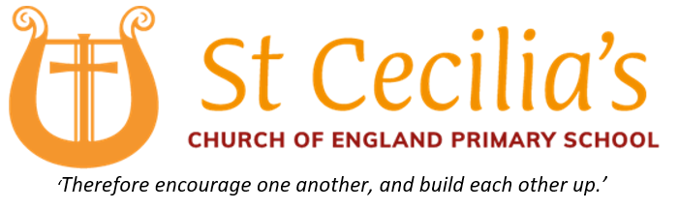
2022 was a very busy and exciting year for St Cecilia’s CofE Primary School. In April 2022, I was appointed as the Head of School and the planning and work began so that we could open the school to Nursery and Reception aged children in September 2024.
Then, in October, due to the high demand for KS2 places in Wokingham Borough, we were approached by the local authority to open St Cecilia’s early so that children, new to Wokingham, had a school they could attend. Even though it would be an extremely quick turnaround, we obliged as we felt it was our moral duty to support these families and provide each child with a strong education. From this point on, the excitement of putting all the plans in to action kicked in. We had to recruit the right people, order all the furniture and order all the resources needed so that the children learn in the most active and fun way. In addition to this, the school completed its pre-opening inspection with Ofsted in early December which went very smoothly. Now we are school with 30 students who each and everyday encourage each other and build each other to be the best they can be as described by our school vision. It will be exciting to see how the school continues to grow through 2023.
Richard Thomas, Headteacher

The Wider View

Deanery Synod Report
2022 was a year of continuing recovery and mutual support. Deaneries are at their best when the parishes are walking alongside each other, sharing ideas, offering support and encouragement, and that has been very visibly true in 2022 as we all began to move out of the shadow of the pandemic together. It was visible in the way parishes and clergy supported those in vacancy, in the way that Parish Administrators rang each other with questions, in the way that an experienced Treasurer helped a new one, and in countless other ways.

In terms of Chapter, Canon Andrew Marsden retired on the ground of ill-health from St Sebs in February and Anna Harwood moved to Cardiff from Ruscombe, Twyford and Hurst in the summer. Laura Wheatley Downs was installed as Vicar of Crowthorne in the Autumn, and Richard Eves (Wargrave) and Becky Medlicott (All Saints) were both ordained priest at Petertide.

We followed our Deanery Plan for recovering from the Pandemic with some success, focusing on rebuilding relationships and mutual support after a broken and disrupted few years.

In June the Diocese approved adjustments to the Parish Share scheme and much of the rest of 2022 was spent responding to that, not least since the proposals as they initially came indicated a rise in Share of over 30% for some of the parishes in the Deanery. The meeting in September focused on Parish Share, with the Archdeacon in attendance, and we agreed as a Synod to set up a small group to look at Share and to make recommendations to the meeting in March 2023. In November we agreed that we would not make any changes to the Scheme for 2023 but just add 2% to every Parish Share as the fairest way of meeting our increased allocation while we took the time to work out a system which is fair across the Deanery.

There was still time in November to have the Rev’d Katie Tupling (Diocesan Disability Advisor) address us on disabled people in Church, and being a community in which everyone is welcome and included. It was an inspiring and encouraging talk, at once challenging and supportive, and Synod and guests enjoyed it immensely.

2022 was a decent year for the Deanery- and it has laid the foundations for the year to come. Please pray for Winnersh and Bearwood, St Sebastians and Ruscombe, Twyford and Hurst as they enter 2023 in vacancy, especially for their Church leaders who have so much more to organise and think about at the moment- and thank you to the members of Synod who have made our meetings so warm, effective and focused on God.

Fr Richard Lamey

Sweden Report

The Link with Vaxjo continues to be a source of strength and encouragement, although it is becoming more of a relationship between clergy than is ideal because it has been so hard to visit each other of late. As well as staying in regular touch on Zoom with Johannes I am also still in regular touch with Stefan and Elin, who moved from Vaxjo to the island of Gotland and are now back in parishes in Kalmar, on the eastern edge of Vaxjo Diocese. In September I had the great privilege of being one of the two Diocesan Reps invited to be part of the 850th Anniversary celebrations of the Diocese of Vaxjo. It was super to see the Diocese in action again, to meet a lot of people at the Cathedral as well as the reps from Pomerania, which is Vaxjo’s other link Diocese, and to see the full breadth of the Diocese- by visiting Kalmar and also spending a day in a small rural parish on the western edge of the Diocese.

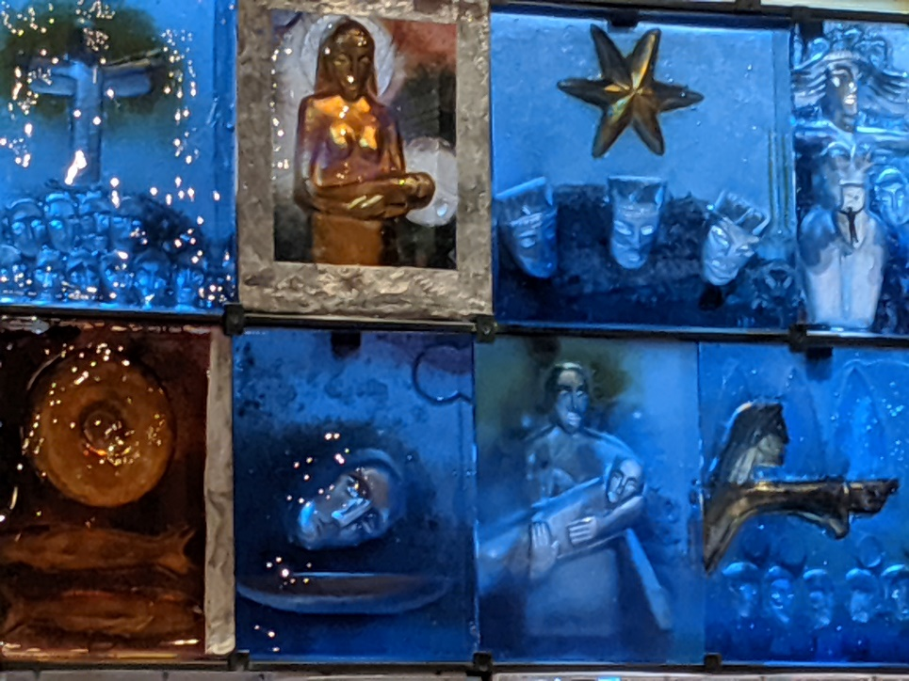
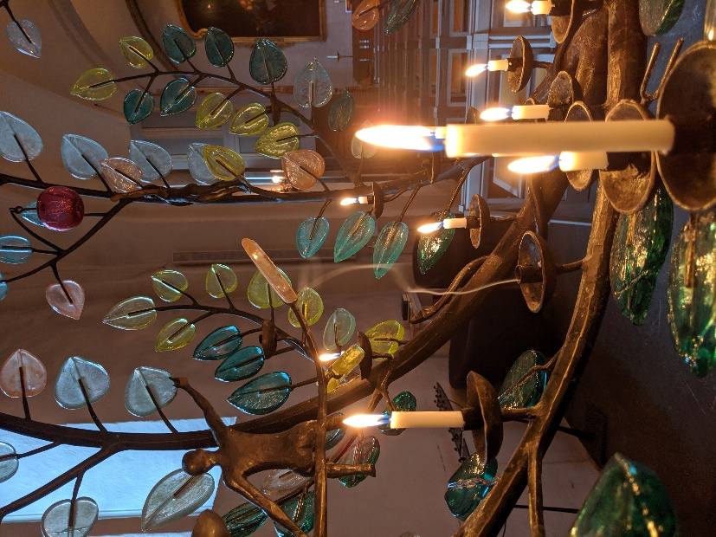

Fr Richard and Johannes Grimheden

