Holy Week 2023
Services at St Paul’s Church, Wokingham
Good Friday – April the 7th
10.00- 12.00 Pop-in Messy Easter for Children
2.00pm Good Friday Liturgy
Holy Saturday – April the 8th
8.00pm Service of Reflection and Readings
Easter Day – April the 9th
Alleluia! Christ is risen!
6.00am Blessing of the Holy Fire and First Mass of Easter followed by breakfast
8.00am BCP Mass for Easter
9.30am Joyful All Together Mass
There are also services at other times at St Nicholas’ Church (Emmbrook Village Hall) and Woosehill Church (behind Hawthorns School), e.g. Good Friday 3.30pm (N) & Easter Day 10am (W) 11am (N).
Holy Week 2023
Services at St Paul’s Church, Wokingham
Palm Sunday – April the 2nd
9.00am Procession of palms from St Paul’s School, followed by 9.30am Parish Mass
6.15pm Service of Readings and Music for Holy Week

Monday (St Paul’s) Tuesday (St Nick’s) Wednesday (Woosehill)
8.00pm Mass with reflection for Holy Week

Maundy Thursday – April the 6th
7.45pm Organ Introit to begin these Holy Days
8.00pm Solemn Mass with foot washing and stripping of the altars, followed by keeping watch until midnight
http://spauls.co.uk/
Parish Office 0118 979 2122
Dear friends,
The week from Palm Sunday to Easter Day is the most important week in the year for Christians, and for St Paul’s Church family, and for the whole of creation. It matters more than anything else, especially after the disruption we are still recovering from in all of our lives and in every community. It is the week which changes everything, and binds us forever to our gracious God.
The events of Holy Week show us the truth which lies behind everything we see and experience. They tell us everything we need to know about love and resurrection and endurance and service and grace. They are the truths against which our daily lives can be understood.
The more you put into Easter, the more closely you walk with Jesus, the more you will get out of it, and the more firmly you will be rooted in the Christian pilgrimage. Put the dates in your diary now, and build your week around what is happening.
The week’s services look like this:
Palm Sunday (April the 2nd) starts with the Palm Procession from St Paul’s School at 9am, followed by the re-telling of the whole Easter story, and the Eucharist. Jesus enters Jerusalem, the lions’ den, and we have to be with him.
Mon, Tues and Wed Night (8.00pm) Mass with a reflection which helps us to connect with the drama of Holy Week- Mon night is at St Paul’s, Tuesday at Emmbrook Village Hall and Wednesday at Woosehill.

Maundy Thursday (8.00pm) is the night when Jesus washes the feet of his disciples, shares bread and wine with his friends, and then is betrayed, arrested and questioned. We share the Eucharist, and then we strip the church of all that is colourful. We keep watch for a time.
Good Friday sees children’s activities in the morning from 10am to 12 noon, and then, at 2pm (3.30 at St Nick’s) we wait at the foot of the cross and witness how much God loves us, the price God pays. The church is quiet and cold, like the grave.
And then on Easter Sunday (April the 9th) we gather together to celebrate the rising of Jesus. It is the most exciting and important day of the year. There are services to suit everyone…
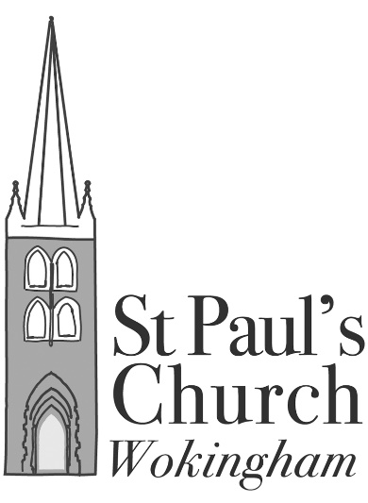
6.00am for the lighting of the Easter fire and the Paschal Candle, followed by the first Mass of Easter,
or at 8am for BCP Mass,
or at 9.30 for the All Together Mass.
A lovely cooked breakfast will be served in the Parish Rooms as well, between about 7.15 and 9.

