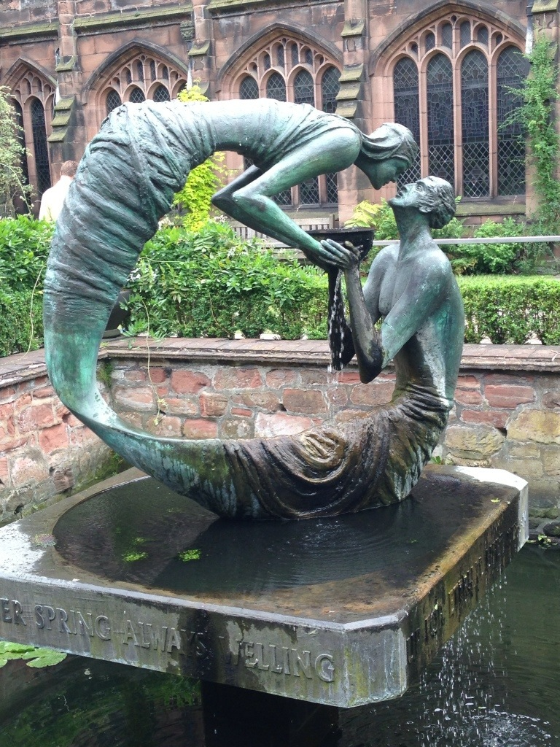
And then, through us, and because of us, and because of who we are, because of who we are together- the whole family of St Paul’s here and spread across the town at this moment- we become the stream bed along which the Living Water flows. Every phone call we make in these dark days. Every errand we run. Every prayer we offer. Every false rumour we reject. Every warm email we send. Every thoughtful act. This is Living Water, bubbling up in us and slowly, almost invisibly, inexorably, watering the desert of fear and isolation until the plants and flowers bloom again.
These are unprecedented times- yes, for us, almost certainly, but not for this building, and not for our liturgy, and not, not, not for our God, who comes to us over and over and over in Jesus Christ the Living Water, who sits with us and is with us, and stays with us, and offers us his Living Water which is hope and peace and presence:
and then gently begins to show us how not to be driven by fear and who we are not but rather how to be Living Water by the way we think and care, by the way we pray and live. We are called simply to be who we are. And in that sense nothing changes at all.

Lent 3 2019, just before the first Lockdown began

