
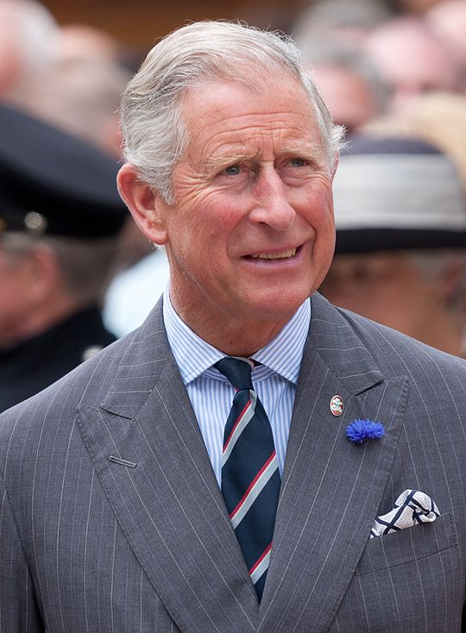
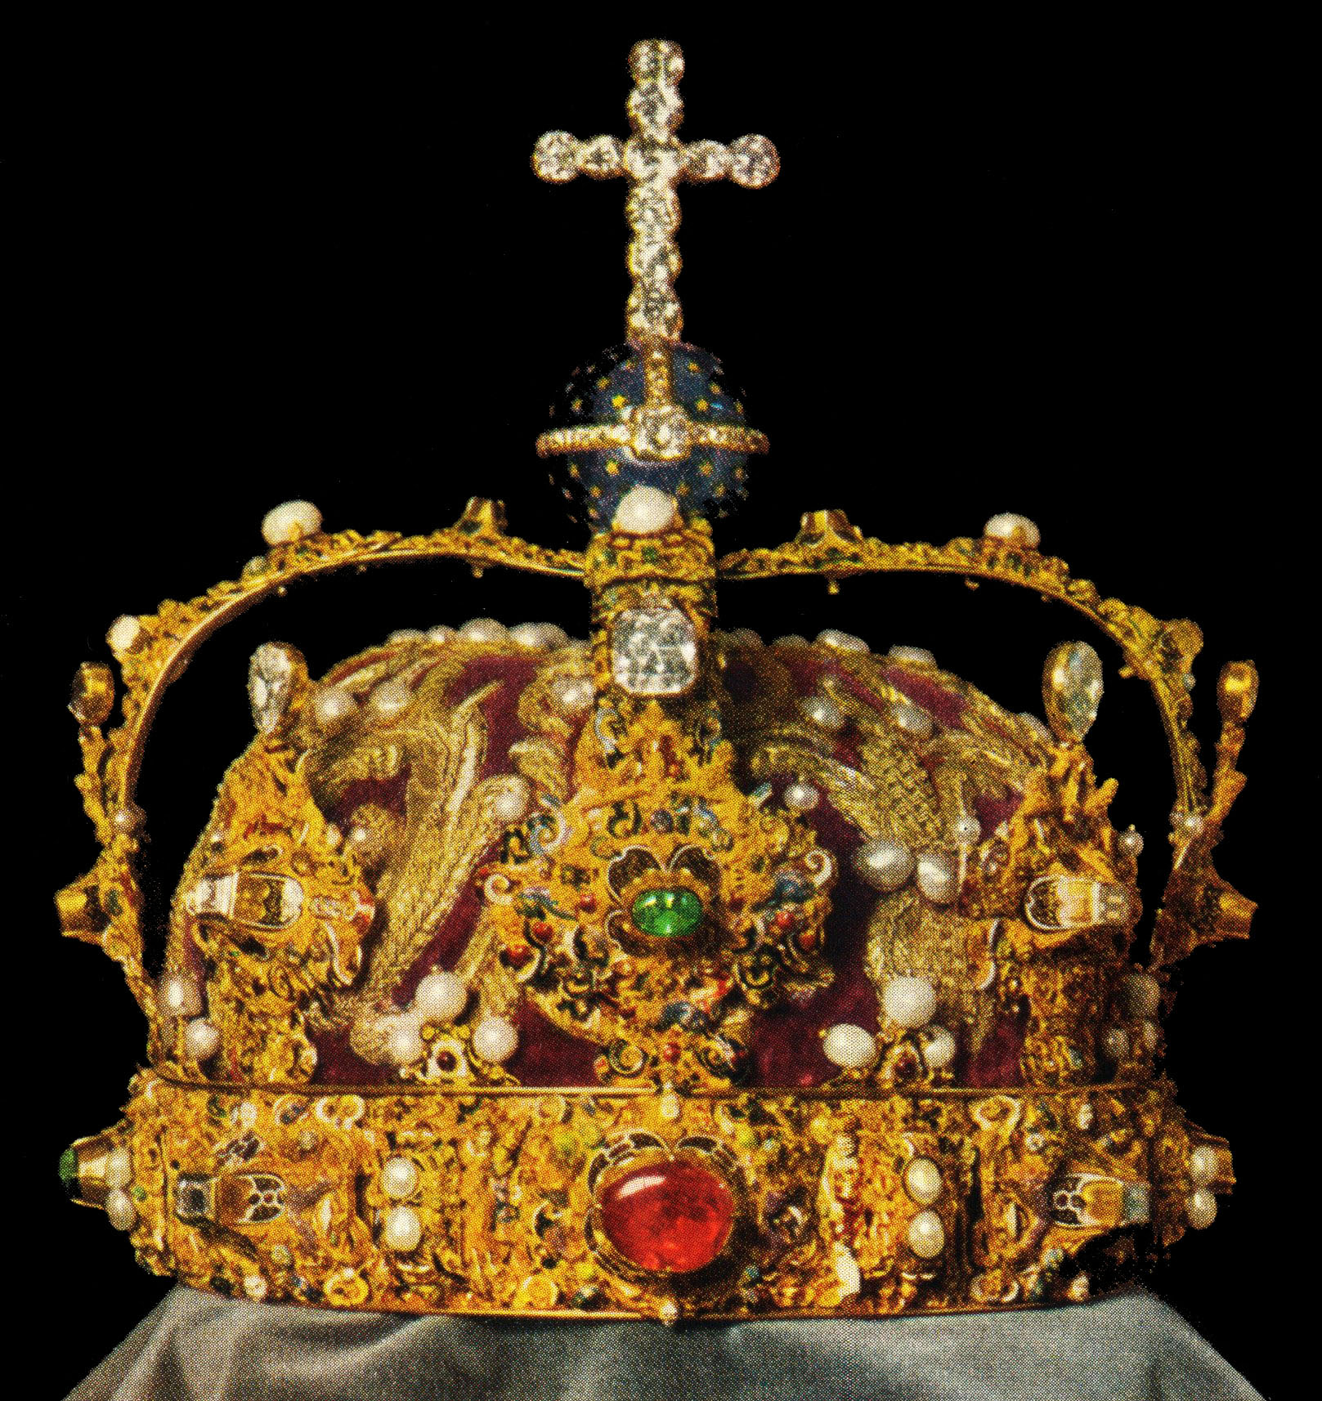

CHAMBER CHOIR DIRECTED BY IAN WESTLEY

ORGANIST: CHRISTOPHER CIPKIN
ACCORDIONIST: BEN de SOUZA

Earley St Peter’s Church, Church Road, Reading RG6 1EY

CONCERT OF SACRED MUSIC WITH A CORONATION TOUCH

SATURDAY 13 MAY 7.00 PM

including

William Boyce – The King Shall Rejoice
Ludwig Van Beethoven – Hallelujah Chorus
Johann Sebastian Bach – Der Geist Hilft
William Child – O Lord, Grant the King a Long Life
and works by
Blow, Gabrieli, Mendelssohn, Aston, Poulenc and Des Prez


in aid of
FRIENDS OF AMANI TANZANIA
and EARLEY ST PETER’S CHURCH

Admission by ticket –
suggested donation £10 for adults, £8 for students, under-18s free

For tickets or more information contact
Maggie Nunn on 07946 620560 or Ian Westley on 0118 947 8382.

