Our Mad Life 82
Back on the job!
After ‘enjoying’ the luxuries of NHS Peterborough General hospital I am back in the midst of life in Mahajanga. In England it seemed impossible to see or even get a callback from a GP (most days the telephone queue was declared full) but for me the paramedics more than fulfilled the void admirably until a consultant took over. Here in Mahajanga city one can see a doctor fairly easily but getting treatment beyond that is something of a lottery.
So a health update. With the help of my pills I am feeling extremely well – much better than when I was in England - and enjoying the warmth. An even greater joy is that the Rev Helarcin is also in great form and since I have got back (and for some time before) he has had no seizures etc. though he also is on medication.
However, his sons have been very ill since Easter with a skin complaint which I diagnosed as chicken pox (the doctor didn’t say what it was and the parents didn’t ask!) and, more alarmingly, the elder boy, Reitchy, 6 years old, had a blood test which showed his fever to be typhoid. In the last 24 hours both are making a good recovery.
My first week back included Holy Week and Easter. It was a great joy to be part of such hearty singing. The congregations’ participation is splendidly enthusiastic though the singing has all the finesse of a crowd at a football final. In fairness I must add that some of the many anthems were carefully rehearsed and performed well. The churches were gaily decorated with greats swags of material but no flowers. The days are drawing in, so no reference to spring and budding new life which, for me, sometimes detracts from the message of the resurrection. In Europe I have some times felt that the wondrous flower arrangements and greenery made Easter a festival of Spring as much as anything else.
Easter Monday, always referred to in French “Lundi de Pâques”, is the day for excursions. For the other Mondays of the year the Malagasy word used is “Alatsinainy”. Would the bishop go on the cathedral excursion to the beach or the St. James’ excursion to a picnic in the countryside? This was of much more interest this year than before since the real question was, “Where is the bishop’s car going and can I go in it?” I opted for the St. James’ excursion as that sounded interesting, much as I love sand and sea. Emilienne booked a place for herself and grandchildren and the Rev Helarcin for his family. In the event Emilienne’s grandchildren persuaded her that the annual trip to the beach was to be their choice while Helarcin’s boys were too ill to go anywhere.
We were due to depart St James’ at 7.30 am. I knew from past experience that was only a vague guide to a possible departure time so I arrived geared not to look at my watch and relax. On our way we had bought a huge block of ice at the market. Three buses were lined up and people were arriving with heavy bags. The major part of the treat is the catering. First I was invited into the rectory with a few others and coffee was served with freshly cooked sugar coated manioc/cassava, little doughnut type breads and slices of baguette. Eventually it was boarding time and we all set off.
Seven inside the car and seven in the back, as well as the three crowded buses.
Our first stop was to look at the diocesan reforestation project. This was a dismal sight. There had been no care for the saplings. Some had died, some were lost in the grass and undergrowth and some had been partially eaten by goats. This is in sharp contrast to the Mothers’ Union reforestation project with a hillside of flourishing young trees.
All the way from Mahajanga we were behind two slow moving vehicles. We were amazed when they turned off the road at the same place as we did and began slowly bumping along a track which was just recognisable as a road. Soon they got stuck in deep ruts. My driver, Tojo, jumped out and summoned some of our men and took over the other vehicles which turned out to be RC Sisters also on their Lundi de Pâques outing. The ladies in my car were so scornful. “Silly women. Fancy coming to a place like this without a single man. …” On we went over increasingly rough terrain, forded a stream and then a long slow climb up a hillside. One of the young men, Angelo, had come on Easter Day after church to cut back some of the denser growth on the road and had been running in front of the car to guide us. He waved us to a halt on the hill top and pointed out the copse on the opposite hill where some people were already arriving.
We gathered up all our picnic baskets and set off on foot down a steep hill where we had to cross another stream. Trousers rolled up I started into the water to discover it was much deeper than I thought and was full of incredibly slippery little stones. People set down their bags and helped the old bishop slowly negotiate the crossing. So embarrassing! We climbed up the bank on the other side only to find a pathless area of shallow water and ankle deep mud. I was told to aim for the tufts of grass as I wouldn’t sink so far there. I was probably the only one in the crowd who wasn’t used to going barefoot so I was immensely pleased with myself when we reached our destination barefoot with my feet unscathed.
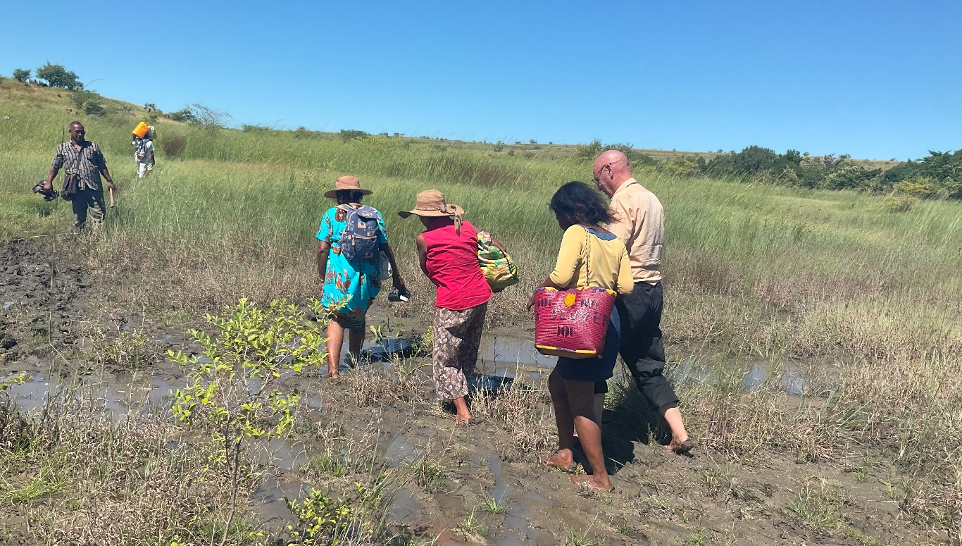
Immediately snacks were served. I was offered a huge plate of pasta and little prawns. I declined as I wasn’t hungry and I knew that I would have to eat a generous lunch before long. Everybody else tucked in. There was a choice of bathing places: down the hill there was cold water and on the other side of the hill was a warm water bathing place. In the heat, 40 C, all the young people opted for the cold water. Among the items carried to our picnic place was a deck chair for the bishop. I alone had this honour and therefore felt that I needed to use it as nobody else would. So gratefully, if self-consciously, I took my place and promptly went to sleep until lunchtime.
One of the humbling things about these shared meals is the excellent quality of the food. Just because people are poor it doesn’t mean they can’t cook sophisticated dishes and enjoy good food. It is simply that they cannot afford it. All around people were digging into copious quantities of rice and various meat and poultry dishes. My favourite was lamb in a rich coconut sauce. The great block of ice had survived the journey and was used to make fresh fruit drinks at the picnic site. These were made at astonishing speed with the fruit being squeezed in the wraps that some of the ladies were wearing. I opted for lemon, somewhat anxious about the contamination, and it was delicious, cool and refreshing. Back to the cold water pool for the young people and a few minutes siesta for the grown-ups and the party games began. All brilliantly organised and hugely enjoyed. And so the afternoon sped by. At 4 pm it was time to pack up and retrace our steps, but not before gracious speeches of thanks in true Malagasy style.
Next day saw the arrival at Bishop’s House of 20 pupils plus teachers from the Anglican Lycée in Port Bergé for a study week. Emilienne got two friends from the Mothers’ Union to help with the catering. The first lecturer cancelled so I found myself at short notice doing a session on Ethics at 7.30 am. Thank goodness for the availability of so much on the internet! The students were attentive and asked good questions. Next was a visit to the Mahajanga university museum and campus. We ALL went in my car. I now know that it can take 30 people at a big squeeze!! We arrived at the university to find it blockaded by students protesting because they had not received their grants for five months.
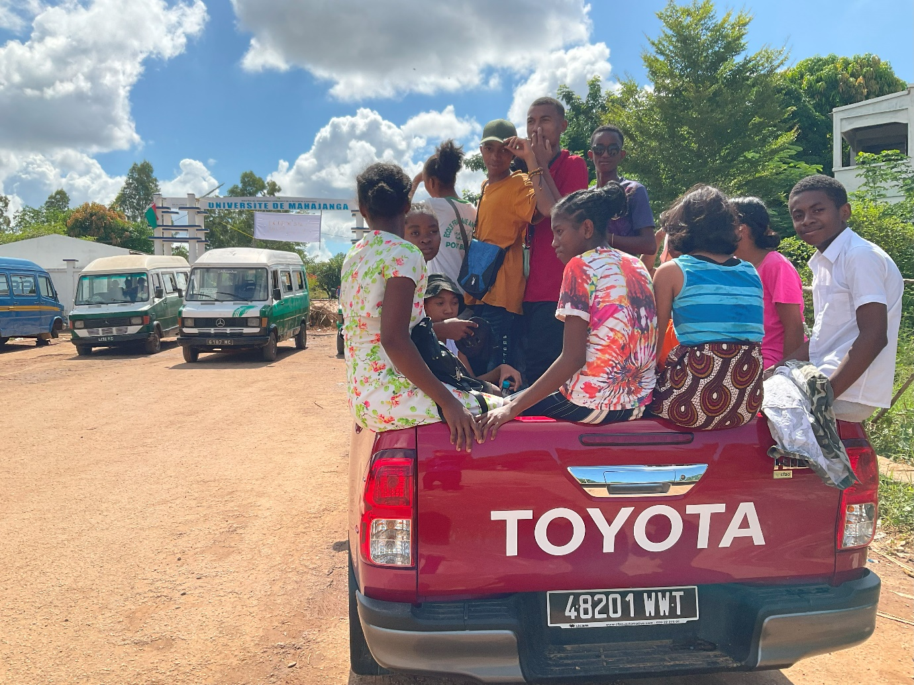
After failed negotiations to enter we set off for the airport. There were no flights that day but the students enjoyed their tour and explanations by the staff. A full programme continued until yesterday when they had time off while the Diocesan Development Committee was meeting.
A complication of the week was that the 1,000 litre water tank for the house proved inadequate for our number. Many of them washed and changed clothes after lunch since they sweated so much in the heat. This complication became a crisis on Friday morning when the electricity for the whole city failed (therefore also the water and WiFi). Astonishingly our programme carried on and in the evening we ate dinner and went to bed, hot and unwashed in the dark. At 1am today we were all up as they were due to set off for the National Park at Ankarafantsika, famous for its rare lemurs, baobabs and much else unique to Madagascar. At 2 am the electricity came on again so we had prayers and farewells at 3 am. I had thought of joining them on the visit to the Park but by Friday night I knew that bed was my only sensible option for the little of the night that remained.
Any church member who has been in hospital is visited by the congregation and receives 20,000 ariary (£5) to help offset the debts incurred at the hospital where nothing is free, right down to the plastic gloves the doctor puts on for the examination. The visit by the congregation is accompanied by flowery speeches thanking God for the renewed health of the individual and emphasising that the 20,000 ariary is a symbol of the love of all for the wonderful person…. I was duly visited by St. James’ church committee and congregation and have just been visited by the cathedral committee who added a framed text and a lovely embroidered brown shirt to the gift. So over the top were the speeches (and shirt) that I waited slightly impatiently for part two: a request for money. The cathedral is building four little shops on the road side and, surprise surprise, have run out of money. Could the bishop find 8 million ariary (approx. £1,600) to finish the project? To cut a long story short I have promised to find 4 million ariary.
And so life continues and counting our blessings is wonderful. The continuing rise in prices is scary but people are extraordinarily resilient and it is such a privilege to be at the heart of a community anywhere, but especially here. Thank you for the prayers and all round support. May the power of the resurrection bringing life after death be our hope and joy.
+Hall
hallspeers@gmail.com

15 April 2023

