Our Mad Life 83
Frustration!
Last time I told you that there was a crisis when the electricity failed. This has now turned into an everyday occurrence. The other day it went off at 5.30am and didn’t come on again until 3.30 am the following morning. When the electricity fails there is no water and no internet connection. So I have learned to go to bed, hot and sweaty, in the dark but with the light switch on so that when it comes on again the light wakes me and I dash into action: reconnect the internet, recharge telephones, laptop, etc, fill the jerry cans with water and have a much needed shower. All these I am prepared to do, albeit with a lot of grumbling, but sitting down to do emails at 4 am is a bridge too far! So intense frustration which peaked when I missed a Zoom meeting of the House of Bishops of the Province.
Why is there no electricity? Because the national electricity and water company (JI.RA.MA.) hasn’t enough diesel for the generators. However, there is no diesel shortage. Some say the workers are stealing the diesel, others that the company is in financial difficulties, others that it is part of the protests leading up to the next presidential election. What I find so depressing is that almost everybody accepts that this is the new normal and is seeking a way to live with it, but not trying to find out what is really going on, much less do anything about it, protest, or call anyone to account. Last Sunday I was leading the worship in the cathedral without amplification. My voice seems none the worse for all the unaccustomed effort.
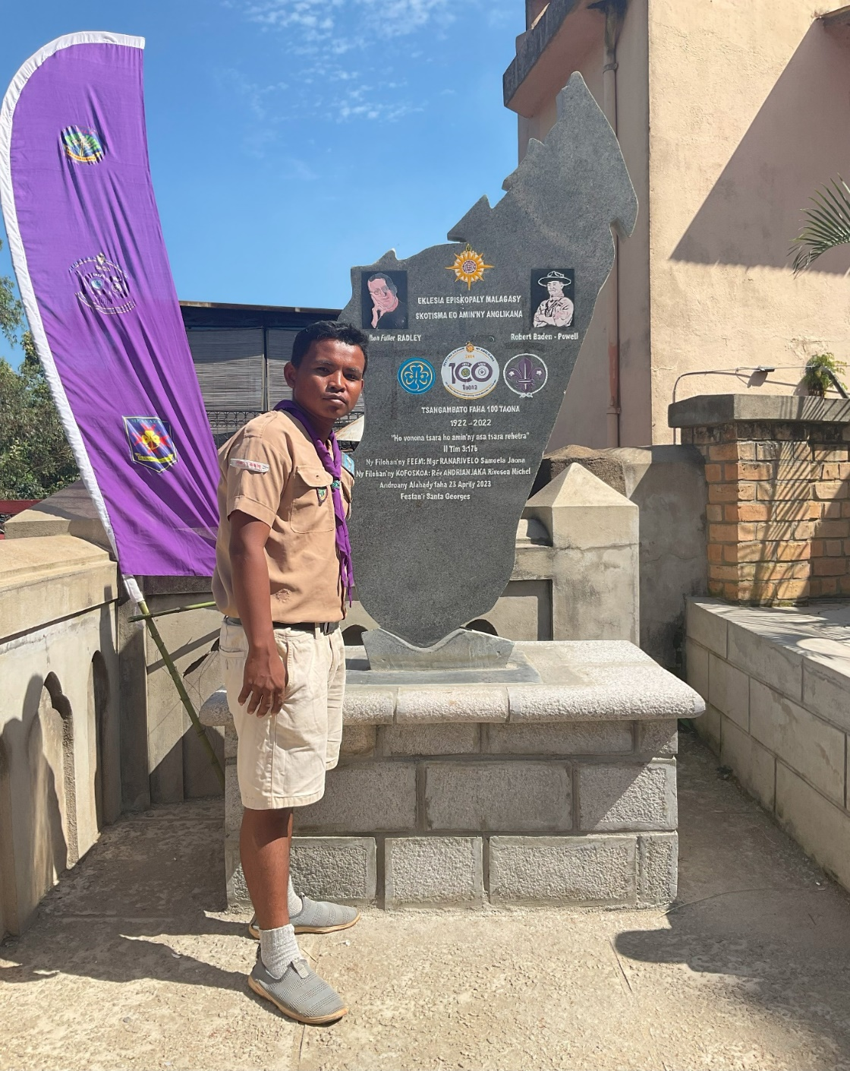
Scout memorial with my driver Mr. Tojo.
Two weekends have been dominated by the concluding events of the Scouting centenary celebrations in Madagascar. Never having been a Scout I am frequently at a loss to know what is going on in some of the rituals. But I am very impressed by the leadership qualities of many women and men who have been nurtured by the movement and who remain faithful to the movement for the rest of their lives both nurturing new generations and still enjoying Scouting events. The high point and final event of the celebrations was the dedication of a memorial stone with reliefs of Lord Baden-Powell and the Rev John Radley (who introduced Scouting to Madagascar) in the grounds of Antananarivo cathedral.
There is growing insecurity again and I have been warned not to attempt the journey to the extreme south of the diocese by road because of the numbers of bandits. This leaves travelling by sea as the only option as internal flights to that region have recently ceased. Last week bandits entered the house of the Catechist/Reader at Ambario and took their money and some possessions and set fire to the house which, with its thatched roof, was reduced to ash in a matter of minutes. The family narrowly escaped with their lives.
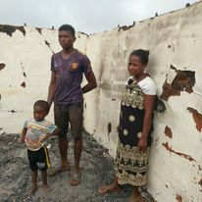
Nevertheless, yesterday I set off south to visit our people at Mitsinjo. Mahajanga lies on the northern side of the very wide river estuary of the Betsiboka river and it is an hour plus ferry crossing to the south side.
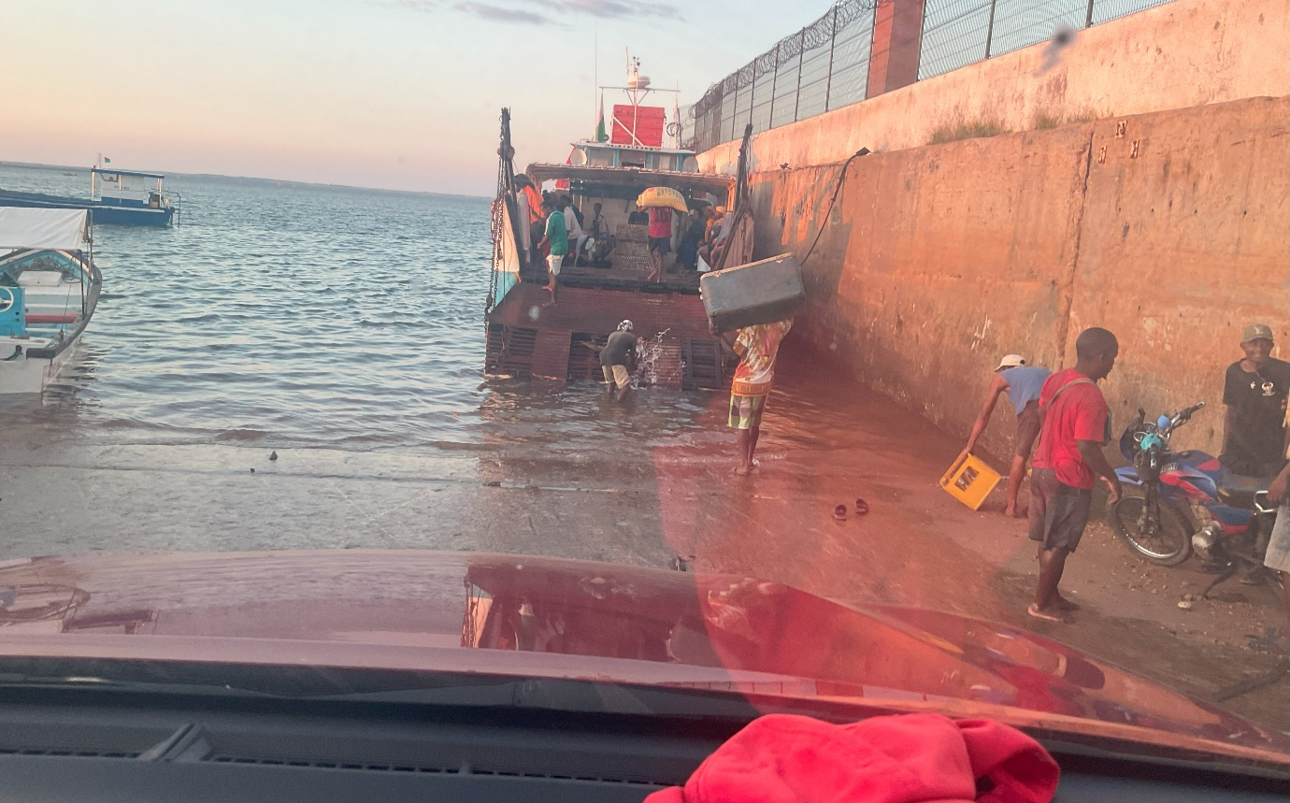
Taking the ferry was a major challenge for us all: Tojo my driver, the Rev Helarcin and myself. There are no ramps such as one sees in Europe so first the vehicle plunges into the water and then goes up the 45 degree ‘back door’ of the boat. Such is the angle that one drives on that the driver (and passengers) cannot see anything except the sky and is totally dependant on the shouts of the ferry crew for directions. Nerve wracking. Once on board driver and passengers are not allowed to leave the vehicle as space is at such a premium as hundreds of people and their luggage are packed in around the vehicle. It was a lovely smooth crossing but we were not in a position to admire any view other than our fellow passengers who were of course fascinating. Another act of faith on arrival as Tojo reversed off into the water, this time on to a sandy beach. I kept taking deep breaths and realised that I had been literally ‘holding my breath’ during some of the more perilous moments.
Off we went towards Mitsinjo. There were no sign posts and no tarmacadam to suggest what might be the road. So frequent stops to shout out, “Is this the road to Mitsinjo?” We were driving through an area officially registered as a “Reserve” because of its white lemurs and various birds. Of these we saw nothing and, more alarmingly, after an hour of driving saw no traces of human life either except the old tyre marks in the sand and dust that we were following. After two hours our host in Mitsinjo rang to ask where we were. We had absolutely no idea. He said the journey only took two hours and make sure we turn left when we saw the sugar cane and the big bridge. An hour later we began to get worried as there was no sugar cane and the road was deteriorating to the point it was hard to work out where it was. The helpful tyre marks disappeared when we drove into water! Is this the road or the river? Or both?!

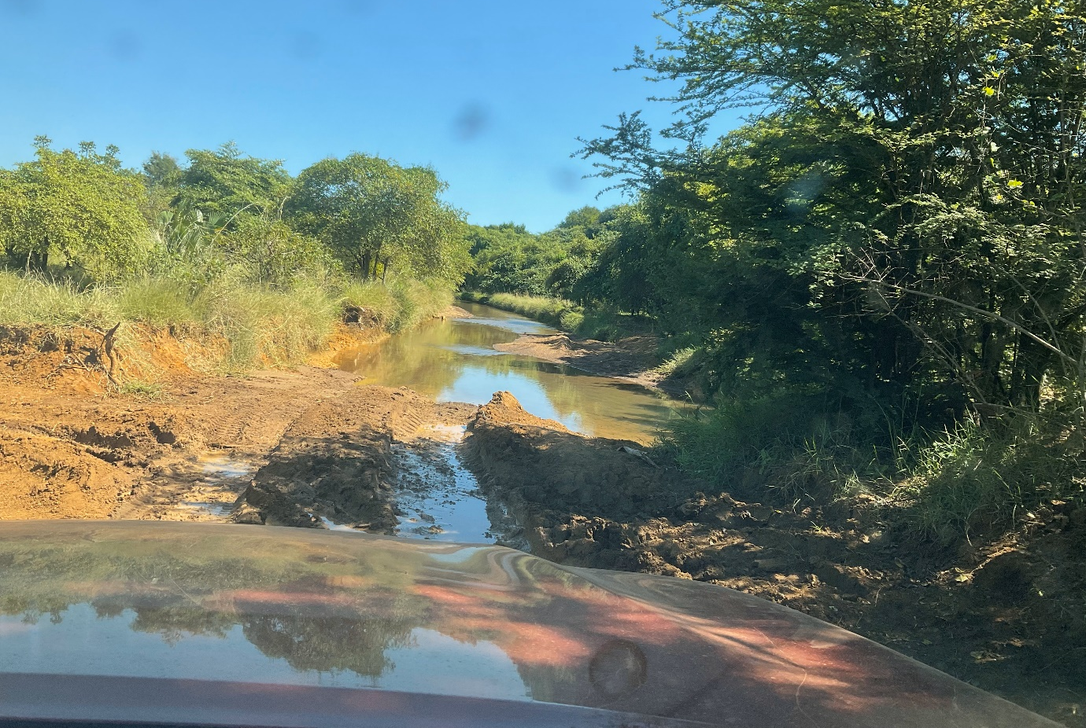
After 5 hours of bouncing around, covered in mud and dust we arrived. Such is the remoteness of the town our arrival was an object of universal interest and children ran out of school to see and all stared… At least one doesn’t have to worry about finding somewhere to park.
This was the first visit by a bishop to the town. There is a new congregation there and the object of my visit was to decide whether or not to buy land for a church, and, if so, where. In these remote places land is cheap but the legal proceedings are just as expensive as anywhere else, as are the building materials. And the inevitable question, “When is the bishop coming again for a Confirmation?” We were generously entertained. However to catch the ferry we had to make a prompt start at 4.30 am and go as fast as we could. We only just made it in time for the 9 am ferry departure. The same perils - but faced with more confidence in Tojo, the vehicle and the ferry men.
I have to say that overall I enjoyed the trip, getting away from the frustrations of a non-functioning office, and the sheer adventure of it all.
The fact that I am writing this means that tonight I have electricity, running water and an internet connection so I feel in the lap of luxury and once more know that there is so much to be thankful for. Would anyone like to come and join me on a Confirmation trip? You would be very welcome.
So, bless you all, my friends and yet again thank you for all the support and encouragement.
Yours
+Hall

hallspeers@gmail.com

6 May 2023

