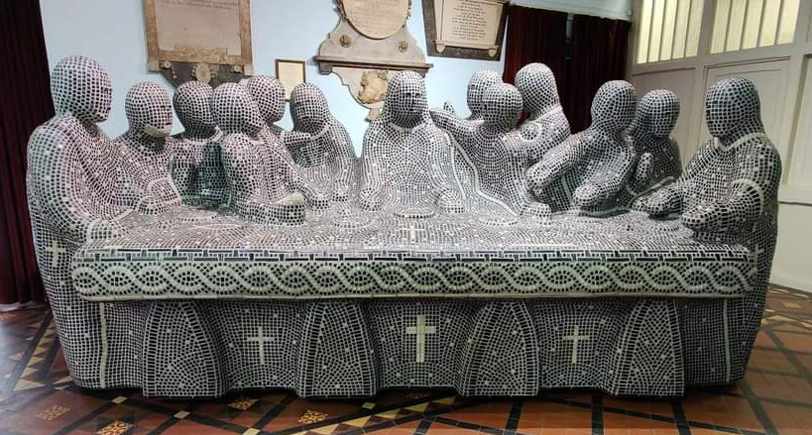
The Last Supper – Peter Barnes
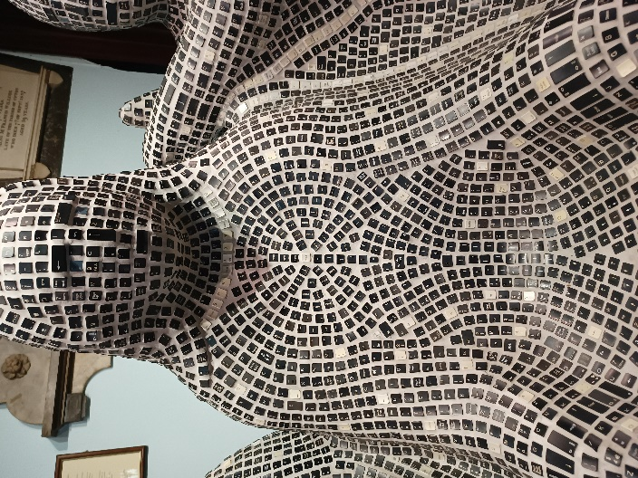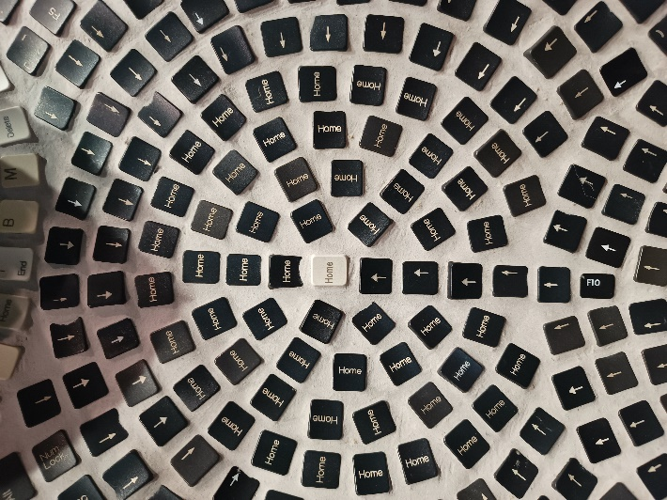

The Last Supper – Peter Barnes

On Monday I went to St John the Baptist Church in Windsor, and they have two depictions of the Last Supper there. One a traditional 400 year old painting by Francis Cleyn, the other an amazing modern sculpture by Peter Barnes. The sculpture is life size and right there as soon as you walk into the church, you can’t miss it, you can touch it, you can walk round it, you can look at it and get drawn in and lost completely in finding details, and then you step back again and find something new. It’s a mosaic, made from the keys from a computer keyboard – 600 keyboards to be precise, using in excess of 50,000 keys. I’m going to describe it, but I really would encourage you to go and see it and experience it if you can whilst it’s at St John’s. It’s incredibly clever in its simplicity and intricacy; when you look at the sculpture as a whole you see plain figures with little detail, they have bodies and arms and faces but without distinguishing features. The disciples crowd around Jesus, around a simple long table.

But then, when you begin to tune your eyes, you see that the mosaic tiles are computer keys, you begin to see that there are black and white keys and the white make up the shape of the cross, the edging of the table. You walk around the table and see that on the backs of the disciples there are Greek letters – alpha and omega, the beginning and the end, there is a fish and a dove and on the back of Jesus is a Celtic trinitarian knot. And as you gaze at the table from the font you realise that the keys aren’t all placed randomly, that woven into the mosaic are the words ‘The Last Supper’ and ‘Amen’ and then your fingers run gently over the words from scripture that say, ‘I can do everything through him who gives me strength’.

You keep looking, because now your eyes are searching this sculpture, and you read ‘trust in the Lord’ and find ‘I am the resurrection and the life.’ You study the disciples again, and see that though they don’t immediately look unique, actually, each of them is named within the mosaic – Peter, James, John, Judas. And your eyes rest upon Jesus and notice that there is a pattern within the computer keys - that arrow keys are used to point the way to his heart, and that his heart has the key you knew it would have, the only possibly key that could be used… the home key.

I stayed a while staring at the design around Jesus, because somehow, a computer keyboard sculpture has managed to convey the most beautiful truth about faith and Christ and The Last Supper and the Eucharist and the bread and the wine. That in Jesus, we find our home. I spent some time watching other people come in and discover the secrets of the sculpture, watching their faces light up as they too realised the hidden words and symbols, as their faces traced the keys, as they also delighted in Jesus as home. And then, I wanted to share what I’d found with others, I sent pictures and spoke if it, and new that it would be perfect for our service tonight.

Because tonight we come to worship and celebrate Corpus Christi, the institution of the Sacrament of the Eucharist, of Holy Communion. We reflect and think on the body of Christ gifted to us in bread and wine, about Christ’s real and continuing presence with us, about the gift we receive that we might become who we are: the body of Christ. The bread and wine are tangible, real, we can look and we can touch and we can feel and then we share that with everyone we interact with in our lives.
The reason I described the sculpture and not the painting, though both represented The Last Supper, is because I could only look at the painting, and as good as it was, it wasn’t the same as trailing my fingertips along the keys in the sculpture, it wasn’t the same as touching and discovering its visible secrets. This is the power and simplicity and wonder of the Eucharist. That all are invited, all are made welcome, that this gift is ours to discover and ours to share. That Christ is our home, and we find ourselves to be home every time we receive the bread and the wine. That when our faith is strong, the eucharist strengthens and confirms that. That when our faith wavers, the bread and the wine become an anchor to help ground us. That when our faith is small and fragile, we are given something tangible to hold, bread to nourish us and wine to sustain us. That when we feel alone, God reminds us that we are the body of Christ and that we are one amongst millions who get to cradle Jesus the living bread in our hands and in our hearts, and we are loved, and we worth everything, and we are home.
Amen.

