Our Mad Life 84
Northern Delights
The Rev Helarcin is not by nature an early bird. Having pleaded with me to be allowed to accompany me on my trip north he groaned when I announced that we would leave, not get ready to leave, at 6.30 am. I was anxious to get a good distance in the cool of the morning and arrive before dark at Port Bergé. Tojo, my driver, on the other hand was ready to leave at 6 am. Winter has arrived and so we set off in a very cool 24C. The roads continue to slowly disintegrate but the rains are over so the biggest holes are clearly visible and one can see how deep the ruts are. The dust swirled up behind us and the few passing vehicles blinded us with their dust clouds.

The consecration of the new church of St. Thomas was to be the climax of the Pentecost weekend. We arrived at our much frequented Plaza Hotel (£10 per night) to find the entrance blocked by a very large black limousine driven by a lady of equally generous proportions with the most engaging of smiles and dazzling personality: none other than our own Deputy(MP) from Mahajanga. Her bodyguards were several heavyweight ladies in the bright orange tee shirts of her political party. Smiles and waves all round. One couldn’t help but feel surrounded by welcoming people, whatever their politics might be. It is presidential election year and one is very conscious of it! Parked behind us were two huge lorries with signs on the windscreens announcing “On Presidential business”.

The business in question turned out to be 110 sparkling new Yamaha motorbikes to be handed over to each mayor in the region at a political rally the next day. Also a great number of bicycles but I can’t remember who they were for. Some were for best performing teachers. Each motor bike was beautifully labelled with the name of the recipient on one handle bar and their location on the other handle bar which made for easy conversation the next morning. The loud music at this celebration went on until 4 am and again the next night which was neither conducive to sleep nor preparation for my activities. The light bulb in my room was the dimmest I have ever come across. It eventually ceased to function, so reading was not an option.

On Saturday afternoon I went off to Bemilolo church for a rehearsal for the service but I found it really hard going getting anyone to concentrate. All questions got a “Oui, Monseigneur” answer until I followed them up with, “Who, Where, How?” As usual at these great celebrations a major source of interest was the catering. This time a very fine sleek black ox.

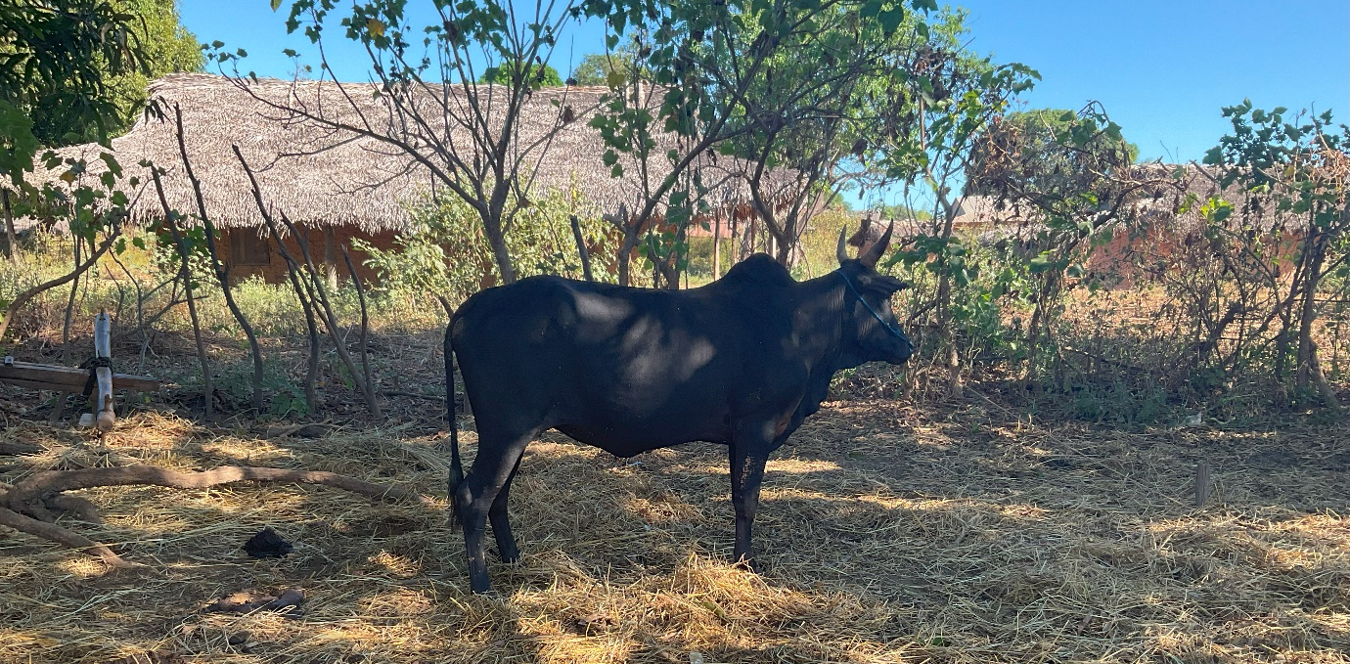

The other source of immediate interest was the concert for all who had arrived early for the service next day. “Monseigneur will really enjoy the concert.” I agreed that I was sure that I would but I really needed to go to bed early given the day ahead. “You must come, it will be over about 8 pm.”. Given past experience, I politely declined the invitation. The concert ended at 11 pm and was a huge success with a great crowd and the rest of my entourage got to bed after midnight. It remains a mystery to me how people always get the timings of these events hopelessly wrong when they are so very predictable.

In the morning we loaded up the car with all manner of equipment, loudspeakers, keyboard, robes, etc. and arrived at Bemilolo at 7.30am. The first priority seemed rather inappropriate to me. This was setting up a table and chairs in front of the chancel steps for me and my party to have our cooked breakfast. Rice and beef, of course. Only after that could the last preparations for the Dedication service take place. These included polishing the floor with red polish: the Red Mansion polish I was so familiar with in my childhood. Appropriate for Pentecost!

At the very last minute the Rural Dean beseeched me to have baptisms in the service. I had previously refused this on the grounds that the service was already extremely long. I acquiesced. One of the candidates was the husband of the Reader/catechist whose house was burned down by bandits that I mentioned in my last notes. Then the generator ran out of petrol and so my driver was requested to return the nearest town and get some.

At last the service began. The priest of the parish was by now somewhat frazzled trying to do so many last minute things including deputising for the organist who eventually arrived over an hour late having come over 100 miles from the other end of the parish. Helarcin was enjoying the proceedings acting as my chaplain while the Revd Nivo, the non-stipendiary lady priest in the parish, was organising where needed and generally keeping things moving in her calm and unobtrusive manner. The other priest in the area, Ndriampidy, was busy keeping out of the bishop’s way and next best thing to invisible.

The congregation duly followed me around the outside of the church with prayers at the four corners before cutting the ribbon and the ceremonial knocking on the door with my bishop’s staff. My crozier has a very useful rubber tip at the bottom to keep it from sliding on floors but this rather diminishes the drama of banging three times on the door: dull thuds rather than resounding knocks.

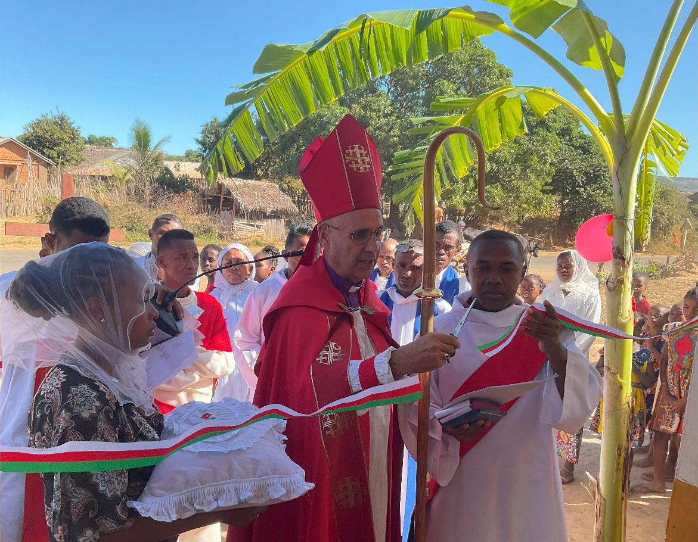
This was the fifth church I have dedicated so I am getting to know where the proceedings take participants by surprise and need a firm lead to stop confusion and chaos. In terms of tribe and dialect this was in Helarcin’s home area and so it was decided that I would preach in official Malagasy and he would translate into the local dialect which I can mostly understand but not speak fluently. It was fascinating to see the congregation’s reaction. My lame attempt at jokes got as many laughs in my version as in the translation. Always a good indicator.

Being Pentecost the sermon was majoring on the gift of the Holy Spirit. Also the church was dedicated to St. Thomas with his great affirmation of Jesus, “My Lord and my God!” The gospel appointed for Pentecost was John 20. 19-23 and the gospel appointed for St.Thomas’ day is John 20. 24-29 so I simply put these together and that brought a great sense of unity to the two themes. I spoke about a Thomas I knew who had been a Jewish child in Nazi Germany. He eventually settled in England and became a very distinguished psychiatrist and a generous Christian. It is in his memory that the church is dedicated to St Thomas.

The congregational participation was whole hearted and the singing as enthusiastic as usual. The proceedings ended at 2 pm having started at 8.30 am but there was absolutely no rush to serve lunch! Eventually everyone sat down to vast quantities of rice and beef and all was declared a great success.

The next day we continued our journey north.

Our power cuts continue daily and I shall send the next instalment when the power is on and I can summon the energy. It is all very encouraging to see how much your support has achieved. Thank you. However, I must confess that the current on/off power supply is really getting me down. Solar power the next step?

Love and prayers
+Hall

hallspeers@gmail.com

12 June 2023

